Supplemental material

Figure S1. Expected and observed time series trends of daily Chlamydia reported cases in Catalonia, August 1st 2017 - August 1st 2020 (dark grey: lockdown, light grey: de-escalation phases).
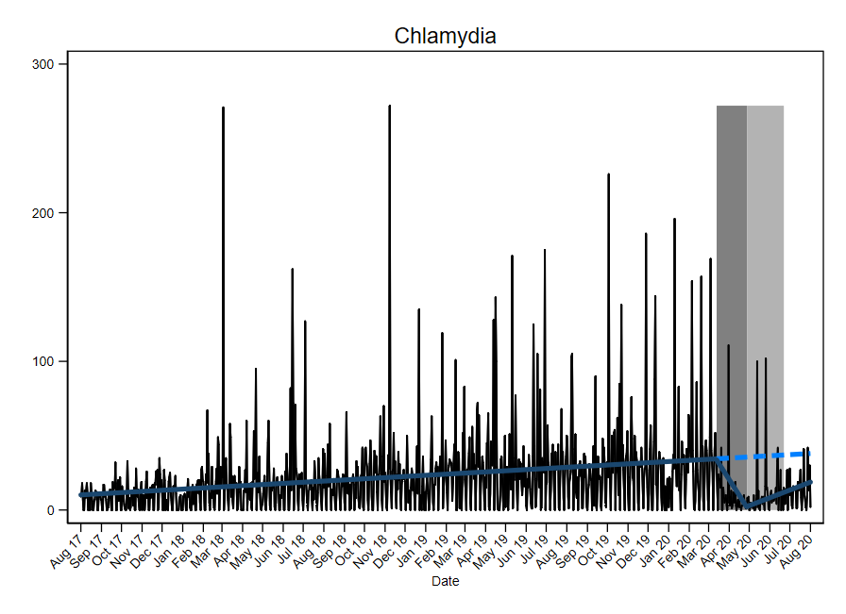
Figure S2. Expected and observed time series trends of daily Gonorrhoea reported cases in Catalonia, August 1st 2017 - August 1st 2020 (dark grey: lockdown, light grey: de-escalation phases).
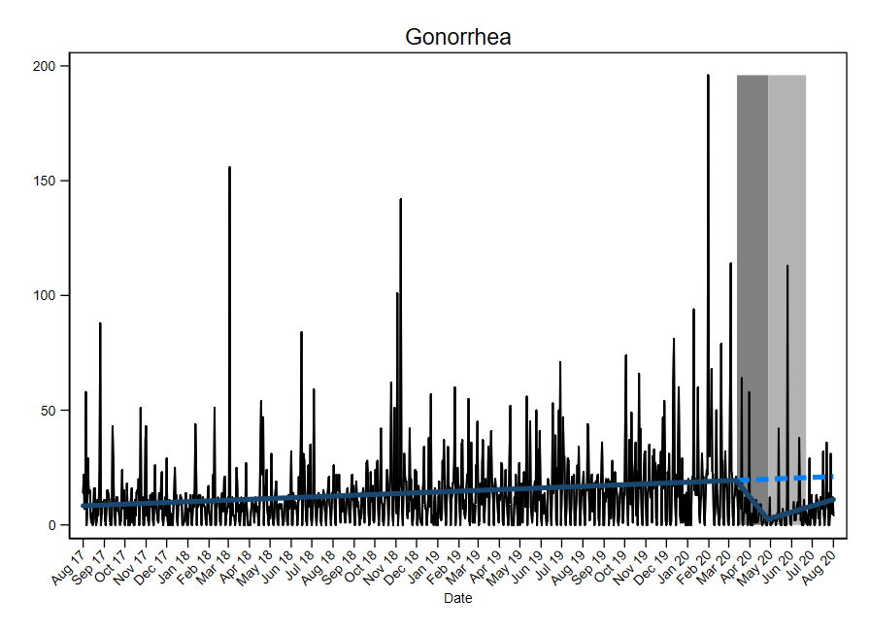

Figure S3. Expected and observed time series trends of daily Syphilis reported cases in Catalonia, August 1st 2017 - August 1st 2020 (dark grey: lockdown, light grey: de-escalation phases).
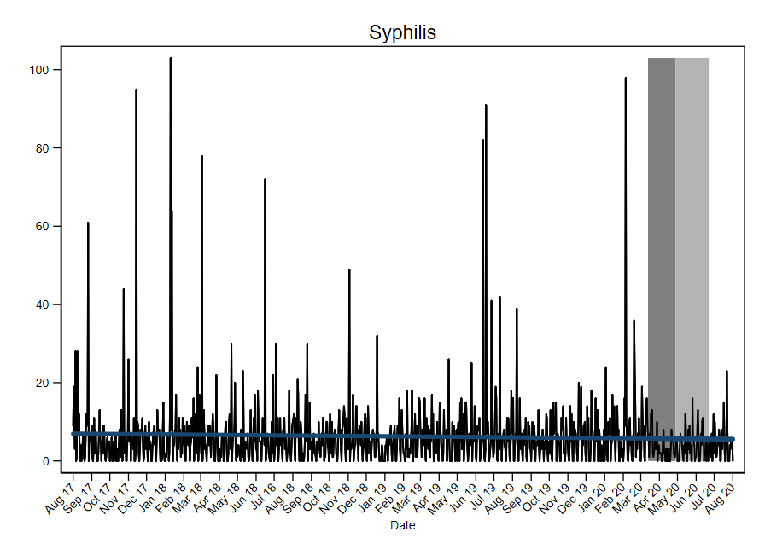
Figure S4. Expected and observed time series trends of daily venereal lymphogranuloma (LGV) reported cases in Catalonia, August 1st 2017 - August 1st 2020 (dark grey: lockdown, light grey: de-escalation phases).
