APPENDIX TABLES
Table A1. Firms at Which Respondents were Employed
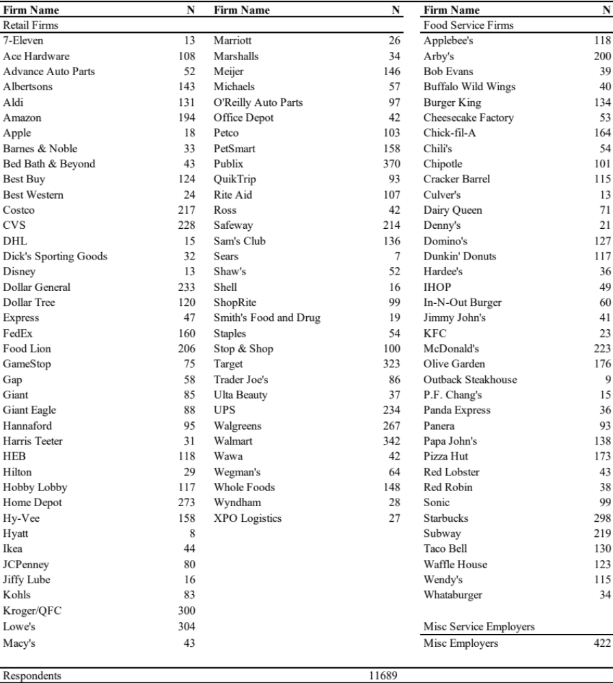

Table A2. Comparison of Workers in American Community Survey (Weighted, 2018 and 2019) and Shift Project Data (Weighted, 2020)

 | ACS | Shift
Gender
Male | 47% | 48%
Female | 53% | 52%
Race/Ethnicity
White, non-Hispanic | 54% | 63%
Black, non-Hispanic | 13% | 9%
Hispanic | 23% | 19%
Other/Two or more races, non-Hispanic | 10% | 8%
Education
High School or Less | 50% | 35%
Some College | 30% | 38%
Associate’s Degree | 8% | 12%
Bachelor’s Degree or more | 12% | 14%
Enrolled in School | 21% | 20%
Age
Mean | 36 | 38
Median | 29 | 35
N | 296,645 | 11,781

Table A3. Full Model Results

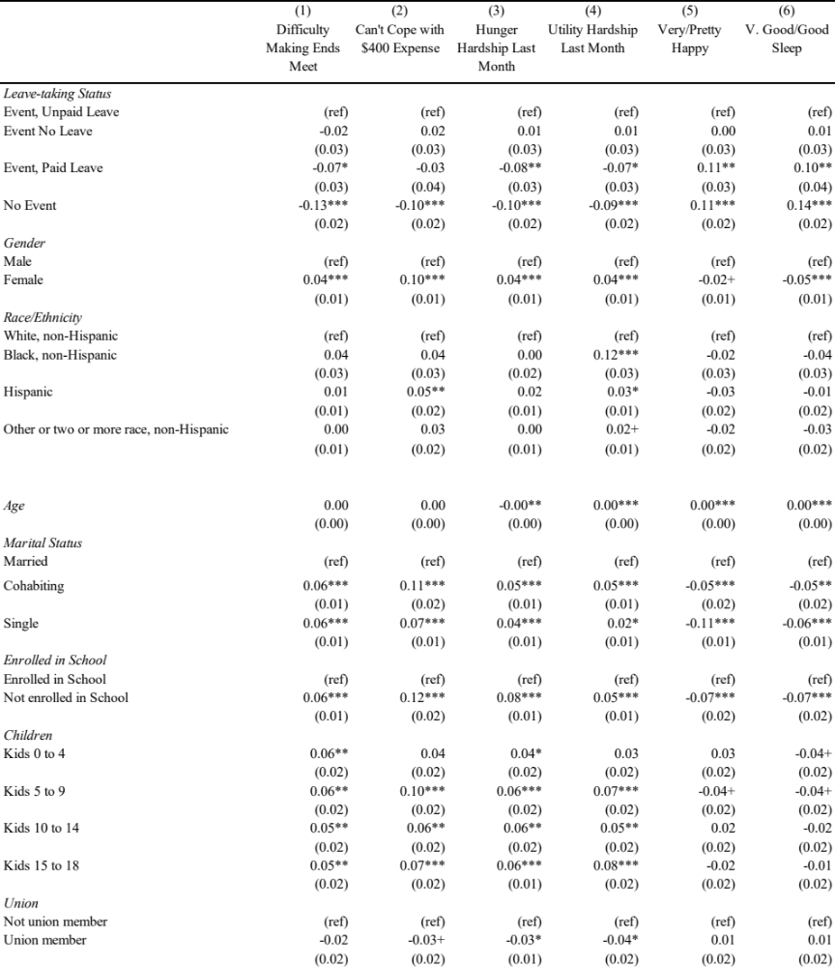

Cont….

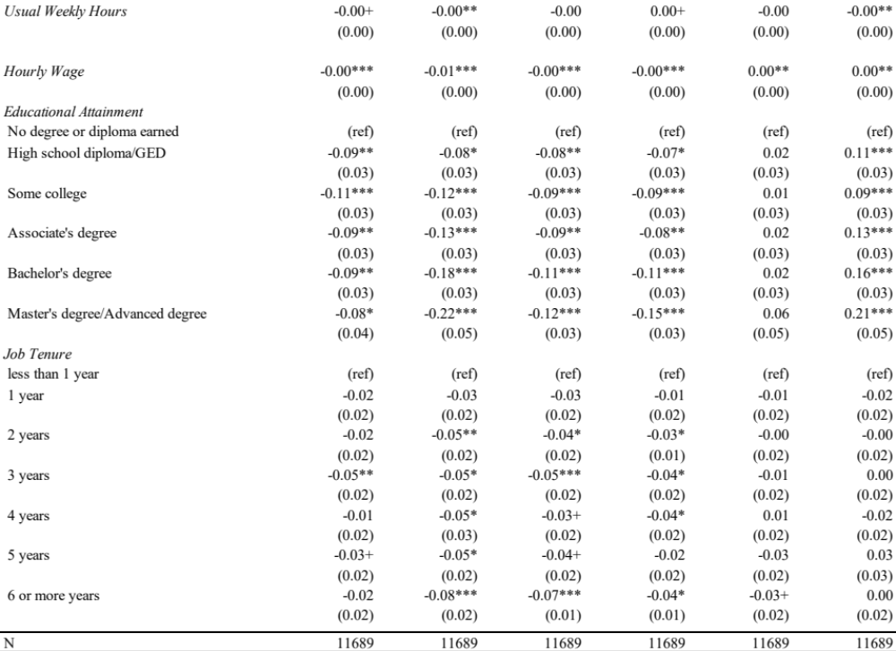
Table A4. Association Between Paid Leave Taking and Economic Security/Wellbeing, Robustness (Conditional on Qualifying Event)

 | (1) | (2) | (3) | (4) | (5) | (6)
 | Difficulty Making | Cannot Cope with | Hunger Hardship | Utility Hardship | Very/Pretty | V. Good/Good
 | Ends Meet | $400 Expense | Last Month | Last Month | Happy | Sleep
Baseline Controls  Event, No Leave | -0.01 | 0.04 | 0.02 | 0.01 | -0.01 | 0.01
Event, Unpaid Leave | (ref) | (ref) | (ref) | (ref) | (ref) | (ref)
Event, Paid Leave | -0.08* | -0.03 | -0.07* | -0.09** | 0.10** | 0.10**
+ Control for Type of Event  Event, No Leave | -0.01 | 0.03 | 0.03 | 0.02 | -0.01 | 0.00
Event, Unpaid Leave | (ref) | (ref) | (ref) | (ref) | (ref) | (ref)
Event, Paid Leave | -0.08* | -0.03 | -0.08** | -0.09** | 0.11** | 0.11**
+ Control for Self-Rated Health  Event, No Leave | -0.01 | 0.02 | 0.03 | 0.02 | -0.01 | 0.00
Event, Unpaid Leave | (ref) | (ref) | (ref) | (ref) | (ref) | (ref)
Event, Paid Leave | -0.07* | -0.02 | -0.06* | -0.08* | 0.09** | 0.08*
Observations | 2,250 | 2,250 | 2,250 | 2,250 | 2,250 | 2,250
Note: Estimates from linear probability models that include controls for gender, race/ethnicity, age, marital status, having children age 0 to 4, age 5 to 9, age 10 to 14, age 15 to 18, school enrollment, educational attainment, job tenure, union membership, usual work hours, and hourly wage, as well as month and state fixed-effects. ∗∗∗ = p < .001; ∗∗ = p < .01; ∗ = p < .05

Figure A1: Predicted Values of Outcomes by Paid Leave Status
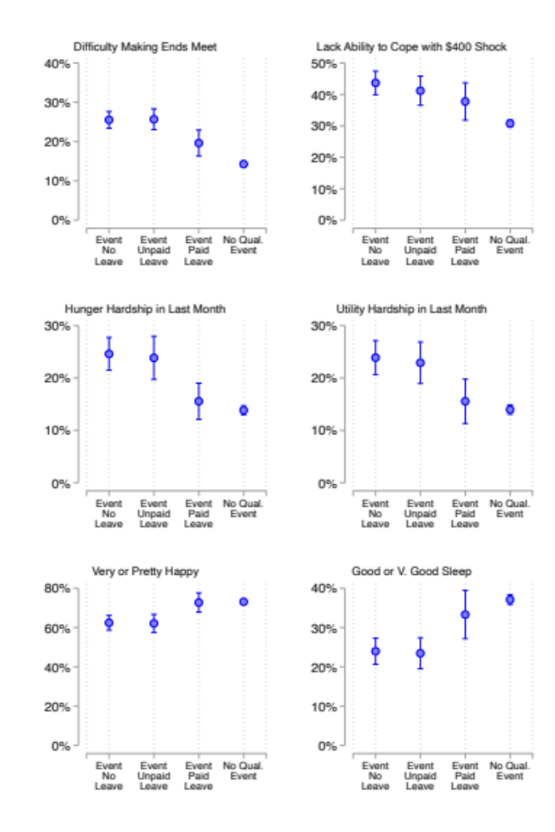
Note: Estimates from models following same specification as Table 3.

