Supplemental Figure 1. Forest plot of sex-stratified associations between household pesticide use and ln-transformed urinary pesticide metabolites with insufficient sleep duration
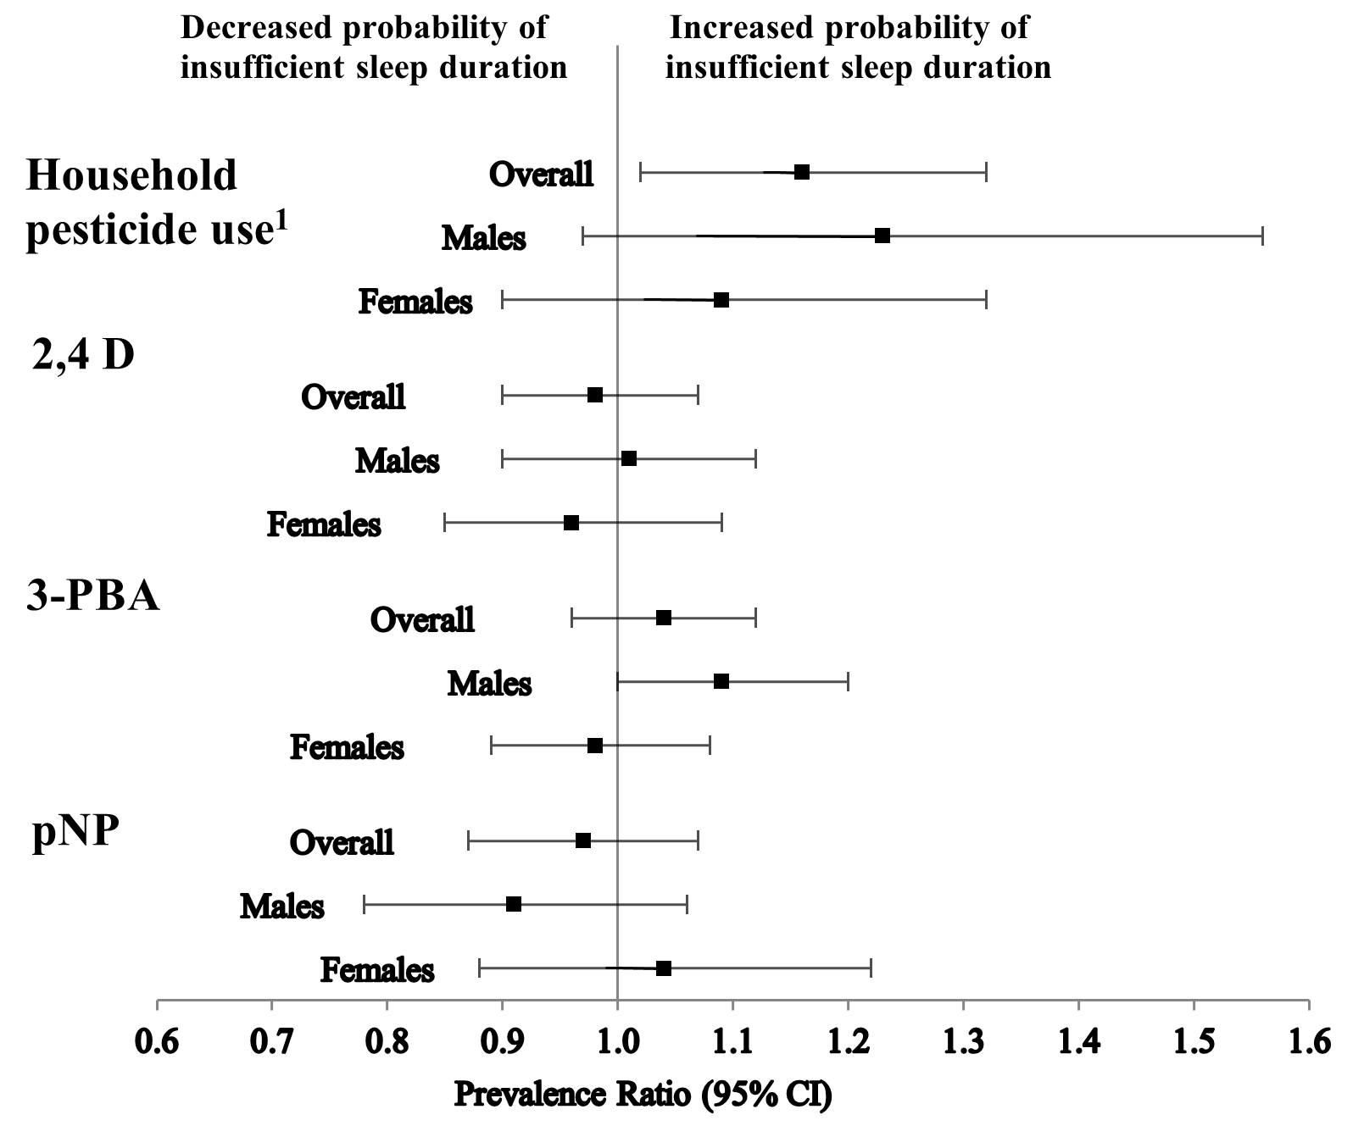
¹Estimates obtained from model three; ABR: PR: prevalence ratio; CI: confidence interval;
4-D: 2,4-dichlorophenoxyacetic acid; 3-PBA: 3-phenoxybenzoic acid; pNP: para-Nitrophenol

Supplemental Figure 2. Forest plot of sex-stratified associations between household pesticide use and ln-transformed urinary pesticide metabolites with trouble sleeping
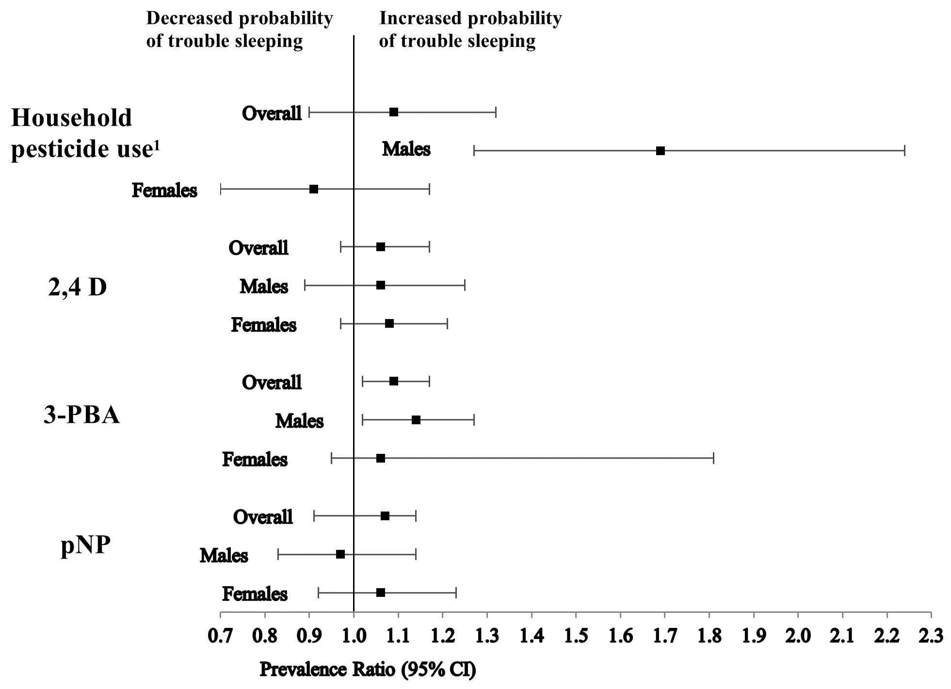
¹Estimates obtained from model three; ABR: PR: prevalence ratio; CI: confidence interval;
4-D: 2,4-dichlorophenoxyacetic acid; 3-PBA: 3-phenoxybenzoic acid; pNP: para-Nitrophenol

