Legend
Supplemental Material
Table S1 Prevalence of cardiovascular risk factors in urban and rural residents
Table S2 Prevalence of cardiovascular risk factors in north and south region
Figure S1 Proposed Directed acyclic graph for the association between PM2.5 and CVR (cardiovascular risk factors)
Figure S2 Annual average PM_{2.5} concentration in 2008, China and distribution of surveyed cities.
Figure S3 Distributions of PM_{2.5} concentration in the surveyed cities (2001-2010).
Boxes covered the 25–75th percentile, with a centerline for the median concentration. Whiskers extend to the highest observation within 3 IQRs (interquartile ranges) of each box. The extreme data were shown as dots.
Figure S4 Exposure-response relationship between PM_{2.5} exposure and cardiovascular risk factors prevalence in general population.
(A) diabetes; (B) hypertension；(C) hyperlipidemia; (D) overweight. The exposure-response relationship was calculated by generalized additive model, and further adjusted by age, sex, education, ethnicity, smoking status, drinking status, intensity of physical activity, diet types. Knots used in the generalized additive model was 3. P value was denoted in each panel.
Figure S5 Exposure-response relationship between PM_{2.5} exposure and cardiovascular risk factors prevalence in population with middle or above education.
(A) diabetes; (B) hypertension; (C) hyperlipidemia; (D) being overweight. The exposure-response relationship was calculated by generalized additive model, and further adjusted by age, sex, ethnicity, smoking status, drinking status, intensity of physical activity, diet types. Knots used in the generalized additive model was 3. P value was denoted in each panel.
Figure S6 Association between PM_{2.5} exposure and cardiovascular risk factors prevalence determined by different logistic regression models.
The odds ratios and relevant 95% CI were scaled to each 10μg/m³ PM_{2.5} exposure and calculated by univariate or multivariable logistic regression.
Model 1 adjusted for: none
Model 2 adjusted for: age, sex
Model 3 adjusted for: Model 2 + education, ethnicity
Model 4 adjusted for: Model 3 + smoking status, drinking status
Model 5 adjusted for: Model 3 + intensity of physical activity
Model 6 adjusted for: Model 3 + diet types
Model 7 adjusted for: Model 3 + smoking status, drinking status, intensity of physical activity, diet types
Model 8 adjusted for: Model 7 + all other diseases
Model 9 adjusted for: Model 3 + residence (rural/ urban)
Model 10 adjusted for: Model 3 + region (south/ north)
Model 11 adjusted for: Model 7 + residence (rural/ urban)
Model 12 adjusted for: Model 7 + region (south/ north)
Figure S7 Association between PM_{2.5} exposure defined by different time duration and cardiovascular risk factors prevalence.
The odds ratios and relevant 95% CI were scaled to each 10μg/m³ PM_{2.5} exposure and calculated by multivariable logistic regression, and further adjusted for age, sex, education, ethnicity, smoking status, drinking status, intensity of physical activity, and diet types.
Figure S8 Association between dichotomous PM_{2.5} exposure and cardiovascular risk factors prevalence.
PM_{2.5} were categorized into “high” or “low” by a threshold of 35 μg/m³. The low exposure group was used as the reference group. The odds ratios and relevant 95% CI were scaled to dichotomous PM_{2.5} exposure and calculated by multivariable logistic regression, and further adjusted for age, sex, education, ethnicity, smoking status, drinking status, intensity of physical activity, and diet types.
Figure S9 Association between PM2.5 exposure and cardiovascular risk factors prevalence stratified by residence (urban or rural).
The odds ratios and relevant 95% CI were scaled to each 10μg/m³ PM_{2.5} exposure and calculated by multivariable logistic regression, and further adjusted for age, sex, education, ethnicity, smoking status, drinking status, intensity of physical activity, and diet types.
Figure S10 Association between PM_{2.5} exposure and cardiovascular risk factors prevalence stratified by region (south or north).
The odds ratios and relevant 95% CI were scaled to each 10μg/m³ PM_{2.5} exposure and calculated by multivariable logistic regression, and further adjusted for age, sex, education, ethnicity, smoking status, drinking status, intensity of physical activity, and diet types.
Figure S11 Association between PM_{2.5} exposure and cardiovascular risk factors prevalence
The odds ratios and relevant 95% CI were scaled to each 10μg/m³ PM_{2.5} exposure and calculated by multivariable logistic regression in crude model, and further adjusted for age, sex, education, ethnicity, residence (urban or rural), smoking status, drinking status, intensity of physical activity, and diet types in adjusted model.
Figure S12 Association between PM_{2.5} exposure and cardiovascular risk factors prevalence stratified by covariates.
Population was stratified by age, sex, education, ethnicity, smoking status, drinking status, intensity of physical activity, and diet types. The odds ratios and relevant 95% CI were scaled to each 10μg/m³ PM_{2.5} exposure and calculated by multivariable logistic regression, and further adjusted for age, sex, education, ethnicity, residence (rural or urban), smoking status, drinking status, intensity of physical activity, and diet types. The significance of interaction effect was tested by introducing an interaction term in the regression model.
Figure S13 Exposure-response relationship between PM_{2.5} exposure and cardiovascular risk factors prevalence in population with preliminary or below education.
(A) diabetes; (B) hypertension; (C) hyperlipidemia; (D) being overweight. The exposure-response relationship was calculated by generalized additive model, and further adjusted by age, sex, ethnicity, residence (rural or urban), smoking status, drinking status, intensity of physical activity, diet types. Knots used in the generalized additive model was 3. P value was denoted in each panel.
Figure S14 Association between PM_{2.5} exposure and cardiovascular risk factors prevalence stratified by cardiovascular risk factors.
The odds ratios and relevant 95% CI were scaled to each 10μg/m³ PM_{2.5} exposure and calculated by multivariable logistic regression, and further adjusted for age, sex, education, ethnicity, residence (urban or rural), smoking status, drinking status, intensity of physical activity, and diet types.

Table S1 Prevalence of cardiovascular risk factors in urban and rural residents
Disease | Overall population | Urban | Rural | P
N, n (%) | 19,236 (100) | 9,777 (50.8) | 9,459 (49.2)
Diabetes, n (%) ª | 755 (3.9) | 369 (3.8) | 386 (4.1) | 0.290
Hypertension, n (%) ª | 4,383 (22.8) | 1,964 (20.1) | 2,419 (25.6) | <0.001
Hyperlipidemia, n (%) ª | 5,391 (28.0) | 2,469 (25.3) | 2,922 (30.9) | <0.001
Overweight, n (%) ª | 7,727 (40.2) | 3,898 (39.9) | 3,829 (40.5) | 0.396
ª Compared by the χ2 test.

Table S2 Prevalence of cardiovascular risk factors in north and south region
Disease | Overall population | South | North | P
N, n (%) | 19,236 (100) | 9,459 (49.2) | 9,777 (50.8)
Diabetes, n (%) ª | 755 (3.9) | 390 (3.8) | 365 (4.1) | 0.422
Hypertension, n (%) ª | 4,383 (22.8) | 2,235 (21.8) | 2,148 (23.8) | 0.001
Hyperlipidemia, n (%) ª | 5,391 (28.0) | 3,015 (29.5) | 2,376 (26.4) | <0.001
Overweight, n (%) ª | 7,727 (40.2) | 3,441 (33.7) | 4,286 (47.6) | <0.001
ª Compared by the χ2 test.

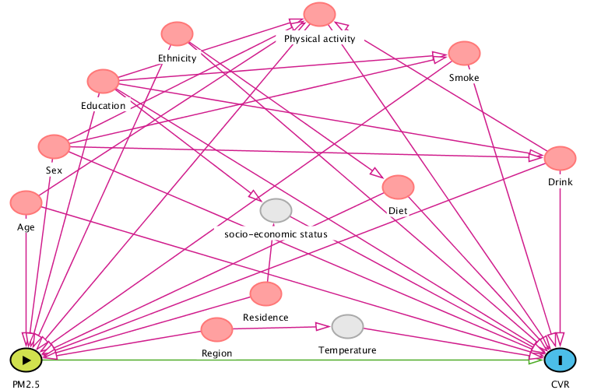

Figure S1 Proposed Directed acyclic graph for the association between PM_{2.5} and CVR (cardiovascular risk factors)

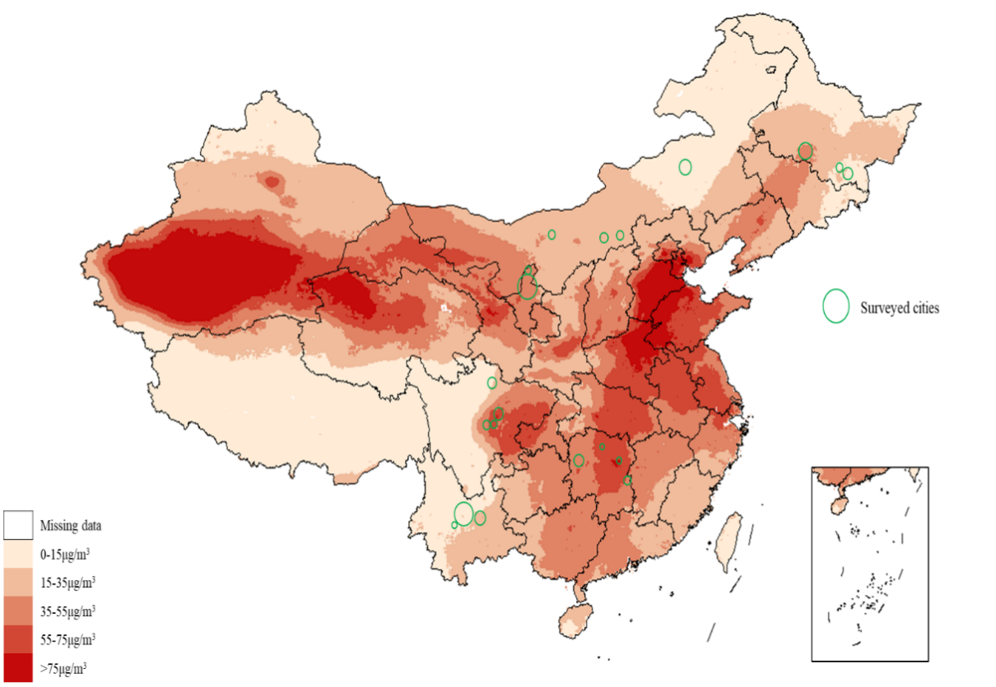

Figure S2 Annual average PM_{2.5} concentration in 2008, China and distribution of surveyed cities.

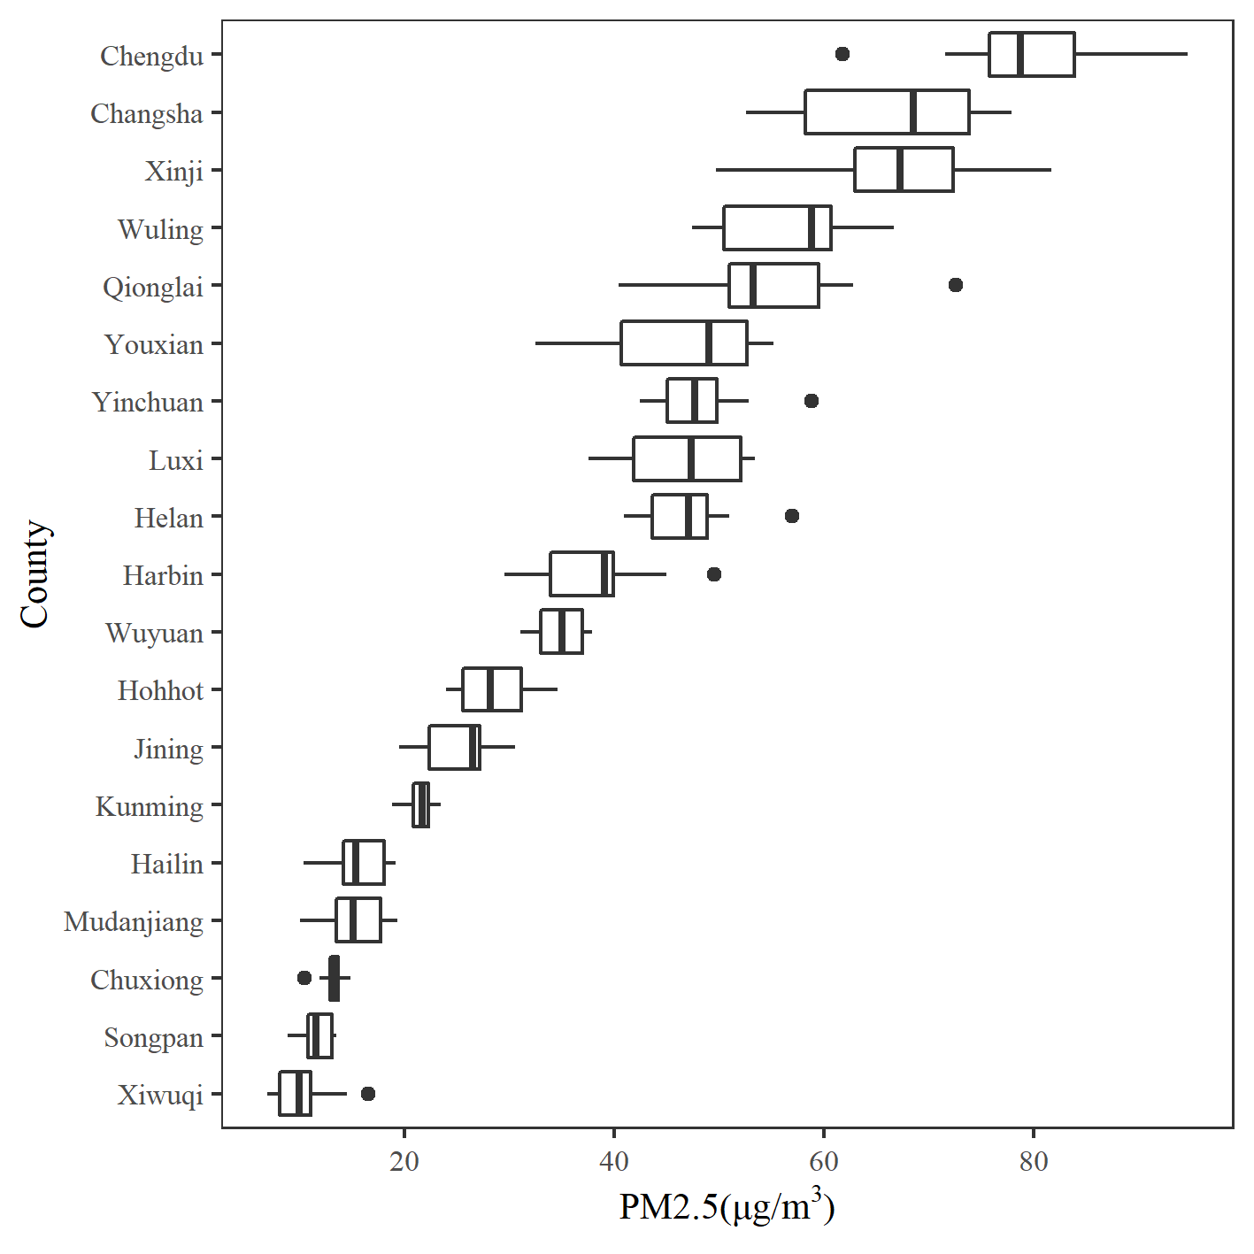

Figure S3 Distributions of PM_{2.5} concentration in the surveyed cities (2001-2010).
Boxes covered the 25–75th percentile, with a centerline for the median concentration. Whiskers extend to the highest observation within 3 IQRs (interquartile ranges) of each box. The extreme data were shown as dots.
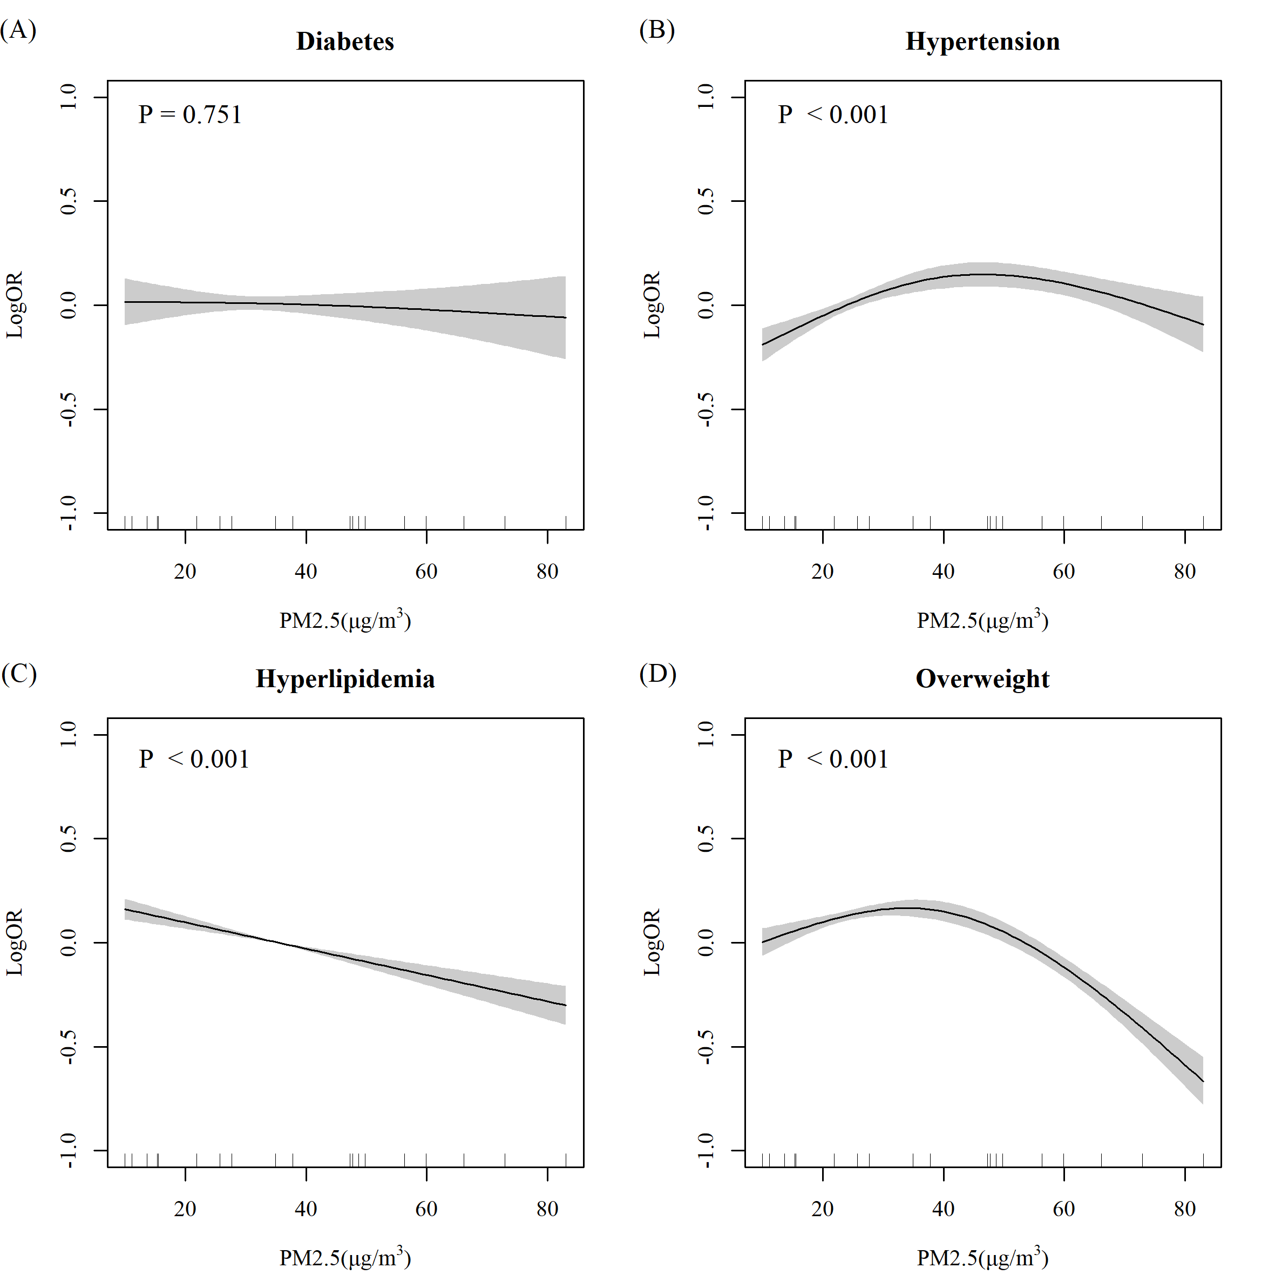

Figure S4 Exposure-response relationship between PM_{2.5} exposure and cardiovascular risk factors prevalence in general population.
(A) diabetes; (B) hypertension；(C) hyperlipidemia; (D) overweight. The exposure-response relationship was calculated by generalized additive model, and further adjusted by age, sex, education, ethnicity, smoking status, drinking status, intensity of physical activity, diet types. Knots used in the generalized additive model was 3. P value was denoted in each panel.
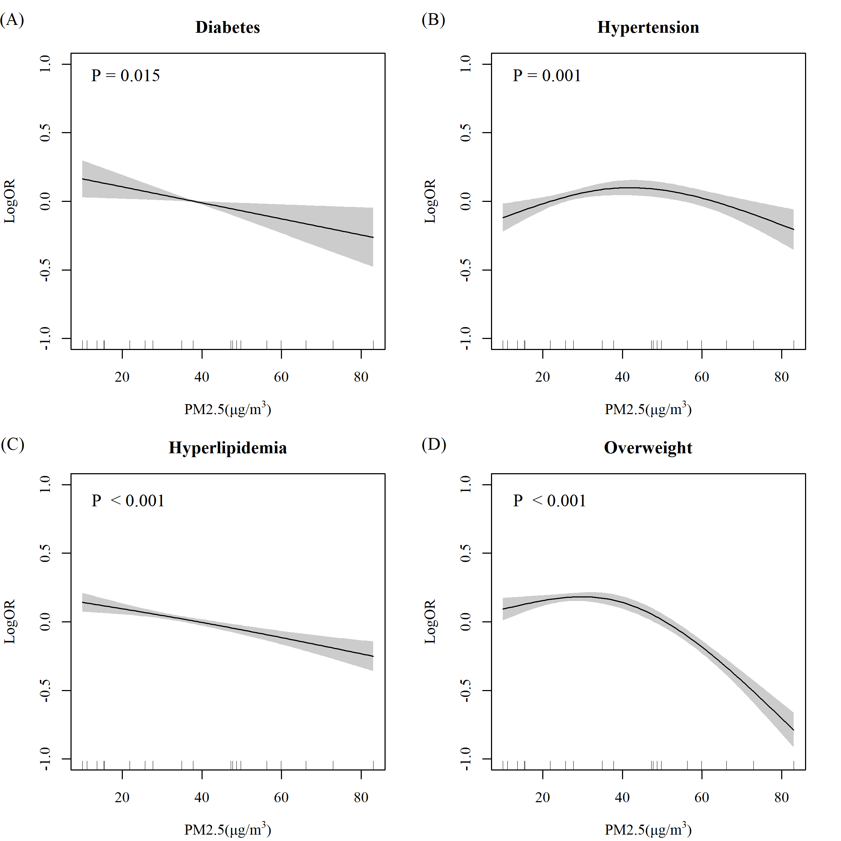

Figure S5 Exposure-response relationship between PM_{2.5} exposure and cardiovascular risk factors prevalence in population with middle or above education.
(A) diabetes; (B) hypertension; (C) hyperlipidemia; (D) being overweight. The exposure-response relationship was calculated by generalized additive model, and further adjusted by age, sex, ethnicity, smoking status, drinking status, intensity of physical activity, diet types. Knots used in the generalized additive model was 3. P value was denoted in each panel.

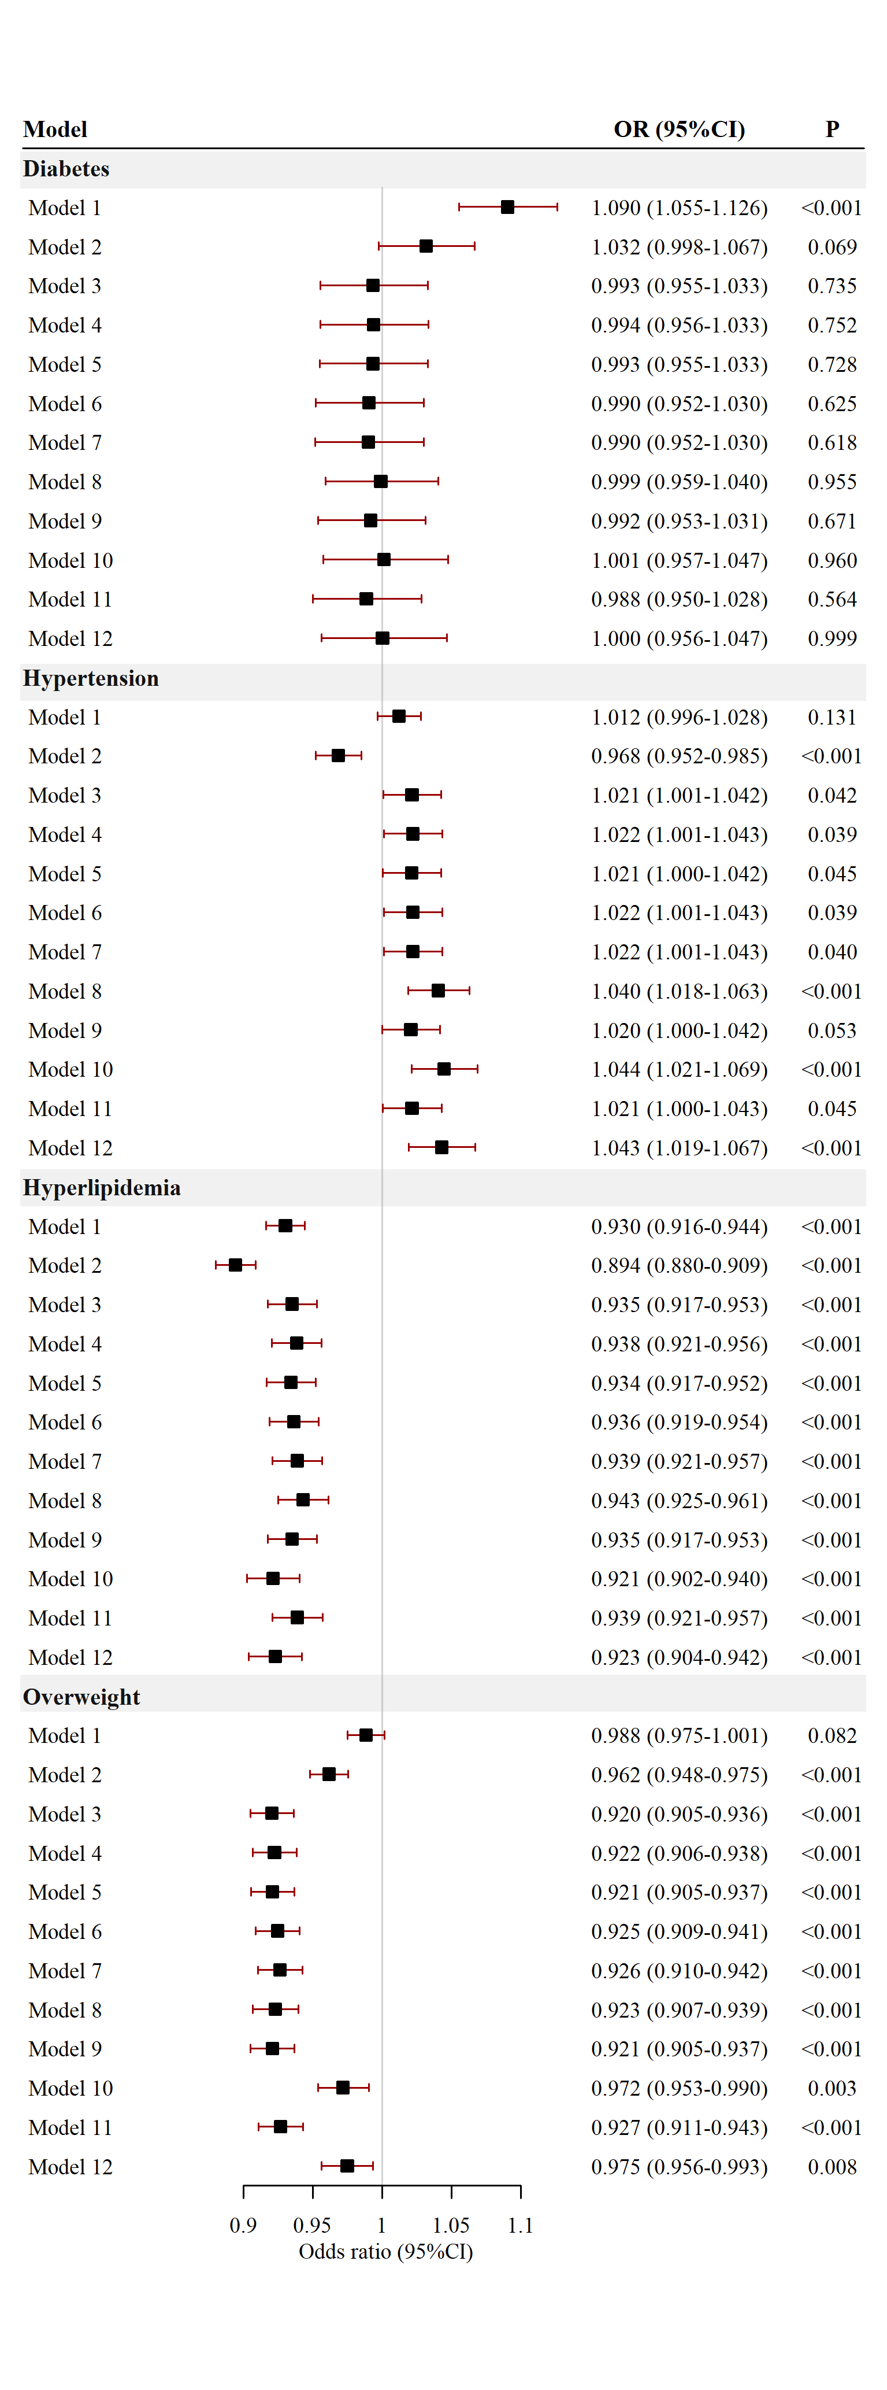

Figure S6 Association between PM_{2.5} exposure and cardiovascular risk factors prevalence determined by different logistic regression models.
The odds ratios and relevant 95% CI were scaled to each 10μg/m³ PM_{2.5} exposure and calculated by univariate or multivariable logistic regression.
Model 1 adjusted for: none
Model 2 adjusted for: age, sex
Model 3 adjusted for: Model 2 + education, ethnicity
Model 4 adjusted for: Model 3 + smoking status, drinking status
Model 5 adjusted for: Model 3 + intensity of physical activity
Model 6 adjusted for: Model 3 + diet types
Model 7 adjusted for: Model 3 + smoking status, drinking status, intensity of physical activity, diet types
Model 8 adjusted for: Model 7 + all other diseases
Model 9 adjusted for: Model 3 + residence (rural/ urban)
Model 10 adjusted for: Model 3 + region (south/ north)
Model 11 adjusted for: Model 7 + residence (rural/ urban)
Model 12 adjusted for: Model 7 + region (south/ north)

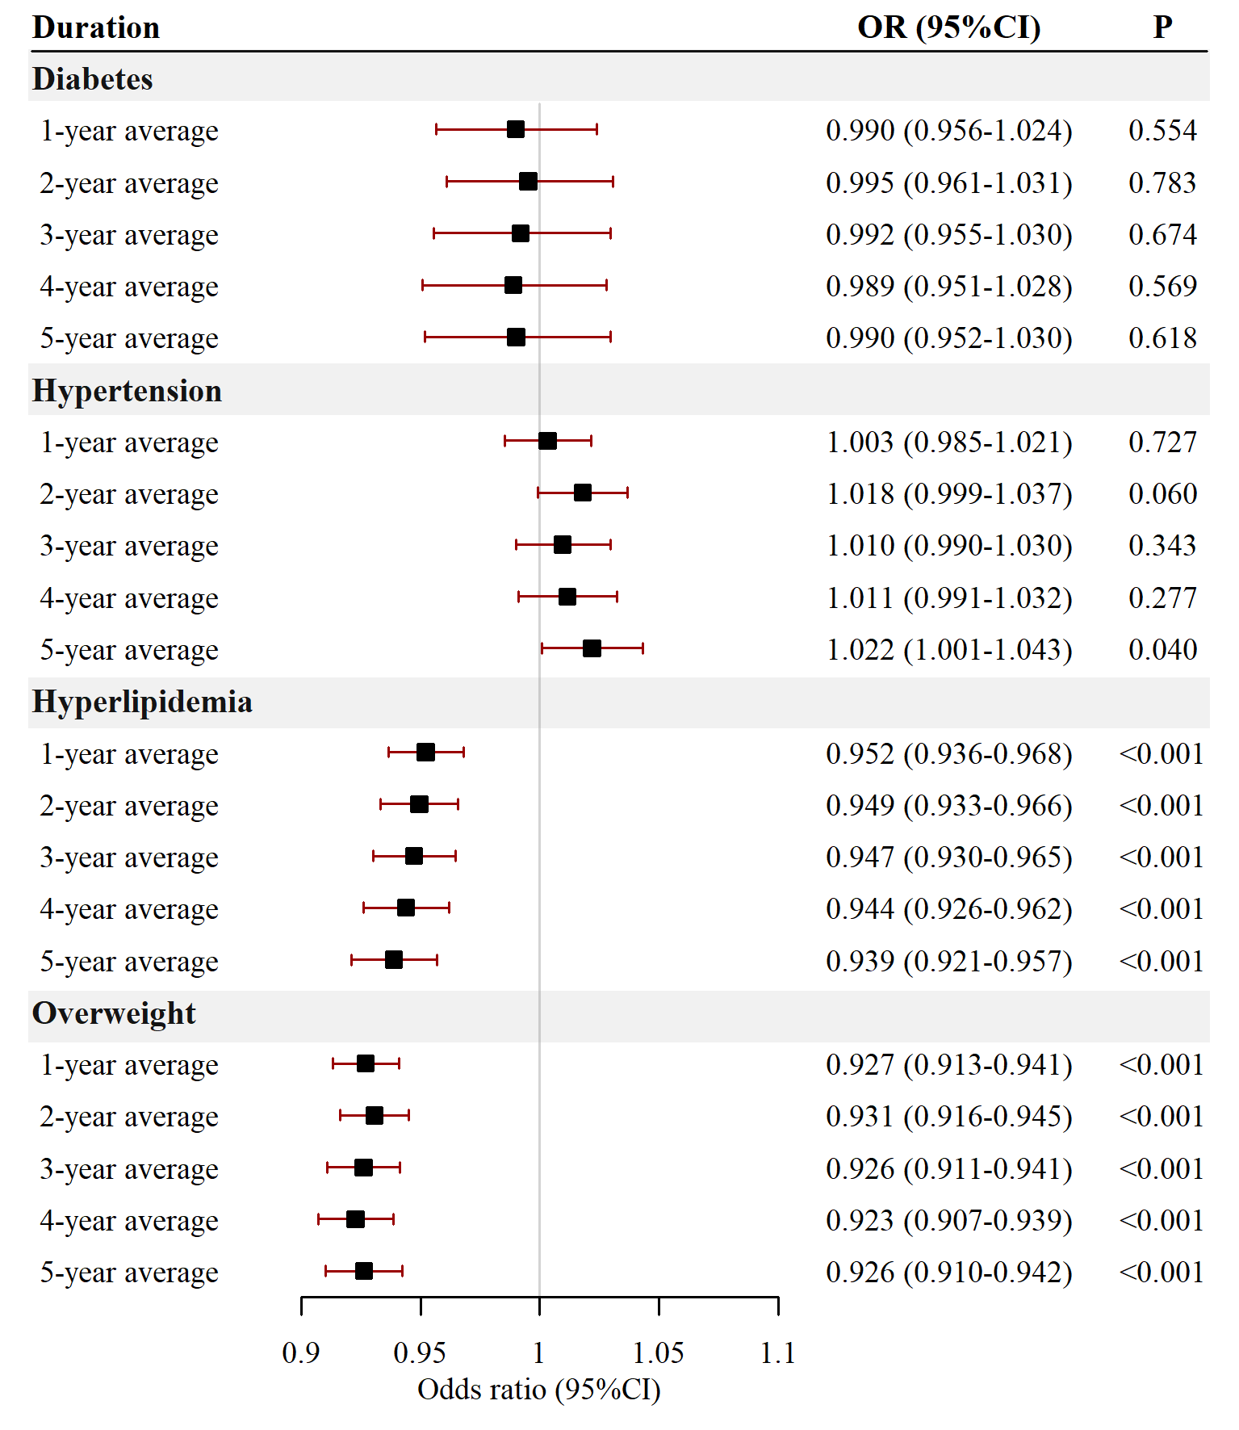

Figure S7 Association between PM_{2.5} exposure defined by different time duration and cardiovascular risk factors prevalence.
The odds ratios and relevant 95% CI were scaled to each 10μg/m³ PM_{2.5} exposure and calculated by multivariable logistic regression, and further adjusted for age, sex, education, ethnicity, smoking status, drinking status, intensity of physical activity, and diet types.

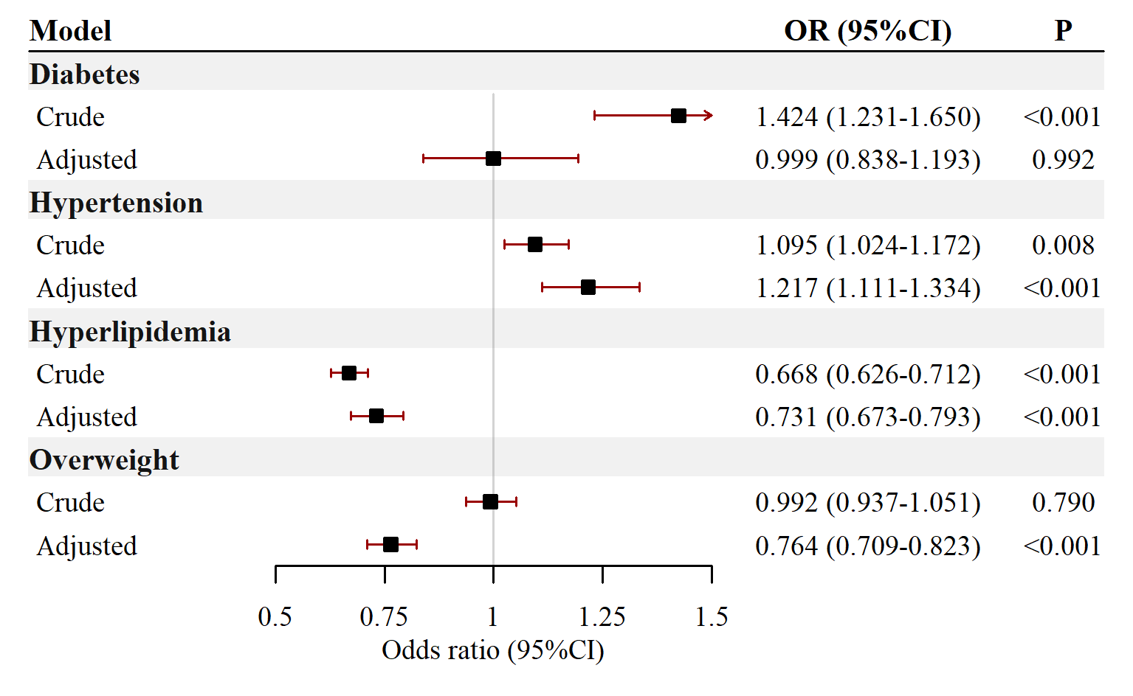

Figure S8 Association between dichotomous PM_{2.5} exposure and cardiovascular risk factors prevalence.
PM_{2.5} were categorized into “high” or “low” by a threshold of 35 μg/m³. The low exposure group was used as the reference group. The odds ratios and relevant 95% CI were scaled to dichotomous PM_{2.5} exposure and calculated by multivariable logistic regression, and further adjusted for age, sex, education, ethnicity, smoking status, drinking status, intensity of physical activity, and diet types.

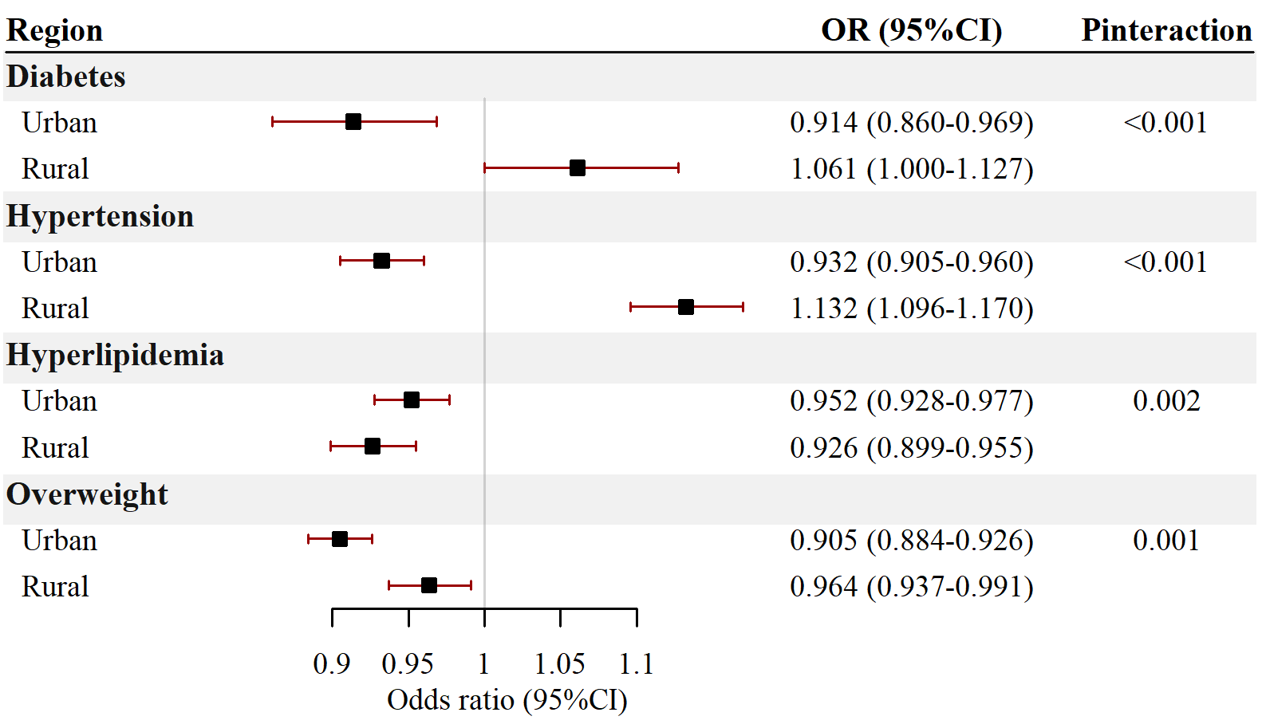

Figure S9 Association between PM_{2.5} exposure and cardiovascular risk factors prevalence stratified by residence (urban or rural).
The odds ratios and relevant 95% CI were scaled to each 10μg/m³ PM_{2.5} exposure and calculated by multivariable logistic regression, and further adjusted for age, sex, education, ethnicity, smoking status, drinking status, intensity of physical activity, and diet types.

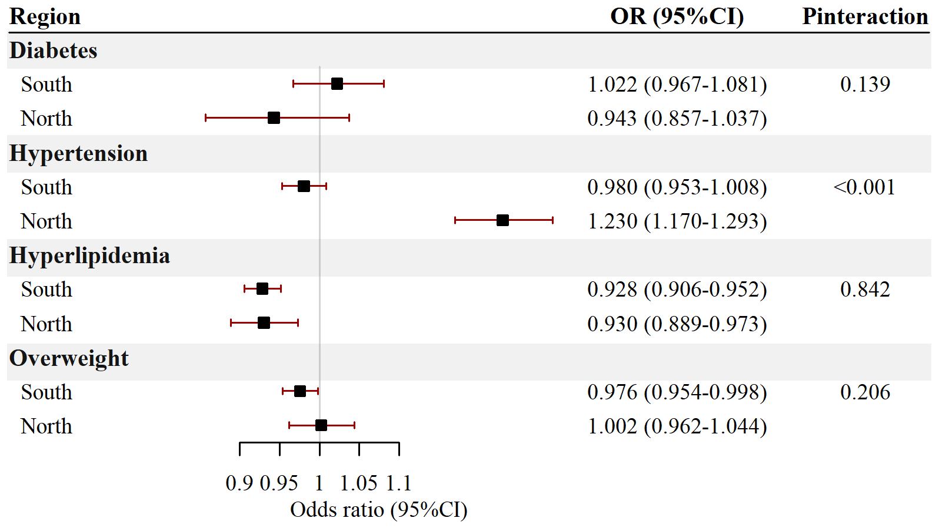

Figure S10 Association between PM_{2.5} exposure and cardiovascular risk factors prevalence stratified by region (south or north).
The odds ratios and relevant 95% CI were scaled to each 10μg/m³ PM_{2.5} exposure and calculated by multivariable logistic regression, and further adjusted for age, sex, education, ethnicity, smoking status, drinking status, intensity of physical activity, and diet types.

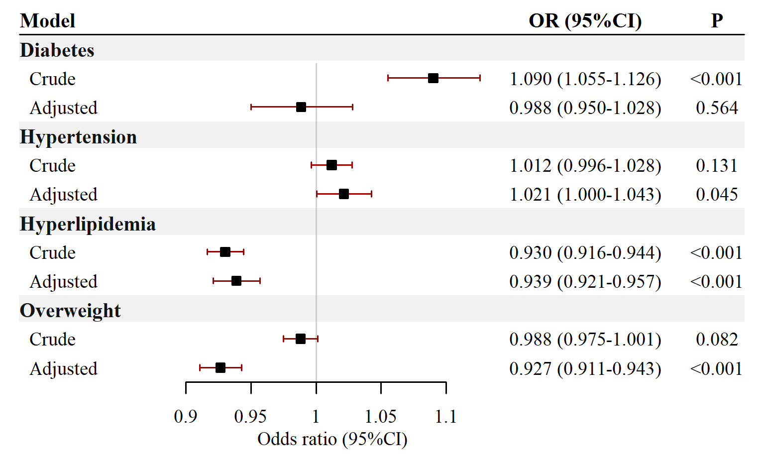
Figure S11 Association between PM_{2.5} exposure and cardiovascular risk factors prevalence
The odds ratios and relevant 95% CI were scaled to each 10μg/m³ PM_{2.5} exposure and calculated by multivariable logistic regression in crude model, and further adjusted for age, sex, education, ethnicity, residence (urban or rural), smoking status, drinking status, intensity of physical activity, and diet types in adjusted model.

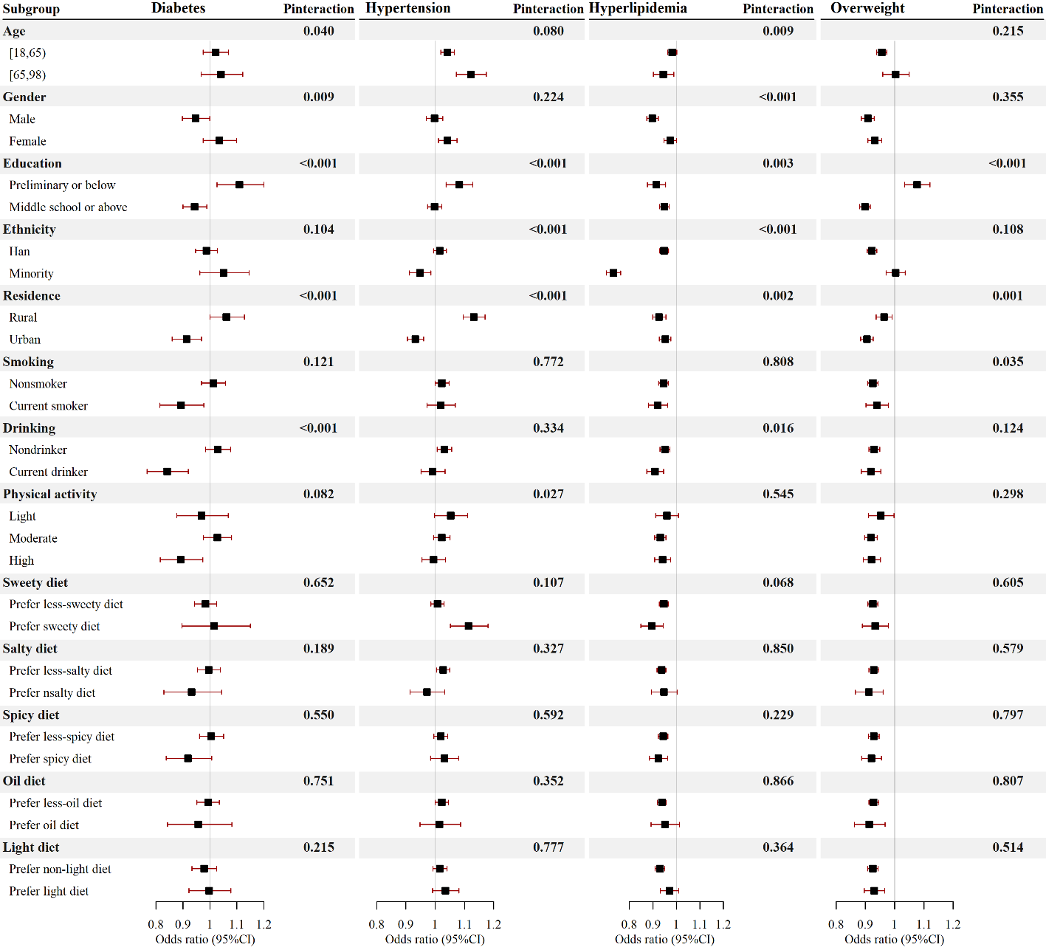
Figure S12 Association between PM_{2.5} exposure and cardiovascular risk factors prevalence stratified by covariates.
Population was stratified by age, sex, education, ethnicity, smoking status, drinking status, intensity of physical activity, and diet types. The odds ratios and relevant 95% CI were scaled to each 10μg/m³ PM_{2.5} exposure and calculated by multivariable logistic regression, and further adjusted for age, sex, education, ethnicity, residence (rural or urban), smoking status, drinking status, intensity of physical activity, and diet types. The significance of interaction effect was tested by introducing an interaction term in the regression model.

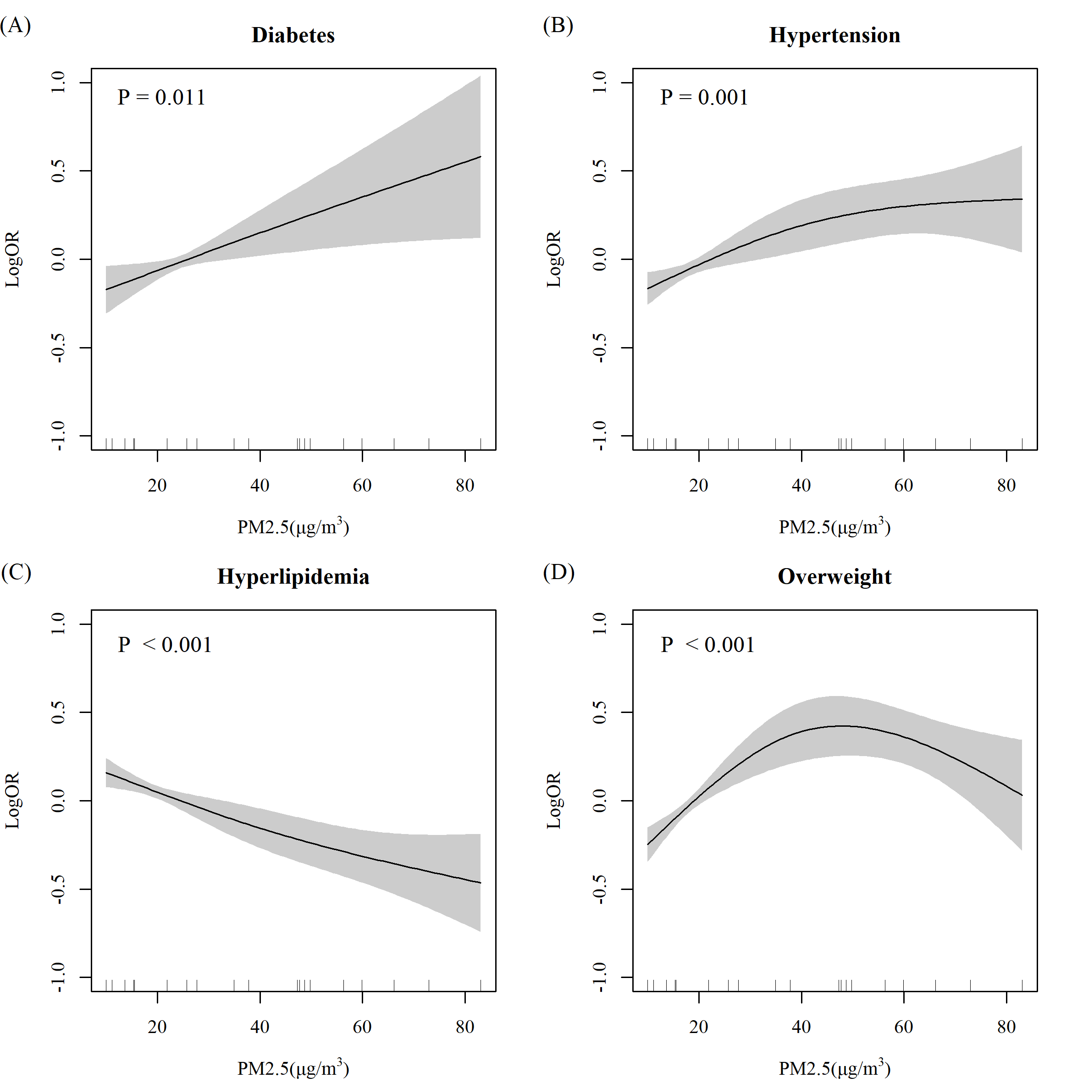
Figure S13 Exposure-response relationship between PM_{2.5} exposure and cardiovascular risk factors prevalence in population with preliminary or below education.
(A) diabetes; (B) hypertension; (C) hyperlipidemia; (D) being overweight. The exposure-response relationship was calculated by generalized additive model, and further adjusted by age, sex, ethnicity, residence (rural or urban), smoking status, drinking status, intensity of physical activity, diet types. Knots used in the generalized additive model was 3. P value was denoted in each panel.

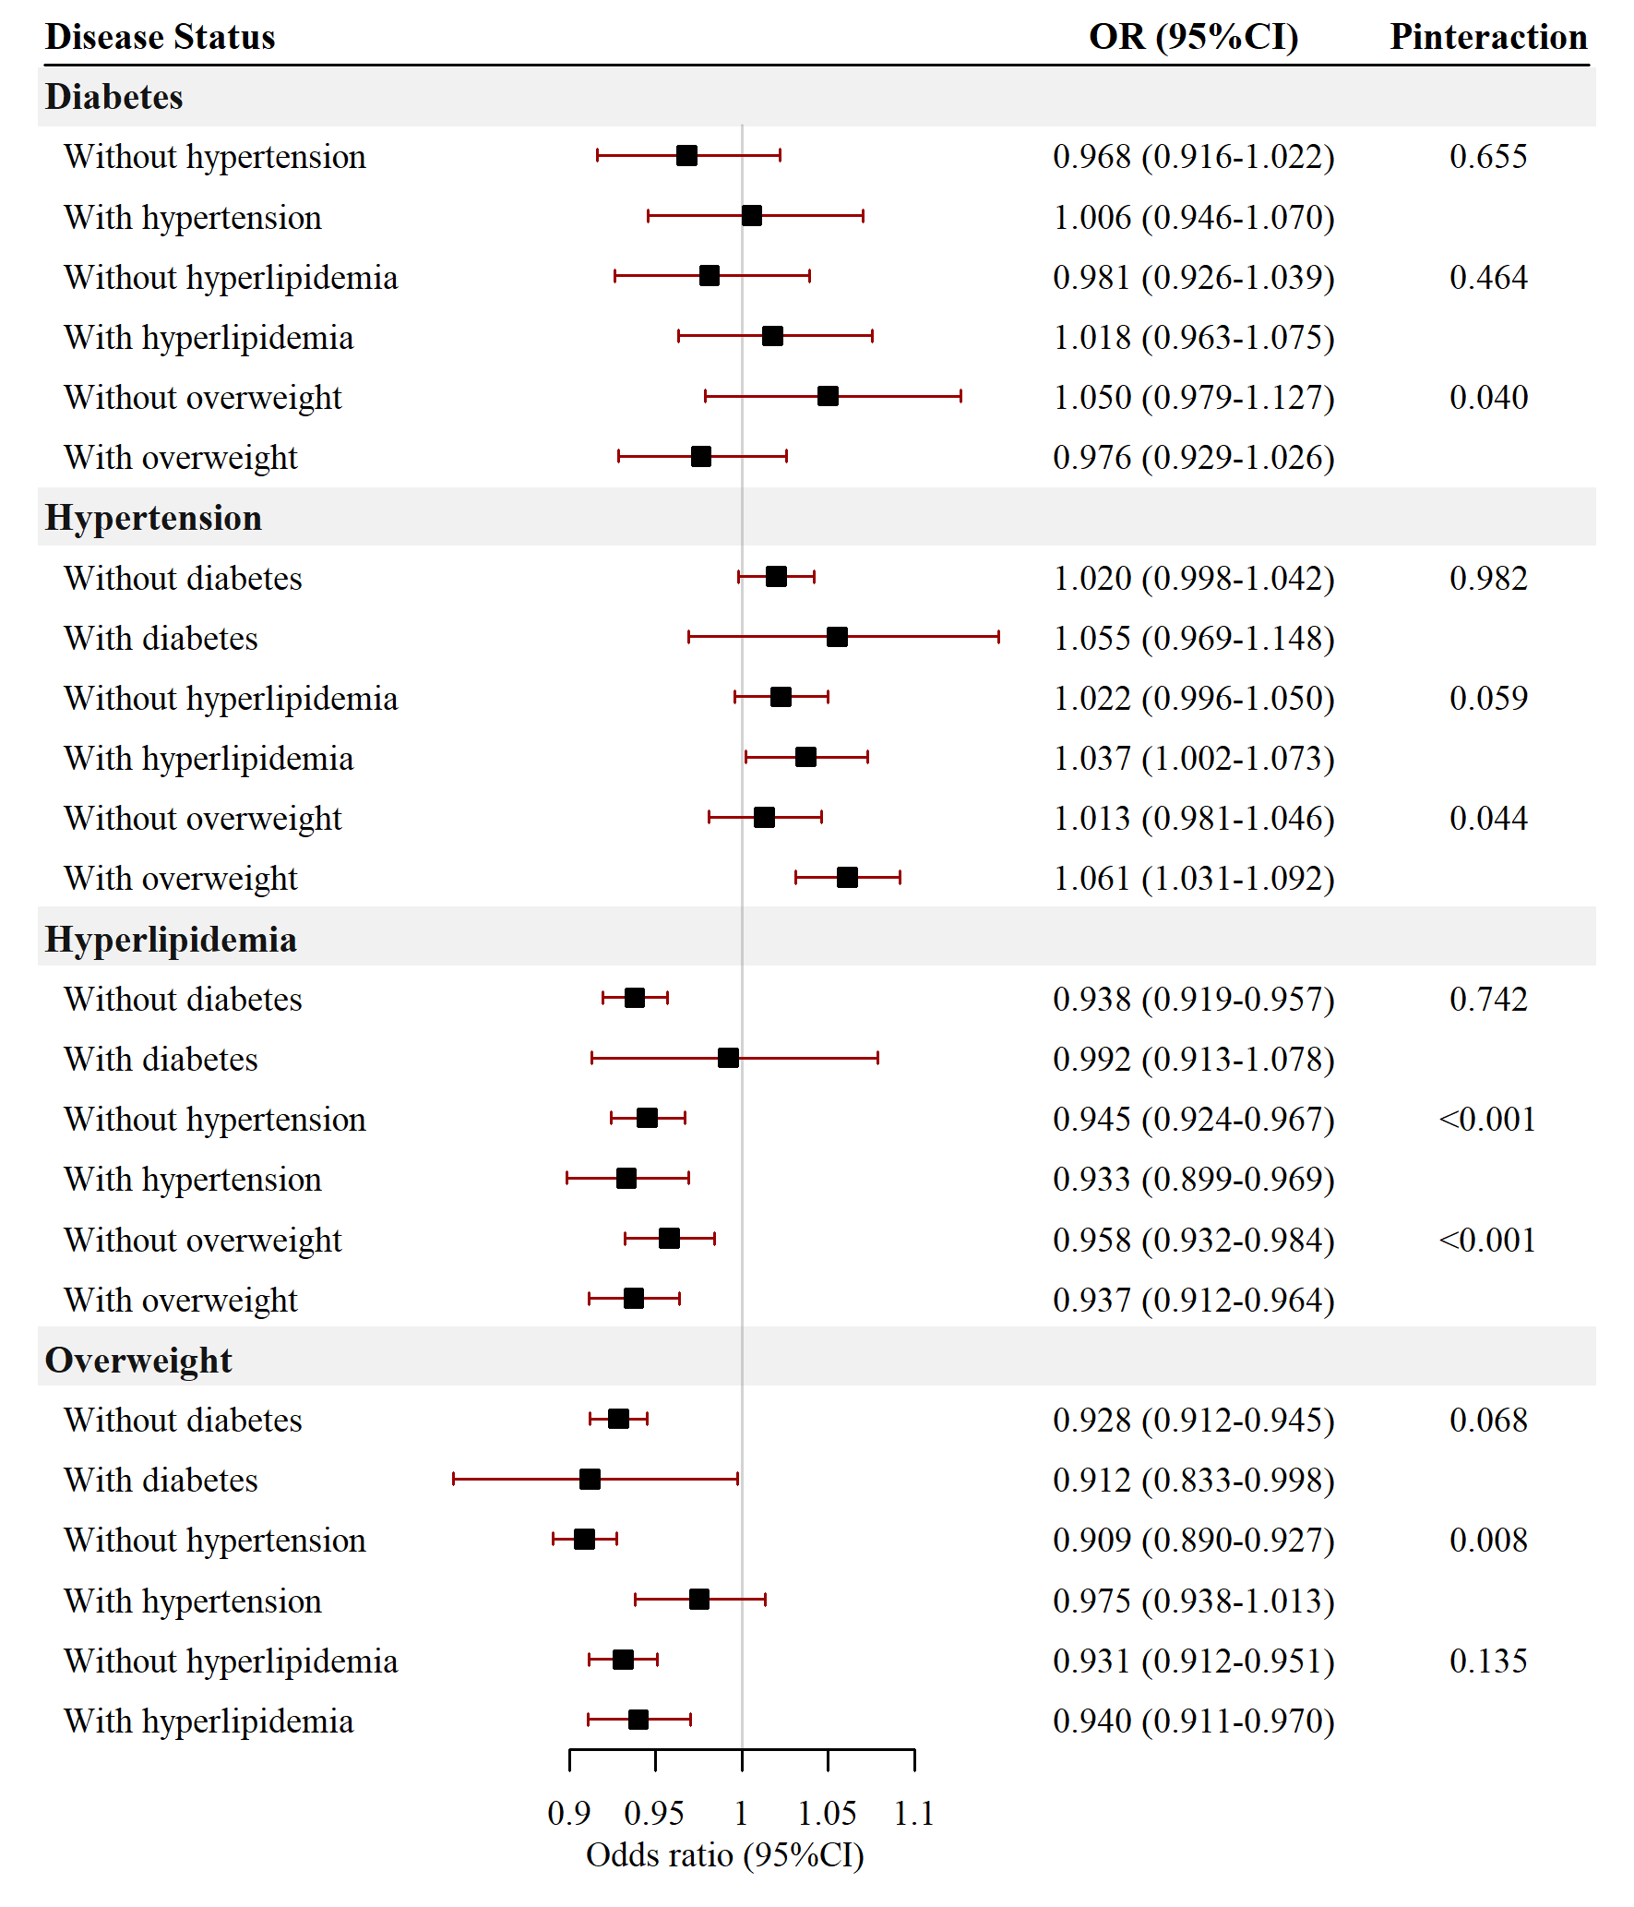
Figure S14 Association between PM_{2.5} exposure and cardiovascular risk factors prevalence stratified by cardiovascular risk factors.
The odds ratios and relevant 95% CI were scaled to each 10μg/m³ PM_{2.5} exposure and calculated by multivariable logistic regression, and further adjusted for age, sex, education, ethnicity, residence (urban or rural), smoking status, drinking status, intensity of physical activity, and diet types.

