Appendix A
Figure 1A. Birth-cohort specific death rates (BCSDR) by gender, time-period and migrant status.
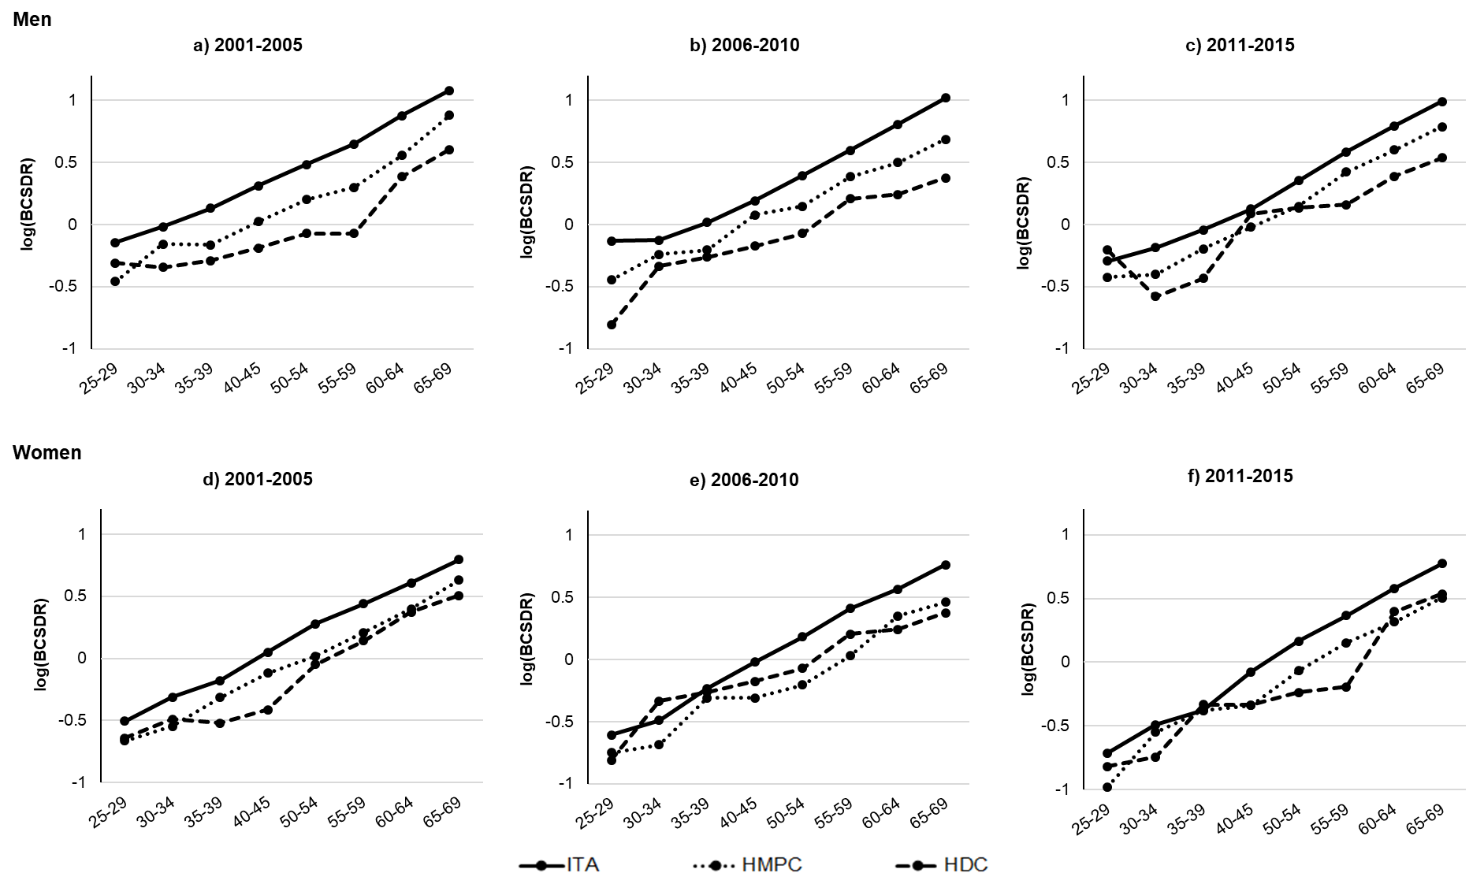
Notes: For the 2001-2005 time-period we selected the birth-cohorts from 1937 to 1976; for the 2006-2010 time-period the birth-cohorts from 1942 to 1981; for the 2011-2015 time-period the birth-cohorts from 1947 to 1986.
Source: Authors’ elaboration on Dynamic Rome Longitudinal Study cohort data and the Register of causes of death (ReNCaM).
Appendix B

Table 1B. Gender-specific mortality HR for migrants versus Italians residing in Rome, by time-period
 |  | 2001-2005
 |  | Men |  |  |  | Women
 |  | HR |  | 95% CI |  | HR |  | 95% CI
Migrant status
Italian |  | 1.00 |  |  |  | 1.00
Migrant |  | 0.48 | *** | (0.446-0.527) |  | 0.60 | *** | (0.546-0.653)
N observations |  | 898172 |  |  |  | 942659
 |  | 2006-2010
Migrant status
Italian |  | 1.00 |  |  |  | 1.00
Migrant |  | 0.52 | *** | (0.484-0.568) |  | 0.51 | *** | (0.467-0.560)
N observations |  | 908115 |  |  |  | 958517
 |  | 2011-2015
Migrant status
Italian |  | 1.00 |  |  |  | 1.00
Migrant |  | 0.64 | *** | (0.596-0.687) |  | 0.59 | *** | (0.543-0.636)
N observations |  | 898317 |  |  |  | 942784
Notes: The asterisks indicate significance *p < 0.05, **p < 0.01, ***p < 0.001. Parametric survival model with Gompertz baseline hazard and age as the time-scale.
Source: Authors’ elaboration on Dynamic Rome Longitudinal Study cohort data and the Register of causes of death (ReNCaM).

Table 2B. Gender-specific mortality HR for different migrant groups versus Italians residing in Rome, by time-period
 |  | 2001-2005
 |  | Men |  |  |  | Women
 |  | HR |  | 95% CI |  | HR |  | 95% CI
Origin area
Italy |  | 1.00 |  |  |  | 1.00
Africa |  | 0.67 | *** | (0.591-0.761) |  | 0.91 |  | (0.778-1.056)
Asia |  | 0.38 | *** | (0.311-0.461) |  | 0.40 | *** | (0.311-0.513)
Latin America |  | 0.46 | *** | (0.357-0.581) |  | 0.47 | *** | (0.364-0.595)
Central-Eastern Europe |  | 0.55 | *** | (0.439-0.684) |  | 0.70 | ** | (0.564-0.875)
HDC |  | 0.32 | *** | (0.263-0.398) |  | 0.52 | *** | (0.441-0.613)
N observations |  | 898172 |  |  |  | 942659
 |  | 2006-2010
Origin area
Italy |  | 1.00 |  |  |  | 1.00
Africa |  | 0.67 | *** | (0.582-0.765) |  | 0.78 | ** | (0.648-0.931)
Asia |  | 0.49 | *** | (0.415-0.572) |  | 0.39 | *** | (0.313-0.494)
Latin America |  | 0.44 | *** | (0.340-0.573) |  | 0.43 | *** | (0.339-0.557)
Central-Eastern Europe |  | 0.64 | *** | (0.542-0.756) |  | 0.53 | *** | (0.441-0.630)
HDC |  | 0.33 | *** | (0.266-0.410) |  | 0.47 | *** | (0.387-0.562)
N observations |  | 908115 |  |  |  | 958517
 |  | 2011-2015
Origin area
Italy |  | 1.00 |  |  |  | 1.00
Africa |  | 0.78 | *** | (0.687-0.894) |  | 0.96 |  | (0.812-1.139)
Asia |  | 0.50 | *** | (0.429-0.572) |  | 0.52 | *** | (0.439-0.624)
Latin America |  | 0.60 | *** | (0.481-0.740) |  | 0.56 | *** | (0.461-0.685)
Central-Eastern Europe |  | 0.82 | *** | (0.718-0.926) |  | 0.53 | *** | (0.460-0.604)
HDC |  | 0.48 | *** | (0.393-0.586) |  | 0.54 | *** | (0.449-0.659)
N observations |  | 898317 |  |  |  | 942784
Notes: The asterisks indicate significance *p < 0.05, **p < 0.01, ***p < 0.001. Parametric survival model with Gompertz baseline hazard and age as the time-scale.
Source: Authors’ elaboration on Dynamic Rome Longitudinal Study cohort data and the Register of causes of death (ReNCaM). Cox Model with age as the time-scale.

