Supplementary materials for “Generating cause of death information to inform health policy: application of automated verbal autopsy methods in the Solomon Islands”
Supplementary table 1: Mapping of ICD-10 codes to SmartVA cause categories
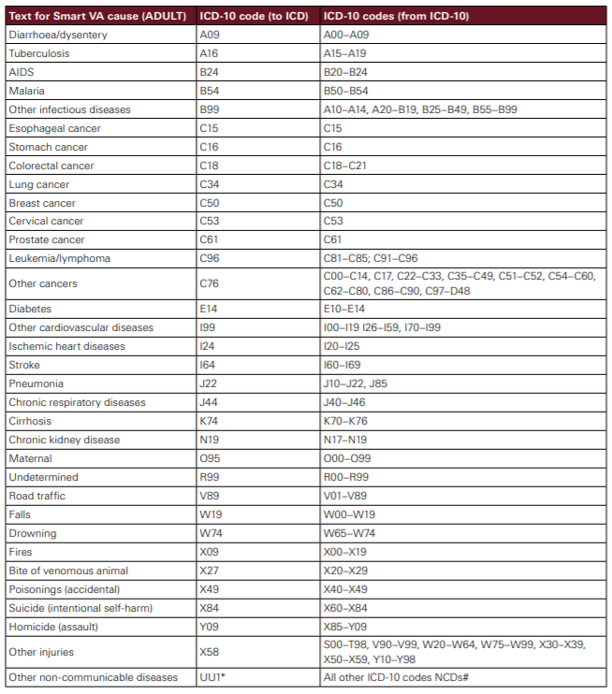
Source: VA interpretation guidelines (22)

Supplementary table 2: Comparison of age distributions of VAs and GBD estimates
Age groups | Both sexes |  | Males |  | Females
Age groups | VA % | GBD % | VA % | GBD % | VA % | GBD %
10 to 14 | 1.2 | 2.1 | 1.4 | 2.3 | 0.8 | 1.9
15 to 19 | 1.9 | 3.3 | 2.3 | 3.0 | 1.1 | 3.6
20 to 24 | 2.5 | 4.3 | 2.5 | 3.1 | 2.5 | 5.6
25 to 29 | 3.3 | 4.8 | 3.6 | 3.9 | 2.8 | 5.8
30 to 34 | 4.9 | 5.9 | 4.6 | 4.7 | 5.4 | 7.2
35 to 39 | 2.8 | 7.0 | 2.5 | 5.7 | 3.4 | 8.4
40 to 44 | 5.4 | 6.2 | 5.9 | 6.6 | 4.5 | 5.8
45 to 49 | 5.3 | 5.8 | 5.5 | 6.3 | 4.8 | 5.2
50 to 54 | 8.2 | 6.5 | 8.9 | 6.8 | 7.1 | 6.1
55 to 59 | 6.6 | 6.6 | 8.2 | 7.4 | 4.0 | 5.7
60 to 64 | 9.7 | 7.4 | 9.5 | 8.8 | 10.2 | 5.9
65 to 69 | 6.8 | 8.1 | 5.9 | 9.9 | 8.2 | 6.2
70 to 74 | 10.7 | 8.5 | 9.6 | 9.1 | 12.4 | 7.7
75 to 79 | 7.8 | 9.0 | 7.0 | 9.0 | 9.0 | 9.0
80 Plus | 17.7 | 14.6 | 15.9 | 13.3 | 20.6 | 16.1
Unknown | 5.3 | N/A | 6.6 | N/A | 3.1 | N/A
Total | 100.0 | 100.0 | 100.0 | 100.0 | 100.0 | 100.0

Supplementary table 3: Leading VA causes by province
Rank | Province
Rank | Guadalcanal+  Honiara | % | Western | % | Other | %
1 | Ischemic Heart Disease | 17.4 | Ischemic Heart Disease | 20.8 | Stroke | 14.9
2 | Stroke | 13.0 | Stroke | 15.7 | Ischemic Heart Disease | 12.5
3 | Pneumonia | 7.2 | Diabetes | 8.5 | Diabetes | 9.7
4 | Diabetes | 5.8 | Pneumonia | 4.2 | Chronic Respiratory | 5.5
5 | Malaria | 4.4 | Chronic Respiratory | 4.7 | Pneumonia | 5.5
6 | Other Injuries | 4.1 | Other Non-communicable Diseases | 3.8 | Cirrhosis | 4.4
7 | Chronic Respiratory | 4.1 | Other Injuries | 3.0 | Cervical Cancer | 4.2
8 | Leukemia/ Lymphomas | 3.4 | Falls | 3.0 | Falls | 3.1
9 | Other Non-communicable Diseases | 2.7 | Cervical Cancer | 3.0 | Other Non-communicable Diseases | 3.1
10 | Road Traffic | 2.7 | Leukemia/Lymphomas | 2.5 | Chronic Kidney Disease | 2.9
11 | Falls | 2.7 | Drowning | 2.1 | Other injuries | 2.3
12 | Chronic Kidney Disease | 2.4 | Breast Cancer | 2.1 | Malaria | 2.1
13 | Maternal | 2.0 | Cirrhosis | 1.7 | Leukemia/ Lymphomas | 1.8
14 | Esophageal cancer, lung cancer | 2.0 | Prostate Cancer, TB | 1.7 | Breast Cancer | 1.8
15 | Undetermined | 10.6 | Undetermined | 13.1 | Undetermined | 15.9

