ADDITIONAL FILES
Vaccination in pregnancy against pertussis and seasonal influenza: Key learnings and components from high-performing vaccine programmes in three countries: the United Kingdom, the United States and Spain

ADDITIONAL FILE 1
Table SI 1: Search terms used for the scientific literature review on Embase
Disease | Vaccination | Population
Pertussis | Vaccination | Pregnant women
Tetanus | Immunisation | Pregnancy
Diphtheria | Vaccine uptake
Influenza | Vaccine Coverage
 | Drivers
 | Barriers
 | Incidence
 | Knowledge
 | Attitudes
 | Perceptions
 | Determinants
 | Predictors
 | Factors
 | Reasons

Table SI 2: PICO process used for the scientific literature review on Embase
PICO | Inclusion Criteria | Exclusion Criteria
Patient | - Pregnant women | - Other population groups
Intervention | - Seasonal influenza vaccination during pregnancy  - Tdap vaccination during pregnancy | - Other vaccinations
Comparison | - Any  - None | - N/A
Outcome | - Vaccine Coverage Rates  - Vaccine Knowledge & Attitudes  - Vaccine Barriers & Drivers | - Vaccine efficacy  - Vaccine effectiveness
PICO: Patient, Intervention, Comparison, Outcome ; N/A : Non Applicable ; Tdap : Tetanus, Diphtheria, acellular Pertussis
Figure SI 1: Pregnancy Vaccine Coverage Rates (VCR) components for the US based on the 5 pillars of the Pregnancy VCR framework
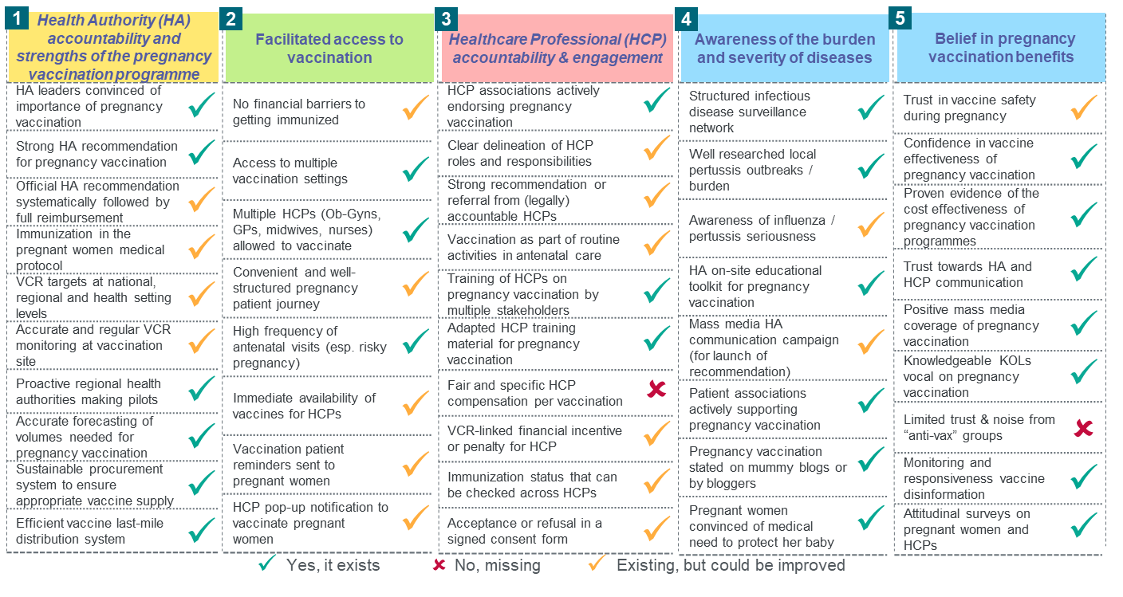
Figure SI 2: Pregnancy Vaccine Coverage Rates (VCR) components for the UK based on the 5 pillars of the Pregnancy VCR framework
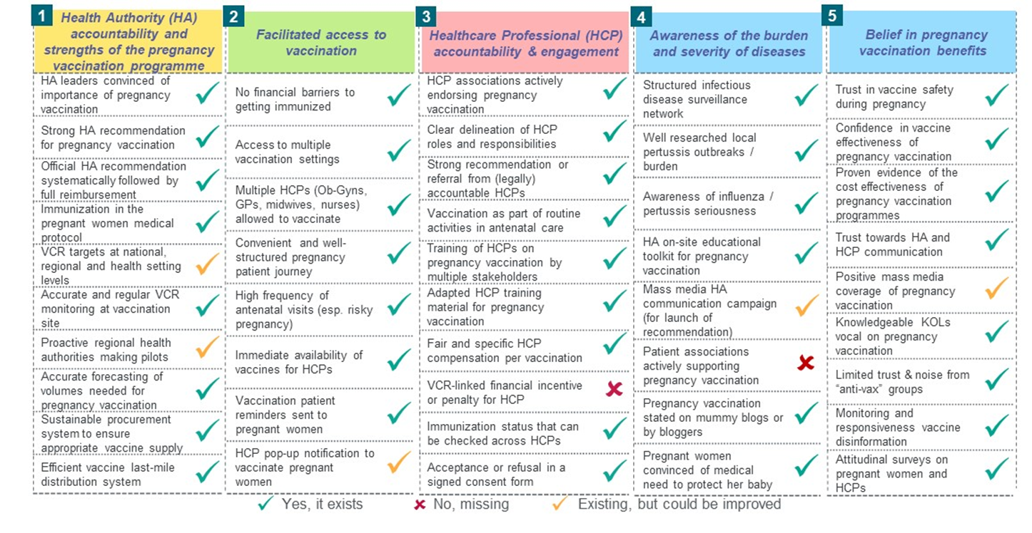
Figure SI 3: Pregnancy Vaccine Coverage Rates (VCR) components for Spain based on the 5 pillars of the Pregnancy VCR framework
