Supplementary methods
This document supplements the methods section, particularly Table 3, of the paper “Face mask uptake in the absence of mandates during the COVID-19 pandemic: a qualitative interview study with Swiss residents”.

Step 3: Preliminary research questions
- What general attitudes did participants express towards face masks?
- What moral norms and values did participants attach to face masks?
- What references or sources were participants referring to concerning the usefulness and wearing of face masks?
- What attributes did participants ascribe to face masks? How did they differ between regions with face mask obligations and those without?
- What were people´s reflections on the voluntary vs mandatory use of face masks?
- How did the perception, use and attitudes towards face masks change in German-speaking Switzerland between April 2020 (lockdown related to first pandemic wave) and October 2020 (beginning of second pandemic wave)?

Steps 3-4: Preliminary analytical framework
- Summary of attitudes and views towards face masks (T1)
- Summary of attitudes and views towards face masks (T2)
- Notes on longitudinal changes in views
- Expressions of moral values/norms in relation to face masks
- References or sources participants referred to concerning the usefulness and wearing of face masks (e.g. Health authorities, media, studies, experts, friends...)
- Attributes participants ascribed to face masks (e.g. protecting themselves / protecting others / visible sign of compliance or noncompliance)
- General attitudes participants expressed towards face masks (wear them even voluntarily, only if obligatory, only reluctantly, not at all, etc.)
- Other relevant aspects

Step 5: descriptive presentation of interview data
The here-presented figures are graphical overviews. Analytical memos, reconsiderations of primary data and group discussions accompanied each analytic step.

Version 5.1
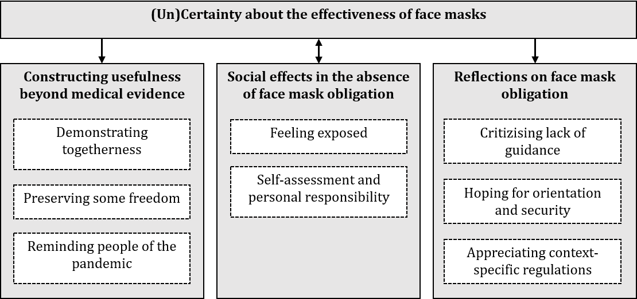

Version 5.2
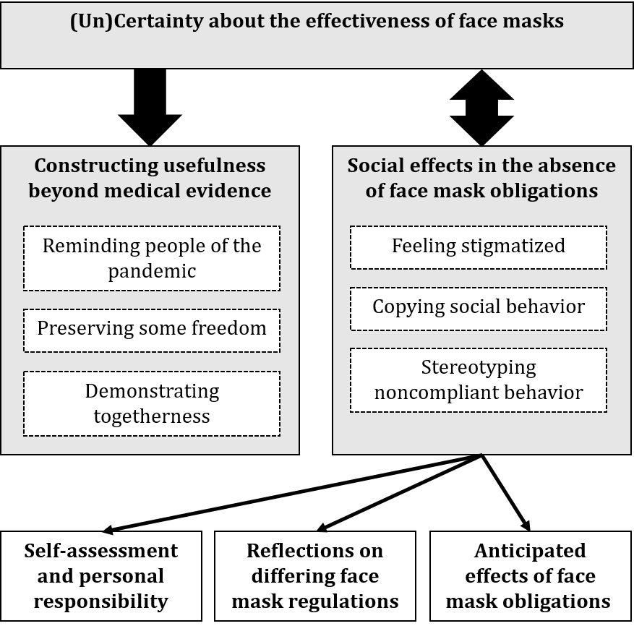

Version 5.3
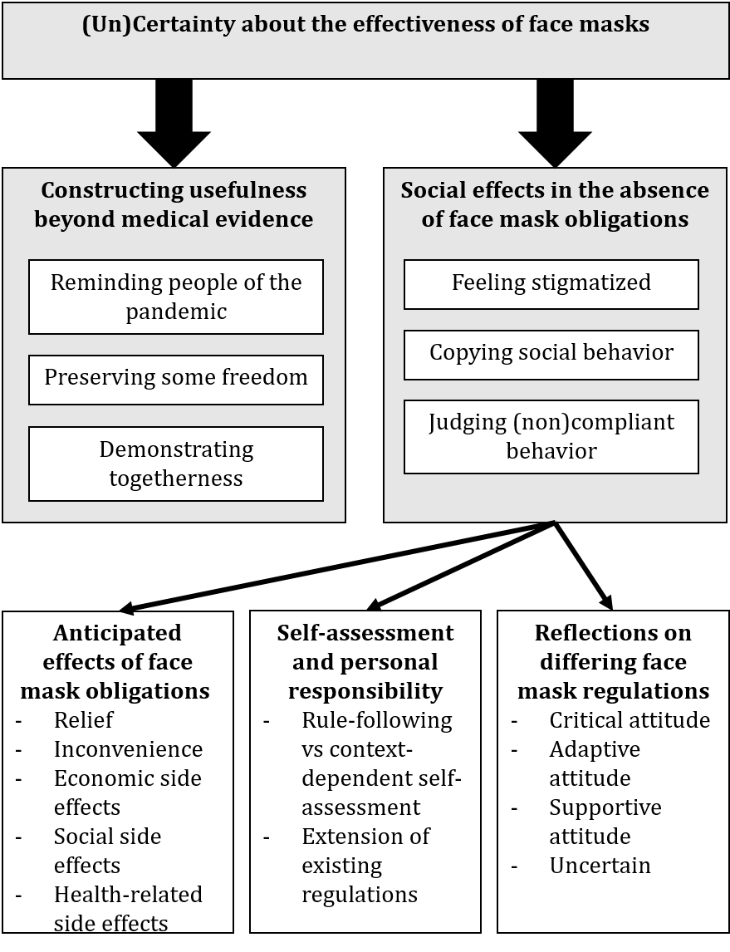:

Version 5.4
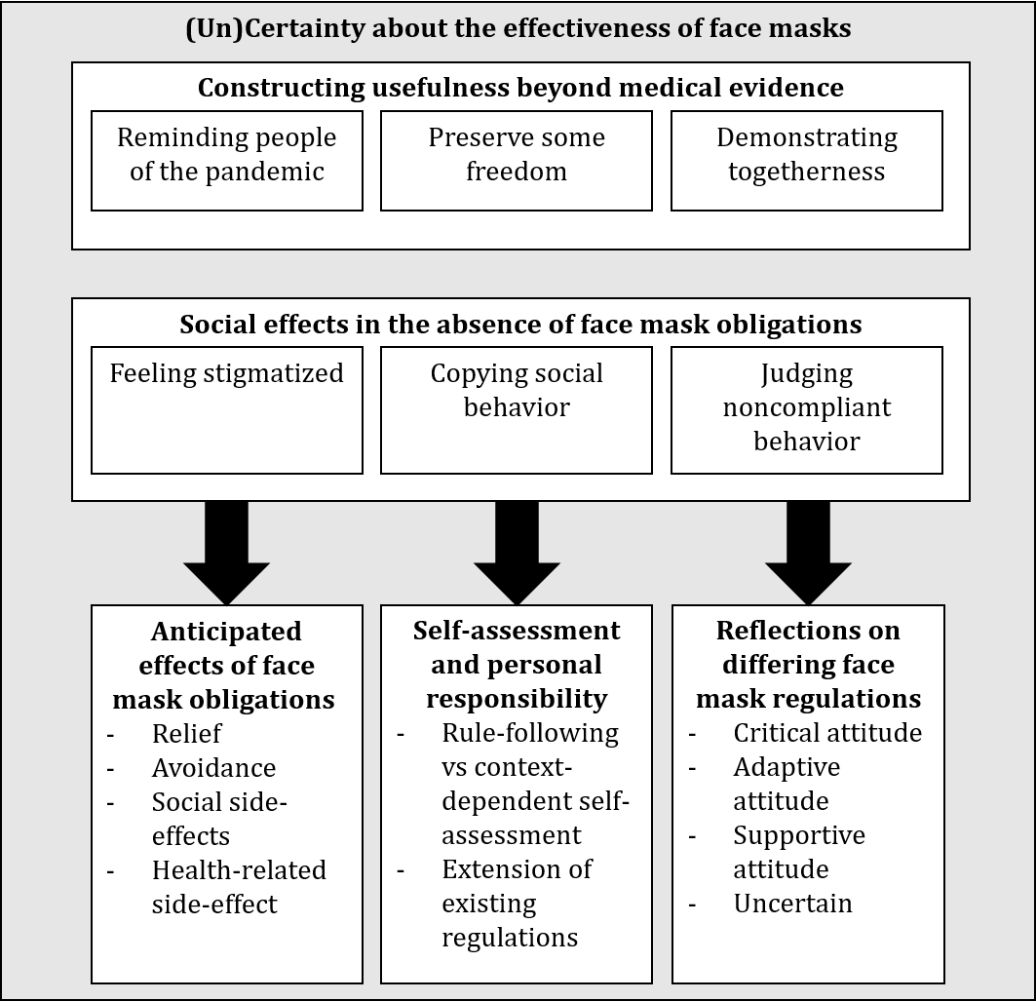

Step 7: mapping with public health ethics framework
Adapted research question: What values and considerations motivate or hinder people to wear face masks if they were not mandated by policymakers?
Descriptive theme from interview data (step 1) | Mapping with public health ethics framework | Presented theme
(Un)Certainty about the effectiveness of face masks | Trust and transparency | Trust and governmental policy
(Un)Certainty about the effectiveness of face masks  Constructing usefulness beyond medical evidence | Beneficence | Perceived benefits
(Un)Certainty about the effectiveness of face masks  Anticipated effects of face mask obligations | Nonmaleficence | Perceived risks
Social effects in the absence of face mask obligations  (Un)Certainty about the effectiveness of face masks | Justice | Social exclusion and prejudice
Self-assessment and personal responsibility  Reflections on differing face mask regulations  Anticipated effects of face mask obligations | Autonomy and personal responsibility | Decision-making in the absence of mandates

