Supplemental Appendix
Measures from COVID Rapid Response Research Survey 1

ABCD Physical Activity questionnaires were adapted from the Youth Risk Behavior Survey (YRBS) [1, 2] and the International Physical Activity Questionnaire (IPAQ) Short-form [3, 4].

Adolescent Questions
Question:
During the past week, on how many days did you do moderate or vigorous physical activities like heavy lifting, running, aerobics, or bicycling? (Moderate or vigorous physical activities refer to activities that take moderate to hard physical effort and make you breathe harder than normal)

Responses:
0 = No moderate or vigorous physical activities; 1 = 1 Days; 2 = 2 Days; 3 = 3 Days; 4 = 4 Days; 5 = 5 Days; 6 = 6 Days; 7 = 7 Days; 8 = Don't know.

Question:
How much time did you usually spend doing moderate or vigorous physical activities on one of those days?

Responses:
Minutes: 0 = 0 minutes; 1 = 10 minutes; 2 = 20 minutes; 3 = 30 minutes; 4 = 40 minutes
Hours: 0 = 0 hours; 1 = 1 hour; 2 = 2 hours; 3 = 3 hours; 4 = 4 hours; 5 = 5 hours; 6 = 6 hours; 7 = 7 hours; 8 = 8 hours; 9 = 9 hours; 10 = 10 hours; 11 = 11 hours; 12 = 12 hours; 13 = 13 hours; 14 = 14 hours; 15 = 15 hours; 16 = 16 hours; 17 = 17 hours; 18 = 18 hours; 19 = 19 hours; 20 = 20 hours; 21 = 21 hours; 22 = 22 hours; 23 = 23 hours

MVPA was calculated as a frequency of MVPA x time spent doing MVPA= estimated MVPA h∙wk⁻¹ during COVID-19.

Parent Questions
Question:
During the past week, on how many days per week did your child do moderate or vigorous physical activities like heavy lifting running aerobics or bicycling?

Responses:
0 = No moderate or vigorous physical activities; 1 = 1 Days; 2 = 2 Days; 3 = 3 Days; 4 = 4 Days; 5 = 5 Days; 6 = 6 Days; 7 = 7 Days; 8 = Don't know.

Question:
How much time did your child usually spend doing moderate or vigorous physical activities on one of those days?

Responses:
Minutes: 0 = 0 minutes; 1 = 10 minutes; 2 = 20 minutes; 3 = 30 minutes; 4 = 40 minutes
Hours: 0 = 0 hours; 1 = 1 hour; 2 = 2 hours; 3 = 3 hours; 4 = 4 hours; 5 = 5 hours; 6 = 6 hours; 7 = 7 hours; 8 = 8 hours; 9 = 9 hours; 10 = 10 hours; 11 = 11 hours; 12 = 12 hours; 13 = 13 hours; 14 = 14 hours; 15 = 15 hours; 16 = 16 hours; 17 = 17 hours; 18 = 18 hours; 19 = 19 hours; 20 = 20 hours; 21 = 21 hours; 22 = 22 hours; 23 = 23 hours

MVPA was calculated as a frequency of MVPA x time spent doing MVPA= estimated MVPA h∙wk⁻¹ during COVID-19.

Supplemental Figures

Figure S1. Agreement between adolescent-parent MVPA reports among female adolescents

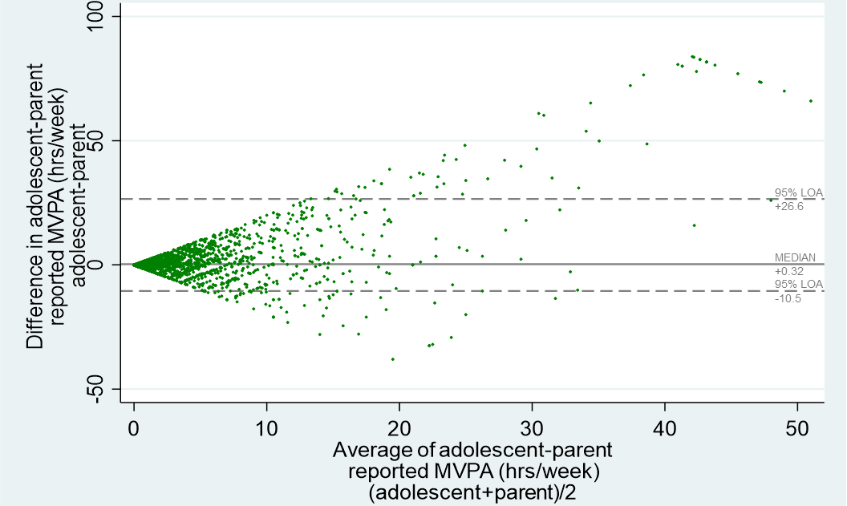
LOA = limits of agreement
Figure S2. Agreement between adolescent-parent MVPA reports among male adolescents
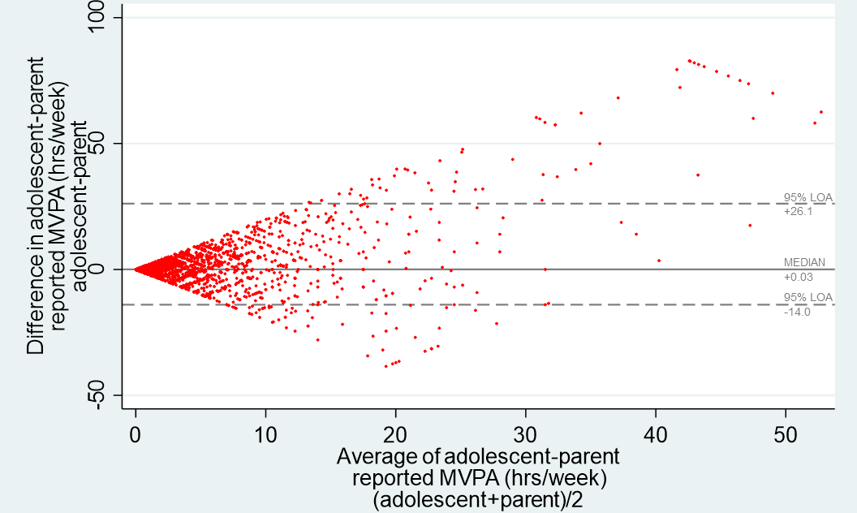
LOA = limits of agreement
Figure S3. Agreement between adolescent-parent MVPA reports among non-white adolescents
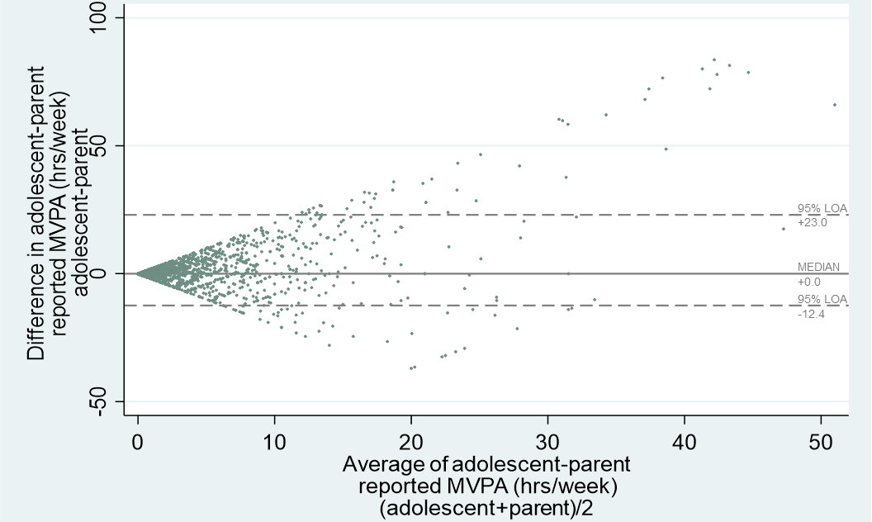
LOA = limits of agreement
Figure S4. Agreement between adolescent-parent MVPA reports among white adolescents
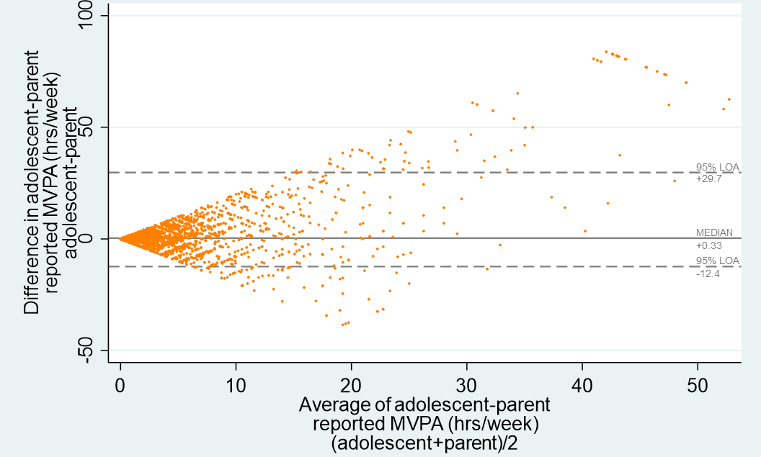
LOA = limits of agreement
Figure S5. Agreement between adolescent-parent MVPA reports in households with income $75,000+
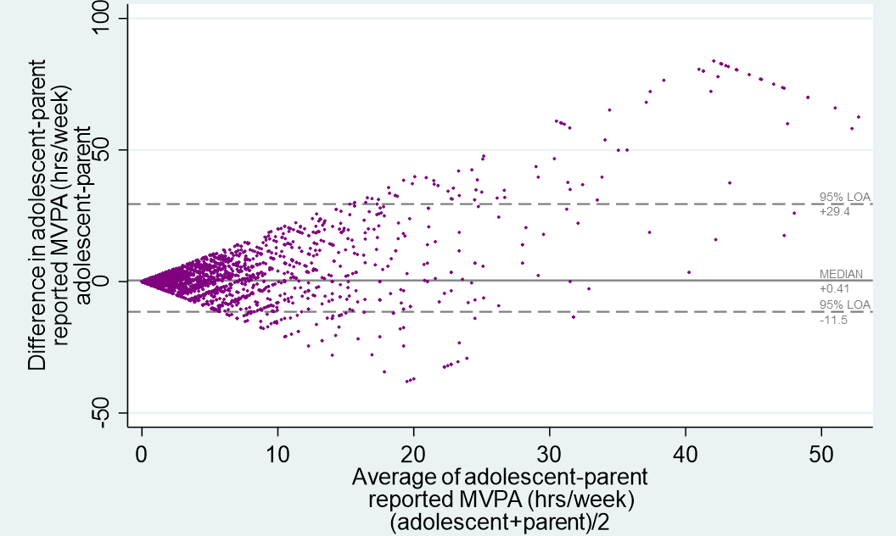
LOA = limits of agreement
Figure S6. Agreement between adolescent-parent MVPA reports in households with income <$75,000
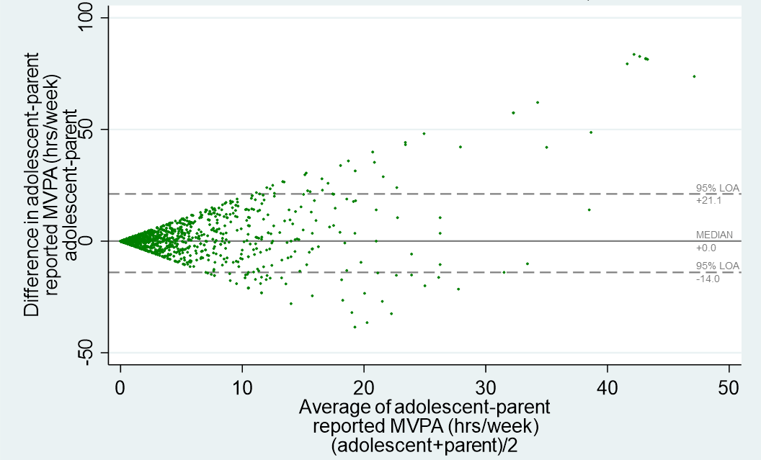
LOA = limits of agreement

