Supplementary tables and figures

The tables and figures below are supporting information alongside the article Reduced dispensing of prescribed antibiotics during the Covid-19 pandemic has not increased severe complications from common infections

Figure S1. Cases of laboratory confirmed Covid-19 in Sweden 2020.
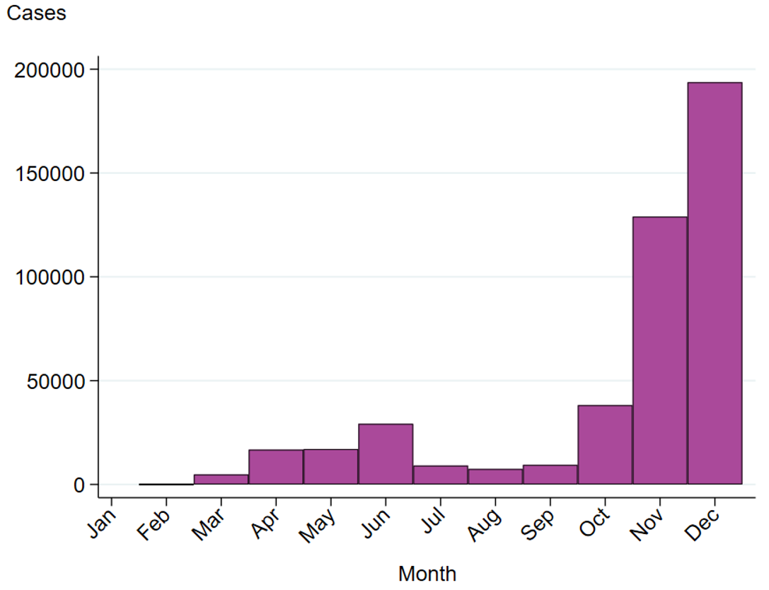

Figure S2. Cases of laboratory confirmed Covid-19 admitted to intensive care unit treatment in Sweden 2020.
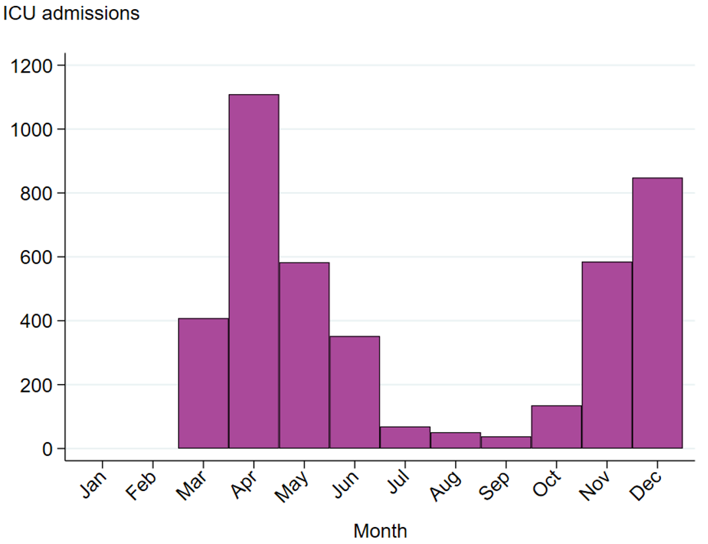

Table S1. Grouping of antibiotics according to main therapeutic indications in Swedish treatment guidelines.
Antibiotic group | Substance name/group name | ATC-codes
Antibiotics commonly used to treat respiratory tract infections | Doxycycline | J01AA02
 | Amoxicillin | J01CA04
 | Phenoxymethylpenicillin | J01CE02
 | Amoxicillin and beta-lactamase inhibitor | J01CR02
 | Cephalosporins | J01DB-DE
 | Macrolides | J01FA
Antibiotics commonly used to treat urinary tract infections | Ciprofloxacin | J01MA02
Antibiotics commonly used to treat urinary tract infections | Nitrofurantoin | J01XE01
Antibiotics commonly used to treat urinary tract infections | Pivmecillinam | J01CA08
Antibiotics commonly used to treat urinary tract infections | Trimethoprim | J01EA01
Antibiotics commonly used to treat skin and soft tissue infections | Flucloxacillin | J01CF05
 | Clindamycin | J01FF01

Table S2. ICD-10 codes used for the studied diagnostic groups.

Diagnostic group | Main diagnoses | ICD-10
Quinsy, etc. | Peritonsillar abscess | J36
Quinsy, etc. | Retropharyngeal and parapharyngeal abscess | J390
Mastoiditis | Acute mastoiditis | H700
Mastoiditis | Petrositis | H702
Mastoiditis | Unspecified mastoiditis | H709
Sinusitis complications | Acute inflammation of orbit | H050
Sinusitis complications | Acute frontal sinusitis | J011
Sinusitis complications | Acute ethmoidal sinusitis | J012
Sinusitis complications | Acute sphenoidal sinusitis | J013
Sinusitis complications | Acute pansinusitis | J014
Pneumonia | Pneumonia due to Streptococcus pneumoniae | J13
Pneumonia | Pneumonia due to Hemophilus influenzae | J14
Pneumonia | Pneumonia due to Klebsiella pneumoniae | J150
Pneumonia | Pneumonia due to Pseudomonas | J151
Pneumonia | Pneumonia due to staphylococcus | J152
Pneumonia | Pneumonia due to streptococcus, group B | J153
Pneumonia | Pneumonia due to other streptococci | J154
Pneumonia | Pneumonia due to Escherichia coli | J155
Pneumonia | Pneumonia due to other aerobic Gram-negative bacteria | J156
Pneumonia | Pneumonia due to Mycoplasma pneumoniae | J157
Pneumonia | Pneumonia due to other specified bacteria | J158
Pneumonia | Unspecified bacterial pneumonia | J159
Pneumonia | Bronchopneumonia, unspecified organism | J180
Pneumonia | Lobar pneumonia, unspecified organism | J181
Pneumonia | Other pneumonia, unspecified organism | J188
Pneumonia | Pneumonia, unspecified organism | J189
Pneumonia | Pyothorax with fistula | J860
Pneumonia | Pyothorax without fistula | J869
Meningitis and brain abscesses | Meningococcal meningitis | A390
Meningitis and brain abscesses | Hemophilus meningitis | G000
Meningitis and brain abscesses | Pneumococcal meningitis | G001
Meningitis and brain abscesses | Streptococcal meningitis | G002
Meningitis and brain abscesses | Staphylococcal meningitis | G003
Meningitis and brain abscesses | Other bacterial meningitis | G008
Meningitis and brain abscesses | Bacterial meningitis, unspecified | G009
Meningitis and brain abscesses | Intracranial abscess and granuloma | G060
Meningitis and brain abscesses | Extradural and subdural abscess, unspecified | G062
Skin and soft tissue infections | Erysipelas | A46
Skin and soft tissue infections | Cellulitis of other parts of limb | L031
Skin and soft tissue infections | Cellulitis and acute lymphangitis of face | L032
Skin and soft tissue infections | Cellulitis of trunk | L033
Skin and soft tissue infections | Cellulitis and acute lymphangitis of other sites | L038
Skin and soft tissue infections | Cellulitis and acute lymphangitis, unspecified | L039
Necrotizing fasciitis | Necrotizing fasciitis | M726
Febrile urinary tract infections | Acute pyelonephritis | N10
Blood-stream infections | Acute meningococcemia | A392
Blood-stream infections | Meningococcemia, unspecified | A394
Blood-stream infections | Sepsis due to streptococcus, group A | A400
Blood-stream infections | Sepsis due to streptococcus, group B | A401
Blood-stream infections | Sepsis due to streptococcus group D and enterococcus | A402
Blood-stream infections | Sepsis due to Streptococcus pneumoniae | A403
Blood-stream infections | Other streptococcal sepsis | A408
Blood-stream infections | Streptococcal sepsis, unspecified | A409
Blood-stream infections | Sepsis due to Staphylococcus aureus | A410
Blood-stream infections | Sepsis due to other specified staphylococcus | A411
Blood-stream infections | Sepsis due to unspecified staphylococcus | A412
Blood-stream infections | Sepsis due to Hemophilus influenzae | A413
Blood-stream infections | Sepsis due to anaerobes | A414
Blood-stream infections | Sepsis due to other Gram-negative organisms | A415
Blood-stream infections | Sepsis, unspecified organism | A419
Blood-stream infections | Septic shock according to Sepsis-3-criteria | R572
Blood-stream infections | Systemic inflammatory response syndrome (SIRS) of non-infectious origin | R651

Figure S3. Overview of number of dispensed prescriptions in Sweden per 1000 inhabitants and year, 1999–2020.
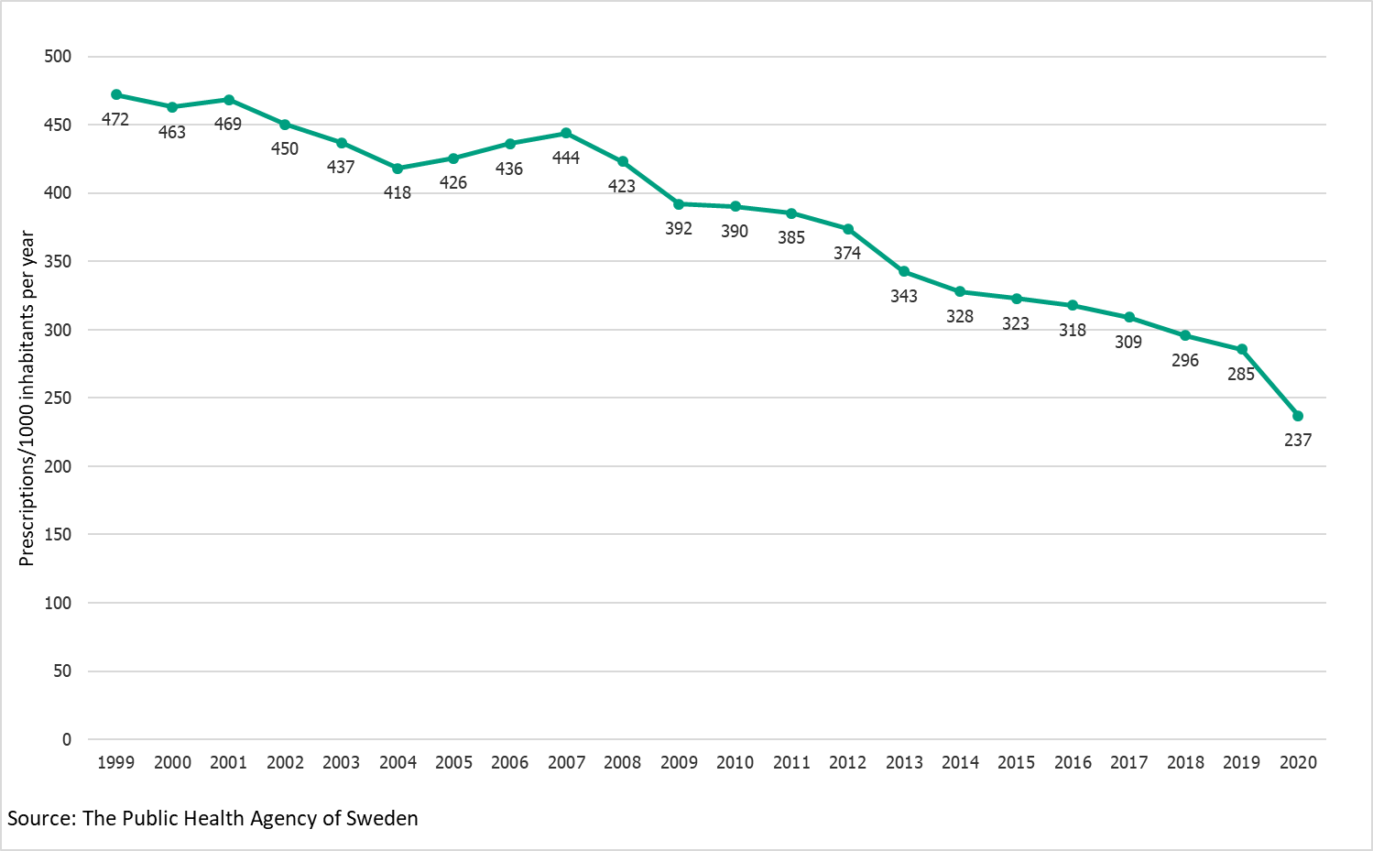

Figure S4. Change in the dispensing of prescribed antibiotics commonly used for urinary tract infections.
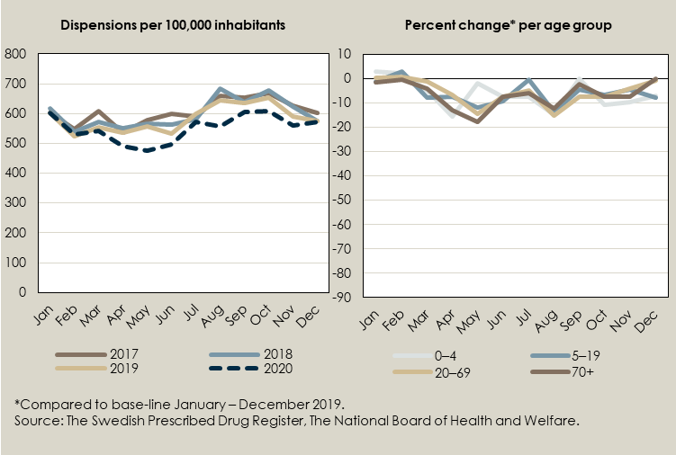
Figure S5. Change in the dispensing of prescribed antibiotics commonly used for skin and soft tissue infections.
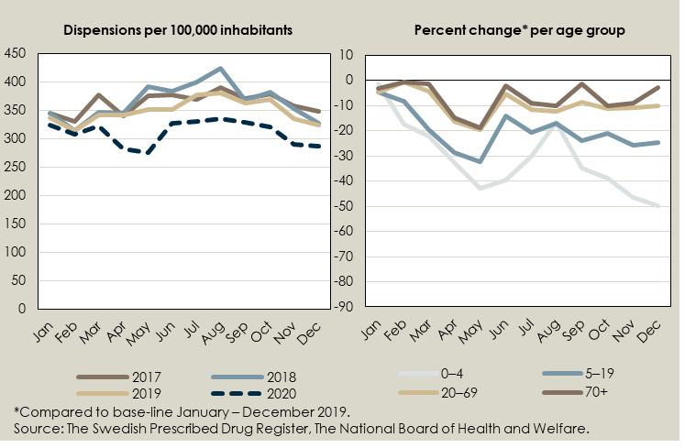
Figure S6. Number of days disbursed to parents caring for their sick children in Sweden, 2019–2020.
