Table S1. Search terms of English databases
Pubmed
#1 | "Sedentary Time"[MeSH Terms] OR "sedentary behaviour"[Title/Abstract] OR "sedentary lifestyle"[Title/Abstract] OR "sedentary time"[Title/Abstract] OR "sedent*"[Title/Abstract] OR "sit*"[Title/Abstract] OR "seated"[Title/Abstract] OR "Screen Time"[MeSH Terms] OR "Television"[MeSH Terms] OR "Computers"[MeSH Terms] OR "Video Games"[MeSH Terms] OR "televisions"[Title/Abstract] OR "television viewing"[Title/Abstract] OR "television watching"[Title/Abstract] OR "TV viewing"[Title/Abstract] OR "TV watching"[Title/Abstract] OR "television time"[Title/Abstract] OR "watch television"[Title/Abstract] OR "view television"[Title/Abstract] OR "watch TV"[Title/Abstract] OR "TV time"[Title/Abstract] OR "TV"[Title/Abstract] OR "screen behavior"[Title/Abstract] OR "screen behaviour"[Title/Abstract] OR "computer"[Title/Abstract] OR "video gaming"[Title/Abstract] OR "occupational sitting"[Title/Abstract] OR "work"[Title/Abstract] OR "transportation"[Title/Abstract]
#2 | "Coronary Disease"[MeSH Terms] OR "Stroke"[MeSH Terms] OR "Myocardial Infarction"[MeSH Terms] OR "Cerebral Arterial Diseases"[MeSH Terms] OR "Brain Infarction"[MeSH Terms] OR "Cardiovascular Diseases"[MeSH Terms] OR "CVD"[Title/Abstract] OR "cardiovascular disease"[Title/Abstract] OR "CHD"[Title/Abstract] OR "coronary heart disease"[Title/Abstract] OR "heart attack"[Title/Abstract] OR "myocardial infarct"[Title/Abstract] OR "brain infarct"[Title/Abstract] OR "coronary arteriosclerosis"[Title/Abstract] OR "MI"[Title/Abstract]
#3 | "Cross-Sectional Studies"[MeSH Terms] OR "Cohort Studies"[MeSH Terms] OR "Case-Control Studies"[MeSH Terms] OR "Mortality"[MeSH Terms] OR "Morbidity"[MeSH Terms] OR "Death"[MeSH Terms] OR "Risk Factors"[MeSH Terms] OR "crude death rate"[Title/Abstract] OR "crude mortality rate"[Title/Abstract] OR "death rate"[Title/Abstract] OR "incidence"[Title/Abstract] OR "risk"[Title/Abstract]
#4 | 80 and over[Filter] OR all adult[Filter] OR young adult[Filter] OR adult[Filter] OR middle aged aged[Filter] OR middle aged[Filter] OR aged[Filter]
#5 | "Randomized Controlled Trial"[Publication Type] OR "Review"[Publication Type]
#6 | "Child"[MeSH Terms] OR "Infant"[MeSH Terms] OR "Adolescent"[MeSH Terms]
#7 | #1 AND #2 AND #3 AND #4 NOT #5 NOT #6
Limit: publication date from January 2015 to November 2021.
Number of literature: 1962

Cochrane Library
#1 | MeSH descriptor: [Sedentary Time] explode all trees
#2 | MeSH descriptor: [Television] explode all trees
#3 | MeSH descriptor: [Computers] explode all trees
#4 | MeSH descriptor: [Video Games] explode all trees
#5 | MeSH descriptor: [Smartphone] explode all trees
#6 | MeSH descriptor: [Screen Time] explode all trees
#7 | ("Sedentary Time" or "sedentary lifestyle" or "sedentary time" or "sitting" or "sit" or "seated" or "screen behavior" or "televisions" or "television viewing" or "television watching" or "television time" or "TV" or "TV watching" or "TV viewing" or "watch television" or "view television" or "TV time" or "watch TV" or "computer" or "video gaming" or "occupational sitting" or "work" or "transportation"):ti,ab,kw
#8 | MeSH descriptor: [Cardiovascular Diseases] explode all trees
#9 | MeSH descriptor: [Coronary Disease] explode all trees
#10 | MeSH descriptor: [Stroke] explode all trees
#11 | MeSH descriptor: [Myocardial Infarction] explode all trees
#12 | MeSH descriptor: [Cerebral Arterial Diseases] explode all trees
#13 | MeSH descriptor: [Brain Infarction] explode all trees
#14 | ("CVD" OR "cardiovascular disease" OR "CHD" OR "coronary heart disease" OR "heart attack" OR "myocardial infarct" OR "brain infarct" OR "coronary arteriosclerosis" OR "MI"):ti,ab,kw
#15 | MeSH descriptor: [Cross-Sectional Studies] explode all trees
#16 | MeSH descriptor: [Cohort Studies] explode all trees
#17 | MeSH descriptor: [Case-Control Studies] explode all trees
#18 | MeSH descriptor: [Mortality] explode all trees
#19 | MeSH descriptor: [Death] explode all trees
#20 | MeSH descriptor: [Risk Factors] explode all trees
#21 | ("crude death rate" OR "crude mortality rate" OR "death rate" OR "incidence" OR "risk"):ti,ab,kw
#22 | (#1 OR #2 OR #3 OR #4 OR #5 OR #6 OR #7) AND (#8 OR #9 OR #10 OR #11 OR #12 OR #13 OR #14) AND (#15 OR #16 OR #17 OR #18 OR #19 OR #20 OR #21)
Limit: publication date from January 2015 to November 2021.
Number of literature: 2351

Web of Science
#1 | AB=("Sedentary Time" or "sedentary lifestyle" or "sedentary time" or "sitting" or "sit" or "seated" or "screen behavior" or "television" or "televisions" or "television viewing" or "television watching" or "television time" or "TV" or "TV watching" or "TV viewing" or "watch television" or "view television" or "TV time" or "watch TV" or "computers" or "computer" or "video game" or "video gaming" or "occupational sitting" or "work" or "transportation")
#2 | AB=("Cardiovascular Diseases" OR "CVD" OR "cardiovascular disease" OR "Coronary Disease" OR "CHD" OR "coronary heart disease" OR "heart attack" OR "myocardial infarction" OR "myocardial infarct" OR "Cerebral Arterial Diseases" OR "Brain Infarction" OR "brain infarct" OR "coronary arteriosclerosis" OR "MI")
#3 | AB=("Cross-sectional Studies" OR "Cohort Studies" OR "Case-control Studies" OR "Mortality" OR "Morbidity" OR "death" OR "crude death rate" OR "crude mortality rate" OR "death rate" OR "incidence" OR "risk factors" OR "risk")
#4 | #1 AND #2 AND #3
Limit: publication date from January 2015 to November 2021.
Number of literature: 1405

Embase
#1 | 'Sedentary Time':ab,ti OR 'sedentary lifestyle':ab,ti OR 'sedentary time':ab,ti OR 'sitting':ab,ti OR 'sit':ab,ti OR 'seated':ab,ti OR 'television':ab,ti OR 'television viewing':ab,ti OR 'television watching':ab,ti OR 'television time':ab,ti OR 'televisions':ab,ti OR 'watch television':ab,ti OR 'view television':ab,ti OR 'TV watching':ab,ti OR 'TV viewing':ab,ti OR 'watch TV':ab,ti OR 'TV time':ab,ti OR 'computers':ab,ti OR 'computer':ab,ti OR 'video games':ab,ti or 'video gaming':ab,ti or 'smartphone':ab,ti or 'occupational sitting':ab,ti or 'work':ab,ti or 'transportation':ab,ti
#2 | 'cardiovascular diseases':ab,ti OR 'cardiovascular disease':ab,ti OR 'cvd':ab,ti OR 'coronary disease':ab,ti OR 'coronary heart disease':ab,ti OR 'chd':ab,ti OR 'stroke':ab,ti OR 'myocardial infarction':ab,ti OR 'myocardial infarct':ab,ti OR 'mi':ab,ti OR 'brain infarction':ab,ti OR 'cerebral arterial diseases':ab,ti OR 'coronary arteriosclerosis':ab,ti OR 'heart attack':ab,ti
#3 | 'cross-sectional study':ab,ti OR 'cohort study':ab,ti OR 'case-control study':ab,ti OR 'mortality':ab,ti OR 'morbidity':ab,ti OR 'death':ab,ti OR 'incidence':ab,ti OR 'risk factors':ab,ti OR 'risk':ab,ti OR 'crude mortality rate':ab,ti OR 'crude death rate':ab,ti OR 'death rate':ab,ti
#4 | (2015:py OR 2016:py OR 2017:py OR 2018:py OR 2019:py OR 2020:py OR 2021:py) AND 'human'/de AND 'article'/it AND ([adult]/lim OR [aged]/lim OR [middle aged]/lim OR [very elderly]/lim OR [young adult]/lim)
#5 | #1 AND #2 AND #3 AND #4
Limit: publication date from January 2015 to November 2021.
Number of literature: 1033

Table S2. Reported Average Duration/Time Range and Estimated Median Duration (in hours/day) for Total Sedentary Time and Screen Time Categories Across Included Studies
Publication | Type of Sedentary Time | Reported Time and Estimated Median | Reference Category, h/d | Category 2, h/d | Category 3, h/d | Category 4, h/d |  |  | Category 5, h/d | Category 6, h/d |  | Category 7, h/d
Park, 2021 | Total sedentary time | Reported Time | 0-6 | ≥7 | NA
Park, 2021 | Total sedentary time | Estimated Median | 3 | 10
Hamer, 2020 | Screen time | Reported Time | 1 | 2 | NA
Hamer, 2020 | Screen time | Estimated Median | 1 | 2
Liu, 2020 | Total sedentary time | Reported Time | ＜5 | 5-＜8 | 8-＜10 | ≥10 |  |  | NA
Liu, 2020 | Total sedentary time | Estimated Median | 2.5 | 6.5 | 9 | 11
Tu, 2020 | Total sedentary time | Reported Time | ＜2 | ≥4 | NA
Tu, 2020 | Total sedentary time | Estimated Median | 1 | 5
Bellettiere, 2019 | Total sedentary time | Reported Time | 3.28-8.18 | 8.20-9.18 | 9.20-10.20 | 10.22-14.08 |  |  | NA
Bellettiere, 2019 | Total sedentary time | Estimated Median | 5.73 | 8.69 | 9.70 | 12.15
Garcia, 2019 | Screen time | Reported Time | ＜2 | 2-4 | ＞4 | NA
Garcia, 2019 | Screen time | Estimated Median | 1 | 3 | 5
Stamatakis, 2019 | Total sitting time | Reported Time | ＜4 | 4-＜6 | 6-≤8 | ＞8 | NA
Stamatakis, 2019 | Total sitting time | Estimated Median | 2 | 5 | 7 | 9
Morales, 2018 | Screen time | Reported Time | ＜2 | 2-3 | NA
Morales, 2018 | Screen time | Estimated Median | 1 | 2.5
Dohrn, 2017 | Total sedentary time | Reported Time | 6.55±0.82 | 8.20±0.36 | 9.83±0.83 | NA
Dohrn, 2017 | Total sedentary time | Estimated Median | 6.55 | 8.20 | 9.83
Engelen, 2017 | Total sitting time | Reported Time | ＜5.14 | ＞5.14 | NA
Engelen, 2017 | Total sitting time | Estimated Median | 2.57 | 7.71
Cumming, 2016 | Screen time | Reported Time | 1.64 | 2 | NA
Cumming, 2016 | Screen time | Estimated Median | 1.64 | 2
Evenson, 2016 | Total sedentary time | Reported Time | ＜6.89 | 6.89-8.29 | 8.30-9.80 | ≥9.81 |  | NA
Evenson, 2016 | Total sedentary time | Estimated Median | 3.45 | 7.59 | 9.05 | 10.56
Evenson, 2016 | Screen time | Reported Time | ≤2 | 2.1-3.5 | ≥3.6 | NA
Evenson, 2016 | Screen time | Estimated Median | 1 | 2.8 | 4.3
Grace, 2016 | Screen time | Reported Time | ＜2 | 2-＜4 | ≥4 | NA
Grace, 2016 | Screen time | Estimated Median | 1 | 3 | 5
McDonnell, 2016 | Screen time | Reported Time | ＜2 | 2-＜4 | ≥4 | NA
McDonnell, 2016 | Screen time | Estimated Median | 1 | 3 | 5
Moller, 2016 | Occupational sitting time | Reported Time | ＜3.57 | ≥3.57 | NA
Moller, 2016 | Occupational sitting time | Estimated Median | 1.79 | 5.36
Borodulin, 2015 | Total sedentary time | Reported Time | 1 | 2 | NA
Borodulin, 2015 | Total sedentary time | Estimated Median | 1 | 2
Ikehara, 2015 | Screen time | Reported Time | ＜2 | 2 | 3 | 4 |  | 5 |  |  | 6 |  | ≥6
Ikehara, 2015 | Screen time | Estimated Median | 1 | 2 | 3 | 4 |  | 5 |  |  | 6 |  | 7
Keadle, 2015 | Screen time | Reported Time | ＜1 | 1-2 | 3-4 | 5-6 |  | ＞7 |  |  | NA
Keadle, 2015 | Screen time | Estimated Median | 0.5 | 1.5 | 3.5 | 5.5 |  | 7.5
Abbreviations: NA: non-available

Table S3a. Sedentary Time Categories and Associated Risk for CVD Morbidity Across Included Studies
Publication | Categories of Sedentary Time | Most adjusted HR/RR by categories (95% CI) | Covariates in the most adjusted model
Park, 2021 | Total sedentary time, h/d  1: 0-6  2: ≥7 | Morbidity of CVD  OR  1: 1.00  2: 1.28 [1.08, 1.51]  RR (after corrected)  1: 1.00  2: 1.24 [1.21, 1.27] | Sex, age, education, household income, marital status, total PA, waist circumference, current smoking, high-risk alcohol consumption, chronic diseases (diabetes mellitus, hypertension, dyslipidemia), and self-rated health
Liu, 2020 | Total sedentary time, h/d  1: ＜5  2: 5-＜8  3: 8-＜10  4: ≥10 | Morbidity of stroke, HR  1: 1.00  2: 1.00 [0.87, 1.14]  3: 1.11 [0.96, 1.28]  4: 1.19 [1.03, 1.38] | Sex, age, geographic region, urbanization, education, family history of CVD, current smoking status, alcohol consumption and MVPA
Liu, 2020 | Total sedentary time, h/d  1: ＜5  2: 5-＜8  3: 8-＜10  4: ≥10 | Morbidity of CHD, HR  1: 1.00  2: 1.08 [0.84, 1.41]  3: 1.52 [1.17, 1.98]  4: 2.12 [1.63, 2.75]
Garcia, 2019 | Screen time, h/d  1: ＜2  2: 2-4  3: ＞4 | Morbidity of CVD, HR  1: 1.00  2: 1.10 [0.73, 1.66]  3: 1.43 [0.96, 2.12] | Age, sex, education, alcohol consumption, smoking status, health diet, body mass index, hypertension, diabetes mellitus, history of myocardial infarction/stroke, leisure time MVPA, occupational sitting
Garcia, 2019 | Occupational sitting time  1: never or seldom  2: sometimes  3: often or always | Morbidity of CVD, HR  1: 1.00  2:1.01 [0.67, 1.51]  3: 1.06 [0.73, 1.55] | Age, sex, education, alcohol consumption, smoking status, health diet, body mass index, hypertension, diabetes mellitus, history of myocardial infarction/stroke, leisure time MVPA, screen time
Morales, 2018 | Screen time, h/d  1: ＜2  2: 2-3 | Morbidity of CVD, HR  1: 1.00  2: 1.04 [1.03, 1.05] | Walking and MVPA, grip strength, categories of sleep duration, dietary intake (alcohol, fruit and vegetables, red meat, processed meat and oily fish intake), systolic blood pressure, prevalent diabetes, hypertension and medication for diabetes, hypertension, and cholesterol. Ex-smokers and current smokers were excluded.
Engelen, 2017 | Total sitting time, h/week  1: ＜36  2: ＞36 | Morbidity of CVD, OR  1: 1.00  2: 1.28 [1.02-1.60] | Waist circumference, occupation, age, sex, self-rated health, smoking status, total PA
Cumming, 2017 | Screen time, h/d  1: 1.64  2: 2 | Morbidity of Stroke, HR  1: 1.00  2: 1.00 [0.997, 1.002] | Age, sex, education,smoking status, alcohol intake, diet quality
McDonnell, 2016 | Screen time, h/d  1: ＜2  2: 2-＜4  3: ≥4 | Morbidity of stroke, HR  1: 1.00  2: 1.10 [0.87, 1.40]  3: 1.14 [0.88, 1.48] | Age, sex, race, region, age-race interaction, MVPA, general health, marital status, employment status, depressive symptoms
Abbreviations: CVD: Cardiovascular Disease; CHD: Coronary Heart Disease; MVPA: Moderate-to-Vigorous Physical Activity; PA: Physical Activity

Table S3b. Sedentary Time Categories and Associated Risk for CVD Mortality Across Included Studies
Publication | Categories of Sedentary Time | Most adjusted HR by categories (95% CI) | Covariates in the most adjusted model
Hamer, 2020 | Screen time, h/d  1: ＜1  2: each additional hour | Mortality of IHD, HR  1: 1.00  2: 1.09 [1.06, 1.12] | Age, sex, smoking, education and prevalent CVD (angina, heart attack, hypertension)
Liu, 2020 | Total sedentary time, h/d  1: ＜5  2: 5-＜8  3: 8-＜10  4: ≥10 | Mortality of CVD, HR  1: 1.00  2: 0.94 [0.79, 1.13]  3: 1.00 [0.82, 1.21]  4: 1.27 [1.05, 1.52] | Sex, age, geographic region, urbanization, education, family history of CVD, current smoking status, alcohol consumption and MVPA
Stamatakis, 2019 | Total sitting time, h/d  1: ＜4  2: 4-＜6  3: 6-≤8  4: ＞8 | Mortality of CVD, HR  1: 1.00  2: 1.13 [0.98, 1.31]  3: 1.23 [1.06, 1.41]  4: 1.26 [1.04, 1.54] | Age, sex, education, marital status, remoteness, body mass index, smoking, self-rated health, total fruit and vegetable consumption, help for disability, psychological distress, diabetes, and MVPA
Patel, 2018 | Leisure sedentary time, h/d  1: ＜3  2: 3-5  3: ≥6 | Mortality of CHD, HR  1: 1.00  2: 1.07 [1.02, 1.13]  3: 1.26 [1.17, 1.35] | Sex, race, education, employment status, alcohol intake, marital status, smoking status, comorbidities, American Cancer Society Diet Score, aspirin use, body mass index, recreational MVPA
Patel, 2018 | Leisure sedentary time, h/d  1: ＜3  2: 3-5  3: ≥6 | Mortality of Stroke, HR  1: 1.00  2: 1.04 [0.96, 1.12]  3: 1.15 [1.03, 1.28]
Patel, 2018 | Leisure sedentary time, h/d  1: ＜3  2: 3-5  3: ≥6 | Mortality of total CVD, HR  1: 1.00  2: 1.06 [1.02, 1.10]  3: 1.19 [1.13, 1.25]
Dohrn, 2017 | Total sedentary time, min/d  1: 392.8±49.1  2: 491.9±21.4  3: 590.0±49.6 | Mortality of CVD, HR  1: 1.00  2: 1.63 [0.36,7.28]  3: 5.51 [1.43, 21.23] | Age, sex, education, smoking, health conditions at baseline (hypertension, heart disease, cancer, diabetes), achieving at least 150 min of MVPA per week and accelerometer wear time.
Evenson, 2016 | Total sedentary time, min/d  1: ≤413.4  2: 413.5-497.6  3: 497.7-588.3  4: ≥588.4 | Mortality of CVD, HR  1: 1.00  2: 1.12 [0.54-2.31]  3: 1.03 [0.50-2.12]  4: 1.44 [0.71-2.90] | Average daily accelerometer wear time, age, sex, race/ethnicity, education, married, cigarette smoking, employment, need special equipment to walk, arthritis, cancer, body mass index, hypertension, diabetes, total PA
Evenson, 2016 | Screen time, h/d  1: ≤2  2: 2.1-3.5  3: ≥3.6 | Mortality of CVD, HR  1: 1.00  2: 0.85 [0.51, 1.42]  3: 0.90 [0.57, 1.41]
Grace, 2016 | Screen time, h/d  1: ＜2  2: 2-＜4  3: ≥4 | Mortality of CVD in non-smokers, HR  1: 1.00  2: 0.93 [0.69, 1.26]  3: 1.04 [0.69, 1.57] | Age, sex, leisure time PA, education, household income, total energy intake, alcohol intake, Dietary Guideline Index, hypertension or anti-hypertensive medication use, total plasma cholesterol,  HDL-C, serum triglycerides, lipid-lowering medication use, and glucose tolerance status.
Grace, 2016 | Screen time, h/d  1: ＜2  2: 2-＜4  3: ≥4 | Mortality of CVD in current-smokers, HR  1: 1.00  2: 1.11 [0.46, 2.63]  3: 2.02 [0.80, 5.12]
Ikehara, 2015 | Screen time, h/d  1: ＜2  2: =2  3: =3  4: =4  5: =5  6: ≥6 | Mortality of stroke, HR  1: 1.00  2: 1.06 [0.93, 1.19]  3: 0.98 [0.87, 1.11]  4: 0.89 [0.76, 1.03]  5: 1.06 [0.90, 1.23]  6: 1.10 [0.92, 1.32] | Age, sex, body mass index, smoking, ethanol intake, education, hours of sport, hours of walking, sleep duration, perceived mental stress, presence of job, frequency of fresh fish intake, depressive symptoms, histories of hypertension and diabetes.
Ikehara, 2015 | Screen time, h/d  1: ＜2  2: =2  3: =3  4: =4  5: =5  6: ≥6 | Mortality of CAD, HR  1: 1.00  2: 1.01 [0.84, 1.21]  3: 0.92 [0.77, 1.11]  4: 1.00 [0.81, 1.24]  5: 1.16 [0.92, 1.45]  6: 1.24 [0.96, 1.61]
Ikehara, 2015 | Screen time, h/d  1: ＜2  2: =2  3: =3  4: =4  5: =5  6: ≥6 | Mortality of total CVD, HR  1: 1.00  2: 1.00 [0.92, 1.08]  3: 0.95 [0.88, 1.04]  4: 0.96 [0.87, 1.05]  5: 1.03 [0.93, 1.14]  6: 1.14 [1.02, 1.28]
Keadle, 2015 | Screen time, h/d  1: ＜1  2: 1-2  3: 3-4  4: 5-6  5: ＞7 | Mortality of CVD, HR  1: 1.00  2: 1.09 [0.97, 1.23]  3: 1.19 [1.06, 1.33]  4: 1.26 [1.11, 1.43]  5: 1.64 [1.42, 1.90] | Age, sex, race, education, smoking history, diet quality, MVPA, body mass index, self-reported health status
Abbreviations: CVD: Cardiovascular Disease; IHD: Ischemic Heart Disease; MVPA: Moderate-to-Vigorous Physical Activity; CHD: Coronary Heart Diseases; PA: Physical Activity; CAD: Coronary Artery Diseases

Table S3c. Sedentary Time Categories and Associated Risk for CVD Morbidity and Mortality Across Included Studies
Publication | Categories of Sedentary Time | Most adjusted HR by categories (95% CI) | Covariates in the most adjusted model
Tu, 2020 | Total sedentary time, h/d  1: ＜2  2: ≥4 | Morbidity and mortality of CVD, HR  1: 1.00  2: 2.07 [1.07-3.40] | Age, sex, education, marital status, region, smoking status, alcohol consumption, total PA and history of hypertension/ diabetes/ hyperlipidemia/ central obesity.
Bellettiere, 2019 | Total sedentary time, min/d  1: 197-491  2: 492-551  3: 552-612  4: 613-845 | Morbidity and mortality of CVD, HR  1: 1.00  2: 1.35 [0.97, 1.86]  3: 1.19 [0.84, 1.68]  4: 1.32 [0.91, 1.90] | Age, ethnicity, education, self-reported health status, family history of MI, multimorbidity, physical functioning, alcohol consumption, current smoking status, MVPA, awake wear time of accelerometer
Moller, 2016 | Occupational sitting time, h/week  1: ＜25  2: ≥25 | Morbidity and mortality of IHD, HR  1: 1.00  2: 0.94 [0.71-1.27] | Sex, age, socioeconomic status, smoking status, alcohol consumption, leisure time PA, decision latitude and calendar year.
Borodulin, 2015 | Total sedentary time, h/d  1: ＜1  2: each additional hour | Morbidity and mortality of CVD, HR  1: 1.00  2: 1.06 [1.01-1.11] | Age, sex, daily total sitting (continuous hours), employment status, education, smoking status, leisure time PA, body mass index, use of vegetables and fruit, alcohol consumption, high blood pressure and/or its medication, and high serum cholesterol and/or its medication.
Abbreviations: CVD: Cardiovascular Disease; PA: Physical Activity; MVPA: Moderate-to-Vigorous Physical Activity; IHD: Ischemic Heart Disease
Table S4. Definitions and Measurements of Sedentary Time, Physical Activity (if included in the most adjusted models) and CVD Outcomes
Publication | Definition of Sedentary Time | Measurement of Sedentary Time | Definition of PA | Measurement of PA | PA adjusted for in the most adjusted model | Definition of CVD Outcomes | Measurement of CVD Outcomes
Park, 2021 | Total sedentary time | Self-reported question: “How much time do you spend sitting of lying down a day?” | Total PA | Global Physical Activity Questionnaire Korean Version | Physical active or inactive | Morbidity of stroke, MI and angina | Self-reported
Hamer, 2020 | Screen time: television watching | Self-reported question: “In a typical day, how many hours do you spend watching TV? If the time you spend watching TV varies a lot, give the average time for a 24 hour day in the last 4 weeks”. | PA was not included in the most adjusted model |  |  | Mortality of IHD (ICD-10 I20-I25) | Death certifications
Liu, 2020 | Total sedentary time | Self-reported question: “During the previous year, how many hours in each  24-h day did you usually spend on the following activities (light, moderate, vigorous physical activity, Sedentary Time and sleep) on weekdays/weekends”. | MVPA | Self-reported question: “During the previous year, how many hours in each 24-h day did you usually spend on the following activities (light, moderate, vigorous physical activity, Sedentary Time and sleep) on weekdays/weekends”. | MVPA: ≥150 or ＜150 min/week | The first diagnosis of stroke (ICD-10 I60-I69), CHD (ICD-10 I20-I25), or CVD death (ICD-10 I00-I99) | Medical records and death certifications
Tu, 2020 | Total sedentary time | Self-reported question | Total PA | Self-reported question | High, moderate or low amount of total PA according to MET/min/week | CVD events: CHD, stroke and CVD death | Medical records
Bellettiere, 2019 | Total sedentary time | ActiGraph GT3X+ accelerometer: <100 counts/minute was defined as Sedentary Time. Participants who had ≥ 10 waking wear hours on ≥ 4 days per week were included. | MVPA | ActiGraph GT3X+ accelerometer: ≥519 vector magnitude accelerometer counts/15-seconds was defined as moderate-to-vigorous physical activity. | Median time spent doing MVPA per week | CVD events: the first occurrence of an MI, revascularization, hospitalized angina, heart failure, stroke, or death from any CVD. | Medical records and death certifications
Garcia, 2019 | Screen time (television watching) | Self-reported question: “During the past year, how often did you watch television?” | Leisure time MVPA | Self-reported question: about the yearly frequency and weekly duration of participation in exercise and sports over the past year. | Poor, intermediate or ideal leisure time MVPA (≥3.5 MET/h/week） | Morbidity of CHD or stroke | Medical records
Garcia, 2019 | Occupational sitting time | Self-reported question: “When you are at work, how often do you sit?”
Stamatakis, 2019 | Total sitting time | Self-reported question: “How many hours in each 24-h day do you usually spend doing the following? Sitting, standing and sleeping.” And in line with the sitting questions in the International Physical Activity Questionnaire. | MVPA | Active Australia Survey questions: “If you add up all the time you spent doing each activity last week, how much time did you spend altogether doing each type of activity?” | No physical activity, ≤149/150-299/300-419/≥420 min/week MVPA (≥3.5 MET/h/week） | CVD-related death | Death certifications
Patel, 2018 | Leisure sedentary time | Self-reported question: “During the past year, on an average day (not counting time spent at your job), how many hours per day did you spend sitting (watching television, reading, etc.)?” | Recreational MVPA | Self-reported question: “During the past year, what was the average time per week you spent at the following kinds of activities: walking, jogging/running, lap swimming, tennis or racquetball, bicycling or stationary biking, aerobics/calisthenics, and dancing?” | MVPA dose in MET/h/week | CVD mortality: CHD (ICD-9 410-414; ICD-10 I20-I25), stroke (ICD-9 430-438; ICD-10 I60-I69), and total CVD (ICD-9 390-459; ICD-10 I00-I99) | Death certifications
Morals, 2018 | Screen time (television viewing and personal computer using) | Self-reported question: “In a typical day, how many hours do you spend watching TV?”, “In a typical day, how many hours do you spend using the computer? (Do not include using a computer at work).” | Walking and MVPA | International Physical Activity Questionnaire short form. | Walking and MVPA dose in MET/h/week | CVD morbidity: ICD-10 I05-I89.9 | Medical records
Dohrn, 2017 | Total sedentary time | Actigraph 7164 accelerometer: <100 counts/minute was defined as Sedentary Time. Participants who had ≥10 waking wear hours on ≥1 days per week were included. | MVPA | Actigraph 7164 accelerometer: light intensity as 100–2019 counts/min, and MVPA as ≥2020 counts/min. | ≥150 min/week MVPA | CVD mortality | Death certifications
Engelen, 2017 | Total sitting time | Self-reported question: “how much time did you spend sitting at work in the last week?”, “In the last week did you spend time sitting to travel to or from places?” and “ how much time, sitting or lying down to leisure activities: 1. Watch television or videos; 2. Play electronic games; 3. Use a computer or the Internet; 4. Use a phone (e.g. text and talk); 5. Other social or leisure activities and; 6. None of these.” | Total PA | Active Australia Questionnaire: total PA was calculated as the sum of the reported minutes spent walking, doing MPA, and twice the total minutes spent doing VPA. | Quartiles 3-4 of total PA | CVD morbidity | Self-reported
Cumming, 2016 | Screen time (television watching or video) | Self-reported question | PA was not included in the most adjusted model |  |  | Morbidity of stroke | Medical records
Evenson, 2016 | Total sedentary time | Actigraph 7164 accelerometer: <100 counts/minute was defined as Sedentary Time. Participants who had ≥8 waking wear hours on ≥3 days per week were included. | Total PA | Actigraph 7164 accelerometer: light intensity as 100–2019 counts/min, and MVPA as ≥2020 counts/min. | Total PA dose in MET/h/week (quartiles) | CVD mortality | Death certifications
Evenson, 2016 | Screen time | Self-reported question
Grace, 2016 | Screen time (television viewing or video) | Self-reported question | Leisure time PA | Active Australia questionnaire | Average time spent doing leisure time PA per day | CVD mortality (ICD-10  I10–I25, I46.1, I48, I50–I99 or R96) | Death certifications
McDonnell, 2016 | Screen time (television watching or video) | Self-reported question: “How many hours do you watch television or video, per day  or per week, on average?” | MVPA | Self-reported question: number of times per week engaged in intense physical activity, sufficient to  work up a sweat. | Number of times per week engaged in MVPA | CVD morbidity: stroke | Medical records
Moller, 2016 | Occupational sitting time | Self-reported question: “Does your job involve sitting?” | Leisure time PA | Self-reported question | ≥2/＜2 h/week | Morbidity and mortality of IHD (ICD-8 410-414, ICD I20-I25) | Medical records and death certifications
Borodulin, 2015 | Total sedentary time | Self-reported question: “How much time did you spend sitting on a typical weekday? This includes work and leisure time sitting, sitting at home and while visiting, and studying and travelling. This also includes sitting or lying down while reading or watching TV.” | Leisure time PA | Self-reported question: “How much do you exercise and stress yourself  physically in your leisure time?” | Physical active or inactive | CVD morbidity and mortality: fatal cases of IHD (ICD-10 I20-I25, I46, R96, R98), nonfatal cases of IHD (ICD-10 I20-I25), and fatal and nonfatal strokes (ICD-10 I61, I63 (not I636), I64) | Medical records and death certifications
Ikehara, 2015 | Screen time (television watching) | Self-reported question: “On average how many hours do you watch TV?” | Sport and walking | Self-reported question | Average time spent doing sports or walking per week or per day | Mortality of stroke (ICD-10 I60-I69), CAD (I20-I25) and total CVD (I01-I99). | Death certifications
Keadle, 2015 | Screen time (television watching and video) | Self-reported question: “During a typical 24-hour period over the past 12 months, how much time did you spend watching television or videos?” | MVPA | Self-reported question | Average time spent doing MVPA per week | Mortality of disease of the heart | Death certifications
Abbreviations: CVD: Cardiovascular Diseases; PA: Physical Activity; MVPA: Moderate-to-Vigorous Physical Activity; ICD: International Classification of Diseases; MI: Myocardial Infarction; IHD: Ischemic Heart Disease; CHD: Coronary Heart Disease; MPA: Moderate Physical Activity; VPA: Vigorous Physical Activity; CAD: Coronary Artery Disease

Table S5. Quality assessment scores of the included studies
Publication | 1 point for prospective study design | If sedentary time was self-reported, 1 for reported reliability, 1 for reported validity. | 2 If an objective measure of sedentary time was used. | 1 if two or more covariates were controlled for | 1 if analysis controlled for physical activity | 1 for an objective measure of the health outcome | Total score
Park, 2021 | 0 | 1 | - | 1 | 1 | 0 | 3
Harmer, 2020 | 1 | 0 | - | 1 | 0 | 1 | 3
Liu, 2020 | 1 | 0 | - | 1 | 1 | 1 | 4
Tu, 2020 | 1 | 0 | - | 1 | 1 | 1 | 4
Bellettiere, 2019 | 1 | - | 2 | 1 | 1 | 1 | 6
Garcia, 2019 | 1 | 2 | - | 1 | 1 | 1 | 6
Stamatakis, 2019 | 1 | 1 | - | 1 | 1 | 1 | 5
Patel, 2018 | 1 | 0 | - | 1 | 1 | 1 | 4
Morales, 2018 | 1 | 0 | - | 1 | 1 | 1 | 4
Dohrn, 2017 | 1 | 0 | 2 | 1 | 1 | 1 | 6
Engelen, 2016 | 0 | 2 | - | 1 | 1 | 1 | 5
Cumming, 2016 | 1 | 1 | - | 1 | 0 | 1 | 4
Evenson, 2016 | 1 | - | 2 | 1 | 1 | 1 | 6
Grace, 2016 | 1 | 2 | - | 1 | 1 | 1 | 6
McDonnel, 2016 | 1 | 2 | - | 1 | 1 | 1 | 6
Moller, 2016 | 1 | 0 | - | 1 | 1 | 1 | 4
Borodulin, 2015 | 1 | 2 | - | 1 | 1 | 1 | 6
Ikehara, 2015 | 1 | 0 | - | 1 | 1 | 1 | 4
Keadle, 2015 | 1 | 1 | - | 1 | 1 | 1 | 5

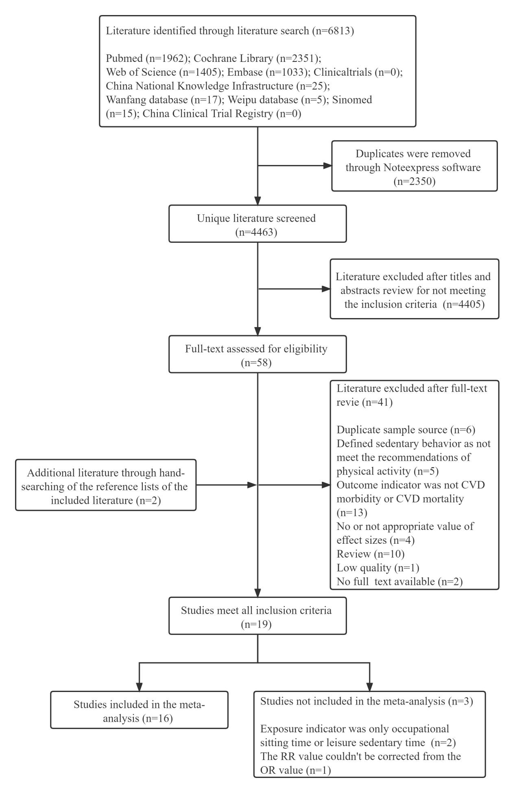
Figure S1. The flowchart of the literature search
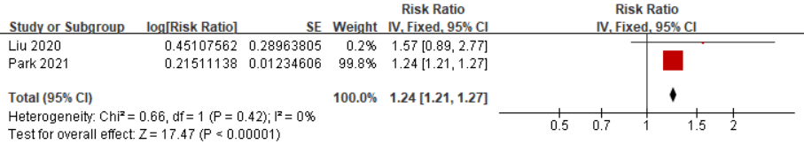
Figure S2. Forest Plot of the Association Between Highest versus Lowest Total Sedentary Time Duration And CVD Morbidity
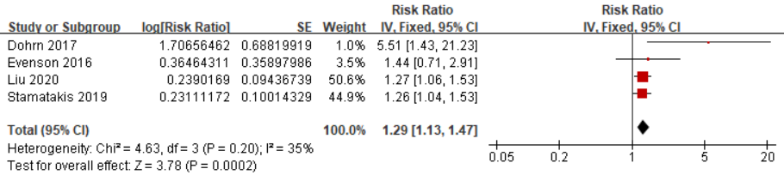
Figure S3. Forest Plot of the Association Between Highest versus Lowest Total Sedentary Time Duration And CVD Mortality
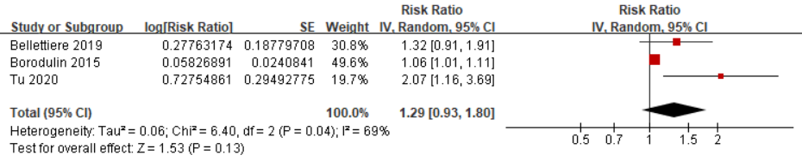
Figure S4. Forest Plot of the Association Between Highest versus Lowest Total Sedentary Time Duration And CVD Morbidity And Mortality
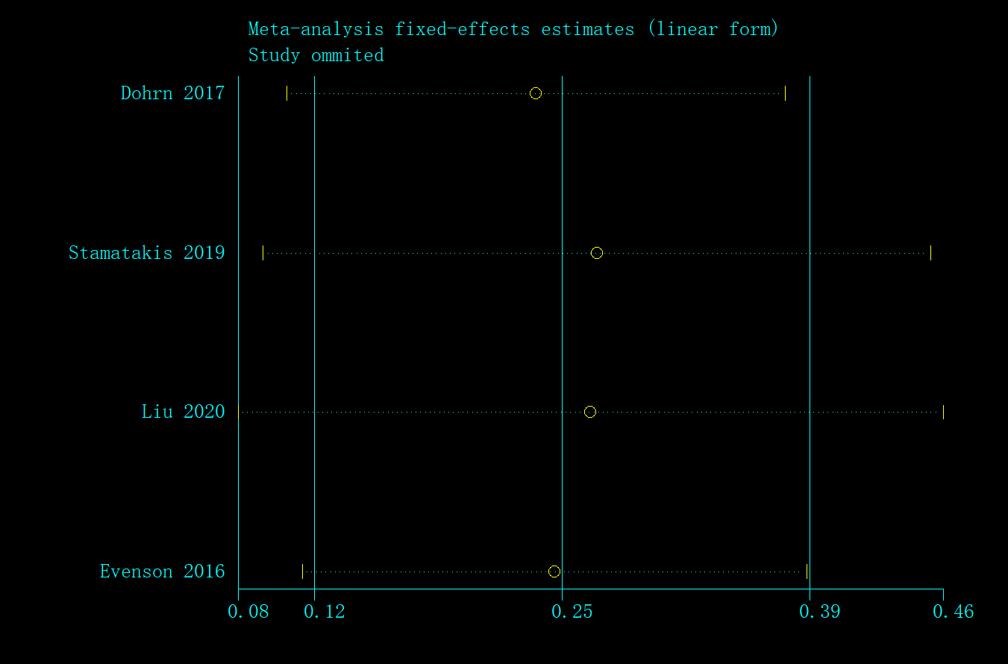
Figure S5. Sensitivity Analysis of the Association Between Highest versus Lowest Total Sedentary Time And CVD Mortality
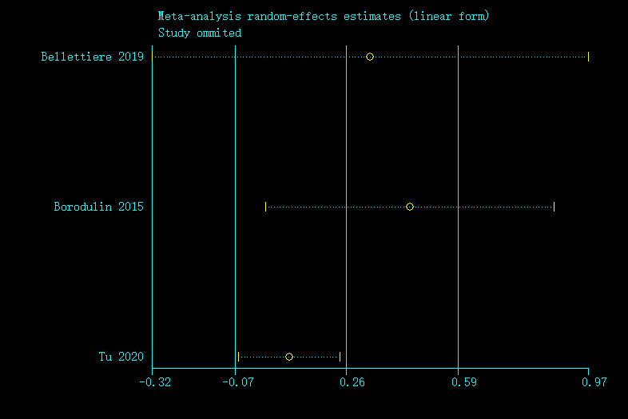
Figure S6. Sensitivity Analysis of the Association Between Highest versus Lowest Total Sedentary Time And CVD Morbidity and Mortality
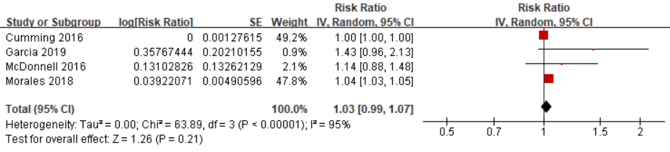
Figure S7. Forest Plot of the Association Between Highest versus Lowest Screen Time And CVD Morbidity
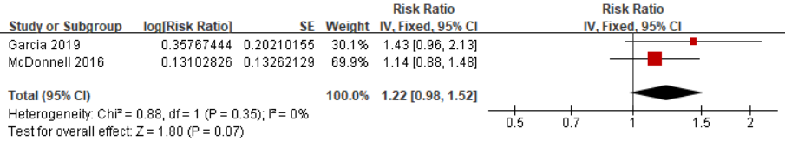
Figure S8. Forest Plot of the Association Between Highest versus Lowest Screen Time And CVD Morbidity (after excluding Cumming, 2016 and Morales, 2018)
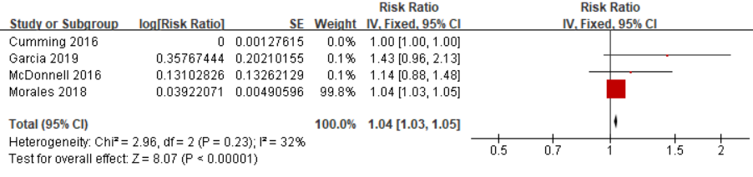
Figure S9. Forest Plot of the Association Between Highest versus Lowest Screen Time And CVD Mortality (after excluding study did not include any physical activity intensity as a covariate in the most adjusted model)
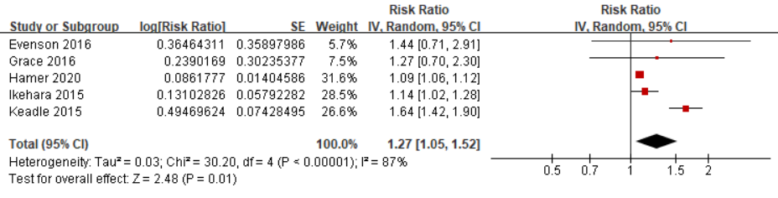
Figure S10. Forest Plot of the Association Between Highest versus Lowest Screen Time And CVD Mortality
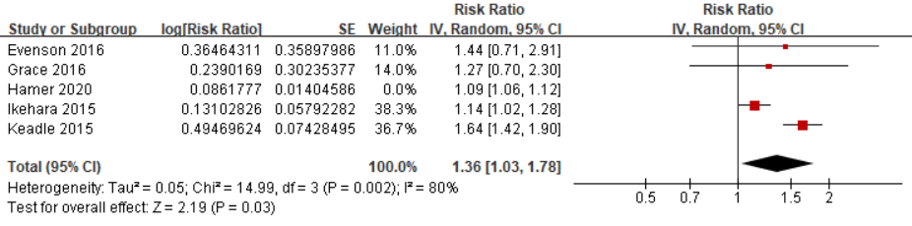
Figure S11. Forest Plot of the Association Between Highest versus Lowest Screen Time And CVD Mortality (after excluding study did not include any physical activity intensity as a covariate in the most adjusted model)
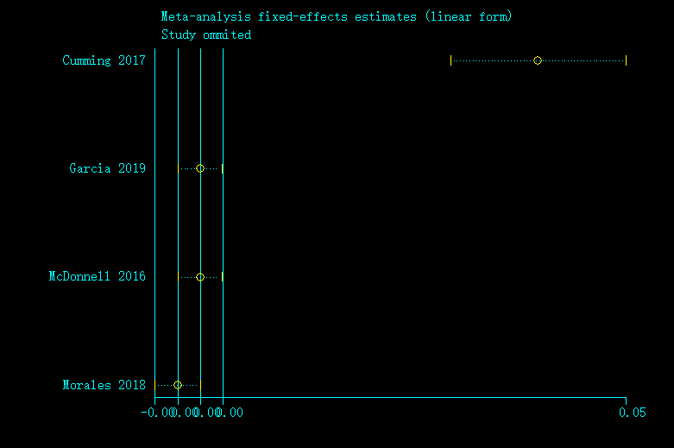
Figure S12. Sensitivity Analysis of the Association Between Highest versus Lowest Screen Time And CVD Morbidity
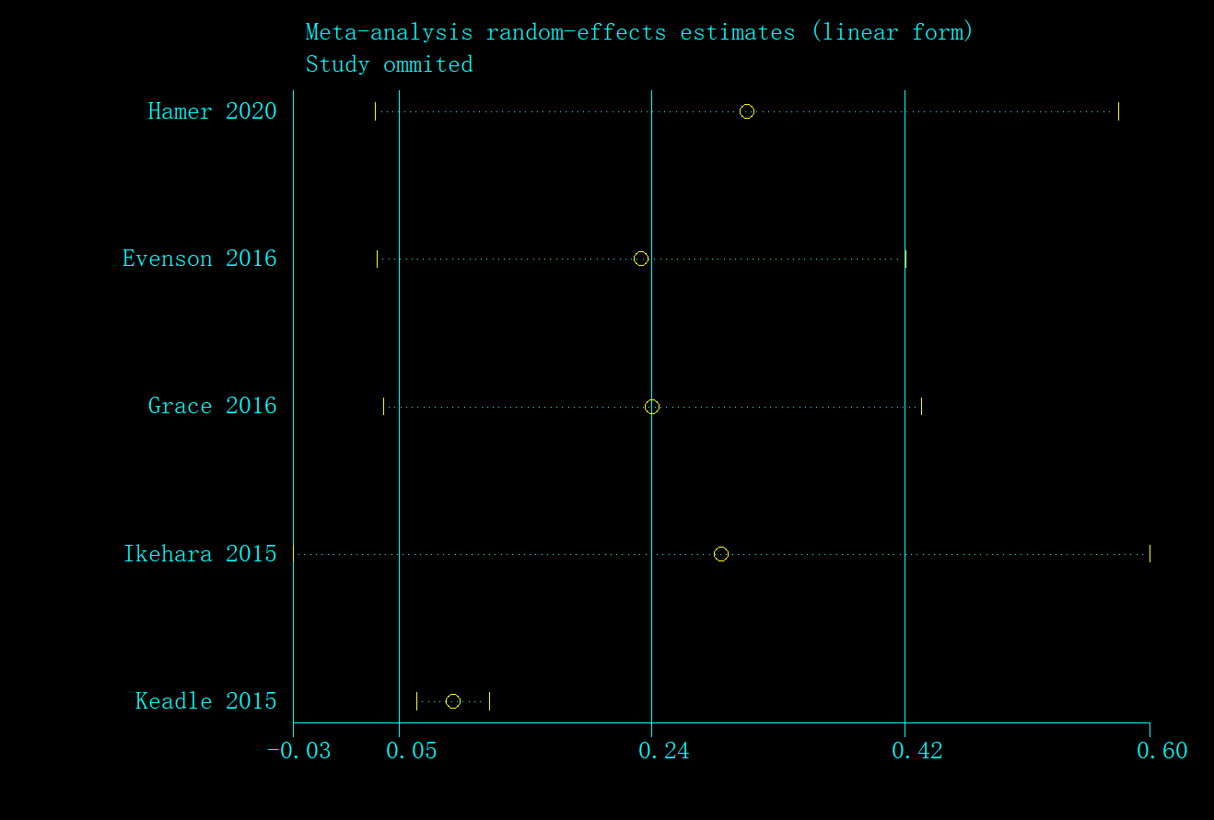
Figure S13. Sensitivity Analysis of the Association Between Highest versus Lowest Screen Time And CVD Mortality

