Appendix

Table A1. Men-employee yearly human capital loss at each stress level ranged between 29 to 116
Reversed GHQ-12 | Job stress-29 | Yearly human capital loss by stress (100 USD)
48.00 | 116 | 139.135
47.59 | 115 | 142.616
47.17 | 114 | 144.330
46.76 | 113 | 145.794
46.34 | 112 | 146.894
45.93 | 111 | 147.897
45.52 | 110 | 149.753
45.10 | 109 | 152.212
44.69 | 108 | 154.783
44.28 | 107 | 158.623
43.86 | 106 | 162.443
43.45 | 105 | 166.918
43.03 | 104 | 170.293
42.62 | 103 | 172.394
42.21 | 102 | 174.081
41.79 | 101 | 174.680
41.38 | 100 | 175.933
40.97 | 99 | 177.059
40.55 | 98 | 177.939
40.14 | 97 | 178.282
39.72 | 96 | 177.917
39.31 | 95 | 178.425
38.90 | 94 | 180.120
38.48 | 93 | 179.736
38.07 | 92 | 178.021
37.66 | 91 | 175.489
37.24 | 90 | 171.066
36.83 | 89 | 167.172
36.41 | 88 | 162.309
36.00 | 87 | 158.262
35.59 | 86 | 154.003
35.17 | 85 | 149.066
34.76 | 84 | 145.249
34.34 | 83 | 140.830
33.93 | 82 | 137.398
33.52 | 81 | 134.087
33.10 | 80 | 130.968
32.69 | 79 | 128.194
32.28 | 78 | 125.353
31.86 | 77 | 123.264
31.45 | 76 | 121.305
31.03 | 75 | 119.934
30.62 | 74 | 118.768
30.21 | 73 | 117.303
29.79 | 72 | 116.928
29.38 | 71 | 115.652
28.97 | 70 | 114.588
28.55 | 69 | 113.765
28.14 | 68 | 113.122
27.72 | 67 | 112.531
27.31 | 66 | 111.586
26.90 | 65 | 110.989
26.48 | 64 | 110.156
26.07 | 63 | 109.192
25.66 | 62 | 108.147
25.24 | 61 | 106.738
24.83 | 60 | 105.577
24.41 | 59 | 104.362
24.00 | 58 | 103.301
23.59 | 57 | 102.107
23.17 | 56 | 100.623
22.76 | 55 | 99.423
22.34 | 54 | 97.641
21.93 | 53 | 96.252
21.52 | 52 | 94.953
21.10 | 51 | 93.641
20.69 | 50 | 92.296
20.28 | 49 | 90.527
19.86 | 48 | 88.541
19.45 | 47 | 86.149
19.03 | 46 | 84.392
18.62 | 45 | 83.255
18.21 | 44 | 81.518
17.79 | 43 | 80.270
17.38 | 42 | 78.664
16.97 | 41 | 76.985
16.55 | 40 | 74.872
16.14 | 39 | 71.994
15.72 | 38 | 68.604
15.31 | 37 | 63.609
14.90 | 36 | 59.612
14.48 | 35 | 53.917
14.07 | 34 | 46.408
13.66 | 33 | 38.121
13.24 | 32 | 22.344
12.83 | 31 | 15.674
12.41 | 30 | 5.782
12.00 | 29 | 0.000

Note: Data sources: Original global survey. The results are derived from Eq. (1).

Table A2. Macro-approach Men-employee lifetime human capital loss at each stress level

Note: The lifetime human capital loss is calculated by Eq. (4). Data sources: original internet survey

Table A3. Micro-approach Men-employee lifetime human capital loss at each stress level (Eq.3)

Note: The lifetime human capital loss is calculated by Eq. (3).
Data sources: original internet survey
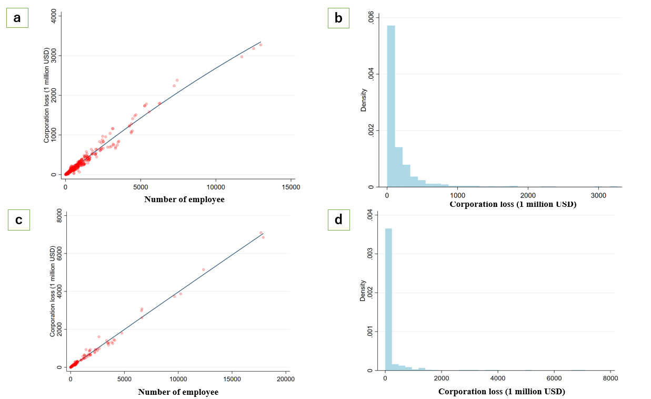
Figure A1. Robustness check of the human capital loss.
Note: The figure (a) and (b), the lifetime human capital loss by stress are derived from micro-approach Eq. (3) with a third-party company. The figure (c) and (d), the macro-approach lifetime human capital and a fourth-party company data is used.
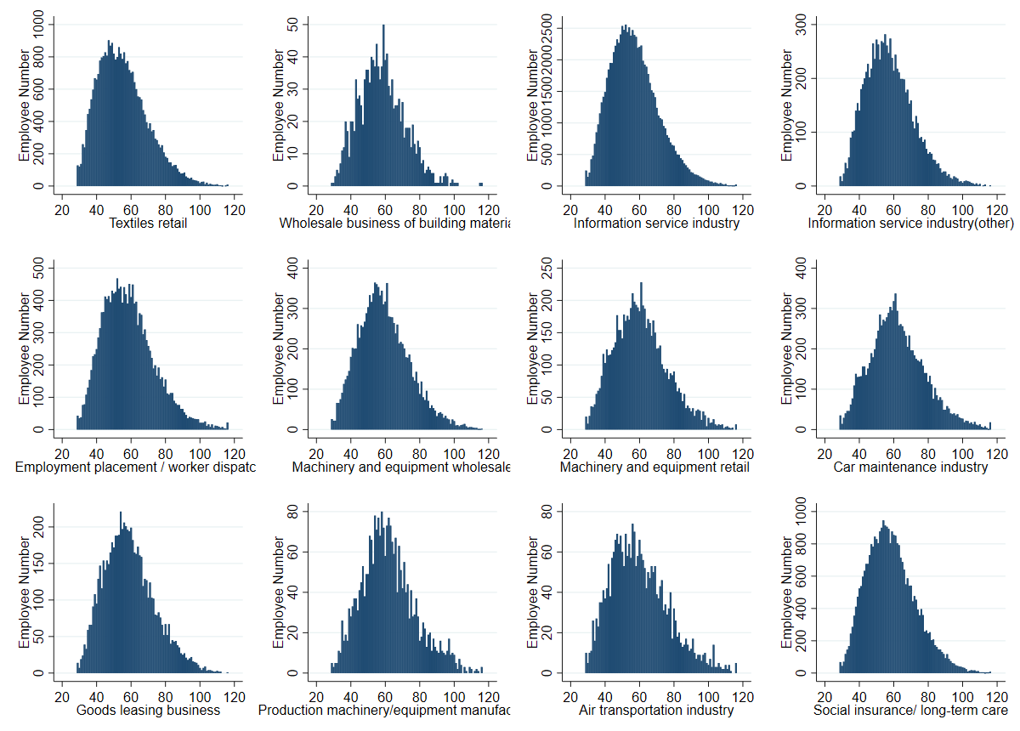
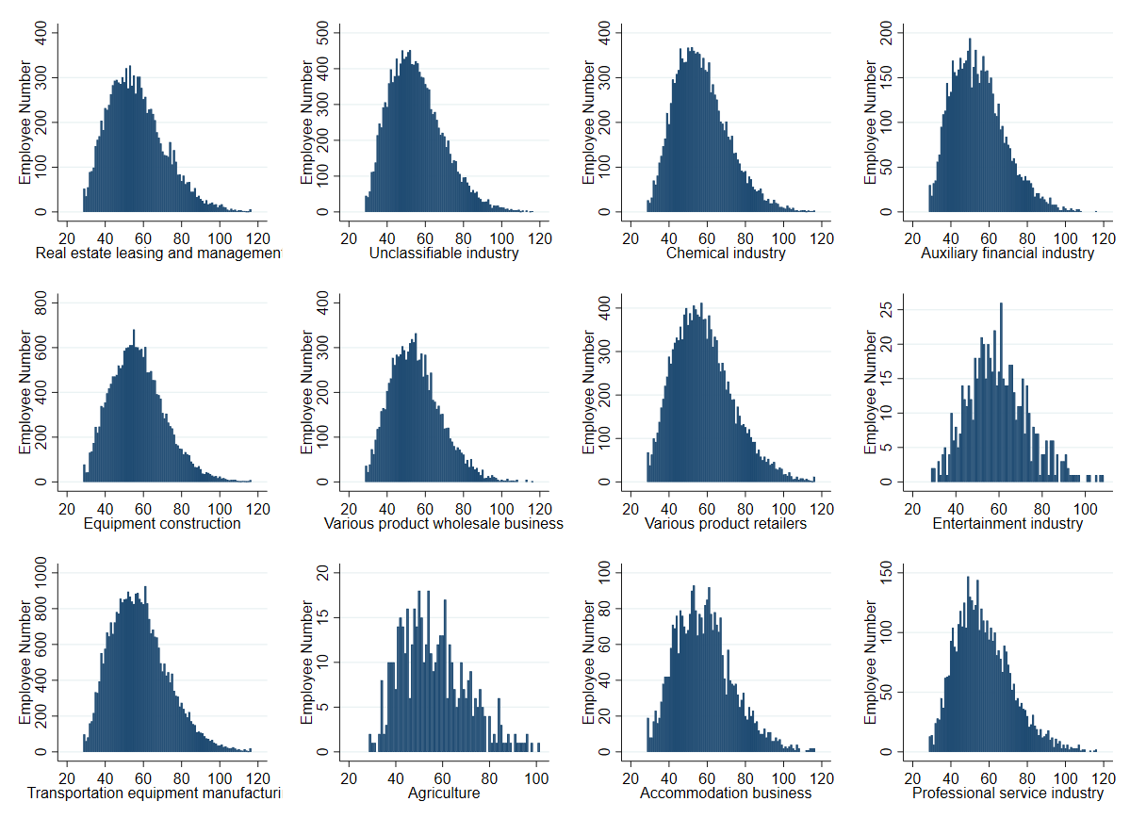
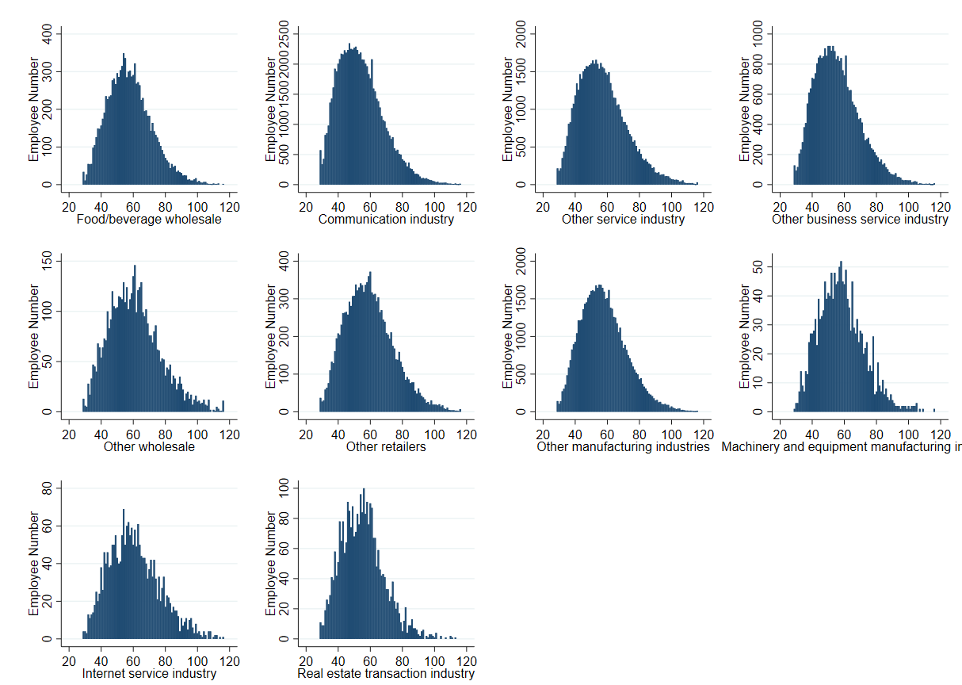
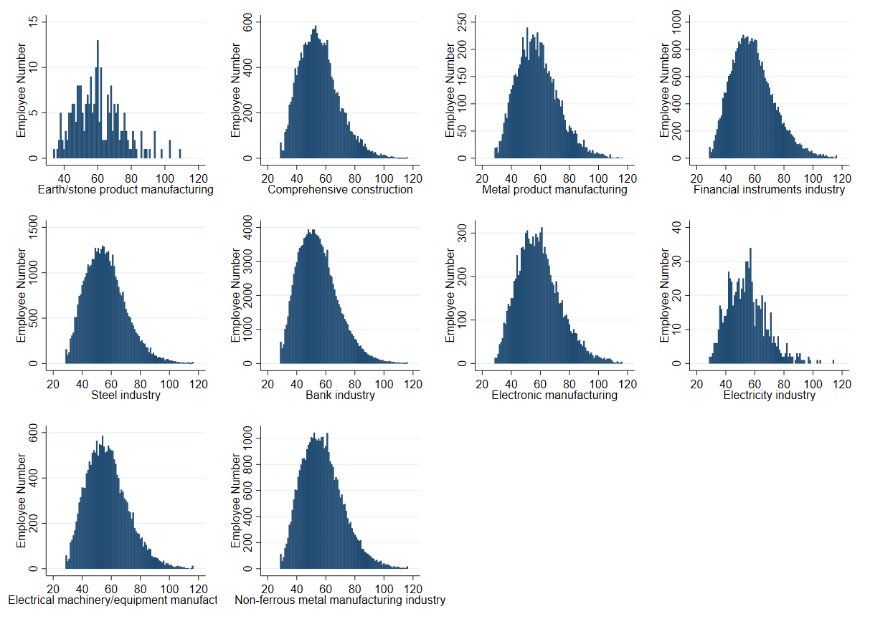
Figure A2. The distribution of employee stress by detailed industry

Table A4. The questionnaire of employee stress conducted by companies.

year Freq. Percent Cum.

2017 371 32.26 32.26
2018 389 33.83 66.09
2019 390 33.91 100.00

Total 1,150 100.00

Table A5 Estimation results of wife's income share 2015.
 | Wife's income share
 | Coeff. |  | (S.E.)
Husband's education attainment
(ref. Junior school or lower)
Senior high school | -0.070 | *** | 0.020
Vocational school | -0.074 | *** | 0.022
College | -0.055 | * | 0.030
University | -0.083 | *** | 0.022
Graduate | -0.120 | *** | 0.032
Wife's education attainment
(ref. Junior school or lower)
Senior high school | 0.049 |  | 0.031
Vocational school | 0.082 | ** | 0.032
College | 0.075 | ** | 0.033
University | 0.073 | ** | 0.033
Graduate | 0.096 | * | 0.053
Husband work status (ref. irregular worker)
Regular | -0.140 | *** | 0.033
Other | -0.102 | *** | 0.034
Wife work status (ref. irregular worker)
Regular worker | 0.235 | *** | 0.011
Other worker | 0.080 | *** | 0.013
Mental health score | 0.001 |  | 0.001
Constant | 0.290 | *** | 0.061
Observations | 748
R-squared | 0.448
Note: *** p<0.01, ** p<0.05, * p<0.1.
Data sources: JPSC 2015. Data from the Japanese Panel Survey of Consumers (JPSC), which was conducted by the Institute for Research on Household Economics. The data was collected annually from 1993 until 2017 and includes detailed demographic, income management, income, savings, and expenditures information. The advantage of the data from JPSC is that the detailed household information is collected annually over multiple years with a low rate of dropout households. The first cohort (Cohort A) was recruited nationally in 1993 by randomly selecting young women aged 24 to 34; and new cohorts have been added in 1997 for young women aged 24 to 27 (Cohort B); in 2003, young women aged 24 to 27 were added as Cohort C; in 2008, women aged 24 to 28 were added as Cohort D; finally, in 2013, Cohort E added young women aged 24 to 28. The sample used in this study includes married women and men from 5 cohorts in 2015, and the observations with missing values are deleted.

