Additional file 2 – Coding schemes
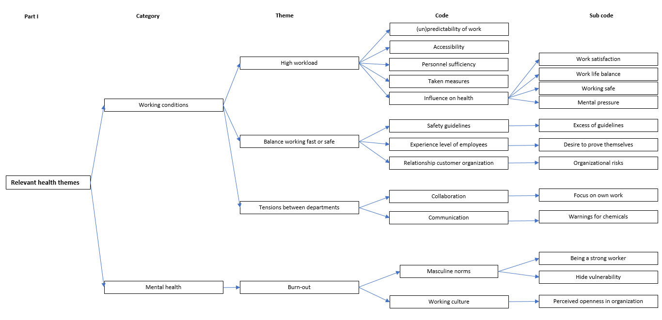
Figure 1. Coding scheme 1. Part I: health themes

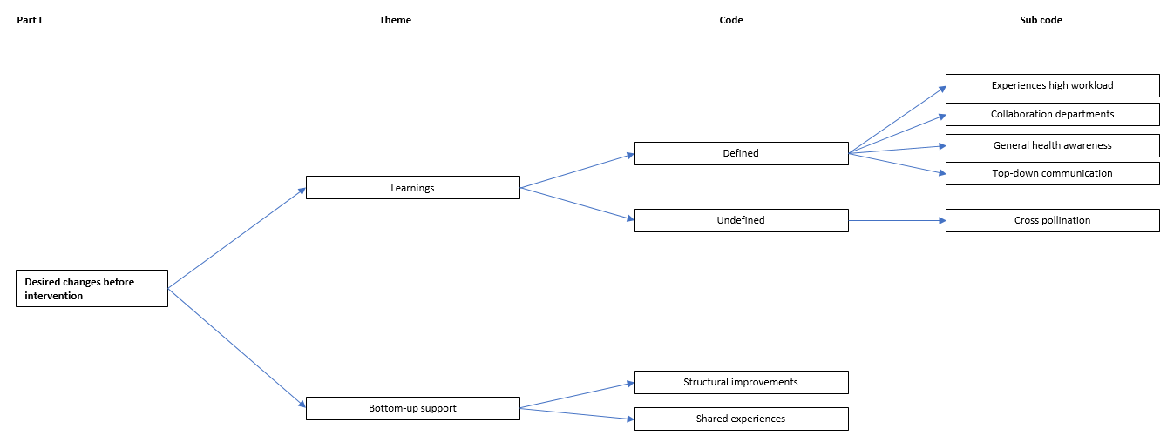
Figure 2. Coding scheme 2. Part I: desired changes before intervention

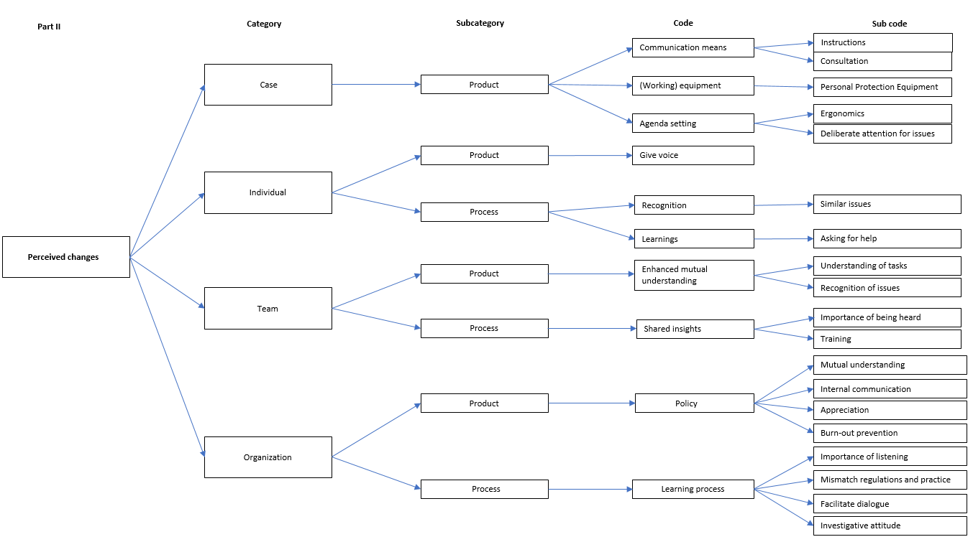
Figure 3. Coding scheme 3. Part II: perceived changes after and during the intervention
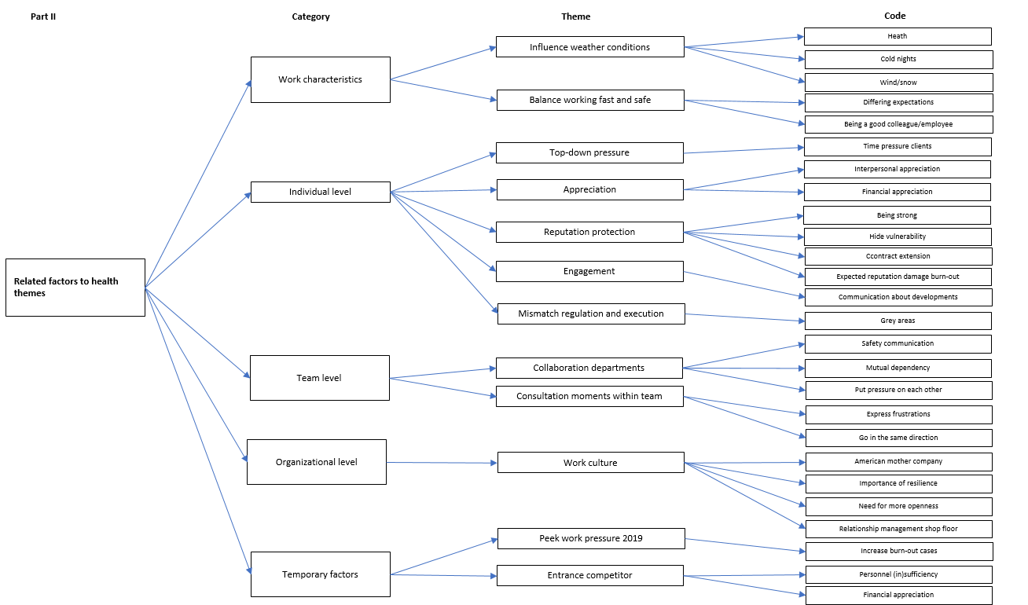
Figure 3. Coding scheme 4. Part II: Factors related to health themes

