Additional File 2.
Means of support ratings for nudging types for people with high versus low belief that food services (FS) should promote healthy food choices

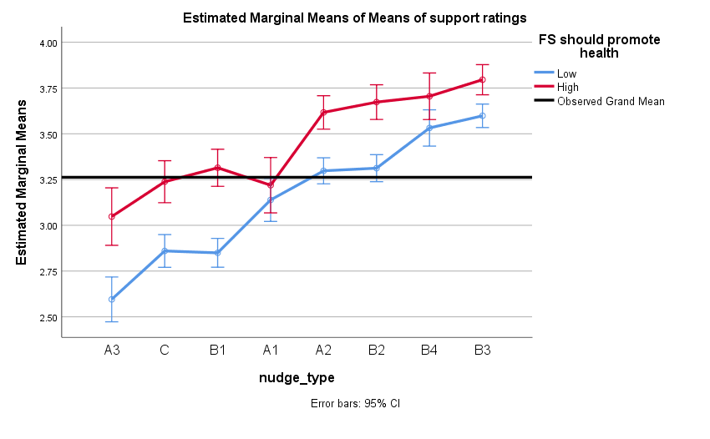
Support ratings of nudging types of A2, B1, B2, B3, C and A3 were significantly higher for people with strong belief that FS should promote healthy food choice than those with weak belief, except for A1 (translating information) and B4 (changing consequences of options).

Means of support ratings for nudging types for people with high versus low perceived important of fruit and vegetable (FV)

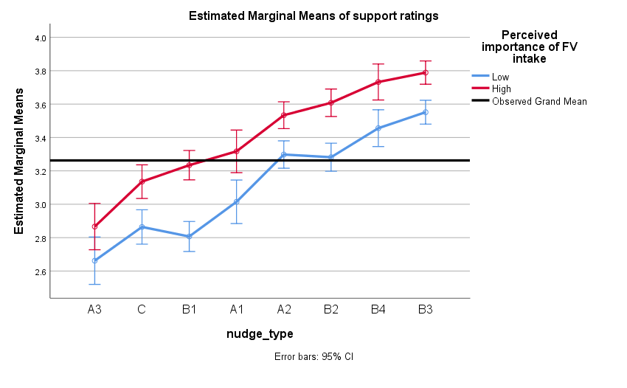
Support ratings for all the types of nudges were significantly higher among those with high versus low perceived importance of FV intake.

Means of support ratings for nudging types for people with strong versus weak belief that nudging is implemented out of concern for users’ well-being.
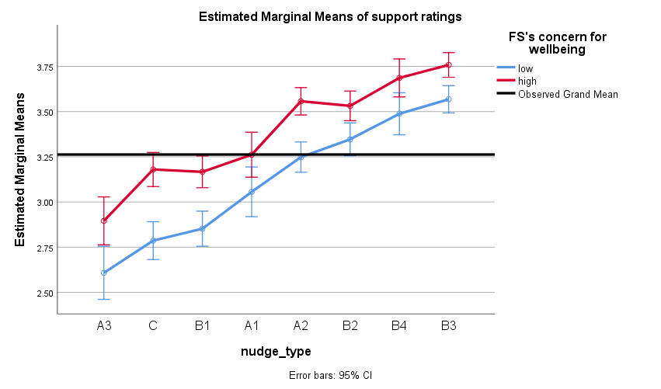
All the types of nudges were significantly higher among those with high belief in nudging implemented to increase users’ well-being versus those with low belief, except for translating information (A1) and changing option-related consequences.

Means of support ratings for nudging types for male versus female

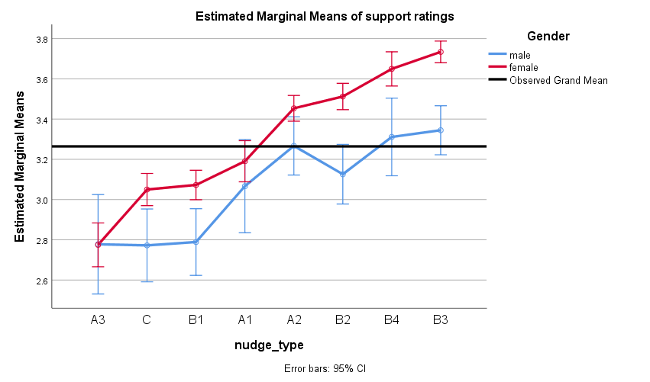

All nudging types received significantly greater support by female participants than males except for A3, A1 and A2 types.

