Appendix 1 – Supplementary Material

Table A1: Categories for unemployment status
Employed | Unemployed | Exclude
Self-employed | Unemployed | Looking after family or home^{Ϯ}
In paid employment | Retired | Doing something else^{Ϯ}
Unpaid worker in family business | Long term sick or disabled | Full time studentᵟ
Working in apprenticeship |  | On government training scheme^{Ϯ}ᵟ
On maternity leave
^{Ϯ} unclear whether involves employment
ᵟ education

Table A2: Binary coding for heterogeneity and subgroup probit regression
Variable | Coded 0 | Coded 1
Age | n/a included as a continuous variable in years
Gender | Male | Female
Ethnicity | White | Non-white
Education | Higher degree | Other (lower) qualification
Marital status | Never married or not currently married | Married or in civil partnership
Household composition | One adult in the household | More than one adult in the household
Number of own children in household | No children | At least one child
Region | North, Midlands and devolved administrations (North East, North West, Yorkshire and Humber, East Midlands, West Midlands, Wales, Scotland, N. Ireland) | South (East of England, London, South East, South West)
How often feels lonely | Hardly ever or some of the time | Often
Current Economic activity | Employed | Unemployed
Health status (for reverse causal analysis) | Fair or poor | Excellent, very good or good

Table A3: Random effect probit regression models
Regressors | Matched sample  Coefficient[95%CI] |  | Propensity score weighted  Coefficient[95%CI]
Regressors | Simple model | Full model | Simple model | Full model
Constant | -7.812***  [-7.890,-7.735] | -6.948***  [-7.256,-6.640] | -6.378***  [-6.601,-6.156] | -7.435***  [-8.342,-6.528]
Loneliness | 0.837***  [0.616,1.058] | 1.158***  [0.997,1.319] | 0.907***  [0.355,1.458] | 1.070***  [0.557,1.583]
Gender |  | 0.199***  [0.081,0.317] |  | 0.039  [-0.367,0.444]
Age |  | 0.074***  [0.069,0.080] |  | 0.057***  [0.040,0.073]
Ethnicity |  | 0.921***  [0.766,1.075] |  | 1.113***  [0.615,1.611]
Education |  | 1.105***  [0.979,1.230] |  | 1.501***  [1.051,1.952]
Marital status |  | -0.771***  [-0.917,-0.624] |  | -0.693**  [-1.219,-0.167]
Household composition |  | -0.318***  [-0.483,-0.153] |  | -0.545*  [-0.994,-0.095]
Number own children in household |  | -1.309***  [-1.453,-1.165] |  | -1.027***  [-1.517,-0.536]
Region |  | -0.404***  [-0.526,-0.283] |  | -0.377  [-0.787,0.033]
*p<0.05, **p<0.01, ***p<0.001. See TableA2 for variable definitions.
Models contain 38,400 observations in 22,725 groups.

Figure A1: Heterogeneous Treatment Effect on Cross-Sectional Models
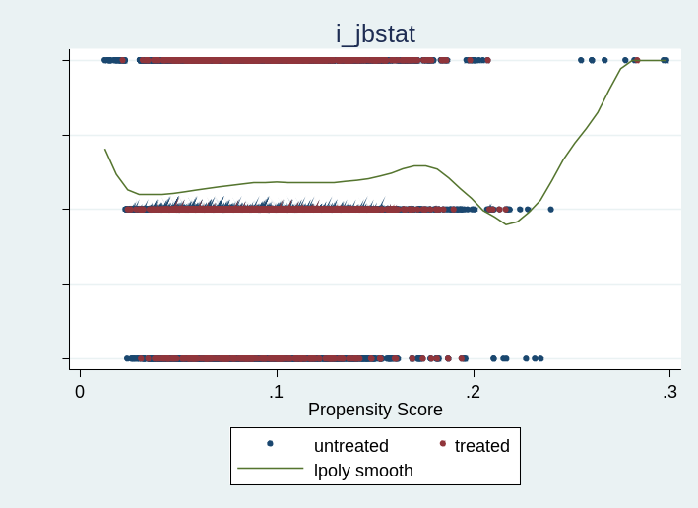
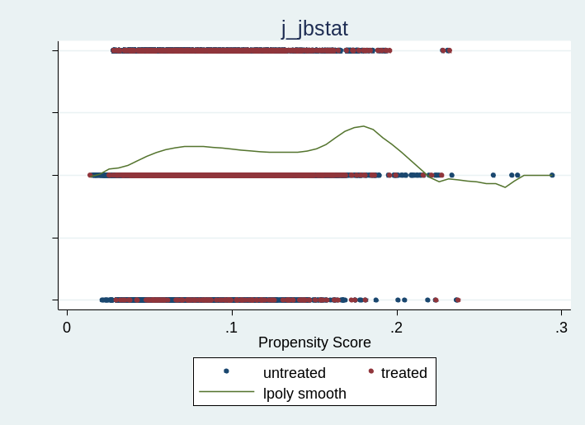
Wave 9
Wave 10
*where lpoly smooth illustrates the pattern of treatment effect heterogeneity

Appendix 2 – Covariate balance

Table A4: Number of observations
Model | Number of obs. |  | Treated obs. |  | Control obs.
Model | Raw | Matched | Raw | Matched | Raw | Matched
Model 1 | 19,566 | 39,132 | 1,626 | 19,566 | 17,940 | 19,566
Model 2 | 18,833 | 37,666 | 1,526 | 18,833 | 17,307 | 18,833
Model 3 | 15,675 | 31,350 | 1,854 | 15,675 | 13,821 | 15,675

Table A5: Covariate balance before and after matching
 | Model 1 |  |  |  | Model 2 |  |  |  | Model 3
Covariate | Standardised differences |  | Variance ratio |  | Standardised differences |  | Variance ratio |  | Standardised differences |  | Variance ratio
Covariate | Raw | Matched | Raw | Matched | Raw | Matched | Raw | Matched | Raw | Matched | Raw | Matched
Gender | 0.127 | -0.001 | 0.968 | 1.000 | 0.141 | 0.017 | 0.962 | 0.997 | 0.123 | -0.033 | 0.971 | 1.003
Age | -0.245 | -0.026 | 1.133 | 0.993 | -0.289 | 0.014 | 1.110 | 1.017 | -0.283 | -0.028 | 1.146 | 1.006
Ethnicity | 0.003 | 0.024 | 0.823 | 0.904 | 0.015 | -0.015 | 0.845 | 0.604 | 0.028 | 0.017 | 0.803 | 0.809
Education | 0.096 | -0.008 | 1.076 | 0.894 | 0.065 | -0.000 | 1.054 | 0.950 | 0.088 | -0.011 | 1.089 | 0.909
Marital status | 0.055 | 0.007 | 1.681 | 1.347 | 0.053 | 0.003 | 1.782 | 1.420 | 0.049 | -0.014 | 1.698 | 1.308
Household composition | -0.020 | -0.025 | 1.295 | 1.170 | -0.059 | -0.023 | 1.307 | 1.223 | -0.007 | 0.020 | 1.306 | 1.206
Number own children at home | -0.176 | 0.050 | 0.803 | 1.243 | -0.149 | 0.000 | 0.905 | 1.179 | -0.125 | 0.025 | 0.919 | 1.218
Region | -0.065 | 0.000 | 0.956 | 0.933 | -0.024 | -0.031 | 0.989 | 0.973 | -0.074 | -0.024 | 0.976 | 1.000

Figure A2: Balance in Raw and Matched Samples
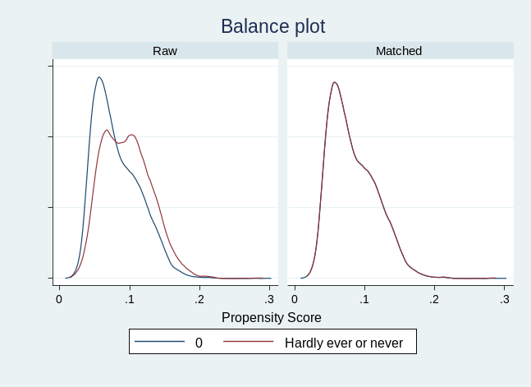
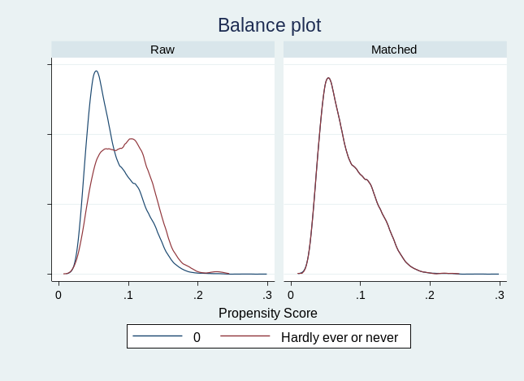
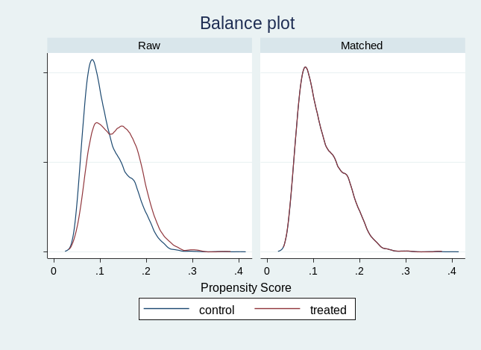

Model 1
Model 2
Model 3

