Relationship between meteorological factors, air pollutants and hand, foot and mouth disease from 2014 to 2020
List of content
Tables
Table.S1:Description of environmental factors in Chengdu from 2014 to 2016
Table.S2:Description of environmental factors in Chengdu from 2017 to 2020
Table.S3:Description of environmental factors in Chengdu in 2020
Table.S4:The overall estimated RR of different meteorological and air pollution factors in different years
Table.S5:The overall estimated RR of different meteorological and air pollutants factors in different age
Figures
Fig.S1 3-D plot of RR along meteorological variables and lags in pre-vaccination period.
Fig.S2 3-D plot of RR along air pollutants and lags in pre-vaccination period.
Fig.S3 3-D plot of RR along meteorological variables and lags in post-vaccination period.
Fig.S4 3-D plot of RR along air pollutants and lags in post-vaccination period.
Fig.S5 3-D plot of RR along meteorological variables and lags in COVID-19 period.
Fig.S6 3-D plot of RR along air pollutants and lags in COVID-19 period.
Fig.S7 Extreme environmental variables with HFMD incidence in in pre-vaccination period.
Fig.S8 Extreme environmental variables with HFMD incidence in post-vaccination period
Fig.S9 Extreme environmental variables with HFMD incidence in COVID-19 period Fig.S10 Extreme meteorological and pollutants variables with HFMD incidence from 2014-2020.
Fig.S11 Low levels of meteorological and pollutants variables with HFMD incidence in different age.
Fig.S12 High levels of meteorological and pollutants variables with HFMD incidence in different age.
Fig. S13 Extreme meteorological and pollutants variables with HFMD incidence in different gender.

Variables | Mean±SD | Min | P₂₅ | Median | P₇₅ | Max
temperature (°C) | 18.13±7.16 | 1.39 | 11.65 | 19.25 | 24.22 | 32.33
Wind speed (m/s) | 3.74±1.58 | 0.98 | 3.00 | 3.00 | 4.16 | 15.02
Relative humidity (%) | 73.99±11.52 | 28.11 | 66.50 | 74.28 | 82.51 | 99.87
Precipitation (mm) | 2.57±8.84 | 0 | 0 | 0 | 1.02 | 121.92
PM_{2.5}(ug/m³) | 72.65±45.77 | 11.76 | 42.81 | 54.18 | 92.30 | 371.21
PM₁₀(ug/m³) | 113.0±71.42 | 12.96 | 61.06 | 93.39 | 145.92 | 555.45
O₃(ug/m³) | 72.25±39.86 | 1.86 | 44.50 | 74.25 | 113.70 | 178.48
NO₂(ug/m³) | 59.58±19.53 | 14.49 | 45.53 | 56.94 | 71.07 | 126.49
SO₂(ug/m³) | 16.91±10.65 | 1.83 | 9.29 | 14.57 | 21.27 | 76.42
C0(mg/m³) | 1.08±0.43 | 0.21 | 0.80 | 0.99 | 1.29 | 2.90
Table.S1:Description of environmental factors in Chengdu from 2014 to 2016
SD: standard deviation; Px: percentile of the data.

Table.S2:Description of environmental factors in Chengdu from 2017 to 2020.
Variables | Mean±SD | Min | P₂₅ | Median | P₇₅ | Max
temperature (°C) | 18.14±7.37 | 1.94 | 11.06 | 18.50 | 24.56 | 31.50
Wind speed (m/s) | 3.83±1.66 | 0.98 | 3.0 | 3.0 | 4.56 | 15.02
Relative humidity (%) | 76.57±11.10 | 29.85 | 69.94 | 77.44 | 85.07 | 99.71
Precipitation (mm) | 3.13±10.37 | 0 | 0 | 0 | 1.27 | 188.47
PM_{2.5}(ug/m³) | 50.83±33.04 | 3.60 | 26.69 | 42.60 | 57.44 | 272.70
PM₁₀(ug/m³) | 75.78±50.23 | 8.64 | 41.04 | 63.08 | 99.45 | 434.58
O₃(ug/m³) | 71.70±38.70 | 2.15 | 40.77 | 65.58 | 107.93 | 175.25
NO₂(ug/m³) | 45.28±19.49 | 2.07 | 31.63 | 43.38 | 56.63 | 114.08
SO₂(ug/m³) | 6.28±3.63 | 0 | 3.76 | 5.57 | 7.72 | 26.33
C0(mg/m³) | 0.74±0.38 | 0 | 0.51 | 0.70 | 0.88 | 2.65
SD: standard deviation; Px: percentile of the data.

Table.S3:Description of environmental factors in Chengdu in 2020
SD: standard deviation; Px: percentile of the data.

Variables | Mean±SD | Min | P₂₅ | Median | P₇₅ | Max
temperature (°C) | 18.35±7.39 | 4.67 | 11.61 | 18.33 | 25.11 | 31.44
Wind speed (m/s) | 3.86±1.68 | 1.07 | 3.00 | 3.35 | 5.01 | 11.98
Relative humidity (%) | 74.56±14.16 | 29.85 | 66.02 | 75.51 | 85.67 | 99.71
Precipitation (mm) | 3.57±15.37 | 0 | 0 | 0 | 1.02 | 188.47
PM_{2.5}(ug/m³) | 41.70±26.55 | 3.60 | 23.99 | 36.31 | 50.12 | 196.92
PM₁₀(ug/m³) | 61.06±36.20 | 8.64 | 36.72 | 50.76 | 81.27 | 251.98
O₃(ug/m³) | 72.01±40.62 | 2.25 | 40.49 | 67.06 | 108.37 | 165.64
NO₂(ug/m³) | 33.98±17.06 | 2.07 | 20.38 | 30.86 | 42.36 | 93.15
SO₂(ug/m³) | 4.38±2.32 | 0 | 3.64 | 3.84 | 5.65 | 13.74
C0(mg/m³) | 0.61±0.21 | 0 | 0.50 | 0.60 | 0.72 | 1.61

Table.S4:The overall estimated RR of different meteorological and air pollution factors in different years
period | Value | 2014-2016 | 2017-2019 | 2020 | 2014-2020
Variables | Value | RR (95%CI) | RR (95%CI) | RR (95%CI) | RR (95%CI)
Low- temperature | 6.6 | 5.19 (3.33-8.10) | 0.79 (0.40-1.55) | 5.67(3.23-9.96) | 0.94(0.61-1.46)
High- temperature | 28.6 | 1.90 (1.42-2.56) | 0.45(0.27-0.74) | 1.86(0.89-3.87) | 0.78(0.58-1.07)
Low- Wind speed | 2.0 | 0.63(0.51-0.77) | 0.51 (0.35-0.72) | 0.60(0.46-0.79) | 0.64(0.52-0.79)
High- Wind speed | 7.0 | 1.27(0.80-2.01) | 0.19(0.10-0.37) | 0.99(0.47-2.02) | 0.77(0.49-1.19)
Low- Relative humidity | 55.7 | 0.59 (0.48-0.73) | 0.04(0.02-0.07) | 0.88(0.41-1.09) | 0.34(0.26-0.43)
High- Relative humidity | 92.3 | 1.13(0.95-1.34) | 1.52(1.23-1.87) | 0.83(0.67-1.02) | 1.63(1.39-1.91)
Low- Precipitation | 0 | 1.15(1.04-1.27) | 1.05(0.96-1.15) | 1.07(0.93-1.24) | 0.99(0.94-1.06)
High- Precipitation | 13.8 | 0.64(0.46-0.88) | 0.86(0.63-1.18) | 0.82(0.51-1.31) | 1.05(0.84-1.29)
Low- PM_{2.5} | 19.2 | 1.06(0.86-1.30) | 0.55(0.42-0.72) | 0.51(0.40-0.64) | 0.98(0.85-1.14)
High- PM_{2.5} | 148.5 | 2.00(1.51-2.64) | 0.59(0.22-1.54) | a | 1.24(0.90-1.71)
Low- PM₁₀ | 26.3 | 1.32(1.13-1.55) | 1.11(0.79-1.54) | 0.55(0.41-0.725) | 1.50(1.30-1.73)
High- PM₁₀ | 211.6 | 2.61(2.09-3.26) | 0.30(0.14-0.62) | b | 2.12(1.59-2.84)
Low- O₃ | 13.6 | 0.95(0.77-1.19) | 0.63(0.43-0.93) | 0.66(0.53-0.81) | 1.32(1.04-1.69)
High- O₃ | 136.9 | 1.54(1.23-1.94) | 1.07(0.73-1.57) | 1.47(0.87-2.49) | 1.86(1.45-2.39)
Low- NO₂ | 19.9 | 3.42(2.18-5.36) | 0.38(0.30-0.49) | 1.11(0.84-1.47) | 0.48(0.41-0.58)
High- NO₂ | 90.2 | 1.63(1.20-2.21) | 0.28(0.16-0.49) | 0.09(0.01-0.53) | 0.99(0.72-1.38)
Low- SO₂ | 1.9 | 0.88(0.76-1.02) | 0.46(0.37-0.57) | 1.38(0.92-2.07) | 1.33(1.23-1.44)
High- SO₂ | 29 | 1.06(0.86-1.30) | 5.48(0.02-1500.11) | 1.13(0.63-2.05) | 1.89(1.49-2.38)
Low- C0 | 0.3 | 0.46(0.34-0.62) | 3.98(3.35-4.73) | 0.54(0.41-0.71) | 1.42(1.09-1.13)
High- C0 | 1.9 | 1.19(0.87-1.64) | 0.45(0.20-1.01) | c | 2.36(2.08-2.69)
a:173.06(5.62-5325.68); b:31911.04(0.44-2292847000); c: 0.08(0.0002-43.1698)

Table.S5 The overall estimated RR of different meteorological and air pollutants factors in different age
Variables | Value | 0–1 year old | 2–3 years old | 4–5 years old | 6-14 years old
Low- temperature | 6.6 | 0.40(0.25-0.65) | 0.96(0.62-1.47) | 0.79(0.53-1.17) | 0.83(0.51-1.34)
High- temperature | 28.6 | 1.14(0.82-1.58) | 0.99(0.72-1.35) | 0.91(0.66-1.25) | 0.71(0.50-1.02）
Low- Wind speed | 2 | 0.57(0.46-0.71) | 0.60(0.49-0.73) | 0.70(0.58-0.86) | 0.56(0.45-0.70)
High- Wind speed | 7 | 0.85(0.54-1.36) | 0.67(0.43-1.04) | 0.74(0.49-1.14) | 0.98(0.60-1.61)
Low-Relative humidity | 56.5 | 0.56(0.43-0.74) | 0.47(0.36-0.60) | 0.41(0.32-0.51) | 0.24(0.18-0.31)
High-Relative humidity | 92.3 | 2.12(1.81-2.49) | 1.54(1.31-1.82) | 1.50(1.27-1.76) | 1.48(1.22-1.79)
Low- Precipitation | 0 | 0.98(0.93-1.04) | 0.98(0.93-1.04) | 0.99(0.93-1.06) | 0.93(0.87-1.01)
High- Precipitation | 14 | 1.11(0.95-1.38) | 1.10(0.89-1.36) | 1.05(0.83-1.33) | 1.27(0.98-1.64)
Low- PM_{2.5} | 19.2 | 1.04(0.90-1.21) | 0.95(0.82-1.09) | 1.17(0.99-1.36) | 1.82(1.56-2.13)
High- PM_{2.5} | 150.4 | 1.27(0.90-1.80) | 1.33(0.97-1.82) | 1.07(0.78-1.47) | 0.69(0.48-1.00)
Low- PM₁₀ | 27 | 1.45(1.25-1.68) | 1.36(1.18-1.56) | 1.90(1.63-2.21) | 2.53(2.18-2.93)
High- PM₁₀ | 211.6 | 2.00(1.45-2.75) | 2.15(1.62-2.85) | 1.62(1.21-2.17) | 1.04(0.75-1.45)
Low- O₃ | 13.5 | 1.41(1.08-1.83) | 1.22(0.95-1.56) | 1.33(1.04-1.69) | 1.03(0.76-1.39)
High- O₃ | 135.6 | 2.21(1.71-2.86) | 1.73(1.35-2.22) | 1.79(1.40-2.28) | 1.04(0.79-1.37)
Low- NO₂ | 20.1 | 0.36(0.29-0.43) | 0.51(0.43-0.61) | 1.16(1.01-1.34) | 1.66(1.44-1.91)
High- NO₂ | 90.5 | 0.90(0.63-1.28) | 0.94(0.68-1.30) | 1.07(0.79-1.47) | 0.41(0.28-0.61)
Low- SO₂ | 1.9 | 1.44(1.32-1.56) | 1.33(1.23-1.44) | 1.33(1.23-1.44) | 1.91(1.74-2.10)
High- SO₂ | 29.1 | 1.72(1.33-2.22) | 2.24(1.79-2.81) | 1.48(1.18-1.86) | 0.90(0.68-1.18）
Low- C0 | 0.3 | 3.69(3.26-4.19) | 1.91(1.75-2.08) | 1.30(1.18-1.42) | 1.59(1.37-1.84)
High- C0 | 1.7 | 1.72(1.30-2.27) | 1.49(1.17-1.91) | 1.15(0.90-1.45) | 1.10(0.82-1.48)

Fig.S1 3-D plot of RR along meteorological variables and lags in pre-vaccination period.

Fig.S2 3-D plot of RR along air pollutants and lags in pre-vaccination period.

Fig.S3 3-D plot of RR along meteorological variables and lags in post-vaccination period.

Fig.S4 3-D plot of RR along air pollutants and lags in post-vaccination period.

Fig.S5 3-D plot of RR along meteorological variables and lags in COVID-19 period.

Fig.S6 3-D plot of RR along air pollutants and lags in COVID-19 period.

Fig.S7 Extreme environmental variables with HFMD incidence in pre-vaccination period.

Fig.S8 Extreme environmental variables with HFMD incidence in post-vaccination period.

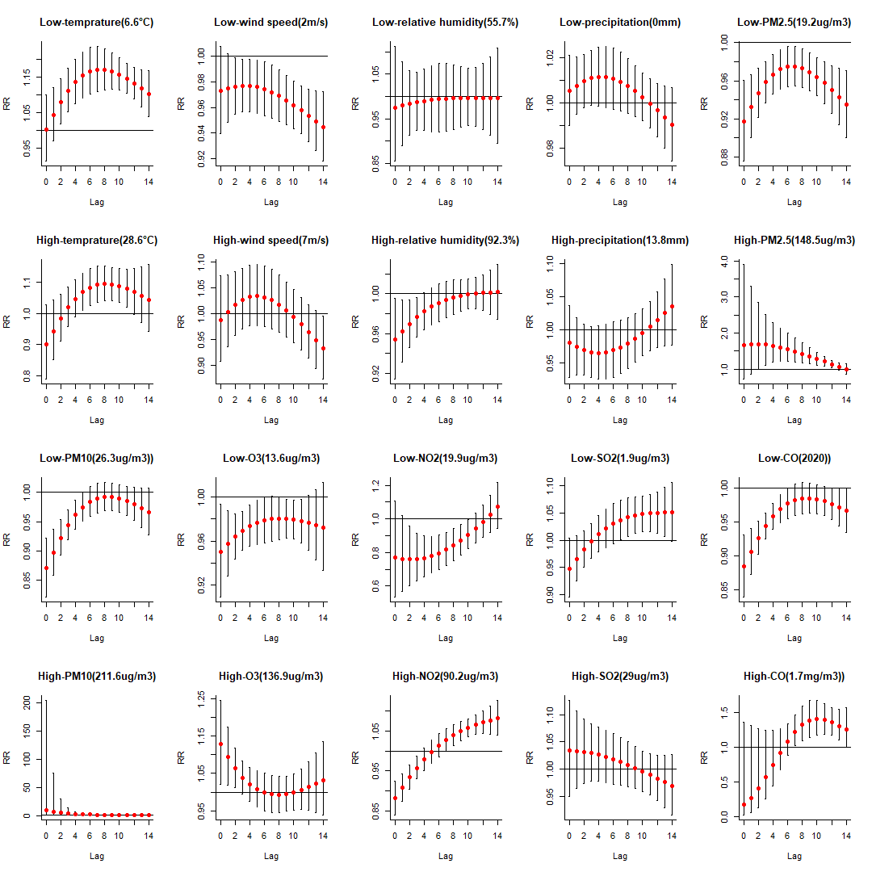
Fig.S9 Extreme environmental variables with HFMD incidence in COVID-19 period.

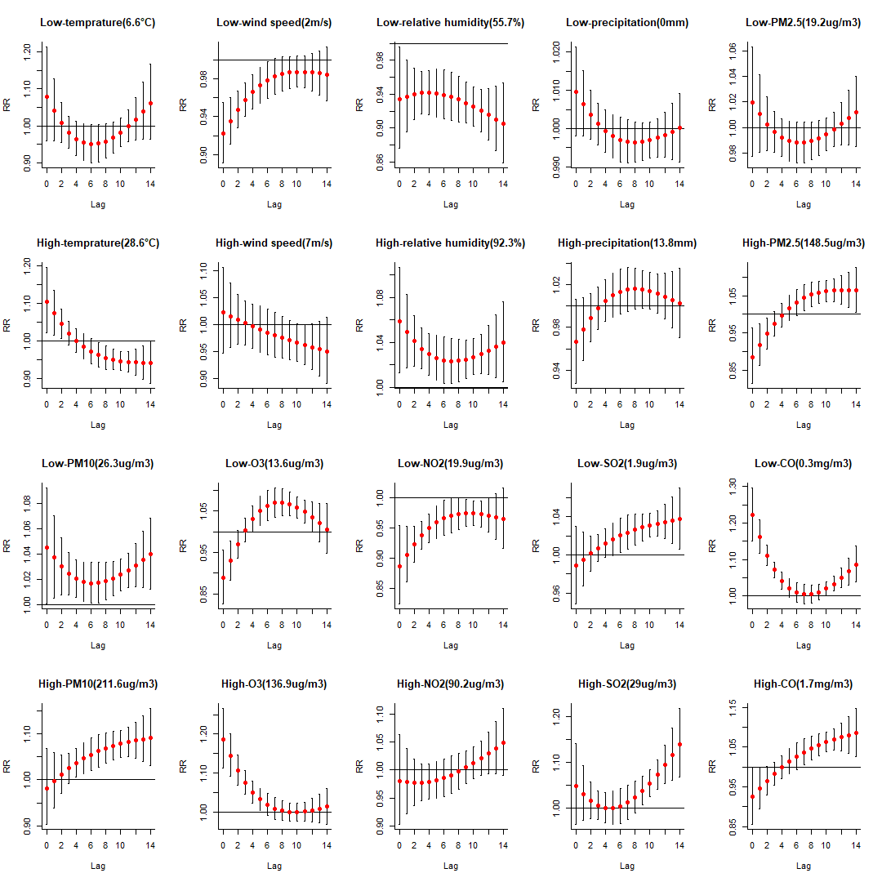
Fig.S10 Extreme meteorological and pollutants variables with HFMD incidence from 2014-2020
Fig.S11 Low levels of meteorological and pollutants variables with HFMD incidence in different age.

Fig.S12 High levels of meteorological and pollutants variables with HFMD incidence in different age.

Fig. S13 Extreme meteorological and pollutants variables with HFMD incidence in different gender.

