Additional file 2
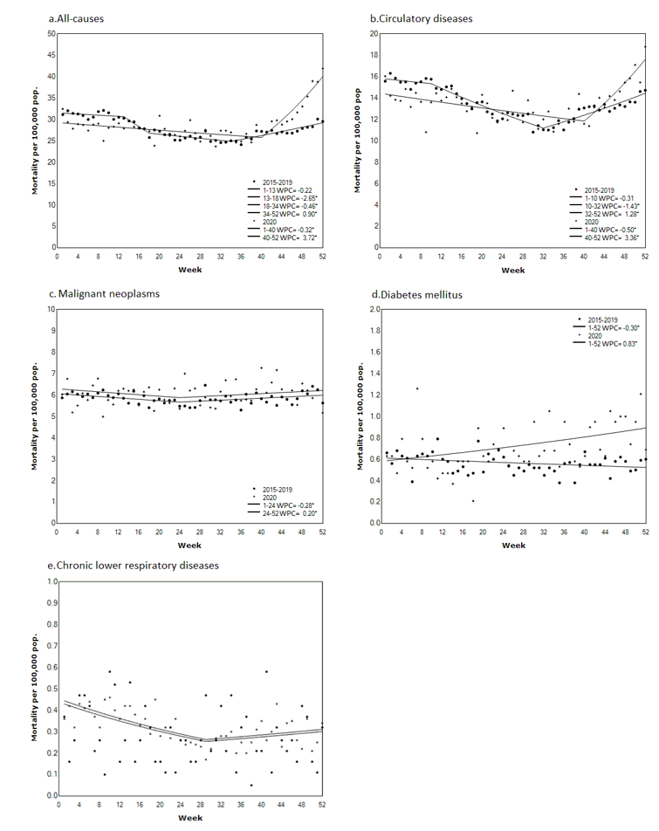
Figure 1 – Additional file 2. Mortality trends in Latvia in 2020 compared to the average from 2015 to 2019: Joinpoint regression analysis
a. All-cause
b. Circulatory diseases
c. Malignant neoplasms
d. Diabetes mellitus
e. Chronic lower respiratory diseases

