Supplementary Appendix to
“Health Care Seeking in Modern Urban LMIC Settings: Evidence from Lusaka, Zambia”

Figure S1: Sample flow diagram

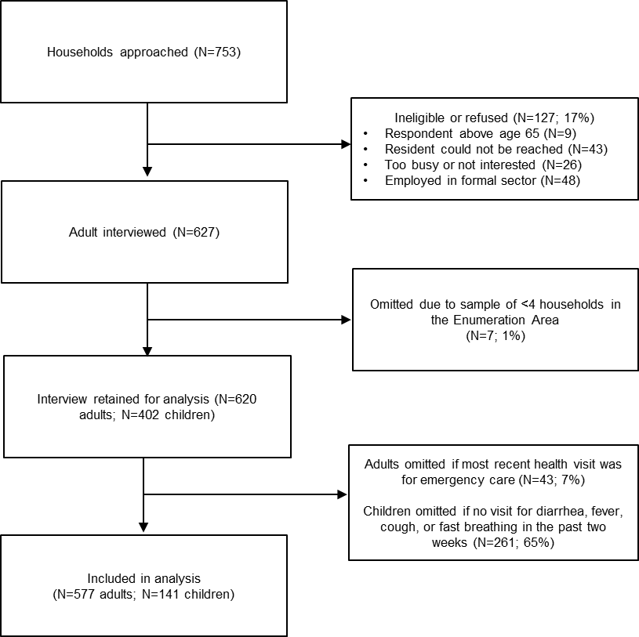

Table S1: Bypassing by study cluster
Cluster | Constituency | Main Public Health Facility  (based on participant response) | Closest Public Health Facilities (spatially) | % Bypassing (primary) | % Bypassing (horizontal) | % Bypassing (2-levels)
1 | Chawama | Chawama Level 1 Hospital | Chawama Level 1 Hospital  Kuku Health Post | 90% | 30% | 10%
2 | Chawama | Chawama Level 1 Hospital | Chawama Level 1 Hospital | 100% | 32% | 0%
3 | Chawama | Chawama Level 1 Hospital | Chawama Level 1 Hospital | 100% | 10% | 5%
4 | Chawama | Chawama Level 1 Hospital | Chawama Level 1 Hospital  Kuku Health Post | 100% | 5% | 0%
5 | Chawama | Chawama Level 1 Hospital  Kuku Health Post | Kuku Health Post | 68% | 21% | 5%
6 | Kabwata | Kamwala Health Centre  Kabwata Health Centre | Kamwala Health Centre  Kamwala South Health Post | 50% | 61% | 22%
7 | Kabwata | UTH  Kabwata Health Centre | Kabwata Health Centre  Kamwala South Health Post | 56% | 25% | 31%
8 | Kabwata | Chilenje Level 1 Hospital | Chilenje Level 1 Hospital | 95% | 47% | 32%
9 | Kanyama | Kanyama Level 1 Hospital | Kanyama Level 1 Hospital | 94% | 31% | 6%
10 | Kanyama | Kanyama Level 1 Hospital  Makeni Ecumenical Centre | Kanyama Level 1 Hospital | 71% | 47% | 6%
11 | Kanyama | Kanyama Level 1 Hospital  Misisi Mini Hospital | Kamwala Health Centre  Kanyama Level 1 Hospital | 82% | 47% | 12%
12 | Kanyama | Kanyama Level 1 Hospital | Makeni Villa Health Post | 60% | 55% | 5%
13 | Kanyama | Kanyama Level 1 Hospital  The Salvation Army Men’s Clinic | Kanyama Level 1 Hospital | 82% | 24% | 0%
14 | Kanyama | Kanyama Level 1 Hospital | Kanyama Level 1 Hospital | 95% | 25% | 5%
15 | Lusaka Central | Bauleni Health Centre | Bauleni Health Centre | 10% | 15% | 5%
18 | Matero | Matero Level 1 Hospital | Matero Level 1 Hospital | 100% | 15% | 0%
19 | Matero | George Health Centre  Kapwewe Health Centre | Lilanda Health Post | 74% | 79% | 5%
20 | Matero | Matero Level 1 Hospital  Matero Health Centre | Matero Health Centre | 60% | 20% | 0%
21 | Matero | Matero Level 1 Hospital  Matero Health Centre | Matero Level 1 Hospital | 89% | 11% | 5%
22 | Matero | Matero Health Centre | Matero Health Centre | 26% | 47% | 11%
23 | Matero | Matero Level 1 Hospital | Matero Level 1 Hospital | 89% | 44% | 22%
24 | Matero | George Health Centre  Paradise Health Post | Paradise Health Post | 28% | 39% | 11%
25 | Munali | Chelstone Health Centre | Chelstone Health Centre | 50% | 56% | 25%
27 | Mandevu | Chipata Level 1 Hospital | Chipata Level 1 Hospital  Mandevu Health Centre | 95% | 10% | 10%
28 | Mandevu | Chipata Level 1 Hospital  Kabanana Health Post | Mandevu Health Centre | 78% | 22% | 11%
29 | Mandevu | Chipata Level 1 Hospital  Chaisa Health Centre | Kabanana Health Post | 70% | 35% | 10%
30 | Mandevu | Chipata Level 1 Hospital  Chaisa Health Centre | Chaisa Health Centre  Garden Shimizu Health Post | 42% | 26% | 5%
31 | Mandevu | Chipata Level 1 Hospital | Chaisa Health Centre | 89% | 28% | 6%
32 | Mandevu | Chipata Level 1 Hospital | Garden Shimizu Health Post | 72% | 28% | 0%
33 | Mandevu | Matero Level 1 Hospital  Mandevu Health Centre | Chipata Level 1 Hospital | 61% | 50% | 6%
34 | Mandevu | Chifundo Clinic  Chaisa Health Centre | Chipata Level 1 Hospital | 20% | 30% | 0%
Notes: Several constituencies have two facilities listed as “closest public facilities (spatially).” This is because different facilities were spatially closest to different respondents within the cluster.
Table S2: Associations between respondent characteristics and bypassing among children

 | (1) |  | (2) | (3)
 | Primary care bypassing | Two-level bypassing |  |  | Horizontal bypassing
Caregiver education (Ref = Primary or less)
Secondary | 1.273** | 0.995 |  |  | 1.127
 | (1.063 - 1.525) | (0.985 - 1.005) |  |  | (0.921 - 1.377)
Higher | 1.016 | 1.107 |  |  | 1.108
 | (0.596 - 1.730) | (0.938 - 1.306) |  |  | (0.811 - 1.513)
Asset quintile | 1.029 | 1.007 |  |  | 0.956
 | (0.954 - 1.111) | (0.997 - 1.017) |  |  | (0.873 - 1.046)
Reason for seeking care
Diarrhea | 1.072 | 1.015 |  |  | 1.077
 | (0.852 - 1.350) | (0.988 - 1.043) |  |  | (0.863 - 1.344)
Fever | 0.905 | 0.993 |  |  | 0.841*
 | (0.728 - 1.125) | (0.982 - 1.005) |  |  | (0.689 - 1.025)
Cough | 0.977 | 1.010 |  |  | 1.155
 | (0.822 - 1.162) | (0.979 - 1.041) |  |  | (0.951 - 1.403)
Fast breathing | 1.081 | 1.062 |  |  | 1.017
 | (0.809 - 1.443) | (0.974 - 1.158) |  |  | (0.790 - 1.310)
Female child | 0.775*** | 1.011 |  |  | 0.957
 | (0.657 - 0.915) | (0.991 - 1.031) |  |  | (0.752 - 1.217)
Constant | 1.713*** | 0.962 |  |  | 1.606***
 | (1.267 - 2.317) | (0.898 - 1.031) |  |  | (1.157 - 2.228)
Observations | 141 | 141 |  |  | 141
R-squared | 0.162 | 0.179 |  |  | 0.067
Notes: Table shows exponentiated coefficients and 95% confidence intervals from logistic regression models. Standard errors are clustered at the enumeration area level. “Ref” indicates the omitted reference group for categorical variables. *** p<0.01, ** p<0.05, * p<0.1

