Appendix

Figure A1 (A) – (D) shows the LISA conditional cluster maps for heroin incident rates based on five socio-demographic characteristics of areas. Tables A1 –A4 show the conditional probabilities of hot zones for the combinations of the characteristics.

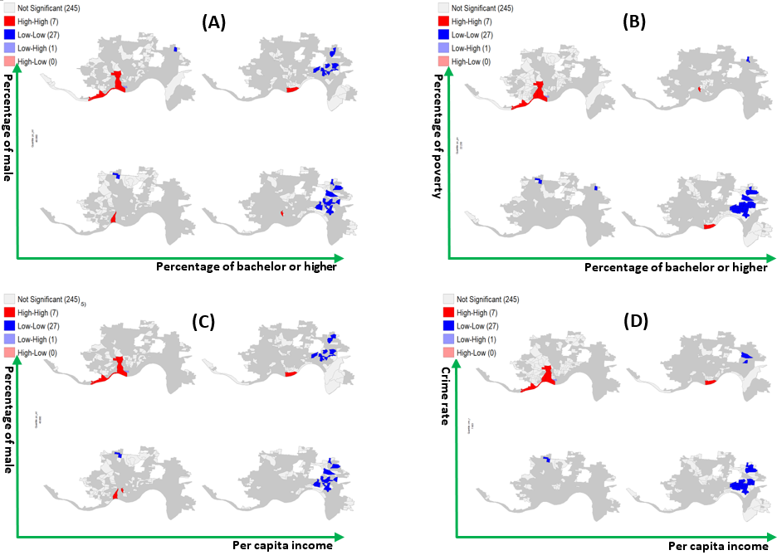
Figure A1. LISA conditional cluster maps for combinations of two variables.

Table A1.Conditional probabilities of hot zones for education and the percentage of male (Figure A1(A))
 | Low education level | High education level | Education total
Low percentage of male | 0.14 | 0.15 | 0.29
High percentage of male | 0.57 | 0.14 | 0.71
Male total | 0.71 | 0.29 | 1

Table A2. Conditional probabilities of hot zones for education and poverty level (Figure A1(B))
 | Low education level | High education level | Education total
Low poverty level | 0.0 | 0.14 | 0.14
High poverty level | 0.71 | 0.15 | 0.86
Poverty total | 0.71 | 0.29 | 1

Table A3. Conditional probabilities of hot zones for income and the percentage of male (Figure A1(C))
 | Low income | High income | Income total
Low percentage of male | 0.29 | 0.0 | 0.29
High percentage of male | 0.57 | 0.14 | 0.71
Male total | 0.86 | 0.14 | 1

Table A4. Conditional probabilities of hot zones for income and crime rate (Figure A1(D))
 | Low income | High income | Income total
Low crime rate | 0.0 | 0.0 | 0
High crime | 0.86 | 0.14 | 1
Crime total | 0.86 | 0.14 | 1

