Additional file 2. Distribution of RDS-associated neonatal mortality crude rates in São Paulo State, Brazil (2004-2015).

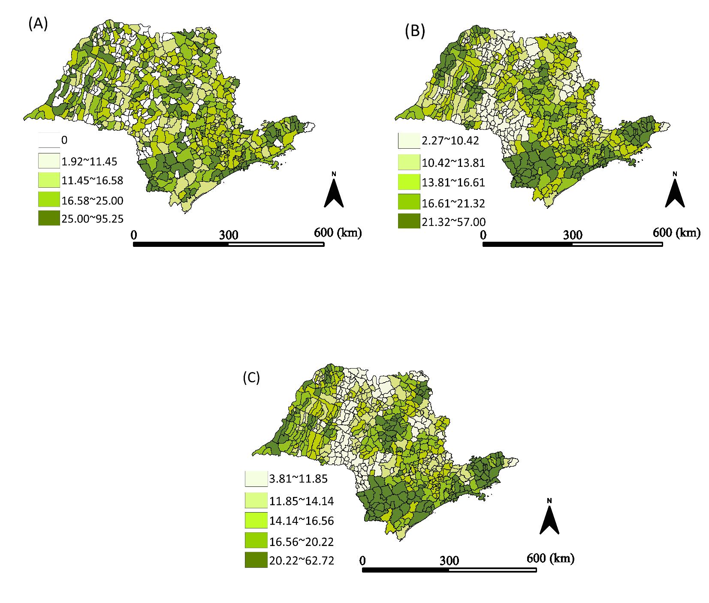
RDS-associated neonatal mortality rates distributed using quintiles. (A) Crude rates; (B) Spatial moving average; (C) Rates after smoothing.

