Supplemental Materials
Table S1. Pit Stop public restroom interventions grouped by neighborhood in San Francisco, California between January 1, 2014 and January 1, 2020.
Pit Stop Location | Restroom Type | Intervention | Intervention  Start Date
Bayview Hunters Point
3rd St. & Palou Ave. (Mendell Plaza) | Portable | Installation of New Restroom | 7/1/2016
Castro/Upper Market
Market St. & Castro St. | JC Decaux | Provision of Attendants | 4/6/2016
Market St. & Castro St. | JC Decaux | Expansion of Service Hours | 8/16/2019
Market St. & Church St. | JC Decaux | Provision of Attendants | 6/12/2015
Market St. & Church St.* | JC Decaux | Provision of Attendants | 7/1/2018
Financial District/South Beach
Embarcadero & Market St. (Embarcadero Plaza) | JC Decaux | Provision of Attendants | 7/1/2018
Golden Gate Park
Ocean Beach | Portable | Installation of New Restroom | 6/10/2019
Stanyan St. & Waller St. | JC Decaux | Provision of Attendants | 12/5/2015
Haight Ashbury
Haight St. & Buena Vista Ave. (Buena Vista Park) | Portable | Installation of New Restroom | 6/15/2016
Mission
16th St. & Capp St. | Portable | Installation of New Restroom | 6/30/2015
16th & Mission St. | JC Decaux | Provision of Attendants | 6/30/2015
24th & Mission St. | JC Decaux | Provision of Attendants | 10/1/2018
McCoppin St. & Valencia St. | Portable | Installation of New Restroom | 6/15/2016
Mission & Sycamore St. | Portable | Installation of New Restroom | 2/1/2016
North Beach
Washington Square Park | JC Decaux | Provision of Attendants | 7/1/2018
South of Market (SoMa)
6th St. & Jessie St. | Portable | Installation of New Restroom | 4/22/2015
6th St. & Jessie St. | Portable | Expansion of Service Hours | 8/16/2019
9th St. & Natoma St. | Portable | Installation of New Restroom | 7/1/2016
Victoria Manalo Draves Park | RPD | Provision of Attendants | 1/1/2017
Sunset/Parkside
Judah St. & La Playa St. | RPD | Provision of Attendants | 7/1/2018
Tenderloin
101 Hyde St. | Portable | Installation of New Restroom | 7/15/2014
133 Golden Gate Ave. | Portable | Installation of New Restroom | 7/15/2014
30 Grove St. (SF Public Library) | Portable | Installation of New Restroom | 9/12/2016
388 Ellis St. | Portable | Installation of New Restroom | 7/15/2014
Eddy St. & Jones St. | JC Decaux | Provision of Attendants | 8/1/2017
Eddy St. & Jones St. | JC Decaux | Expansion of Service Hours | 8/16/2019
Eddy St. & Larkin St. | Portable | Installation of New Restroom | 11/14/2018
Grove & Larkin St. (Civic Center Plaza) | JC Decaux | Provision of Attendants | 7/1/2015
5th St. & Market St. (Hallidie Plaza) | JC Decaux | Provision of Attendants | 9/8/2016
Myrtle & Larkin St. | JC Decaux | Provision of Attendants | 3/5/2018
Market St. & 7th St. (U.N. Plaza) | JC Decaux | Provision of Attendants | 7/1/2015

Note: *Pit Stop intervention was implemented temporarily in 2015 and later reintroduced in 2018. RPD = Recreation and Park Department.
Figure S1. Temporal trends of exposed feces reports per week within a 500-meter walking distance buffer of Pit Stop interventions implemented in San Francisco, California between January 1, 2014 and January 1, 2020 separated by year and season. Dashed vertical lines indicate the start date of Pit Stop interventions included in the analysis. Mean represents average number of feces reports per week across all Pit Stop locations by year (SD=standard deviation; N=total number of weekly reports across all locations by year).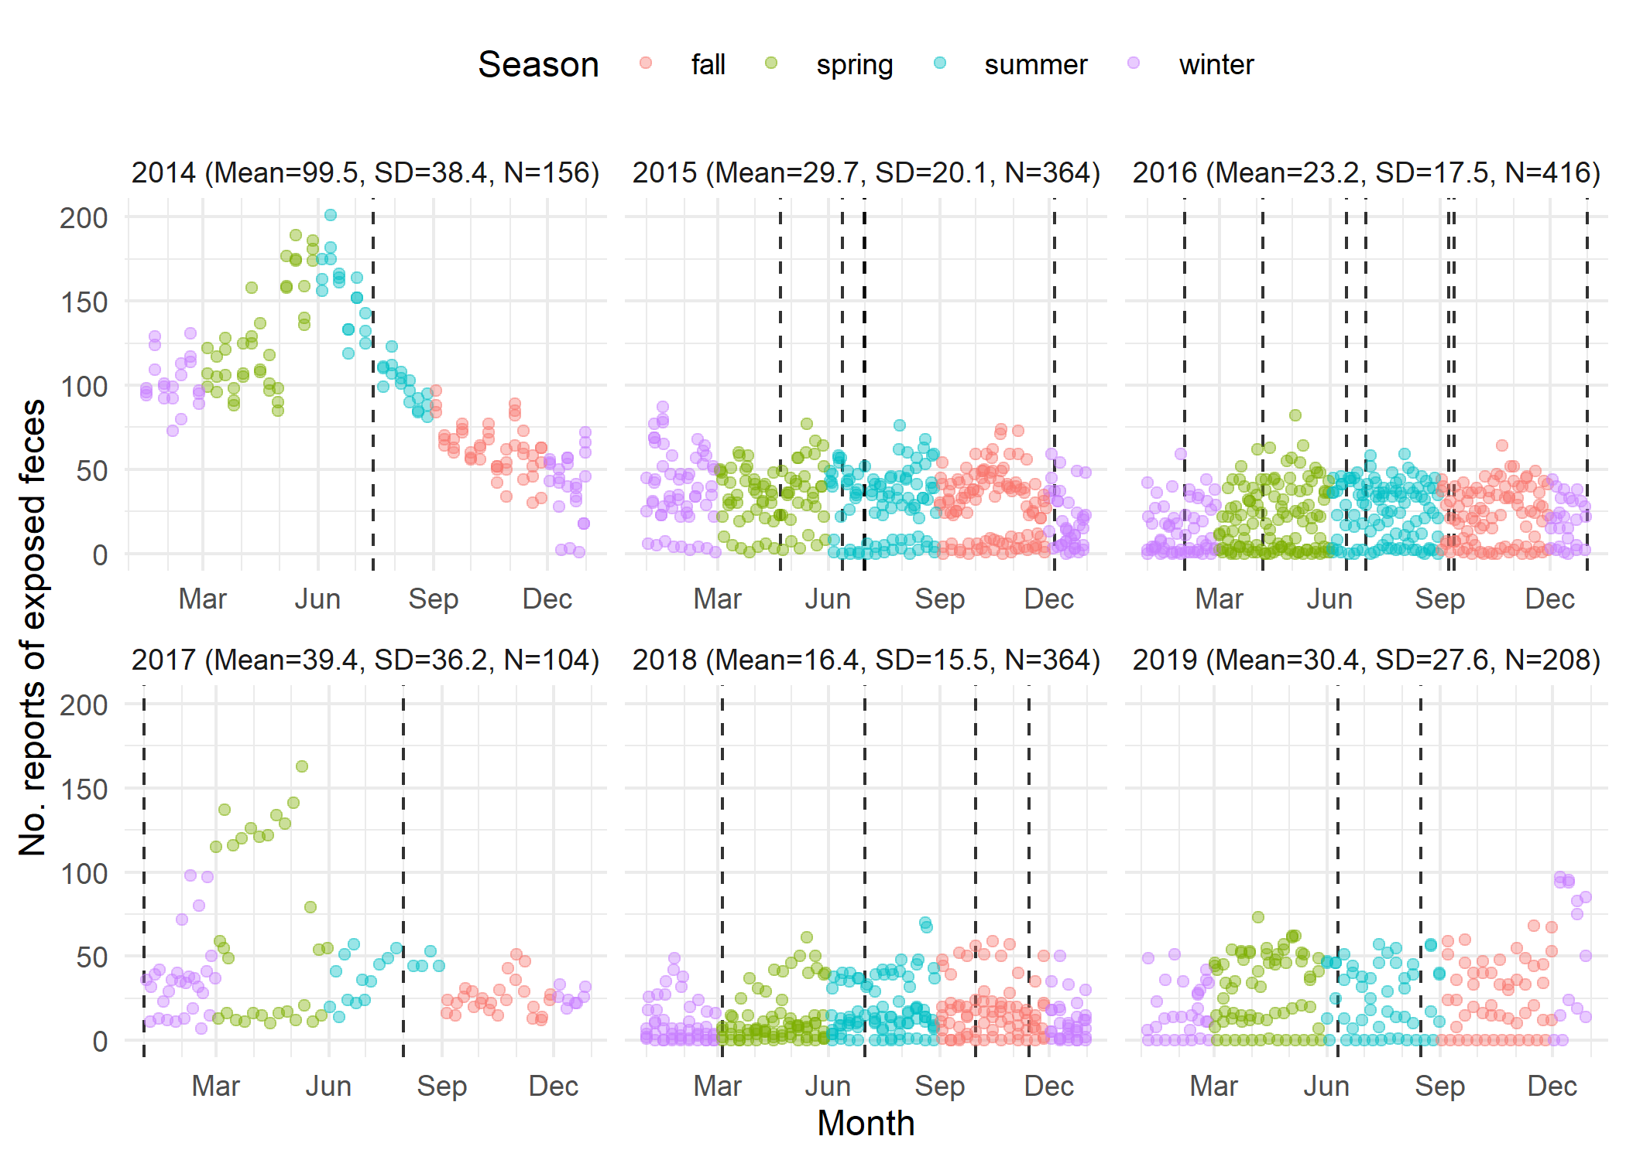
Figure S2. Exposed feces reports per week in all of San Francisco, California between 2014 and 2020. Vertical lines indicate Pit Stop intervention start dates (blue=new restroom installation; green=provision of attendants; red=expansion of service hours).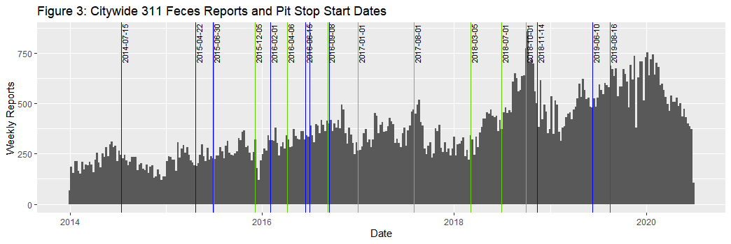
Appendix A.
Supplemental References
No Place To Go: An audit of the public toilet crisis in Skid Row. Published June 2017. Accessed March 30, 2022. https://lafla.org/wp-content/uploads/2017/08/No-Place-To-Go-final.pdf
The Sphere Handbook: Humanitarian Charter and Minimum Standards in Humanitarian Response. Fourth edition, Sphere Association, 2018. Accessed March 30, 2022. https://cms.emergency.unhcr.org/documents/11982/32968/Sphere+Handbook+%282018%29/da022ac9-0f23-4ac0-b1a9-b4239cc65456#_ga=2.150147318.1379321749.1649024965-639639887.1649024965
It’s no laughing matter - SF forming Poop Patrol to keep sidewalks clean. SFChronicle.com. Published August 14, 2018. Accessed December 4, 2020. https://www.sfchronicle.com/bayarea/heatherknight/article/It-s-no-laughing-matter-SF-forming-Poop-13153517.php
Doo-Doo, the New Urban Crisis - RealtyHop. Accessed December 4, 2020. https://www.realtyhop.com/blog/doo-doo-the-new-urban-crisis/
Snapcrap - How I built an app to solve San Francisco’s poop problem. Snapcrap - How I built an app to solve San Francisco’s poop problem. Accessed December 4, 2020. https://www.plivo.com/blog/snapcrap-how-built-app-solve-san-francisco-poop-problem/

