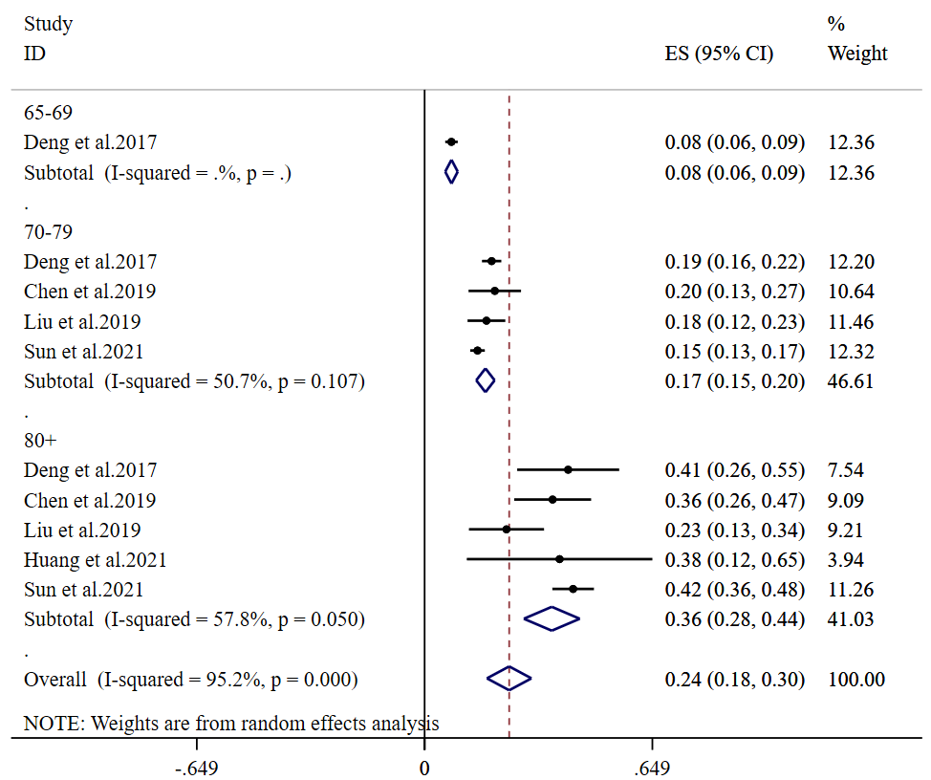
Additional file 3: Figure S2.

