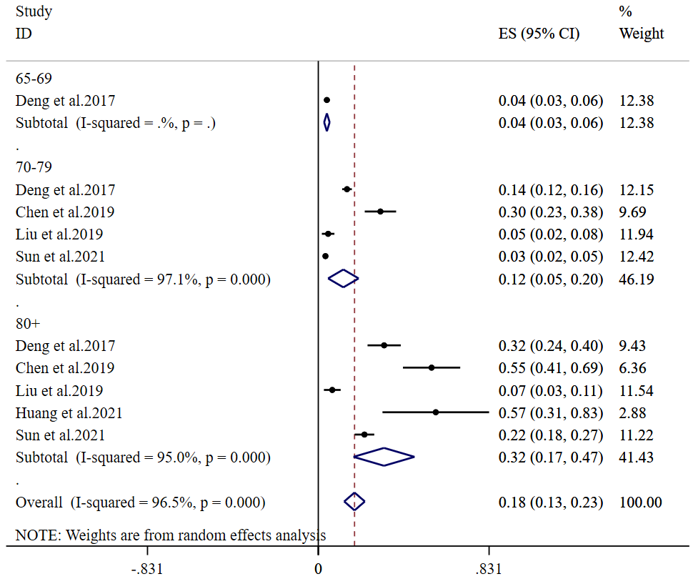
Additional file 4: Figure S3.

