Supplementary figure 1.
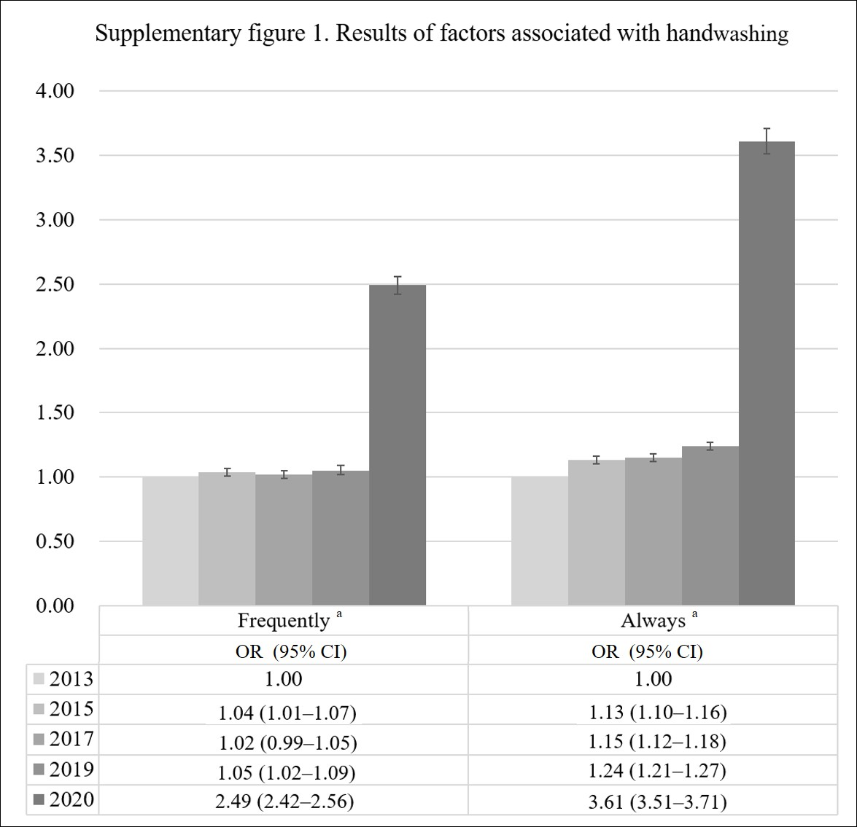
ª P for trend <0.0001; odds ratio (OR); 95% confidence intervals (95% CI)
Supplementary figure 1 showed the change in always handwashing by year 2013 as a reference.
Adjusted for other covariates

Supplementary figure 2.
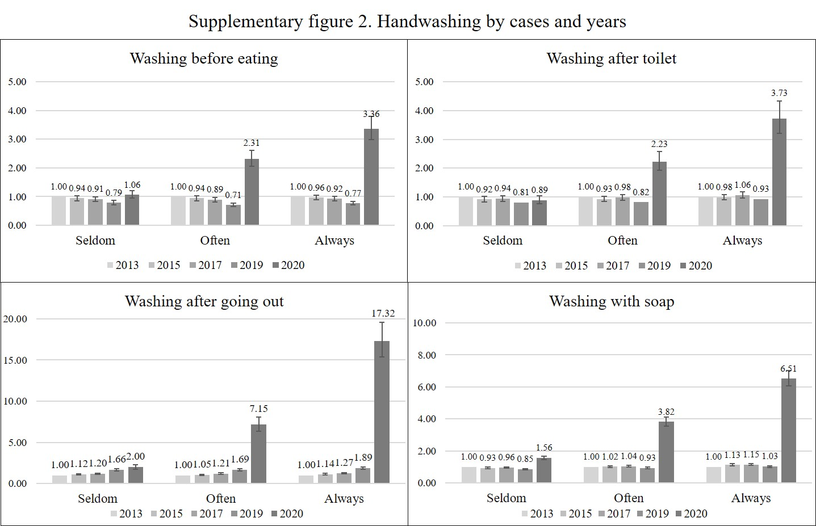
Supplementary figure 2 showed handwashing situations as odds ratios (numbers on the bars) and 95% confidence intervals (lines across the bars) by year and frequency.
Adjusted for other covariates

