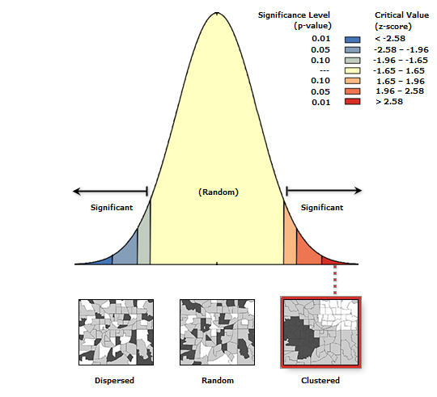

Additional file 1: Moran’s I Spatial Autocorrelation of UBA in Chad

