Online supplementary file 1.

Technical details on design-based estimators.

Ignoring the sampling weights, the Bayesian smoothing model takes the form:
$$y_{i }| p_{i}=Binomial(m_{i}, p_{i})$$
$$θ_{i}=Log \left(\frac{p_{i}}{{1-p}_{i}} \right)= d_{i}β + ε_{i} + s_{i}$$
$$ε_{i} \sim N(0, σ_{ε}^{2})$$
$$s_{i}| s_{j}, j ∊ ne\left(i\right)\sim N(\overline{s}, \frac{σ_{s}^{2}}{n_{i}}),$$
where $m_{i}$is the number of observations in municipality $i$, $n_{i}$ is the number of neighbors for area $i$, $\overline{s}$ = $\frac{1}{n_{i}}$ $\sum_{j∊ne(i)}{s_{j}}$. $d_{i}$= (1, $d_{i1}, d_{i2}… d_{ip})$ is the vector of the intercept and $p$ covariates corresponding to municipality $i$, and β = ($β_{0}, β_{1}, β_{2}… β_{p}$) is the coefficient vector.

The unstructured component $ε_{i}$ is modelled as independent and identically distributed normal variables with zero mean and variance $σ_{ε}^{2}$. Hyperpriors are put on $β$, $σ_{ε}^{2}$, and $σ_{s}^{2}.$

Table S1. Proportion of missing data on smoking by education, age and gender.
 | N complete | N missing | N(%) missing
Low education | 3745 | 1146 | 23%
High education | 3932 | 747 | 16%
Age <65 | 5895 | 1475 | 20%
Age 65+ | 1934 | 449 | 19%
Male | 3744 | 930 | 20%
Female | 4085 | 994 | 20%

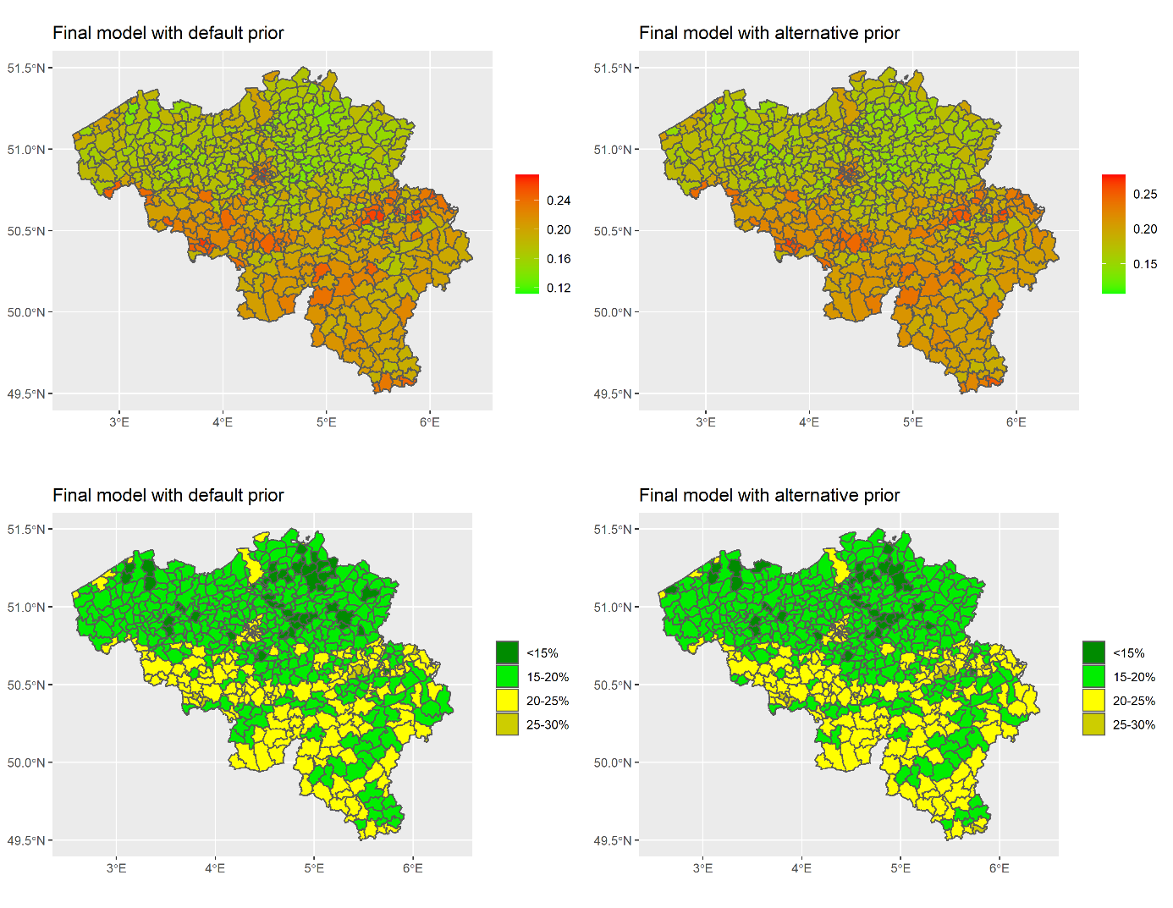
Figure S1 Smoothed current smoking prevalence from fully adjusted model with PC prior with alternative parameters (changing pc.u and pc.alpha from the default value u=1 and α=0.01 to u=0.1,α=0.01)

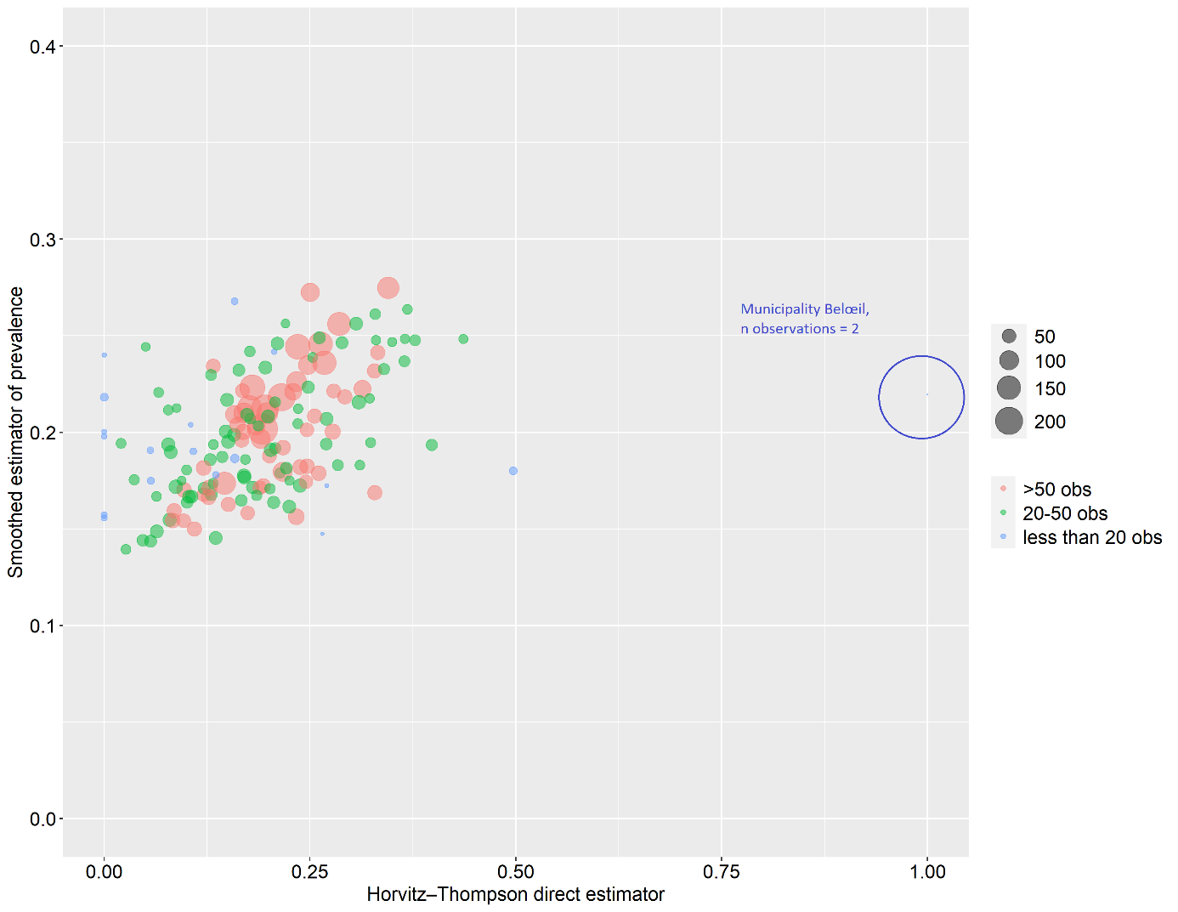
Figure S2 Horvitz–Thompson (HT) estimator vs smoothed prevalence in 154 sampled municipalities (model adjusted for age, gender and education)

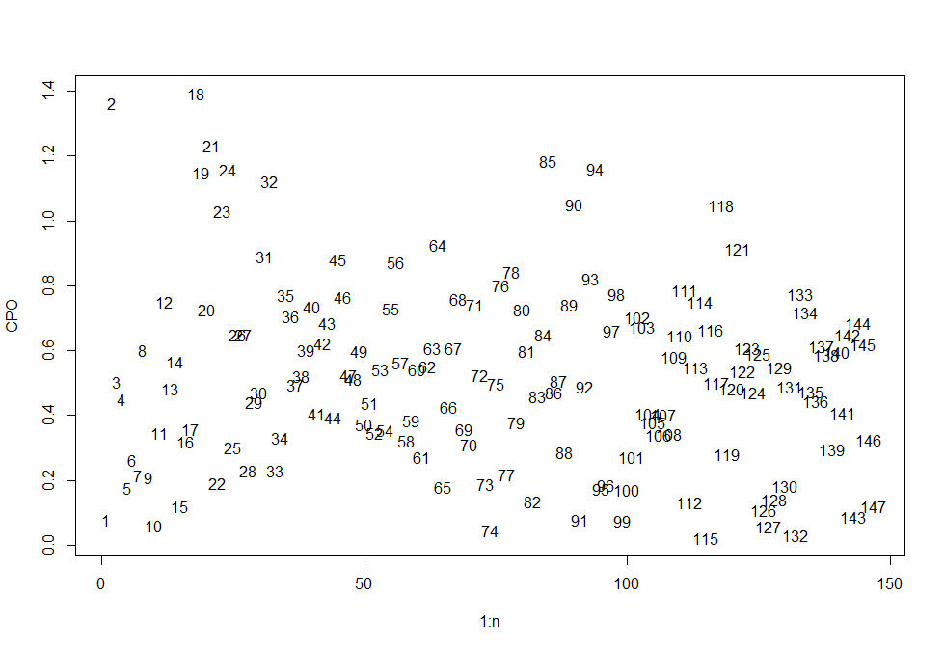
Figure S3 Conditional Predictive Ordinate for in-sample municipalities from the fully adjusted model

