Additional file 1 Sample Advertisement on Facebook

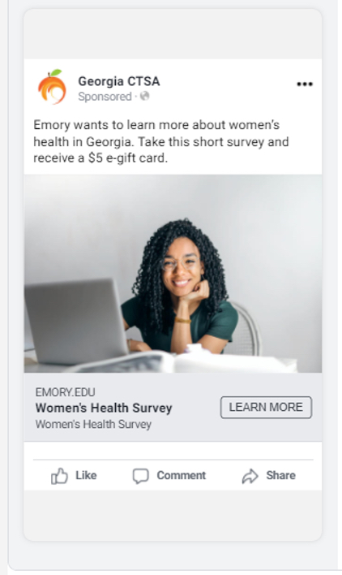
The image used in the survey promotion is a freely available image.

