Table S1. Parental characteristics based on the low and high-risk clusters
 |  | Low risk  (n=941) | High risk  (n=1204) | P-value
Maternal characteristics
 | Age | 35.39 (5.78) | 40.12(7.85) | <0.001
 | Education |  |  | <0.001
 | Illiterate/primary | 155 (16.5) | 1010 (83.9)
 | Secondary | 657 (69.8) | 192 (15.9)
 | Higher | 129 (13.7) | 2 (0.2)
 | Employment status |  |  | <0.001
 | Unemployed | 743 (79.0) | 1204 (100.0)
 | Employed | 198 (21.0) | 0 (0.0)
 | BMI status |  |  | <0.001
 | Normal | 363 (38.6) | 190 (15.8)
 | Overweight | 473 (50.3) | 492 (40.9)
 | Obese | 105 (11.2) | 522 (43.4)
 | Metabolic syn. |  |  | <0.001
 | No | 827 (87.9) | 535 (44.4)
 | Yes | 114 (12.1) | 669 (55.6)
Paternal characteristics
 | Age | 40.97 (6.17) | 47.47 (9.08) | <0.001
 | Education |  |  | <0.001
 | Illiterate/primary | 126 (13.4) | 863 (71.7)
 | Secondary | 570 (60.6) | 238 (19.8)
 | Higher | 245 (26.0) | 103 (8.6)
 | Employment status |  |  | <0.001
 | Unemployed | 28 (3.0) | 196 (16.3)
 | Employed | 913 (97.0) | 1008 (83.7)
 | BMI status |  |  | 0.005
 | Normal | 344 (37.1) | 435 (36.7)
 | Overweight | 459 (49.5) | 531 (44.8)
 | Obese | 125 (13.5) | 220 (18.5)
 | Metabolic syn. |  |  | 0.004
 | No | 512 (57.3) | 591 (50.9)
 | Yes | 381 (42.7) | 569 (49.1)

Table S2. Group Based models results.
Nb.  Latent  classes | Polynomial degree | Log-Lik | BIC | % Participants per class | Mean posterior  probabilities | Posterior probabilities | odds of correct classification
1 | Linear | -29702.09 | -29713.59 | 100 | NA | NA | NA
1 | Quadratic | -29573.00 | -29588.34 | 100 | NA | NA | NA
1 | Cubic | -29572.60 | -29591.78 | 100 | NA | NA | NA
2 | Linear | -27452.58 | -27475.60 | 71.40 , 28.60 | 0.97 , 0.95 | 71.4 , 28.6 | 15.23 , 43.54
2 | Quadratic | -27125.31 | -27155.99 | 71.12 , 28.87 | 0.98 , 0.95 | 71.1 , 28.9 | 19.31 , 42.13
2 | Cubic | -27117.17 | -27155.52 | 71.18 , 28.82 | 0.98 , 0.95 | 71.2 , 28.8 | 18.20 , 45.39
3 | Linear | -26527.57 | -26562.09 | 55.83 , 36.06 , 8.11 | 0.95 , 0.92 , 0.95 | 55.8 , 36.1 , 8.1 | 15.5 , 20.04 , 210.95
 | Quadratic | -26076.89 | -26122.91 | 55.71 , 36.30 , 7.99 | 0.96 , 0.93 , 0.95 | 55.7 , 36.3 , 8.0 | 17.33 , 25.63 , 209.97
 | Cubic | -26069.80 | -26127.33 | 55.71 , 36.27 , 8.02 | 0.96 , 0.93 , 0.95 | 56.1 , 35.8 , 8.01 | 17.51 , 25.21 , 218.05
4 | Linear | -26090.78 | -26136.80 | 40.22 , 36.74 , 18.47 , 4.56 | 0.91 , 0.88 , 0.92 , 0.96 | 40.2 , 36.7 , 18.5 , 4.6 | 15.54 , 12.71 , 50.81 , 485.63
 | Quadratic | -25526.03 | -25587.40 | 40.69 , 36.33 , 18.73 , 4.26 | 0.93 , 0.89 , 0.93 , 0.96 | 40.7 , 36.4 , 18.6 , 4.2 | 21.11 , 14.94 , 56.08 , 523.99
 | Cubic | -25512.87 | -25589.58 | 36.43 , 40.53 , 18.73 , 4.30 | 0.89 , 0.94 , 0.93 , 0.96 | 36.4 , 40.5 , 18.7 , 4.3 | 14.40 , 22.08 , 56.48 , 506.40
5 | Linear | -25953.52 | -26011.05 | 37.23, 36.55, 19.31, 5.86, 1.03 | 0.90, 0.87, 0.89, 0.91, 0.98 | 37.2, 36.5, 19.3, 5.8, 1.0 | 14.91, 12.10, 35.35, 172.80, 4404.99
 | Quadratic | -25325.61 | -25402.32 | 40.57, 36.30, 4.25, 18.73, 0.14 | 0.94, 0.90, 0.97, 0.93, 1 | 40.6, 36.3, 4.3, 18.7, 0.1 | 22.43, 15.56, 649.10, 58.16, NA
 | Cubic | -25317.58 | -25413.46 | 36.24, 40.25, 17.71, 1.48, 4.31 | 0.90, 0.94, 0.92, 0.83, 0.96 | 36.2, 40.3, 17.7, 1.5, 4.3 | 15.04, 23.17, 54.75, 379.10, 581.48
Reported are: The number of latent class considered, the polynomial form of the model, the maximum Log-Likelihood (Log-Lik), the Bayesian information Criterion (BIC), and for models with 2 or more classes, the a-posteriori classification of subjects in each class (%), the mean of posterior probabilities in each latent class, and the % of subjects classified in each class with a posterior probability above 0.7. The best fitting model is highlighted in bold characters. (n.a: not applicable).

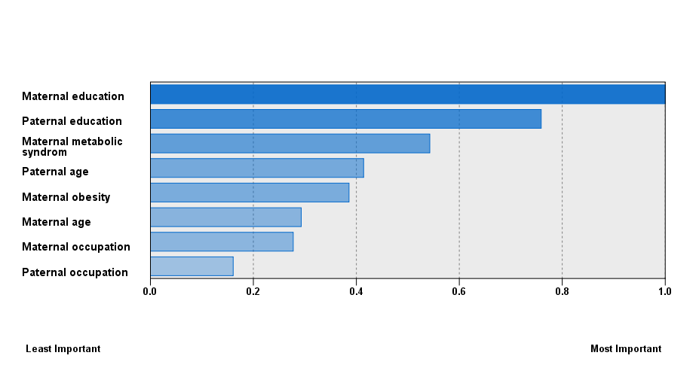

Figure S1. Importance values of parental characteristics included in the cluster analysis

