SUPPLEMENTARY APPENDIX

Protective behavior and SARS-CoV-2 infection risk in the population –
Results from the Gutenberg COVID-19 Study

Rieke Baumkötter^{1,2}; Simge Yilmaz^{1,2}; Daniela Zahn¹;
Katharina Fenzl¹; Jürgen H. Prochaska^{1,2,3}; Heidi Rossmann⁴; Irene Schmidtmann⁵; Alexander K. Schuster⁶; Manfred E. Beutel⁷; Karl J. Lackner^{2,4}; Thomas Münzel^{2,8}; Philipp S. Wild^{1,2,3,9}

- Preventive Cardiology and Preventive Medicine, Center for Cardiology, University Medical Center of the Johannes Gutenberg University Mainz, Langenbeckstr. 1, 55131 Mainz, Germany;
- German Center for Cardiovascular Research (DZHK), Partner Site Rhine Main, University Medical Center of the Johannes Gutenberg University Mainz, Germany;
- Center for Thrombosis and Hemostasis (CTH), University Medical Center of the Johannes Gutenberg University Mainz, Mainz, Germany;
- Institute of Clinical Chemistry and Laboratory Medicine, University Medical Center of the Johannes Gutenberg University Mainz, Mainz, Germany;
- Institute of Medical Biostatistcs, Epidemiology and Informatics, University Medical Center of the Johannes Gutenberg University Mainz, Mainz, Germany;
- Department of Ophthalmology, University Medical Center of the Johannes Gutenberg University Mainz, Mainz, Germany;
- Department of Psychosomatic Medicine, University Medical Center of the Johannes Gutenberg University Mainz, Mainz, Germany;
- Cardiology I, Center for Cardiology, University Medical Center of the Johannes Gutenberg University Mainz, Germany;
- Institute of Molecular Biology (IMB), Mainz, Germany.

Correspondence
Philipp S. Wild, MD, MSc
Professor of Clinical Epidemiology
University Medical Centre Mainz of the Johannes Gutenberg University Mainz, Langenbeckstr. 1, 55131 Mainz, Germany
Phone: +49 6131 17 7163; Fax: +49 6131 17 8460;
Email: philipp.wild@unimedizin-mainz.de

TABLE OF CONTENTS

Identifier | Title | Page
ST | Additional information on PCR and antibody testing | 3
S1 | Effect of protective behavior on SARS-CoV-2 infection risk in the population sample. | 4
SF1 | Effect of protective behavior on SARS-CoV-2 infections stratified by waves of the SARS-CoV-2 pandemic | 5
S2 | Effect of protective behavior on SARS-CoV-2 infection risk according to time periods when different virus variants dominated (February 2020-March 2021 – Wild-type variant; March 2021-June 2021 – alpha variant). | 6
SF2 | Effect of protective behavior on SARS-CoV-2 infection risk: interaction with age | 7
R | References | 9

Supplemental Text. Additional information on PCR and antibody testing.

RT-qPCR Testing
To detect an acute SARS-CoV-2 infection, a swab was taken from the participant’s throat for quantitative reverse transcription polymerase chain reaction (RT-qPCR) analysis. Samples (swabs in 750 µl phosphate-buffered saline) were collected, stored at 4-8°C, and analyzed within 4 days at the latest. For SARS-CoV-2 screening, 200 µl of swab fluid was pooled from each of 5 subjects, RNA was extracted using the QiaAmp UltraSens Virus Kit (Qiagen) and eluted in 30 µl buffer. 10 µl of the eluate were assayed in a 25 µl one-step reverse transcription / qPCR reaction on a cobas z 480 Analyzer (Roche Deutschland Holding GmbH, Germany). Primer and probes for E-gene (plus EAV control) amplification were supplied by TIB MolBiol (Light Mix SarbecoV, TIB Molbiol, Germany), reagents for reverse transcription and qPCR by Qiagen (One-Step QuantiTect Probe RT-PCR Kit, Qiagen, Germany). Details on assay implementation, quality and quality control are described in Hauser et al. (1, methods: ‘laboratory 2’). In case of a positive pool, all samples were re-tested individually by E-gene and RdRP-gene (Light Mix SarbecoV, TIB Molbiol, Germany) qPCR as described in Hauser et al. [1; methods: ‘laboratory 2’].

SARS-CoV-2 Antibody Testing
EDTA samples were analyzed regarding circulating antibodies targeted at SARS-CoV-2 nucleocapsid with a qualitative microparticle chemiluminescent immunoassay (Architect SARS-CoV-2 IgG, Abbott, Germany) with a threshold of 1.4 relative light units and second, a qualitative microparticle electro-chemiluminescence immunoassay (Elecsys Anti-SARS-CoV-2 Pan-Ig, Roche, Germany) with a cutoff index of 0.8. Samples were collected and stored at room temperature and were analyzed with the Abbott immunoassay within two days at the latest. Subsequently, samples were stored at −80°C in a state-of-the-art biobanking facility at the University Medical Center Mainz. After defrosting the samples, they were re-analyzed with the immunoassay of Roche.

Supplemental Table 1. Effect of protective behavior on SARS-CoV-2 infection risk in the population.

 | Univariate analysis* |  | Adjusted for time of enrollment, sociodemographics, pandemic-related behavior†
 | Hazard ratio [95% CI] | P | Hazard ratio [95% CI] | P
Physical distancing | 0.56 [0.40; 0.77] | 0.00052 | 0.66 [0.43; 1.02] | 0.058
Use of face masks | 0.91 [0.53; 1.58] | 0.74 | 1.22 [0.63; 2.37] | 0.56
Hand hygiene | 1.09 [0.74; 1.60] | 0.67 | 1.14 [0.72; 1.82] | 0.58

Cox regression models. Dependent variable: SARS-CoV-2 infections since January 2020 (individuals without date of infection were excluded); independent variables: physical distancing, wearing face masks, and hand hygiene at baseline.
* physical distancing (n=9,344, 155 events), use of face masks (n=9,362, 156 events), hand hygiene (n=9,016, 145 events).
† Adjustment for time of enrolment into study, age, sex, socioeconomic status, occupational
status, COVID-19 vaccination status, COVID-19 contact in the past two weeks, participation in gatherings in the past two weeks, travel (any), disinfecting hands (>2 per day), and avoidance of shaking hands, attending gatherings, and hugging of people in direct surrounding area (n=6,945, 111 events). CI, confidence interval.
Supplemental Figure 1. Effect of protective behavior on SARS-CoV-2 infections stratified by waves of the SARS-CoV-2 pandemic.

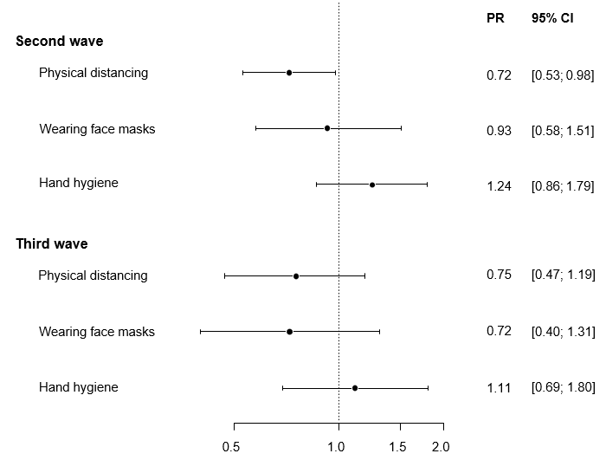
Prevalence ratio

Presented are prevalence ratios of multivariable robust Poisson regression models.
Second wave of the SARS-CoV-2 pandemic in Germany: September 28, 2020 to February 28, 2021 (n=7,016). Third wave of the SARS-CoV-2 pandemic in Germany: March 1, 2021 to June 13, 2021 (n=6,928).
Dependent variable: SARS-CoV-2 infections during baseline and follow-up; independent variables: physical distancing, wearing face masks, and hand hygiene at baseline.
Adjustment for time of enrollment into study, age, sex, socioeconomic status, occupational status, COVID-19 vaccination status, COVID-19 contact in the past two weeks, participation in gatherings in the past two weeks, travel (any), disinfecting hands (>2 per day) and avoidance of shaking hands, attending gatherings, and hugging of people in direct surrounding area. PR, prevalence ratio; CI, confidence interval.

Supplemental Table 2. Effect of protective behavior on SARS-CoV-2 infection risk
according to time periods when different virus variants dominated
(February 2020-March 2021– Wild-type variant; March 2021-June
2021 – alpha variant).

 | February 2020-March 2021 |  | March 2021-June 2021
 | Prevalence ratio [95% CI] | P | Prevalence ratio [95% CI] | P
Physical distancing | 0.78 [0.59; 1.04] | 0.089 | 0.81 [0.60; 1.10] | 0.17
Use of face masks | 0.85 [0.54; 1.32] | 0.46 | 1.00 [0.62; 1.59] | 0.99
Hand hygiene | 1.08 [0.78; 1.50] | 0.64 | 1.17 [0.83; 1.64] | 0.38

February 2020-March 2021: time period in which the wild type was dominant in Germany (N=7,804, n=251 events). March 2021-June 2021: time period in which alpha was the dominant strain in Germany (N=7,797, n=250 events) [2]. Robust Poisson regression with adjustment for age, sex, SES, occupational status. CI, confidence interval.

Supplemental Figure 2. Effect of protective behavior on SARS-CoV-2 infection risk: interaction with age.
Panel A. Physical distancing
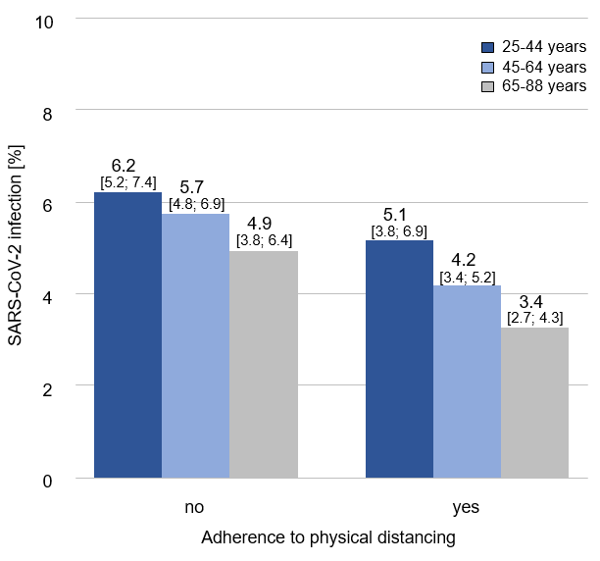
P for interaction = 0.81

Panel B. Wearing face masks
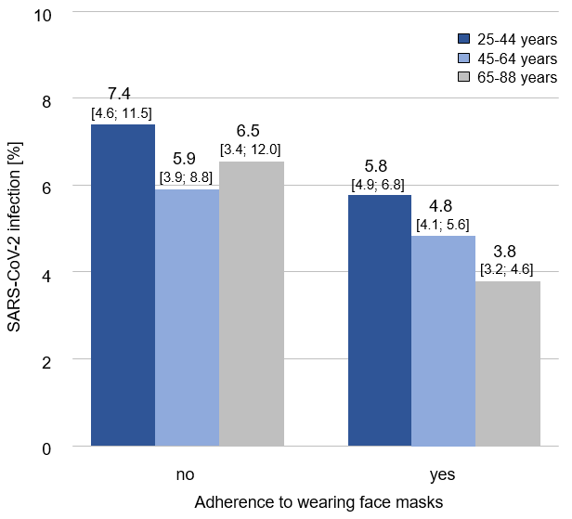
P for interaction = 0.74
Panel C. Hand hygiene
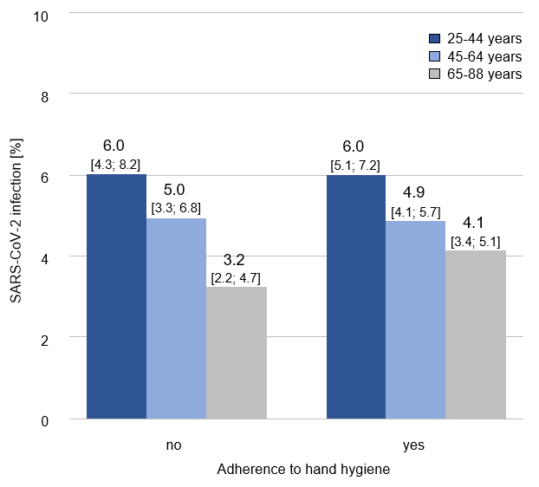
P for interaction = 0.93

References

1. Hauser F, Sprinzl MF, Dreis KJ, Renzaho A, Youhanen S, Kremer WM, et al. Evaluation of a laboratory-based high-throughput SARS-CoV-2 antigen assay for non-COVID-19 patient screening at hospital admission. Med Microbiol Immunol. 2021;210(2-3):165-71.
2. Robert Koch Institut (RKI). Bericht zu Virusvarianten von SARS-CoV-2 in Deutschland. 2021.

