Geospatial modelling process

Covariate preparation and selection

After obtaining all covariates listed in the Supplementary Table 2, these were standardized in the WGS84 EPSG coordinate reference system using lat/long projection and aggregated to the 5 x 5 km resolution through bilinear interpolation using the raster package in R. When the covariate data were extracted for each cluster location, we drew 2 km buffers in urban areas and 5 km buffers in rural areas to account for the displacement added to protect the anonymity of the respondents. We used only continuous variables and extracted the weighted mean of all cells within the buffer radius for the analysis. We tested the association between all covariates using Pearson’s correlation to prevent any issues with multicollinearity. Then, we performed a backwards elimination process using a binomial logistic regression allowing for fractional polynomials of the up to the second order to find the best fit for each covariate. We kept only the covariate with the highest association (highest z-value in a bivariate analysis) to the outcome when two or more highly correlated covariates (rho>0.8) were selected for a single model.

Model fit details

We used a geostatistical model based on the equation presented in the main paper fitted in a Bayesian framework using the INLA-SPDE approach with non-informative $N({0,10}^{6}I)$ priors. The SPDE model used penalized complexity priors with alpha set to 2, the spatial range of the field set to (0.01, 0.92 (5% of the north-south extent of the country)), and the standard deviation of the field set to (3, 0.01). The mesh was constructed using the cluster coordinates, country boundaries, max edge of 0.05 for inner triangles, 0.6 for outer triangles and a cut-off of 0.1. Afterwards, it was assessed through visual inspection. For each model, we generated 1000 samples from the posterior distribution for the predicted location at 5 x 5 km grid cell resolution. These estimates were further aggregated at the first and second administrative divisions using the boundaries obtained from GADM (https://gadm.org), weighted by the population estimates obtained from Worldpop (www.worldpop.org).

Supplementary table 1 - Complete definitions for the composite coverage index (CCI) and its indicators
Indicator | Acronym | Numerator | Denominator
Demand for family planning satisfied by modern methods | FPSm | Who is using (or whose partner is using) a modern contraceptive method | Women aged 15-49 years either married or in union in need of contraception
Antenatal care 4 or more visits | ANC4 | Attended at least four antenatal care (ANC) visits with any provider | Women aged 15-49 years who had a birth in the last 3 years before the survey
Skilled attendant at delivery | SBA | Delivered by a skilled attendant (based on each country’s definition of skilled attendant) | Women aged 15-49 years who had a birth in the last 3 years before the survey
BCG vaccination | BCG | Received Bacillus Calmette-Guérin (BCG) vaccine | All live-children, 12-23 months
DPT3 vaccination | DPT3 | Received 3 doses of Diphteria, Pertussis, Tetanus (DPT) vaccine | All live-children, 12-23 months
Measles vaccination | MSL | Received measles vaccine | All live-children, 12-23 months
Treatment for diarrhea | ORS | Received oral rehydration salts (ORS) | All live children aged 0-59 months with diarrhea in the last 2 weeks
Care-seeking for pneumonia | CAREP | Sought treatment from an appropriate health facility or provider. | Live children, 0-59 months, suspected pneumonia in the last 2 weeks
Composite coverage index | CCI

Supplementary table 2 – Description of covariates included in the analysis
Covariate | Year | Resolution | Unit | Source
Altitude | NA | 1km | meters | SRTM (raster package)
Travel time to cities >50,000 | 2000 | 1km | minutes | ftp://ftp.worldpop.org.uk/GIS/Covariates/Global_2000_2020/PER/
Distance to health facilities | 2017 | 1km | meters | https://www.datosabiertos.gob.pe/dataset/minsa-ipress
Enhanced vegetation index | 2017 | 1km | 0 to 10000 (least to most vegetation) | https://ladsweb.modaps.eosdis.nasa.gov/search/history
Urbanicity | 2014 | 1km | 0.00 to 1.00 (extremely rural to urban) | https://jeodpp.jrc.ec.europa.eu/ftp/jrc-opendata/GHSL/GHS_BUILT_LDSMT_GLOBE_R2018A/
Nighttime lights | 2016 | 100m | nW/cm2/sr | ftp://ftp.worldpop.org.uk/GIS/Covariates/Global_2000_2020/PER/
Improved water coverage | 2018 | 1km | proportion | Interpolated using kriging
Improved sanitation coverage | 2018 | 1km | proportion | Interpolated using kriging
Mean number of household members | 2018 | 1km | number | Interpolated using kriging
% of households in Q1 or Q2 | 2018 | 1km | proportion | Interpolated using kriging
Mean women's years of education | 2018 | 1km | proportion | Interpolated using kriging
% of indigenous population | 2018 | 1km | proportion | Interpolated using kriging
Distance to protected areas | 2017 | 100m | km | ftp://ftp.worldpop.org.uk/GIS/Covariates/Global_2000_2020/PER/
Distance to build settlements (BGSM) | 2017 | 100m | km | ftp://ftp.worldpop.org.uk/GIS/Covariates/Global_2000_2020/PER/

Supplementary Table 3 - Summary statistics for covariates included in the analysis
Covariate | Mean | Median | Min | P1% | P99% | Max
Altitude | 1373.00 | 487.00 | 0.00 | 6.60 | 4350.00 | 4876.00
Distance to health facilities | 0.02 | 0.01 | 0.00 | 0.00 | 0.09 | 0.31
Travel time to health facilities | 14.67 | 2.21 | 0.00 | 0.00 | 219.00 | 888.00
Travel time to cities 50k | 172.50 | 44.49 | 0.51 | 0.51 | 1438.00 | 3269.00
Enhanced vegetation index | 2025.00 | 1771.00 | -3000.00 | -1666.00 | 5581.00 | 6378.00
Urbanicity | 15.65 | 0.36 | 0.00 | 0.00 | 92.99 | 96.95
Nighttime lights | 13.67 | 1.85 | -0.07 | -0.03 | 75.00 | 85.00
Improved water | 0.96 | 0.98 | 0.01 | 0.37 | 1.00 | 1.00
Improved sanitation | 0.63 | 0.75 | 0.00 | 0.00 | 0.98 | 0.99
% of households in Q1 or Q2 | 0.49 | 0.45 | 0.00 | 0.00 | 0.99 | 0.99
Mean number of household members | 3.84 | 3.82 | 2.35 | 2.72 | 4.84 | 5.45
Distance to built settlements | 1.14 | 0.33 | -2.17 | -1.78 | 13.90 | 64.00
Distance to protected areas | 705.00 | 702.00 | 56.00 | 195.00 | 1240.00 | 1278.00
Years of education (women) | 10.00 | 10.40 | 4.10 | 5.30 | 13.60 | 14.00
% of indigenous population | 0.07 | 0.00 | 0.00 | 0.00 | 0.99 | 0.99
Note: Zeros and negative values were replaced by a positive value close to 1 for some covariates

Supplementary Table 4 - Covariates selected for each modeled indicator
Covariate | BCG | DPT3 | MSL | CAREP | ORS | SBA3 | ANC4 | FPSmo
Altitude |  | X |  |  | X | X
Distance to health facilities |  |  | X |  | X |  | X | X
Travel time to health facilities |  |  |  |  | X
Travel time to cities 50k |  | X | X |  |  | X
Enhanced vegetation index | X |  | X |  | X | X
Urbanicity |  |  |  |  |  | X
Nighttime lights |  | X |  |  | X | X |  | X
Improved water
Improved sanitation | X | X | X |  | X | X | X | X
% of households in Q1 or Q2 |  | X |  | X |  |  | X | X
Mean number of household members | X |  | X |  |  | X | X
Distance to built settlements |  |  | X |  |  | X
Distance to protected areas |  |  | X |  | X | X | X
Years of education (women) | X | X |  |  | X | X | X | X
% of indigenous population |  | X |  |  |  |  | X | X
BCG Bacillus Calmette-Guérin vaccine; DPT3 3 doses of Diphteria, pertussis, tetanus vaccine; CAREP Care-seeking for pneumonia; SBA Skilled attendant at delivery; ANC4 Antenatal care 4 or more visits; ORS Oral rehydration salts; FPSmo Demand for family planning satisfied by modern methods

Supplementary Table 5 – Model validation metrics
 | Cross-validation |  |  | In-sample
Indicator | Correlation | Bias | MAE | Correlation | Bias | MAE
BCG | 0.31 | 0.00 | 0.07 | 0.61 | 0.00 | 0.06
DPT3 | 0.20 | 0.00 | 0.18 | 0.55 | 0.00 | 0.16
Measles | 0.20 | 0.00 | 0.22 | 0.59 | 0.00 | 0.20
CAREP | 0.03 | 0.00 | 0.30 | 0.80 | 0.00 | 0.25
SBA | 0.73 | 0.00 | 0.04 | 0.88 | 0.00 | 0.03
ANC4 | 0.25 | 0.00 | 0.06 | 0.45 | 0.00 | 0.06
ORS | 0.26 | 0.00 | 0.27 | 0.60 | 0.00 | 0.24
FPSmo | 0.34 | -0.01 | 0.24 | 0.54 | -0.01 | 0.22
MAE Mean absolute error; BCG Bacillus Calmette-Guérin vaccine; DPT3 3 doses of Diphteria, pertussis, tetanus vaccine; CAREP Care-seeking for pneumonia; SBA Skilled attendant at delivery; ANC4 Antenatal care 4 or more visits; ORS Oral rehydration salts; FPSmo Demand for family planning satisfied by modern methods

Supplementary Table 6 – Comparison of predicted vs observed estimates at department-level for the composite coverage index (CCI) and its 8 indicators
Department | BCG |  |  | DPT3 |  |  | MEASLES |  |  | CARE-SEEKING |  |  | ORS |  |  | ANC4 |  |  | SBA |  |  | FPSmo |  |  | CCI
Department | Pred | Obs | Diff | Pred | Obs | Diff | Pred | Obs | Diff | Pred | Obs | Diff | Pred | Obs | Diff | Pred | Obs | Diff | Pred | Obs | Diff | Pred | Obs | Diff | Pred | Obs | Diff
Amazonas | 94.6 | 93.6 | 1.0 | 84.5 | 83.4 | 1.1 | 85.9 | 81.1 | 4.7 | 66.9 | 65.9 | 1.0 | 27.7 | 24.2 | 3.5 | 94.7 | 92.4 | 2.3 | 85.7 | 81.3 | 4.4 | 66.0 | 61.2 | 4.7 | 72.7 | 69.6 | 3.1
Ancash | 97.6 | 98.0 | -0.4 | 87.6 | 90.0 | -2.4 | 83.3 | 89.0 | -5.7 | 69.6 | 74.5 | -4.8 | 26.6 | 19.1 | 7.5 | 97.7 | 98.2 | -0.5 | 97.9 | 98.0 | -0.2 | 64.7 | 63.0 | 1.8 | 74.9 | 74.9 | 0.0
Apurímac | 97.2 | 99.2 | -2.0 | 89.0 | 90.3 | -1.3 | 82.9 | 82.6 | 0.3 | 68.4 | 75.6 | -7.2 | 23.7 | 22.9 | 0.9 | 96.8 | 97.7 | -0.9 | 99.1 | 99.9 | -0.7 | 59.8 | 61.5 | -1.7 | 73.3 | 75.0 | -1.7
Arequipa | 97.8 | 98.6 | -0.8 | 91.9 | 93.9 | -2.1 | 80.5 | 78.4 | 2.1 | 69.7 | 80.5 | -10.8 | 30.3 | 30.8 | -0.5 | 96.7 | 96.3 | 0.4 | 98.8 | 99.0 | -0.1 | 71.0 | 67.3 | 3.7 | 77.3 | 77.9 | -0.6
Ayacucho | 95.7 | 93.8 | 1.8 | 88.2 | 87.6 | 0.6 | 81.0 | 84.9 | -3.9 | 68.6 | 59.4 | 9.2 | 22.9 | 22.0 | 1.0 | 95.6 | 95.2 | 0.4 | 97.5 | 98.3 | -0.8 | 53.2 | 56.8 | -3.6 | 71.0 | 70.7 | 0.3
Cajamarca | 94.8 | 95.3 | -0.5 | 87.2 | 90.2 | -3.0 | 85.4 | 91.3 | -5.9 | 67.3 | 62.4 | 4.9 | 21.8 | 21.4 | 0.5 | 95.5 | 95.4 | 0.0 | 87.1 | 87.4 | -0.3 | 56.2 | 57.4 | -1.2 | 70.2 | 70.6 | -0.4
Callao | 96.4 | 96.1 | 0.3 | 81.4 | 82.5 | -1.1 | 81.5 | 78.0 | 3.5 | 73.7 | 74.6 | -0.9 | 40.8 | 40.5 | 0.3 | 97.2 | 96.6 | 0.5 | 99.6 | 99.8 | -0.2 | 73.4 | 72.4 | 1.0 | 78.5 | 78.2 | 0.3
Cusco | 96.5 | 96.1 | 0.4 | 88.4 | 85.9 | 2.5 | 83.2 | 74.7 | 8.5 | 66.5 | 74.8 | -8.3 | 28.1 | 33.3 | -5.2 | 97.1 | 97.9 | -0.8 | 97.5 | 98.2 | -0.7 | 55.1 | 58.2 | -3.1 | 72.2 | 74.0 | -1.8
Huancavelica | 95.6 | 97.8 | -2.2 | 86.9 | 88.7 | -1.8 | 84.7 | 89.0 | -4.4 | 66.1 | 71.6 | -5.5 | 18.3 | 19.5 | -1.2 | 95.1 | 95.9 | -0.7 | 92.9 | 93.1 | -0.3 | 42.9 | 46.6 | -3.7 | 66.9 | 69.4 | -2.5
Huánuco | 95.6 | 96.4 | -0.8 | 89.6 | 92.2 | -2.6 | 84.2 | 86.5 | -2.4 | 65.9 | 64.9 | 1.0 | 22.7 | 27.0 | -4.3 | 96.4 | 96.4 | 0.0 | 94.2 | 96.1 | -1.9 | 60.8 | 66.9 | -6.1 | 72.5 | 75.2 | -2.7
Ica | 97.1 | 97.3 | -0.1 | 83.8 | 80.0 | 3.9 | 87.0 | 88.2 | -1.2 | 73.0 | 85.8 | -12.8 | 39.1 | 38.2 | 1.0 | 97.0 | 97.3 | -0.3 | 99.2 | 99.4 | -0.2 | 67.2 | 65.1 | 2.1 | 77.3 | 78.0 | -0.6
Junín | 96.5 | 95.8 | 0.7 | 89.6 | 91.8 | -2.2 | 80.6 | 81.0 | -0.4 | 63.2 | 60.5 | 2.7 | 29.0 | 23.6 | 5.4 | 95.6 | 96.3 | -0.7 | 89.7 | 91.7 | -1.9 | 62.1 | 64.2 | -2.1 | 72.5 | 72.6 | -0.1
La Libertad | 97.1 | 96.7 | 0.4 | 82.6 | 80.6 | 2.0 | 82.9 | 80.7 | 2.2 | 68.0 | 64.3 | 3.7 | 32.1 | 34.9 | -2.8 | 96.8 | 96.3 | 0.4 | 92.1 | 89.8 | 2.3 | 66.5 | 62.6 | 3.9 | 74.3 | 72.5 | 1.8
Lambayeque | 95.9 | 95.4 | 0.4 | 86.1 | 84.5 | 1.7 | 74.5 | 71.5 | 3.0 | 68.9 | 72.6 | -3.6 | 36.6 | 37.4 | -0.8 | 95.1 | 94.0 | 1.0 | 97.1 | 95.2 | 1.8 | 68.6 | 60.9 | 7.7 | 75.8 | 73.6 | 2.2
Lima Province | 95.2 | 94.9 | 0.3 | 83.6 | 82.8 | 0.8 | 80.3 | 79.0 | 1.3 | 73.1 | 75.5 | -2.4 | 38.4 | 37.4 | 1.0 | 97.3 | 97.6 | -0.2 | 99.6 | 99.5 | 0.0 | 72.6 | 70.2 | 2.4 | 78.1 | 77.5 | 0.6
Loreto | 83.8 | 85.6 | -1.8 | 79.3 | 81.7 | -2.5 | 70.4 | 75.8 | -5.4 | 66.2 | 73.1 | -6.9 | 32.5 | 40.0 | -7.5 | 90.2 | 90.1 | 0.1 | 66.1 | 72.3 | -6.2 | 59.2 | 61.3 | -2.1 | 66.2 | 70.1 | -3.8
Madre de Dios | 95.5 | 99.5 | -4.0 | 81.0 | 82.2 | -1.2 | 71.8 | 73.8 | -1.9 | 61.7 | 52.2 | 9.5 | 31.2 | 45.7 | -14.6 | 93.4 | 94.7 | -1.2 | 88.6 | 97.9 | -9.3 | 54.5 | 65.4 | -10.9 | 68.6 | 73.8 | -5.2
Moquegua | 98.0 | 98.3 | -0.3 | 90.1 | 88.8 | 1.4 | 85.9 | 88.8 | -2.9 | 70.1 | 77.0 | -6.9 | 29.4 | 36.3 | -6.8 | 97.4 | 97.9 | -0.5 | 97.7 | 99.5 | -1.8 | 69.2 | 72.2 | -3.0 | 76.9 | 79.7 | -2.8
Pasco | 96.3 | 95.3 | 1.0 | 85.6 | 83.9 | 1.7 | 82.3 | 81.0 | 1.3 | 65.6 | 71.9 | -6.3 | 22.5 | 31.2 | -8.7 | 96.2 | 96.7 | -0.5 | 93.6 | 96.8 | -3.3 | 65.4 | 69.9 | -4.5 | 72.9 | 76.1 | -3.1
Piura | 97.2 | 98.0 | -0.8 | 85.7 | 87.5 | -1.8 | 81.1 | 81.8 | -0.7 | 67.4 | 69.3 | -1.9 | 36.8 | 37.5 | -0.7 | 96.6 | 96.8 | -0.2 | 91.9 | 91.9 | 0.0 | 71.9 | 70.8 | 1.1 | 76.4 | 76.8 | -0.4
Puno | 94.5 | 91.4 | 3.1 | 76.3 | 75.0 | 1.4 | 72.7 | 70.9 | 1.9 | 64.4 | 40.8 | 23.6 | 21.3 | 18.6 | 2.7 | 92.5 | 91.9 | 0.6 | 92.5 | 95.0 | -2.5 | 41.2 | 43.4 | -2.1 | 64.1 | 61.1 | 3.0
San Martín | 94.6 | 93.2 | 1.4 | 90.2 | 90.9 | -0.7 | 82.7 | 78.5 | 4.1 | 64.0 | 50.0 | 14.0 | 39.4 | 42.1 | -2.7 | 97.5 | 98.1 | -0.6 | 93.5 | 92.0 | 1.5 | 66.2 | 66.5 | -0.3 | 75.7 | 74.0 | 1.7
Tacna | 98.5 | 99.3 | -0.8 | 90.2 | 90.2 | 0.0 | 81.7 | 78.9 | 2.9 | 70.9 | 64.8 | 6.0 | 32.1 | 21.2 | 10.9 | 97.5 | 97.7 | -0.2 | 98.2 | 98.6 | -0.4 | 63.6 | 60.0 | 3.6 | 75.8 | 72.7 | 3.1
Tumbes | 98.0 | 98.4 | -0.4 | 92.9 | 93.9 | -1.1 | 87.2 | 89.7 | -2.4 | 63.9 | 67.9 | -4.1 | 43.8 | 51.1 | -7.3 | 96.5 | 96.7 | -0.2 | 98.4 | 99.1 | -0.6 | 85.2 | 83.2 | 2.0 | 82.3 | 83.6 | -1.3
Ucayali | 92.7 | 94.5 | -1.8 | 84.7 | 87.1 | -2.4 | 70.2 | 69.1 | 1.0 | 61.4 | 60.8 | 0.6 | 41.5 | 42.0 | -0.5 | 92.0 | 94.0 | -2.1 | 82.5 | 88.6 | -6.2 | 66.3 | 65.9 | 0.4 | 72.0 | 73.3 | -1.3
BCG Bacillus Calmette-Guérin vaccine; DPT3 3 doses of Diphteria, pertussis, tetanus vaccine; CAREP Care-seeking for pneumonia; SBA Skilled attendant at delivery; ANC4 Antenatal care 4 or more visits; ORS Oral rehydration salts; FPSmo Demand for family planning satisfied by modern methods; CCI Composite coverage index
Supplementary table 7 – Predicted estimates for the composite coverage index (CCI) for the provinces of Peru
Provinces | Point estimate | Standard error | 2.5th percentile | 97.5th percentile
Abancay | 75.9 | 4.3 | 66.7 | 83.7
Acobamba | 66.9 | 2.2 | 62.4 | 71.0
Acomayo | 72.3 | 2.8 | 66.5 | 77.6
Aija | 70.2 | 2.5 | 65.0 | 74.8
Alto Amazonas | 61.9 | 1.7 | 58.6 | 65.1
Ambo | 72.4 | 1.7 | 69.0 | 75.6
Andahuaylas | 71.8 | 1.4 | 69.0 | 74.4
Angaraes | 67.1 | 2.0 | 62.9 | 70.7
Anta | 73.2 | 1.9 | 69.4 | 76.6
Antabamba | 71.7 | 2.0 | 67.8 | 75.6
Antonio Raymondi | 69.9 | 2.2 | 65.5 | 74.2
Arequipa | 77.5 | 2.1 | 73.3 | 81.3
Ascope | 76.8 | 1.9 | 73.0 | 80.3
Asunción | 71.9 | 2.4 | 66.9 | 76.7
Atalaya | 60.2 | 2.5 | 55.0 | 64.9
Ayabaca | 69.8 | 2.0 | 65.9 | 73.6
Aymaraes | 73.1 | 1.7 | 69.8 | 76.2
Azángaro | 61.6 | 2.0 | 57.5 | 65.4
Bagua | 73.6 | 2.0 | 69.5 | 77.2
Barranca | 79.4 | 2.5 | 74.2 | 84.0
Bellavista | 72.8 | 1.9 | 69.0 | 76.3
Bolognesi | 71.5 | 1.8 | 68.1 | 74.9
Bolívar | 63.3 | 2.4 | 58.5 | 68.0
Bongará | 73.5 | 2.7 | 67.8 | 78.5
Cajabamba | 66.9 | 2.0 | 63.1 | 70.8
Cajamarca | 69.8 | 2.0 | 65.8 | 73.4
Cajatambo | 71.4 | 2.2 | 67.1 | 75.4
Calca | 71.6 | 2.0 | 67.5 | 75.3
Callao | 78.5 | 2.8 | 72.1 | 83.8
Camaná | 79.5 | 2.3 | 74.9 | 83.9
Canas | 69.6 | 2.2 | 65.1 | 73.7
Canchis | 70.8 | 4.3 | 61.9 | 78.9
Candarave | 70.8 | 2.4 | 65.8 | 75.6
Cangallo | 67.5 | 1.8 | 63.9 | 70.8
Canta | 74.3 | 3.2 | 67.3 | 79.8
Carabaya | 66.5 | 2.2 | 62.3 | 70.9
Caravelí | 76.4 | 2.3 | 71.6 | 80.6
Carhuaz | 72.4 | 2.3 | 67.7 | 76.6
Carlos Fermin Fitzcarrald | 70.8 | 2.2 | 66.5 | 75.1
Casma | 76.0 | 2.2 | 71.6 | 80.1
Castilla | 76.1 | 2.4 | 71.1 | 80.3
Castrovirreyna | 63.6 | 2.5 | 58.7 | 68.4
Caylloma | 70.6 | 2.0 | 66.5 | 74.3
Cañete | 76.5 | 2.4 | 71.6 | 80.9
Celendín | 67.5 | 2.0 | 63.5 | 71.2
Chachapoyas | 77.3 | 4.6 | 68.2 | 85.3
Chanchamayo | 74.3 | 4.7 | 64.0 | 82.3
Chepén | 77.6 | 4.0 | 69.4 | 84.4
Chiclayo | 77.0 | 2.7 | 71.4 | 81.8
Chincha | 77.3 | 4.0 | 68.9 | 84.2
Chincheros | 71.2 | 2.7 | 65.7 | 76.2
Chota | 69.1 | 1.5 | 65.9 | 72.0
Chucuíto | 59.9 | 2.5 | 55.0 | 64.8
Chumbivilcas | 69.9 | 1.8 | 66.4 | 73.3
Chupaca | 71.5 | 2.9 | 65.8 | 76.9
Churcampa | 66.1 | 1.7 | 62.6 | 69.3
Concepción | 71.0 | 3.0 | 65.0 | 76.5
Condesuyos | 74.3 | 2.3 | 69.7 | 78.6
Condorcanqui | 54.8 | 2.4 | 50.3 | 59.3
Contralmirante Villar | 80.7 | 1.7 | 77.1 | 83.8
Contumazá | 71.1 | 2.1 | 66.8 | 74.9
Coronel Portillo | 74.2 | 2.9 | 68.1 | 79.7
Corongo | 67.0 | 2.6 | 61.8 | 71.6
Cotabambas | 72.7 | 1.7 | 69.5 | 75.9
Cusco | 73.9 | 4.4 | 65.1 | 82.0
Cutervo | 71.2 | 2.3 | 66.4 | 75.8
Daniel Alcides Carrión | 71.9 | 1.6 | 68.7 | 74.9
Dos de Mayo | 69.4 | 1.9 | 65.8 | 73.2
El Collao | 62.9 | 2.8 | 57.0 | 68.3
El Dorado | 73.6 | 2.3 | 68.9 | 77.7
Espinar | 67.2 | 2.7 | 61.5 | 72.3
Ferreñafe | 71.2 | 2.1 | 67.1 | 75.3
General Sánchez Cerro | 72.3 | 2.2 | 67.9 | 76.4
Gran Chimú | 70.3 | 3.6 | 62.8 | 76.6
Grau | 72.7 | 2.3 | 68.1 | 76.9
Huacaybamba | 67.5 | 2.2 | 63.2 | 71.8
Hualgayoc | 69.8 | 4.1 | 61.4 | 77.1
Huallaga | 74.4 | 3.4 | 67.2 | 80.8
Huamalíes | 71.7 | 1.5 | 68.8 | 74.3
Huamanga | 72.0 | 4.1 | 64.1 | 79.6
Huanca Sancos | 68.2 | 2.2 | 64.0 | 72.6
Huancabamba | 64.4 | 2.0 | 60.2 | 68.2
Huancane | 61.8 | 2.2 | 57.3 | 66.1
Huancavelica | 67.1 | 2.0 | 63.0 | 70.9
Huancayo | 73.9 | 3.0 | 68.0 | 79.4
Huanta | 68.4 | 1.4 | 65.6 | 71.0
Huaral | 78.1 | 2.0 | 73.8 | 81.9
Huaraz | 74.8 | 4.3 | 65.7 | 82.2
Huari | 71.0 | 1.6 | 67.8 | 74.2
Huarmey | 75.7 | 2.0 | 71.5 | 79.3
Huarochiri | 74.1 | 1.8 | 70.4 | 77.5
Huaura | 77.5 | 2.0 | 73.5 | 81.2
Huaylas | 70.1 | 3.0 | 64.1 | 75.8
Huaytara | 66.3 | 2.1 | 62.3 | 70.2
Huenuco | 75.0 | 2.2 | 70.2 | 79.0
Ica | 77.3 | 3.5 | 70.0 | 83.7
Ilo | 80.4 | 3.4 | 73.3 | 86.8
Islay | 78.6 | 2.2 | 74.3 | 82.4
Jauja | 72.3 | 1.9 | 68.6 | 76.0
Jaén | 72.5 | 1.6 | 69.1 | 75.5
Jorge Basadre | 77.0 | 2.3 | 72.2 | 81.2
Julcan | 62.8 | 2.8 | 56.9 | 68.2
Junín | 72.9 | 1.8 | 69.1 | 76.3
La Convención | 71.7 | 1.7 | 68.0 | 74.9
La Mar | 70.0 | 1.4 | 67.0 | 72.7
La Unión | 72.3 | 2.6 | 67.3 | 77.1
Lago Titicaca | 63.3 | 2.8 | 57.4 | 68.6
Lamas | 76.1 | 2.3 | 71.0 | 80.4
Lambayeque | 73.8 | 1.5 | 70.5 | 76.8
Lampa | 63.3 | 2.1 | 59.1 | 67.3
Lauricocha | 69.4 | 1.9 | 65.3 | 73.2
Leoncio Prado | 75.8 | 1.7 | 72.4 | 78.9
Lima | 78.1 | 1.3 | 75.6 | 80.6
Loreto | 61.7 | 2.1 | 57.8 | 66.1
Lucanas | 72.3 | 1.7 | 69.1 | 75.7
Luya | 72.8 | 1.5 | 69.8 | 75.6
Manu | 68.0 | 2.4 | 63.6 | 72.6
Marañón | 69.2 | 1.7 | 65.7 | 72.4
Mariscal Cáceres | 75.4 | 4.3 | 65.9 | 82.9
Mariscal Luzuriaga | 71.6 | 2.2 | 67.4 | 75.8
Mariscal Nieto | 76.9 | 2.1 | 72.5 | 80.8
Mariscal Ramón Castilla | 62.9 | 2.6 | 57.7 | 68.1
Maynas | 69.1 | 2.0 | 65.0 | 72.7
Melgar | 65.4 | 2.0 | 61.4 | 69.3
Moho | 63.9 | 2.8 | 58.2 | 69.0
Morropón | 73.4 | 1.9 | 69.7 | 77.0
Moyobamba | 76.3 | 3.2 | 69.8 | 81.9
Nazca | 78.7 | 3.0 | 72.2 | 83.9
Ocros | 73.7 | 2.2 | 69.5 | 77.9
Otuzco | 67.0 | 1.9 | 63.2 | 70.7
Oxapampa | 71.0 | 1.6 | 67.8 | 74.0
Oyon | 72.6 | 3.0 | 66.5 | 77.8
Pacasmayo | 76.8 | 2.3 | 71.8 | 81.0
Pachitea | 70.5 | 1.9 | 66.7 | 74.1
Padre Abad | 72.8 | 1.8 | 69.4 | 76.4
Paita | 77.8 | 2.8 | 71.9 | 82.8
Pallasca | 65.2 | 2.5 | 60.0 | 69.8
Palpa | 76.4 | 4.6 | 66.2 | 84.6
Parinacochas | 71.7 | 2.9 | 65.7 | 77.1
Paruro | 72.4 | 1.8 | 68.8 | 75.9
Pasco | 74.7 | 1.5 | 71.6 | 77.4
Pataz | 68.3 | 2.5 | 63.2 | 73.1
Paucar del Sara Sara | 73.1 | 2.4 | 68.3 | 77.7
Paucartambo | 69.0 | 1.8 | 65.1 | 72.7
Picota | 73.6 | 2.5 | 68.7 | 78.3
Pisco | 76.4 | 2.1 | 72.3 | 80.4
Piura | 78.3 | 2.2 | 73.7 | 82.3
Pomabamba | 70.6 | 2.3 | 66.0 | 75.0
Puerto Inca | 70.2 | 1.9 | 66.5 | 73.8
Puno | 64.2 | 3.9 | 56.2 | 71.5
Purús | 55.2 | 3.5 | 48.3 | 62.0
Quispicanchi | 70.5 | 1.9 | 66.7 | 74.0
Recuay | 72.8 | 2.0 | 68.4 | 76.4
Requena | 65.1 | 2.2 | 60.7 | 69.3
Rioja | 73.7 | 1.9 | 69.8 | 77.1
Rodríguez de Mendoza | 75.9 | 1.9 | 72.0 | 79.6
San Antonio de Putina | 62.9 | 2.5 | 58.4 | 67.7
San Ignacio | 71.2 | 1.7 | 67.8 | 74.6
San Marcos | 69.0 | 3.2 | 62.4 | 74.7
San Martín | 78.7 | 4.4 | 69.5 | 86.2
San Miguel | 71.2 | 1.9 | 67.2 | 74.9
San Pablo | 71.0 | 3.6 | 63.6 | 77.5
San Román | 65.6 | 6.1 | 53.6 | 76.8
Sandia | 67.4 | 2.3 | 62.7 | 71.8
Santa | 78.2 | 3.0 | 71.9 | 83.7
Santa Cruz | 71.7 | 2.1 | 67.6 | 75.6
Santiago de Chuco | 65.3 | 2.3 | 60.8 | 69.8
Satipo | 68.2 | 2.4 | 63.3 | 72.7
Sechura | 75.4 | 2.4 | 70.6 | 79.9
Sihuas | 69.8 | 2.0 | 65.6 | 73.6
Sucre | 70.9 | 1.9 | 66.9 | 74.8
Sullana | 79.5 | 1.8 | 75.8 | 82.8
Sánchez Carrión | 68.6 | 2.1 | 64.3 | 72.5
Tacna | 76.2 | 2.8 | 70.2 | 81.2
Tahuamanu | 69.0 | 2.4 | 64.0 | 73.6
Talara | 78.8 | 4.1 | 69.7 | 86.5
Tambopata | 68.8 | 1.8 | 64.9 | 72.2
Tarata | 70.2 | 3.5 | 62.5 | 76.8
Tarma | 74.8 | 1.9 | 71.1 | 78.2
Tayacaja | 67.6 | 1.2 | 65.2 | 70.1
Tocache | 73.7 | 1.8 | 69.8 | 77.0
Trujillo | 77.2 | 3.7 | 69.4 | 83.6
Tumbes | 82.5 | 2.6 | 77.0 | 87.3
Ucayali | 64.1 | 2.5 | 59.6 | 69.4
Urubamba | 73.3 | 2.2 | 69.0 | 77.4
Utcubamba | 74.7 | 1.5 | 71.6 | 77.7
Victor Fajardo | 69.2 | 1.8 | 65.5 | 72.7
Vilcas Huamán | 68.2 | 1.9 | 64.6 | 71.8
Viru | 71.8 | 2.9 | 66.2 | 77.4
Yarowilca | 69.2 | 2.4 | 64.4 | 73.9
Yauli | 73.9 | 3.7 | 66.1 | 80.7
Yauyos | 67.0 | 2.0 | 62.9 | 70.6
Yungay | 70.9 | 2.1 | 66.6 | 75.0
Yunguyo | 67.9 | 4.2 | 59.2 | 75.5
Zarumilla | 82.2 | 2.9 | 75.7 | 87.2

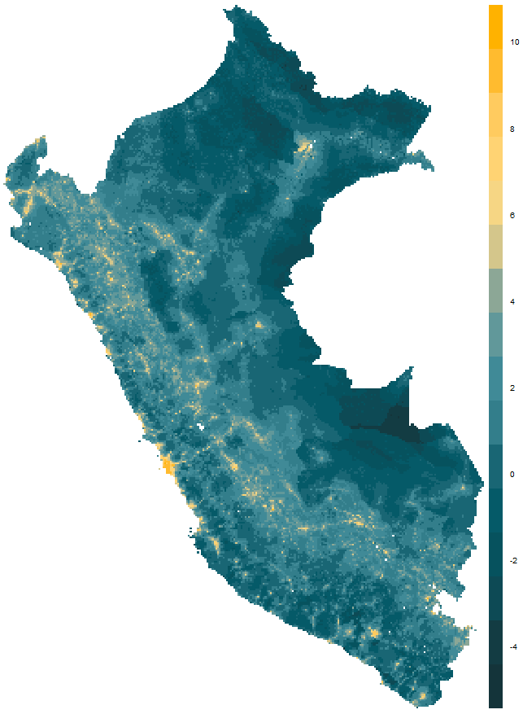
Supplementary Figure 1 – Map of log of population density in Peru
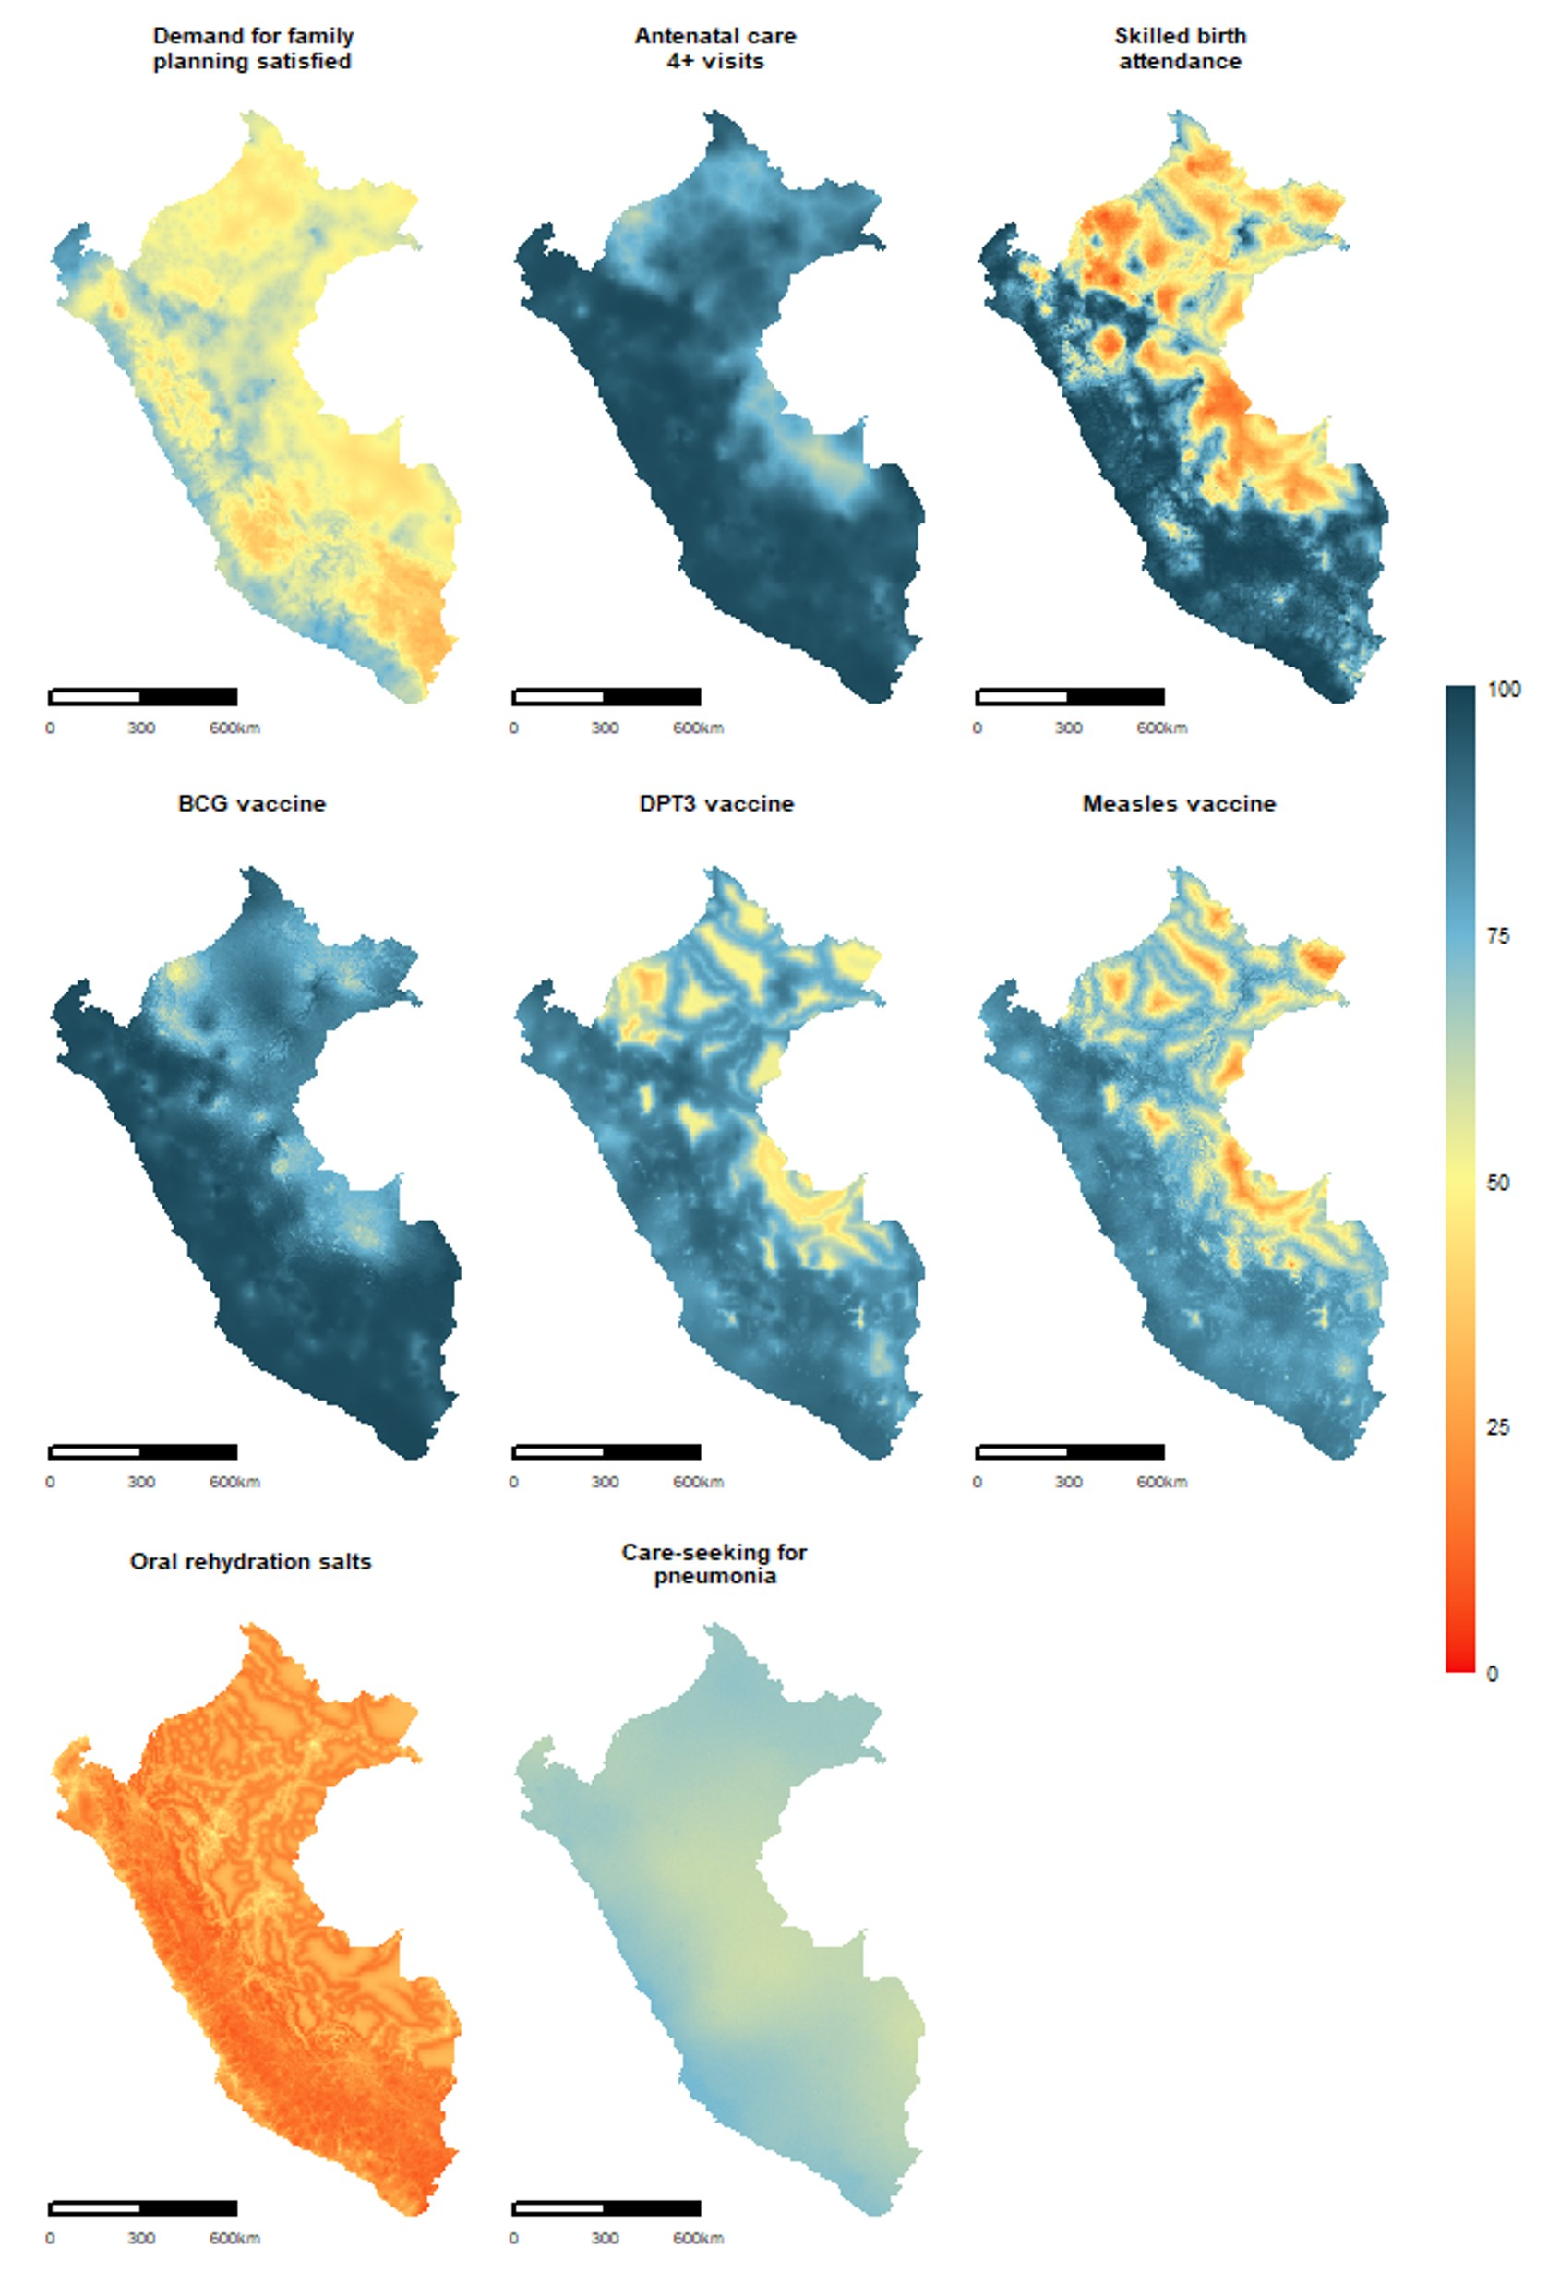
Supplementary Figure 2 – Predicted coverage for all eight composite coverage index (CCI) indicators in Peru

