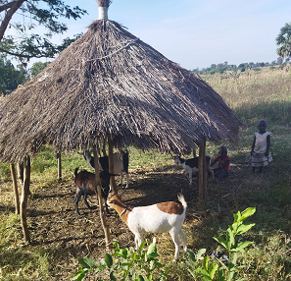
Figure 1: showing interaction between humans, animals and the environment.
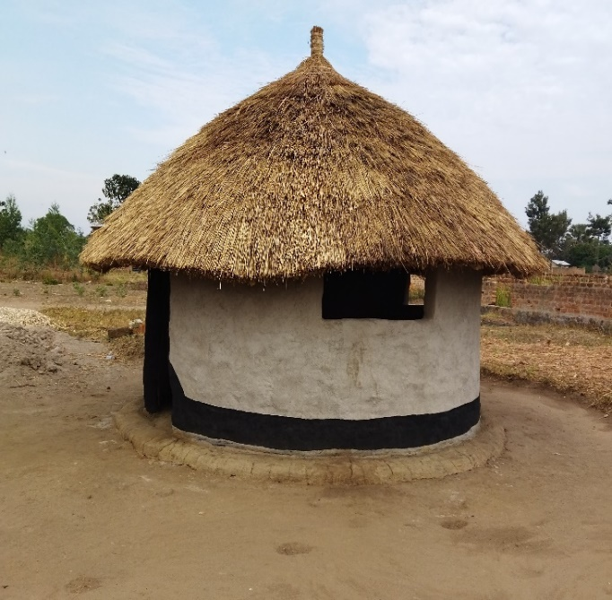
Figure 2: Showing the use of animal droppings in construction of houses.

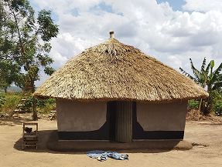
Figure 3: Showing the use of animal droppings in construction of houses.

