Supplementary material

- Causal diagram
The causal diagram used in the confounder selection process is presented here, accompanied by a table explaining the connections between factors/variables (see Rothman et al., 2008 for a detailed tutorial). The exposure and outcome are in a d-connected relation (highlighted in blue) after adjustment (variables in squares), meaning no confounder bias if the diagram is correct. The direction of linkages dictates chronological relation and dependency.
D-connected relation suggests that all back-door paths are closed, and only direct paths between the exposure and outcome remain open (Pearl, 2009). For example, in supplementary figure 1, social deprivation is a confounder because it affects both the exposure and outcome (indirectly through other variables). Any path connecting confounders to the outcome (not through the exposure), regardless of the direction of arrows, is a back-door path, such as Link 23 -> 25 -> 15. A path is naturally open if there is no collider (e.g., given X -> Y <- Z, Y is collider as both X and Z point to it), or closed when a collider is present. Adjusting for a collider opens the path (e.g., the dashed paths resulted from adjusting for ‘overdose’ and ‘prior experience’), otherwise conditioning on non-colliders would close the naturally open paths (e.g., Link 25 -> 14).

  - Diagram
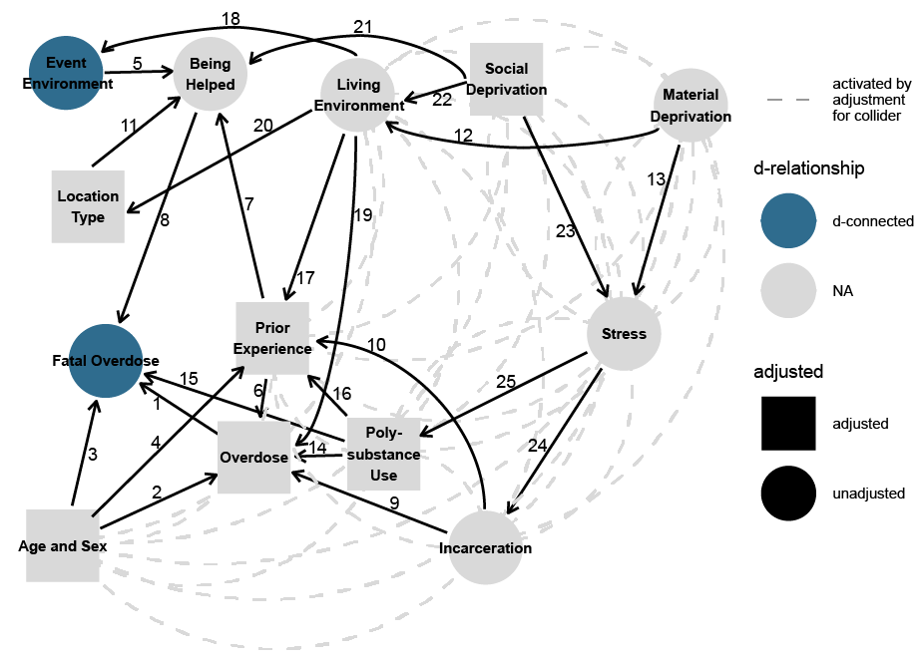
Supplementary figure 1. Causal diagram for the path between event environment and fatal overdose based on literature review.

  - Explanation table
Supplementary table 1. Explanations for the links in the causal diagram for the path between event environment and fatal overdose.
To | From | Link No. | Connection
Fatal overdose | Overdose | 1 | Overdose occurred before the fatal/non-fatal outcome
Fatal overdose | Age and sex | 3 | Individual conditions that are known to affect the outcome of an overdose (Martins et al., 2015)
Fatal overdose | Being helped | 8 | Death could be prevented if the overdose event was witnessed
Fatal overdose | Poly-substance use | 15 | Using opioids (a depressant) with other sedatives, e.g., benzodiazepines, could double the depressant effect, which also affects the chance of death (White and Irvine, 1999)
Being helped | Event environment | 5 | Events happened in urban areas with higher population density could be more likely to be witnessed and helped
Being helped | Prior experience | 7 | People with overdose experience may be more likely to use naloxone kits or harm reduction services due to fear of death
Being helped | Location type | 11 | Events that happened in public buildings or outside are more likely to be witnessed and helped compared to those in private residences
Being helped | Social deprivation | 21 | Socially deprived people may tend to use drugs alone, reducing the chance of being witnessed
Overdose | Age and sex | 2 | Individual conditions that are known to affect overdose occurrence
Overdose | Prior experience | 6 | People with overdose experience may use services, e.g., OAT, affecting the chance of having recurrent events
Overdose | Incarceration | 9 | Recent releases from prison are associated with elevated overdose risk (Bukten et al., 2017)
Overdose | Poly-substance use | 14 | Similar to Link 15, Poly-substance use could also affect the likelihood of overdose (Kerr et al., 2007)
Overdose | Living environment | 19 | The living environment determines access to healthcare and the availability/prevalence of illicit drug supply. A specific drug that is prevalent in a particular region could be more toxic than the prevalent drugs in other places (Amlani et al., 2015), leading to spatial variations in overdose occurrence.
Living environment | Material deprivation | 12 | People that are materially deprived tend to live in low-income neighborhoods
Living environment | Social deprivation | 22 | People that are socially deprived tend to live in places such as single room apartments
Stress | Material deprivation | 13 | Economic burden creates stress
Stress | Social deprivation | 23 | Social isolation creates stress
Event location | Living environment | 18 | Events may tend to happen in the vicinity of residence, given that most happened in private residences
Location type | Living environment | 20 | Location type could be independent of event location, e.g., indoor/outdoor at the same location. However, it may depend on neighborhoods (e.g., a specific type does not exist in some neighborhoods)
Prior experience | multiple factors | 4,10,16,17 | All factors that affect overdose occurrence would also affect the chance of having prior experience
Poly-substance use,  Incarceration | Stress | 24, 25 | Stress from socioeconomic conditions may lead to substance abuse and related crime (Williams and Latkin, 2007)

- Sensitivity analysis results

  - Impact of data exclusion
Supplementary table 2. Comparison between two identical models of fatal overdose risk, with (n = 35569) and without (n = 42711) filtering records with missing location information.
 | Presented Model |  |  | Model without Filtering Data
Variable | OR¹ | 95% CI | p-value | OR² | 95% CI | p-value
Urbanicity
Large | — | — |  | — | —
Medium | 1.27 | 1.10, 1.47 | 0.001 | 1.36 | 1.18, 1.56 | <0.001
Small | 1.22 | 1.01, 1.47 | 0.035 | 1.35 | 1.13, 1.62 | 0.001
Rural | 1.57 | 1.29, 1.90 | <0.001 | 1.62 | 1.34, 1.96 | <0.001
Recurrent Event
No | — | — |  | — | —
Yes | 0.52 | 0.48, 0.56 | <0.001 | 0.52 | 0.48, 0.56 | <0.001
Age
18 - 29 | — | — |  | — | —
<18 | 0.50 | 0.36, 0.71 | <0.001 | 0.52 | 0.37, 0.72 | <0.001
30 - 49 | 1.73 | 1.59, 1.89 | <0.001 | 1.74 | 1.60, 1.89 | <0.001
50 - 64 | 2.71 | 2.45, 2.99 | <0.001 | 2.75 | 2.50, 3.03 | <0.001
≥65 | 2.76 | 2.37, 3.22 | <0.001 | 3.12 | 2.70, 3.61 | <0.001
Sex
F | — | — |  | — | —
M | 1.62 | 1.50, 1.75 | <0.001 | 1.61 | 1.49, 1.73 | <0.001
Social Deprivation
Q3 | — | — |  | — | —
Q1 | 1.28 | 1.12, 1.46 | <0.001 | 1.24 | 1.09, 1.41 | 0.001
Q2 | 1.08 | 0.95, 1.22 | 0.2 | 1.07 | 0.95, 1.20 | 0.3
Q4 | 0.99 | 0.88, 1.11 | 0.9 | 0.97 | 0.87, 1.09 | 0.6
Q5 | 0.96 | 0.87, 1.06 | 0.4 | 0.94 | 0.85, 1.04 | 0.2
Benzodiazepines Prescription
No | — | — |  | — | —
Yes | 1.43 | 1.26, 1.63 | <0.001 | 1.44 | 1.27, 1.63 | <0.001
Other Sedatives Prescription | — | — |  | — | —
No | 0.89 | 0.81, 0.96 | 0.005 | 0.88 | 0.81, 0.95 | 0.002
Yes
Opioids for pain Prescription | — | — |  | — | —
No | 1.14 | 1.00, 1.30 | 0.054 | 1.18 | 1.04, 1.34 | 0.009
Yes | 1.27 | 1.10, 1.47 | 0.001 | 1.36 | 1.18, 1.56 | <0.001
Year
2015-2016 | — | — |  | — | —
2017-2018 | 1.40 | 1.29, 1.52 | <0.001 | 1.47 | 1.36, 1.60 | <0.001
Urbanicity * Year
Medium * 2017-2018 | 0.86 | 0.72, 1.03 | 0.11 | 0.80 | 0.67, 0.96 | 0.014
Small * 2017-2018 | 1.07 | 0.86, 1.35 | 0.5 | 0.98 | 0.79, 1.22 | 0.9
Rural * 2017-2018 | 0.89 | 0.70, 1.14 | 0.4 | 0.89 | 0.70, 1.12 | 0.3
¹Adjusted for all covariates except location type
²Adjusted for the same covariates including data with missing location type

  - Comparison between spatial and non-spatial models
Supplementary table 3. Comparison between a conventional logistic regression model of fatal overdose risk and an equivalent Generalized Additive Model with spatial smoothing.
 | Urbanicity Model |  |  | Spatial Smoothing Model
Variable | OR¹ | 95% CI¹ | p-value | OR¹ | 95% CI¹ | p-value
Urbanicity
Large | — | — |  | — | —
Medium | 1.14 | 0.98, 1.32 | 0.090
Small | 1.03 | 0.85, 1.24 | 0.8
Rural | 1.31 | 1.07, 1.60 | 0.009
Location Type
Private | — | — |  | — | —
Public Buildings | 0.08 | 0.06, 0.09 | <0.001 | 0.20 | 0.18, 0.22 | <0.001
Healthcare Facilities | 0.19 | 0.14, 0.27 | <0.001 | 0.32 | 0.27, 0.37 | <0.001
Outdoor | 0.16 | 0.15, 0.18 | <0.001 | 0.29 | 0.27, 0.31 | <0.001
Others | 0.65 | 0.57, 0.75 | <0.001 | 0.68 | 0.62, 0.74 | <0.001
Recurrent Event
No | — | — |  | — | —
Yes | 0.60 | 0.56, 0.65 | <0.001 | 1.5 | 1.5, 1.6 | <0.001
Age
<30 | — | — |  | — | —
<18 | 0.54 | 0.38, 0.76 | <0.001 | 0.55 | 0.39, 0.78 | <0.001
<50 | 1.68 | 1.54, 1.83 | <0.001 | 1.8 | 1.6, 1.9 | <0.001
<65 | 2.30 | 2.07, 2.54 | <0.001 | 2.6 | 2.3, 2.8 | <0.001
65+ | 2.24 | 1.91, 2.64 | <0.001 | 2.6 | 2.2, 3.0 | <0.001
Sex
F | — | — |  | — | —
M | 1.81 | 1.67, 1.96 | <0.001 | 1.8 | 1.6, 1.9 | <0.001
Social Deprivation
Q3 | — | — |  | — | —
Q1 | 1.22 | 1.06, 1.40 | 0.004 | 1.3 | 1.1, 1.4 | 0.001
Q2 | 1.12 | 0.99, 1.27 | 0.083 | 1.1 | 1.0, 1.3 | 0.075
Q4 | 1.00 | 0.88, 1.12 | >0.9 | 1.0 | 0.89, 1.1 | 0.9
Q5 | 1.00 | 0.90, 1.11 | >0.9 | 1.0 | 0.87, 1.1 | 0.5
Benzodiazepines Prescription
No | — | — |  | — | —
Yes | 1.37 | 1.20, 1.56 | <0.001 | 1.4 | 1.2, 1.6 | <0.001
Other Sedatives Prescription
No | — | — |  | — | —
Yes | 0.88 | 0.81, 0.96 | 0.004 | 0.86 | 0.79, 0.94 | 0.001
Opioids for pain Prescription
No | — | — |  | — | —
Yes | 1.04 | 0.91, 1.19 | 0.6 | 1.1 | 1.0, 1.3 | 0.10
Year
2015-2016 | — | —
2017-2018 | 1.39 | 1.28, 1.52 | <0.001
Urbanicity * Year
Medium * 2017-2018 | 0.91 | 0.75, 1.09 | 0.3
Small * 2017-2018 | 1.05 | 0.83, 1.33 | 0.7
Rural * 2017-2018 | 0.90 | 0.70, 1.15 | 0.4
¹OR = Odds Ratio, CI = Confidence Interval

  - Alternative smoothers
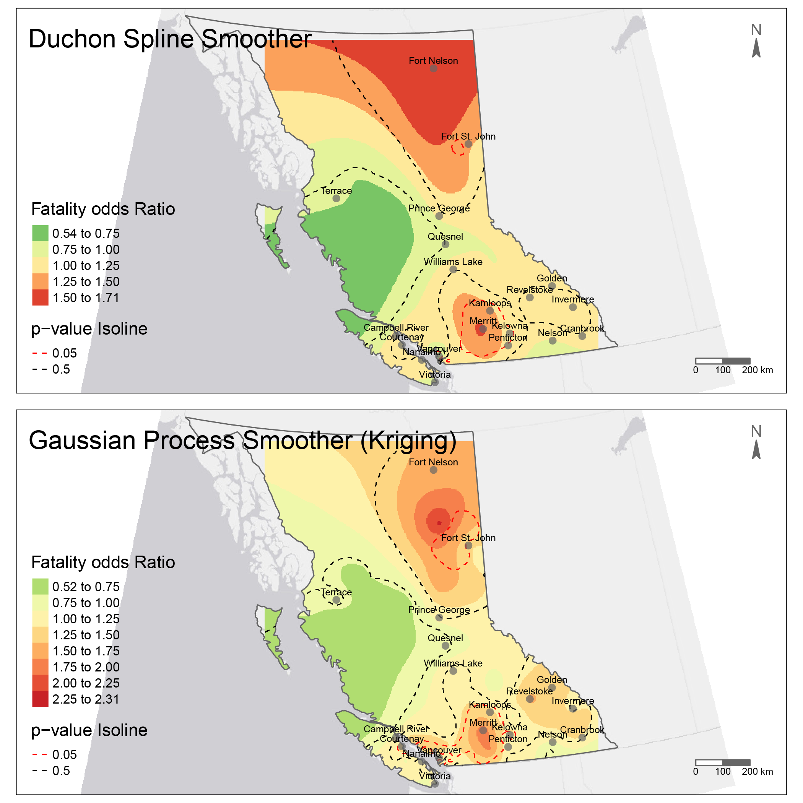
Supplementary figure 2. Comparison between two identical Generalized Additive Models of fatal overdose risk with different spatial smoothers.

- Reference
Amlani, A., McKee, G., Khamis, N., Raghukumar, G., Tsang, E., Buxton, J.A., 2015. Why the FUSS (Fentanyl Urine Screen Study)? A cross-sectional survey to characterize an emerging threat to people who use drugs in British Columbia, Canada. Harm Reduct. J. 12, 1–7. https://doi.org/10.1186/s12954-015-0088-4
Bukten, A., Stavseth, M.R., Skurtveit, S., Tverdal, A., Strang, J., Clausen, T., 2017. High risk of overdose death following release from prison: variations in mortality during a 15-year observation period. Addiction 112, 1432–1439. https://doi.org/10.1111/add.13803
Kerr, T., Fairbairn, N., Tyndall, M., Marsh, D., Li, K., Montaner, J., Wood, E., 2007. Predictors of non-fatal overdose among a cohort of polysubstance-using injection drug users. Drug Alcohol Depend. 87, 39–45. https://doi.org/10.1016/j.drugalcdep.2006.07.009
Martins, S.S., Sampson, L., Cerdá, M., Galea, S., 2015. Worldwide prevalence and trends in unintentional drug overdose: A systematic review of the literature. Am. J. Public Health 105, e29–e49. https://doi.org/10.2105/AJPH.2015.302843
Pearl, J., 2009. Causality. Cambridge University Press, New York, UNITED STATES.
Rothman, K.J., Greenland, S., Lash, T.L., 2008. Modern epidemiology. Lippincott Williams \& Wilkins.
White, J.M., Irvine, R.J., 1999. Mechanisms of fatal opioid overdose. Addiction 94, 961–972. https://doi.org/10.1046/j.1360-0443.1999.9479612.x
Williams, C.T., Latkin, C.A., 2007. Neighborhood Socioeconomic Status, Personal Network Attributes, and Use of Heroin and Cocaine. Am. J. Prev. Med. 32, S203. https://doi.org/10.1016/J.AMEPRE.2007.02.006

