Amplified effect of social vulnerability on health inequality regarding COVID-19 mortality: The mediating role of vaccination allocation
Supplementary Figure 1. Graphical maps of the Social Vulnerability Index 2018 by themes at the county level in USA
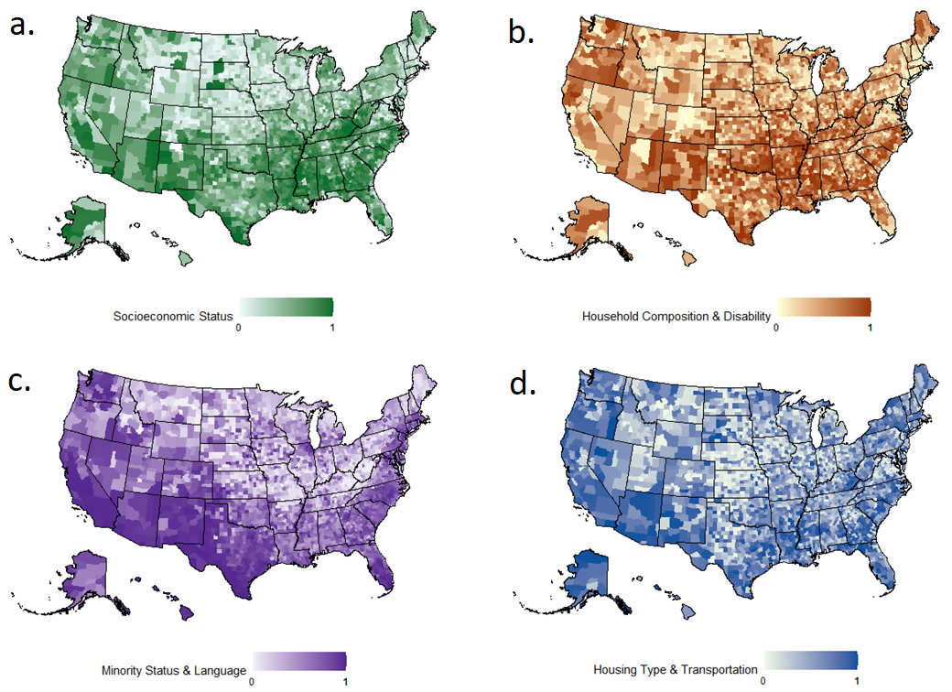

Supplementary Table 1. Vaccination coverage rate of COVID-19, and case fatality rate of COVID-19 at the county level of USA on 31st March, 30th June, 30th September, and 31st December 2021
Mean
(Standard Deviation)
Vaccination coverage rate of COVID-19
Fully vaccinated, on 31st March 2021 | 0.137 (0.075)
Fully vaccinated, on 30th June 2021 | 0.308 (0.154)
Fully vaccinated, on 30th September 2021 | 0.386 (0.167)
Fully vaccinated, on 31st December 2021 | 0.472 (0.131)
Case fatality rate of COVID-19
Rate on 31st March 2021 | 0.020 (0.010)
Rate on 30th June 2021 | 0.020 (0.010)
Rate on 30th September 2021 | 0.017 (0.009)
Rate on 31st December 2021 | 0.017 (0.008)

Supplementary Table 2. Association of social vulnerability index with vaccination coverage rate of COVID-19 (fully vaccinated, based on the data of 31st March 2021, 30th September 2021, and 31st December 2021)
31st March 2021 | Simple regression analyses |  | Multiple regression analysis
31st March 2021 | Regression coefficient (99.9% confidence intervals) | R²  (for individual variables) | Regression coefficient  (99.9% confidence intervals) | R²  (for the whole model)
Individual variable
Socioeconomic status | -0.0318 (-0.0405, -0.0231) | 0.0441 | -0.0293 (-0.0392, -0.0193) | -
Household composition & disability | -0.0107 (-0.0196, -0.0018) | 0.0047 | 0.0045 (-0.0053, 0.0143) | -
Minority status & language | -0.0325 (-0.0412, -0.0238) | 0.0461 | -0.0277 (-0.0364, -0.0190) | -
Housing type & transportation | -0.0076 (-0.0165, 0.0013) | - | - | -
Model | - | - | - | 0.0774
30th September 2021 | Simple regression analyses |  | Multiple regression analysis
30th September 2021 | Regression coefficient (99.9% confidence intervals) | R²  (for individual variables) | Regression coefficient  (99.9% confidence intervals) | R²  (for the whole model)
Individual variable
Socioeconomic status | -0.0992 (-0.1179, -0.0804) | 0.0883 | -0.0847 (-0.1065, -0.0630) | -
Household composition & disability | -0.0660 (-0.0853, -0.0467) | 0.0389 | -0.0244 (-0.0458, -0.0029) | -
Minority status & language | -0.0307 (-0.0503, -0.0111) | 0.0082 | -0.0155 (-0.0345, 0.0036) | -
Housing type & transportation | -0.0050 (-0.0246, 0.0147) | - |  | -
Model | - | - | - | 0.0936
31st December 2021 | Simple regression analyses |  | Multiple regression analysis
31st December 2021 | Regression coefficient (99.9% confidence intervals) | R²  (for individual variables) | Regression coefficient  (99.9% confidence intervals) | R²  (for the whole model)
Individual variable
Socioeconomic status | -0.0729 (-0.0878, -0.0580) | 0.0767 | -0.0676 (-0.0847, -0.0506) | -
Household composition & disability | -0.0551 (-0.0703, -0.0399) | 0.0437 | -0.0236 (-0.0404, -0.0068) | -
Minority status & language | 0.0242 (0.0087, 0.0396) | 0.0081 | 0.0364 (0.0215, 0.0514) | -
Housing type & transportation | 0.0152 (-0.0003, 0.0307) | - | - | -
Model | - | - | - | 0.1022

Supplementary Table 3. Association of social vulnerability index and vaccination coverage rate of COVID-19 with case fatality rate of COVID-19 (fully vaccinated, based on the data of 31st March 2021, 30th September 2021, and 31st December 2021)
31st March 2021 | Simple regression analyses |  | Multiple regression analysis
31st March 2021 | Regression coefficient (99.9% confidence intervals) | R²  (for individual variables) | Regression coefficient  (99.9% confidence intervals) | R²  (for the whole model)
Individual variable
Social vulnerability index
Socioeconomic status | 0.0043 (0.0031, 0.0055) | 0.0424 | 0.0023 (0.0009, 0.0037) | -
Household composition & disability | 0.0042 (0.0030, 0.0054) | 0.0406 | 0.0029 (0.0015, 0.0043) | -
Minority status & language | 0.0001 (-0.0012, 0.0013) | - | - | -
Housing type & transportation | 0.0004 (-0.0009, 0.0016) | - | - | -
Vaccination coverage rate of COVID-19 | -0.0238 (-0.0319, -0.0158) | 0.0294 | -0.0193 (-0.0273, -0.0112) | -
Model | - | - | - | 0.0739
30th September 2021 | Simple regression analyses |  | Multiple regression analysis
30th September 2021 | Regression coefficient (99.9% confidence intervals) | R²  (for individual variables) | Regression coefficient  (99.9% confidence intervals) | R²  (for the whole model)
Individual variable
Social vulnerability index
Socioeconomic status | 0.0038 (0.0028, 0.0048) | 0.0490 | 0.0018 (0.0006, 0.0029) | -
Household composition & disability | 0.0036 (0.0026, 0.0046) | 0.0437 | 0.0021 (0.0009, 0.0032) | -
Minority status & language | 0.0003 (-0.0007, 0.0013) | - | - | -
Housing type & transportation | 0.0002 (-0.0008, 0.0012) | - | - | -
Vaccination coverage rate of COVID-19 | -0.0137 (-0.0167, -0.0107) | 0.0693 | -0.0109 (-0.0139, -0.0078) | -
Model | - | - | - | 0.1020
31st December 2021 | Simple regression analyses |  | Multiple regression analysis
31st December 2021 | Regression coefficient (99.9% confidence intervals) | R²  (for individual variables) | Regression coefficient  (99.9% confidence intervals) | R²  (for the whole model)
Individual variable
Social vulnerability index
Socioeconomic status | 0.0054 (0.0045, 0.0064) | 0.1122 | 0.0033 (0.0023, 0.0044) | -
Household composition & disability | 0.0047 (0.0038, 0.0056) | 0.0839 | 0.0024 (0.0014, 0.0034) | -
Minority status & language | 0.0002 (-0.0007, 0.0012) | - | - | -
Housing type & transportation | 0.0007 (-0.0003, 0.0016) | - | - | -
Vaccination coverage rate of COVID-19 | -0.0186 (-0.0221, -0.0151) | 0.0904 | -0.0132 (-0.0167, -0.0097) | -
Model | - | - | - | 0.1747

Supplementary Table 4. Quantification of medication effects (based on the data of 30th March 2021, 31st September 2021, and 31st December 2021)
31st March 2021 | By social vulnerability index domain |  |  | Overall
 | Socioeconomic status | Household composition & disability | Minority status & language
Path a: (X > M) | -0.0293 | 0.0045 | -0.0277 | -
Path b: (M > Y) | 0.0238 | -0.0238 | -0.0238 | -
Indirect effect (a×b: X > M > Y) | 0.0007 | -0.0001 | 0.0007 | 0.0012
Direct effect (Path c’: X > Y adjusted for M) | 0.0023 | 0.0029 | - | 0.0052
Total effect (Path c: X > Y) | 0.0030 | 0.0028 | 0.0007 | 0.0064
Mediated (a×b/c), % | 23.3 | -3.8 | 100.0 | 19.4
30th September 2021 | By social vulnerability index domain |  |  | Overall
 | Socioeconomic status | Household composition & disability | Minority status & language
Path a: (X > M) | -0.0847 | -0.0244 | -0.0155 | -
Path b: (M > Y) | -0.0137 | -0.0137 | -0.0137 | -
Indirect effect (a×b: X > M > Y) | 0.0012 | 0.0003 | 0.0002 | 0.0017
Direct effect (Path c’: X > Y adjusted for M) | 0.0018 | 0.0021 | - | 0.0039
Total effect (Path c: X > Y) | 0.0030 | 0.0024 | 0.0002 | 0.0056
Mediated (a×b/c), % | 39.2 | 13.7 | 100.0 | 30.4
31st December 2021 | By social vulnerability index domain |  |  | Overall
 | Socioeconomic status | Household composition & disability | Minority status & language
Path a: (X > M) | -0.0676 | -0.0236 | 0.0364 | -
Path b: (M > Y) | -0.0186 | -0.0186 | -0.0186 | -
Indirect effect (a×b: X > M > Y) | 0.0013 | 0.0004 | -0.0007 | 0.0010
Direct effect (Path c’: X > Y adjusted for M) | 0.0033 | 0.0024 | - | 0.0057
Total effect (Path c: X > Y) | 0.0046 | 0.0028 | -0.0007 | 0.0067
Mediated (a×b/c), % | 27.6 | 15.5 | 100.0 | 15.2

