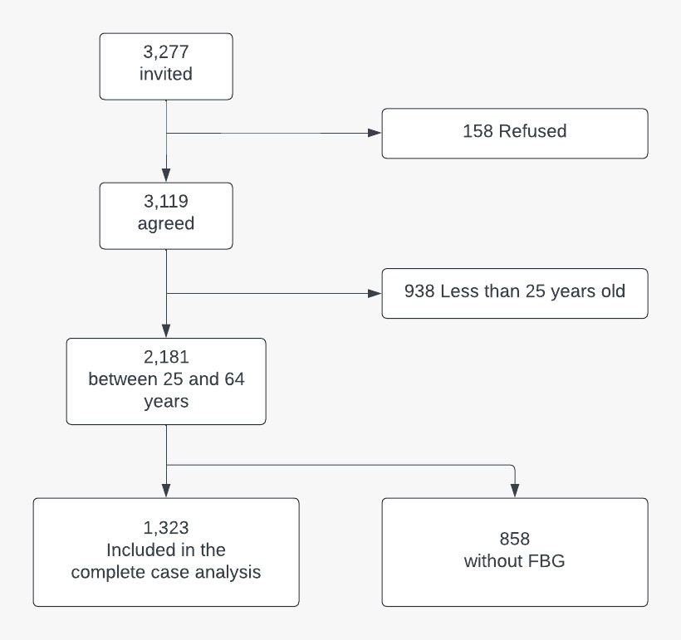
Figure 1 - Flowchart of the participants included and excluded in the study sample

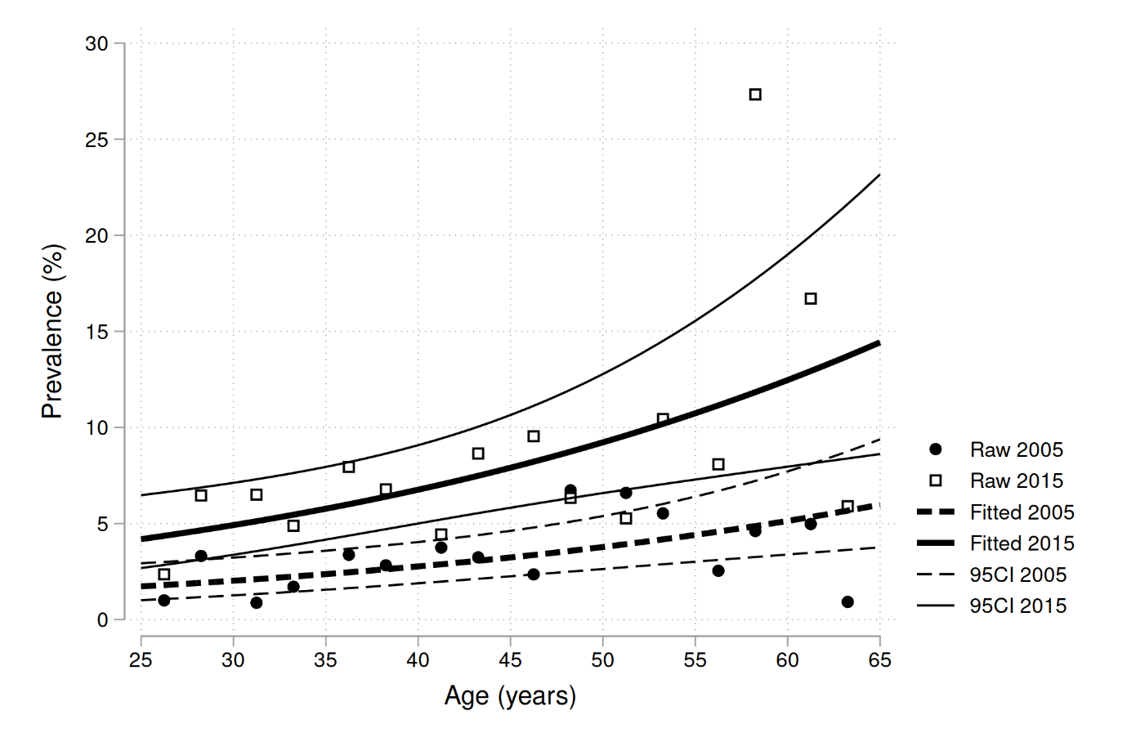
Figure 2 - 2005 and 2015 comparison of type 2 diabetes prevalence trend in adult Mozambican population from 25 to 65 years.
The points are raw prevalence for each 2.5 years age group. The lines are fitted from a logistic regression on the aggregated dataset.

