Figure Legend
Supplemental Figure S1: Age and sex adjusted rates of individuals dispensed antidepressants by census division (per 1,000 population)
Supplemental Figure S2: Age and sex adjusted rates of individuals dispensed stimulants by census division (per 1,000 population)
Supplemental Figure S3: Age and sex adjusted rates of individuals dispensed benzodiazepines by census division (per 1,000 population)
Supplemental Figure S4: Age and sex adjusted rates of individuals dispensed antipsychotics by census division (per 1,000 population)

Supplemental Figure S1: Age and sex adjusted rates of individuals dispensed antidepressants by census division (per 1,000 population)
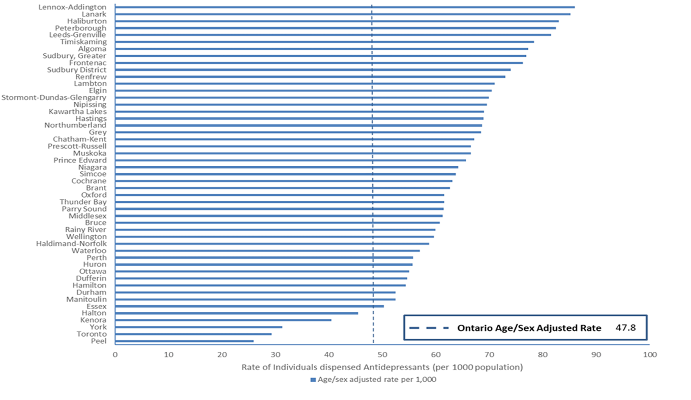

Supplemental Figure S2: Age and sex adjusted rates of individuals dispensed stimulants by census division (per 1,000 population)
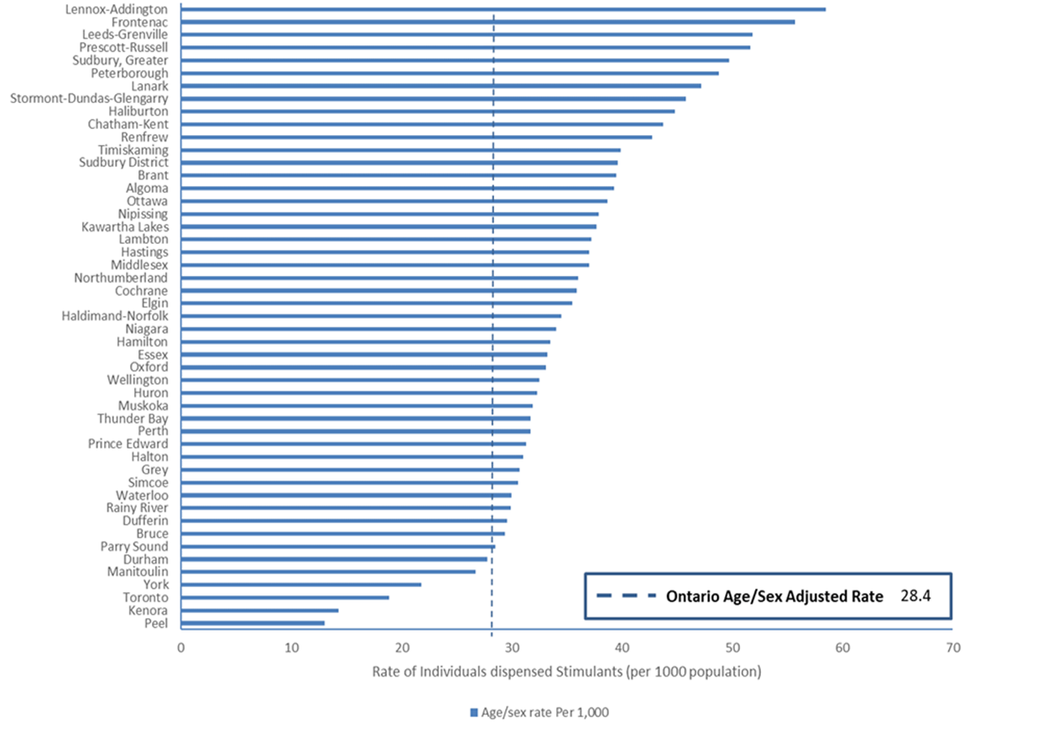

Supplemental Figure S3: Age and sex adjusted rates of individuals dispensed benzodiazepines by census division (per 1,000 population)
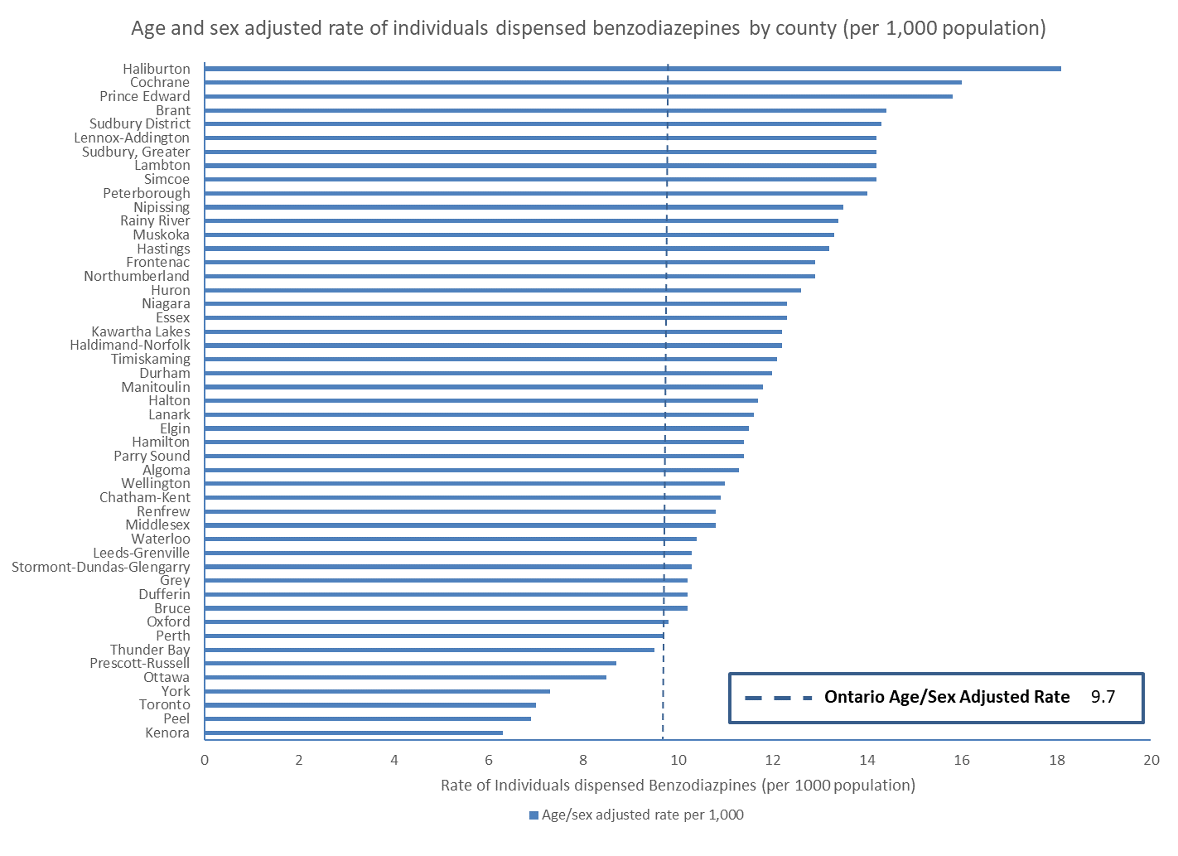

Supplemental Figure S4: Age and sex adjusted rates of individuals dispensed antipsychotics by census division (per 1,000 population)
