Supplementary Figures/Tables: Identifying long-term effects of SARS-CoV-2 and their association with social determinants of health in a cohort of over one million COVID-19 survivors
Authors: Sumit Mukherjee⁵* (BS, MS, PHD), Meghana Kshirsagar¹* (BS, MS, PHD), Nicholas Becker^{1,2} (BS, MS), Yixi Xu¹ (BS, PHD), William B Weeks³ (BS, MD, MBA, PHD), Shwetak Patel² (BS, PHD), Juan Lavista Ferres¹ (BS, MS), Michael L. Jackson⁴ (BA, MPH, PHD).
*Equal contributing authors in random order of names
¹AI for Good Research Lab, Microsoft Corporation, Redmond, USA.
²University of Washington, Seattle, USA.
³Microsoft Corporation, Paris, France.
⁴Kaiser Permanente Washington, Seattle, USA.
⁵Insitro Labs, USA

Corresponding author: Dr. Meghana Kshirsagar, email: Meghana.Kshirsagar@microsoft.com, postal address: 1 Microsoft Way, Redmond, WA 98052, phone: +1 (425) 4218258.

Contents
Supplementary Figure 1: Study design showing the time periods for defining the co-morbidities, the outcome and control periods with respect to the COVID-19 onset date. A) Study design for identification of long-term effects and their association with SDOH variables. B) Study design for identification of long-term effects in different one-month windows post-diagnosis.
Supplementary Table 1: 4 digit ICD10 codes (in the D84.* and G93.* range) that were observed in a significantly higher proportion in the post-covid window compared to the control window.
Supplementary Table 2: Co-occurring patterns whose presence was significantly higher in the post-COVID period compared to the control period. Reported statistics and p-values computed on the non-SDOH cohort.
Supplementary Figure 2: Association analysis of comorbidity and past conditions with ICD10 codes corresponding to long term effects of COVID-19. Green indicates no association, blue indicates a negative association, yellow indicates a positive association.
Supplementary Figure 3: CONSORT diagram showing the cohort

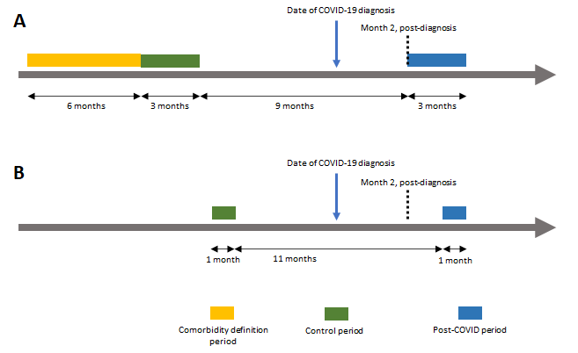
Supplementary Figure 1: Study design showing the time periods for defining the co-morbidities, the outcome and control periods with respect to the COVID-19 onset date. A) Study design for identification of long-term effects and their association with SDOH variables. B) Study design for identification of long-term effects in different one-month windows post-diagnosis.

ICD10 | Condition | Control% | Post% | p-value
D84.9 | Immunodeficiency | 0.029 | 0.047 | 3.11E-09
G93.1 | Anoxic brain damage | 0.033 | 0.050 | 6.20E-08
G93.3 | Postviral fatigue syndrome | 0.015 | 0.066 | 1.92E-55
G93.4 | Unspecified encephalopathy | 0.492 | 0.605 | 9.03E-22
G93.6 | Cerebral edema | 0.020 | 0.028 | 2.79E-04

Supplementary Table 1: 4 digit ICD10 codes (in the D84.* and G93.* range) that were observed in a significantly higher proportion in the post-covid window compared to the control window.

ICD10 | Control% | Post% | p-value
D64, I10 | 1.126794 | 1.15878 | 3.1E-02

Supplementary Table 2: Co-occurring patterns whose presence was significantly higher in the post-COVID period compared to the control period. Reported statistics and p-values computed on the non-SDOH cohort.

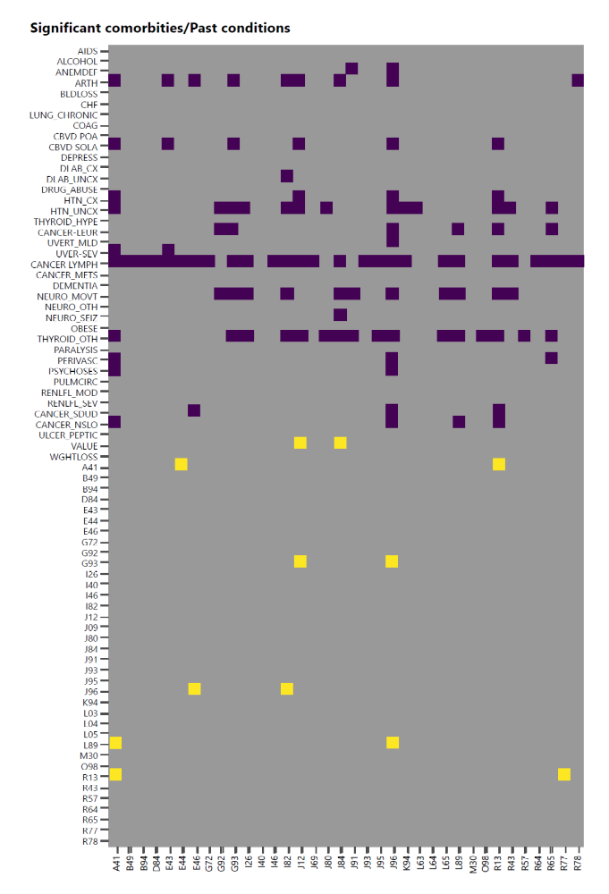Supplementary Figure 2: Association analysis of comorbidity and past conditions with ICD10 codes corresponding to long term effects of COVID-19. Green indicates no association, blue indicates a negative association, yellow indicates a positive association.

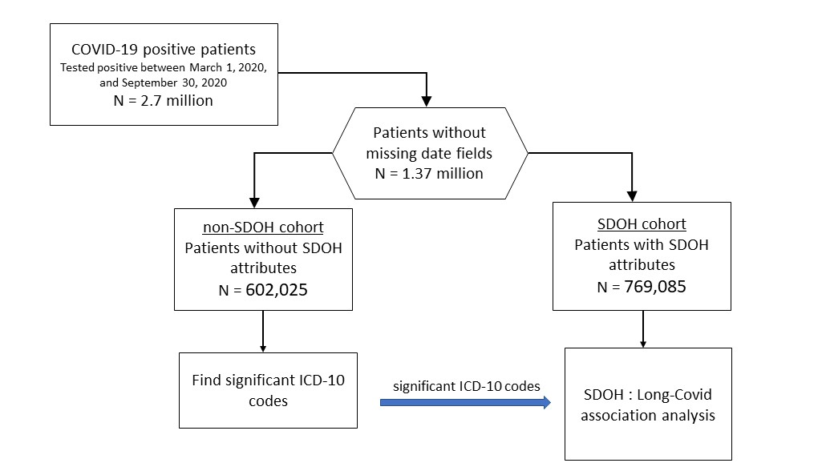
Supplementary Figure 3: FLOW diagram showing the study cohort

