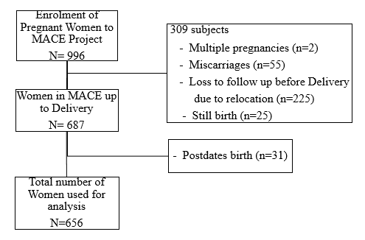
SupFigure 1. Flowchart illustrating final number of participant women used in the study from MACE birth cohort

