Supplemental Appendix
Supplemental table A1 AOM Read diagnosis code definitions
Read code | Read term
F526.00 | Acute left otitis media
F528.00 | Acute bilateral otitis media
F527.00 | Acute right otitis media
F525.00 | Recurrent acute otitis media
SN30.11 | Aero-otitis media
A552.00 | Postmeasles otitis media
F520100 | Acute suppurative otitis media tympanic membrane ruptured
F520z00 | Acute suppurative otitis media NOS
F520.00 | Acute suppurative otitis media
F520300 | Acute suppurative otitis media due to disease EC
F520000 | Acute suppurative otitis media tympanic membrane intact
F52..00 | Suppurative and unspecified otitis media
F524000 | Bilateral suppurative otitis media
F523.00 | Chronic suppurative otitis media NOS
FyuP200 | [X]Other chronic suppurative otitis media
F52z.00 | Otitis media NOS
FyuP400 | [X]Otitis media in viral diseases classified elsewhere
FyuP300 | [X]Otitis media in bacterial diseases classified elsewhere
F521.00 | Chronic suppurative otitis media, tubotympanic
F522.00 | Chronic suppurative otitis media, atticoantral
Abbreviations: AOM: acute otitis media; EC: elsewhere classified; NOS: not otherwise specified.

Supplement Figure A1 Study population flowchart
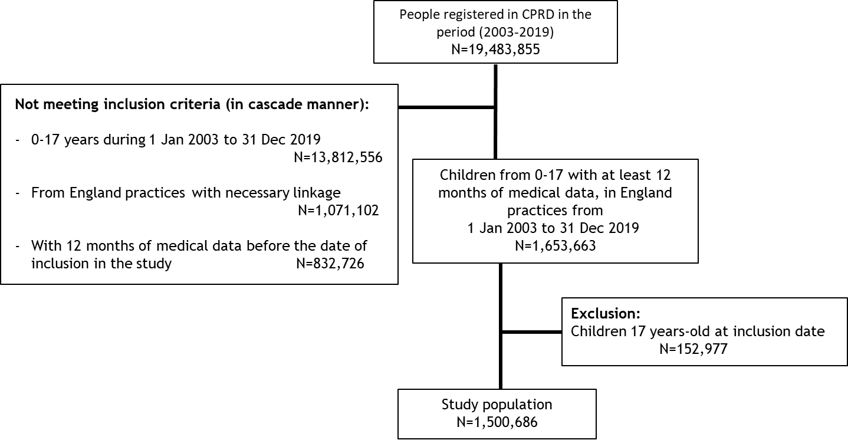
Supplemental table A2 Overall AOM IRs by age group (2003-2019)
 | Overall |  | <2 years |  | 2-4 years |  | 5-17 years
 | N episodes | Rate per 100,000 PY (95% CI) | N episodes | Rate per 100,000 PY (95% CI) | N episodes | Rate per 100,000 PY (95% CI) | N episodes | Rate per 100,000 PY (95% CI)
2003 | 22899 | 4871.4  (4808.5-4934.9) | 3799 | 10598.7  (10264.3-10941.2) | 8235 | 10704.5  (10474.6-10938.3) | 10865 | 3040.9  (2984.0-3098.6)
2004 | 21629 | 4318.5  (4261.1-4376.4) | 4425 | 10390.3  (10086.4-10701.1) | 7425 | 9256.2  (9046.9-9469.2) | 9779 | 2586.7  (2535.7-2638.5)
2005 | 21910 | 4201.8  (4146.4-4257.8) | 4104 | 9070.9  (8795.5-9352.8) | 7674 | 9158.1  (8954.4-9365.4) | 10132 | 2582.0  (2532.0-2632.8)
2006 | 21375 | 3978.1  (3925.0-4031.8) | 4059 | 8687.4  (8422.2-8958.9) | 7713 | 8806.7  (8611.3-9005.5) | 9603 | 2382.8  (2335.4-2431.0)
2007 | 21813 | 3967.4  (3914.9-4020.4) | 4211 | 8553.7  (8297.3-8816.0) | 7882 | 8666.0  (8475.7-8859.5) | 9720 | 2372.9  (2325.9-2420.5)
2008 | 22175 | 3952.8  (3901.0-4005.2) | 4605 | 9026.5  (8767.7-9291.0) | 7966 | 8424.4  (8240.4-8611.4) | 9604 | 2311.9  (2265.9-2358.6)
2009 | 20999 | 3720.1  (3669.9-3770.7) | 4443 | 8676.6  (8423.3-8935.6) | 7459 | 7737.3  (7562.7-7914.9) | 9097 | 2182.2  (2137.6-2227.5)
2010 | 20894 | 3742.4  (3691. 9-3793.5) | 4219 | 8329.2  (8079.8-8584.4) | 7756 | 7974.3  (7797.8-8153.7) | 8919 | 2173.3  (2128.5-2218.9)
2011 | 19098 | 3505.2  (3455.7-3555.3) | 3891 | 7739.7  (7498.4-7986.8) | 6942 | 7275.8  (7105.6-7449.0) | 8265 | 2070.6  (2026.2-2115.78)
2012 | 20639 | 3836.1  (3784.0-3888.8) | 4019 | 8101.2  (7852.7-8355.6) | 7677 | 8105.9  (7925.5-8289.2) | 8943 | 2271.5  (2224.7-2319.1)
2013 | 16626 | 3286.2  (3236.4-3336.5) | 3333 | 7305.9  (7059.9-7558.2) | 6263 | 7074.3  (6900.2-7251.8) | 7030 | 1890.9  (1846.9-1935.6)
2014 | 13764 | 3154.4  (3101.9-3207.5) | 2590 | 6918.4  (6654.5-7190.1) | 5261 | 6895.2  (6710.2-7084.1) | 5913 | 1832.8  (1786.4-1880.2)
2015 | 10315 | 2930.0  (2873.7-2987.1) | 2079 | 7097.7  (6795.8-7409.5) | 3857 | 6381.4  (6181.5-6586.0) | 4379 | 1669.4  (1620.3-1719.6)
2016 | 7113 | 2780.7  (2716.4-2846.1) | 1289 | 6059.2  (5732.9-6399.2) | 2724 | 6273.6  (6040.2-6513.7) | 3100 | 1622.1  (1565.5-1680.2)
2017 | 5026 | 2440.4  (2373.4-2508.8) | 1092 | 6299.8  (5931.7-6684.8) | 1821 | 5340.0  (5097.6-5591.1) | 2113 | 1367.5  (1309.8-1427.1)
2018 | 4445 | 2548.9  (2474.5-2625.0) | 869 | 6314.7  (5901.8-6748.9) | 1709 | 5961.6  (5682.3-6251.1) | 1867 | 1414.8  (1351.4-1480.5)
2019 | 3288 | 2232.4  (2156.7-2310.0) | 710 | 6247.2  (5796.0-6724.1) | 1277 | 5371.1  (5080.5-5674.0) | 1301 | 1160.1  (1097.9-1224.9)
Abbreviations: AOM: acute otitis media; CI: confidence interval; IR: incidence rate; N: number; PY: person-years.

Supplemental table A3 Simple AOM and recurrent AOM IRs by patient characteristics at the time of episode (2003-2019)
 | Simple AOM |  |  | Recurrent AOM
 | N episodes | N PY at risk | Rate per 100,000 PY  (95% CI) | N episodes | N PY at risk | Rate per 100,000 PY  (95% CI)
All individuals | 265768 | 7424238.8 | 3579.7 (3566.1, 3593.4) | 8240 | 7435014.5 | 110.8 (108.5, 113.3)
Age group
<2 years | 51730 | 648557.1 | 7976.2 (7,907.6, 8,045.2) | 2007 | 650601.0 | 308.5 (295.1, 322.3)
2-4 years | 95464 | 1253240.2 | 7617.4 (7,569.1, 7,665.9) | 4177 | 1257081.3 | 332.3 (322.3, 342.5)
5-17 years | 118574 | 5522441.5 | 2147.1 (2,134.9, 2,159.4) | 2056 | 5527332.3 | 37.2 (35.6, 38.8)
Sex
Male | 139450 | 3839570.6 | 3631.9 (3612.9, 3651.0) | 4746 | 3845210.8 | 123.4 (119.9, 127.0)
Female | 126318 | 3584668.2 | 3523.8 (3504.4, 3543.3) | 3494 | 3589803.7 | 97.3 (94.1, 100.6)
Geographic region
North East | 5221 | 156229.0 | 3341.9 (3251.9, 3433.8) | 159 | 156441.7 | 101.6 (86.5, 118.7)
North West | 46063 | 1221980.2 | 3769.5 (3735.2, 3804.1) | 1523 | 1223846.1 | 124.4 (118.3, 130.9)
Yorkshire & The Humber | 10378 | 251996.6 | 4118.3 (4039.5, 4198.3) | 330 | 252417.5 | 130.7 (117.0, 145.6)
East Midlands | 6931 | 191633.4 | 3616.8 (3532.2, 3703.0) | 243 | 191914.8 | 126.6 (111.2, 143.6)
West Midlands | 37792 | 904565.5 | 4177.9 (4135.9, 4220.3) | 1359 | 906093.3 | 150.0 (142.1, 158.2)
East of England | 31396 | 752956.4 | 4169.7 (4123.7, 4216.1) | 991 | 754226.5 | 131.4 (123.3, 139.8)
South West | 29837 | 860289.7 | 3468.3 (3429.0, 3507.8) | 854 | 861503.5 | 99.1 (92.60, 106.0)
South Central | 39326 | 988294.6 | 3979.2 (3940.0, 4018.7) | 1295 | 989886.5 | 130.8 (123.8, 138.2)
London | 22692 | 933056.5 | 2432.0 (2400.5, 2463.9) | 520 | 933981.7 | 55.7 (51.0, 60.7)
South East Coast | 36132 | 1163237.0 | 3106.2 (3074.2, 3138.4) | 966 | 1164703.0 | 82.9 (77.8, 88.3)
Urbanicity
Urban | 228863 | 6478839.3 | 3532.5 (3518.0, 3547.0) | 7015 | 6488119.6 | 108.1 (105.6, 110.7)
Rural | 36905 | 945399.4 | 3903.6 (3863.9, 3943.7) | 1225 | 946895.0 | 129.4 (122.2, 136.8)
Social deprivation (IMD Score)
Quintile 1 (least deprived) | 67137 | 1770396.3 | 3792.2 (3763.6, 3821.0) | 2127 | 1773119.6 | 120.0 (114.9, 125.2)
Quintile 2 | 55249 | 1492562.8 | 3701.6 (3670.8, 3732.6) | 1827 | 1494803.0 | 122.2 (116.7, 128.0)
Quintile 3 | 53907 | 1458923.0 | 3695.0 (3663.9, 3726.3) | 1655 | 1461109.0 | 113.3 (107.9, 118.9)
Quintile 4 | 47509 | 1352687.3 | 3512.2 (3480.7, 3543.9) | 1527 | 1354609.8 | 112.7 (107.1, 118.5)
Quintile 5 (most deprived) | 41760 | 1343889.1 | 3107.4 (3077.7, 3137.4) | 1102 | 1345584.3 | 81.9 (77.1, 86.9)
Abbreviations: AOM: acute otitis media; IMD: Index of Multiple Deprivation; IR: incidence rate; N: number; PY: person-years.

Supplemental table A4 Simple AOM IRs by age group (2003-2019)
 | Overall |  | <2 years |  | 2-4 years |  | 5-17 years
 | N episodes | Rate per 100,000 PY (95% CI) | N episodes | Rate per 100,000 PY (95% CI) | N episodes | Rate per 100,000 PY (95% CI) | N episodes | Rate per 100,000 PY (95% CI)
2003 | 22522 | 4791.1  (4728.7-4854.0) | 3692 | 10298.9  (9969.4-10636.6) | 8054 | 10468.2  (10240.8-10699.4) | 10776 | 3016.0  (2959.3-3073.5)
2004 | 20775 | 4147.7  (4091.4-4204.4) | 4229 | 9928.1  (9631.1-10231.9) | 7012 | 8739.4  (8536.0-8946.4) | 9534 | 2521.9  (2471.5-2573.0)
2005 | 21131 | 4052.2  (3997.7-4107.2) | 3923 | 8669.3  (8400.1-8944.9) | 7286 | 8693.3  (8494.8-8895.3) | 9922 | 2528.5  (2479.0-2578.7)
2006 | 20667 | 3846.2  (3793.9-3899.0) | 3906 | 8358.7  (8098.6-8625.1) | 7356 | 8397.6  (8206.8-8591.7) | 9405 | 2333.7  (2286.7-2381.3)
2007 | 21123 | 3841.7  (3790.0-3893.8) | 4041 | 8207.1  (7956.0-8464.1) | 7531 | 8278.7  (8092.8-8467.8) | 9551 | 2331.6  (2285.1-2378.8)
2008 | 21471 | 3827.1  (3776.1-3878.7) | 4439 | 8699.9  (8445.9-8959.7) | 7610 | 8046.6  (7866.8-8229.4) | 9422 | 2268.0  (2222.5-2314.3)
2009 | 20359 | 3606.5  (3557.1-3656.4) | 4266 | 8329.7  (8081.6-8583.5) | 7131 | 7396.0  (7225.3-7569.7) | 8962 | 2149.8  (2105.5-2194.8)
2010 | 20328 | 3640.9  (3591.0-3691.3) | 4088 | 8069.7  (7824.2-8320.9) | 7425 | 7632.8  (7460.2-7808.4) | 8815 | 2148.0  (2103.4-2193.3)
2011 | 18521 | 3399.2  (3350.4-3448.5) | 3767 | 7492.3  (7254.9-7735.4) | 6655 | 6974.0  (6807.5-7143.7) | 8099 | 2029.0  (1985.1-2073.7)
2012 | 19988 | 3714.9  (3663.6-3766.8) | 3838 | 7735.2  (7492.4-7983.8) | 7362 | 7772.1  (7595.6-7951.7) | 8788 | 2232.1  (2185.7-2279.3)
2013 | 16082 | 3178.5  (3129.6-3228.0) | 3207 | 7028.9  (6787.7-7276.5) | 5986 | 6760.5  (6590.3-6934.0) | 6889 | 1852.9  (1809.4-1897.2)
2014 | 13369 | 3063.7  (3012.0-3116.1) | 2478 | 6618.3  (6360.3-6884.2) | 5084 | 6662.6  (6480.7-6848.3) | 5807 | 1800.0  (1754.0-1846.9)
2015 | 10021 | 2846.4  (2790.9-2902.7) | 2002 | 6834.0  (6537.9-7140.1) | 3711 | 6139.1  (5943.2-6339.9) | 4308 | 1642.3  (1593.6-1692.1)
2016 | 6932 | 2709.8  (2646.4-2774.4) | 1258 | 5913.1  (5590.8-6249.1) | 2610 | 6010.4  (5782.0-6245.5) | 3064 | 1603.3  (1547.0-1661.1)
2017 | 4920 | 2388.8  (2322.6-2456.5) | 1066 | 6149.4  (5785.8-6530.0) | 1761 | 5163.7  (4925.3-5410.6) | 2093 | 1354.5  (1297.1-1413.8)
2018 | 4361 | 2500.7  (2427.0-2576.0) | 853 | 6198.1  (5789.1-6628.4) | 1660 | 5790.2  (5515.0-6075.6) | 1848 | 1400.4  (1337.3-1465.8)
2019 | 3198 | 2171.2  (2096.6-2247.8) | 677 | 5956.1  (5515.8-6422.1) | 1230 | 5173.0  (4887.9-5470.4) | 1291 | 1151.2  (1089.2-1215.7)
Abbreviations: AOM: acute otitis media; CI: confidence interval; IR: incidence rate; N: number; PY: person-years.

Supplemental table A5 Recurrent AOM IRs by age group (2003-2019)
 | Overall |  | <2 years |  | 2-4 years |  | 5-17 years
 | N episodes | Rate per 100,000 PY (95% CI) | N episodes | Rate per 100,000 PY (95% CI) | N episodes | Rate per 100,000 PY (95% CI) | N episodes | Rate per 100,000 PY (95% CI)
2003 | 377 | 80.0 (72.2-88.6) | 107 | 297.3 (243.6-359.2) | 181 | 234.3 (201.4-271.0) | 89 | 24.9 (20.0-30.6)
2004 | 854 | 170.2 (159.0-182.0) | 196 | 458.3 (396.4-527.2) | 413 | 513.0 (464.7-564.9) | 245 | 64.7 (56.9-73.4)
2005 | 779 | 149.1 (138.9-160.0) | 181 | 398.6 (342.7-461.1) | 388 | 461.3 (416.6-509.6) | 210 | 53.5 (46.5-61.2)
2006 | 708 | 131.6 (122.0-141.6) | 153 | 326.3 (276.7-382.3) | 357 | 406.2 (365.1-450.6) | 198 | 49.1 (42.5-56.4)
2007 | 690 | 125.3 (116.1-135.0) | 170 | 344.2 (294.4-400.0) | 351 | 384.6 (345.4-427.0) | 169 | 41.2 (35.2-47.9)
2008 | 704 | 125.3 (116.2-134.9) | 166 | 324.2 (276.8-377.5) | 356 | 375.2 (337.3-416.3) | 182 | 43.8 (37.6-50.6)
2009 | 640 | 113.2 (104.6-122.3) | 177 | 344.5 (295.6-399.1) | 328 | 339.2 (303.5-377.9) | 135 | 32.4 (27.1-38.3)
2010 | 566 | 101.2 (93.1-109.9) | 131 | 257.8 (215.5-305.9) | 331 | 339.2 (303.7-377.8) | 104 | 25.3 (20.7-30.7)
2011 | 577 | 105.8 (97.3-114.7) | 124 | 245.9 (204.5-293.2) | 287 | 299.9 (266.2-336.7) | 166 | 41.6 (35.5-48.4)
2012 | 651 | 120.8 (111.7-130.5) | 181 | 363.7 (312.6-420.7) | 315 | 331.5 (295.9-370.2) | 155 | 39.3 (33.4-46.0)
2013 | 544 | 107.4 (98.5-116.8) | 126 | 275.4 (229.4-327. 9) | 277 | 312.0 (276.3-351.0) | 141 | 37.9 (31.9-44.7)
2014 | 395 | 90.4 (81.7-99.8) | 112 | 298.4 (245.7-359.0) | 177 | 231.3 (198.5-268.0) | 106 | 32.8 (26.9-39.7)
2015 | 294 | 83.4 (74.2-93.5) | 77 | 262.1 (206.9-327.6) | 146 | 240.9 (203.4-283.3) | 71 | 27.1 (21.1-34.1)
2016 | 181 | 70.7 (60.8-81.8) | 31 | 145.4 (98.8-206.3) | 114 | 261.9 (216.0-314.6) | 36 | 18.8 (13.2-26.1)
2017 | 106 | 51.4 (42.1-62.2) | 26 | 149.6 (97.7-219.2) | 60 | 175.6 (134.0-226.0) | 20 | 12.9 (7.9-20.0)
2018 | 84 | 48.1 (38.4-59.6) | 16 | 116.0 (66.3-188.3) | 49 | 170.5 (126.2-225.4) | 19 | 14.4 (8.7-22.5)
2019 | 90 | 61.1 (49.1-75.0) | 33 | 289.7 (199.4-406.8) | 47 | 197.3 (144.9-262.3) | 10 | 8.9 (4.3-16.4)
Abbreviations: AOM: acute otitis media; CI: confidence interval; IR: incidence rate; N: number; PY: person-years.
Supplement Figure A2 Incidence monthly Ratio of AOM from 2003 to 2019
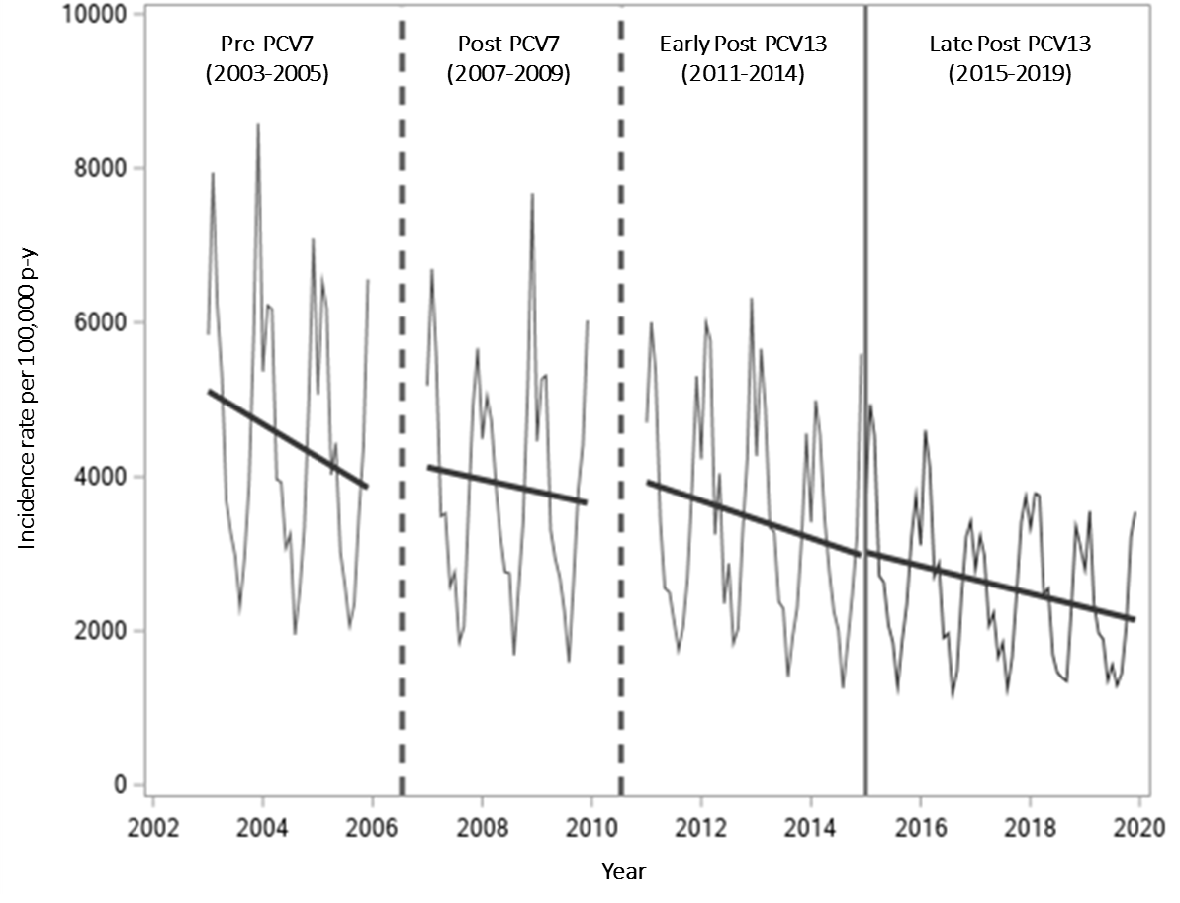
Abbreviations: AOM: acute otitis media; PCV: pneumococcal conjugate vaccine; PY: person-years. The dashed vertical lines correspond to the years of PCV introduction (2006 and 2010) where monthly episode rates of these years were not calculated. The solid vertical line denotes the separation of early and late PCV13 periods-where all years were included in the monthly episode rates.

