Supplementary Material
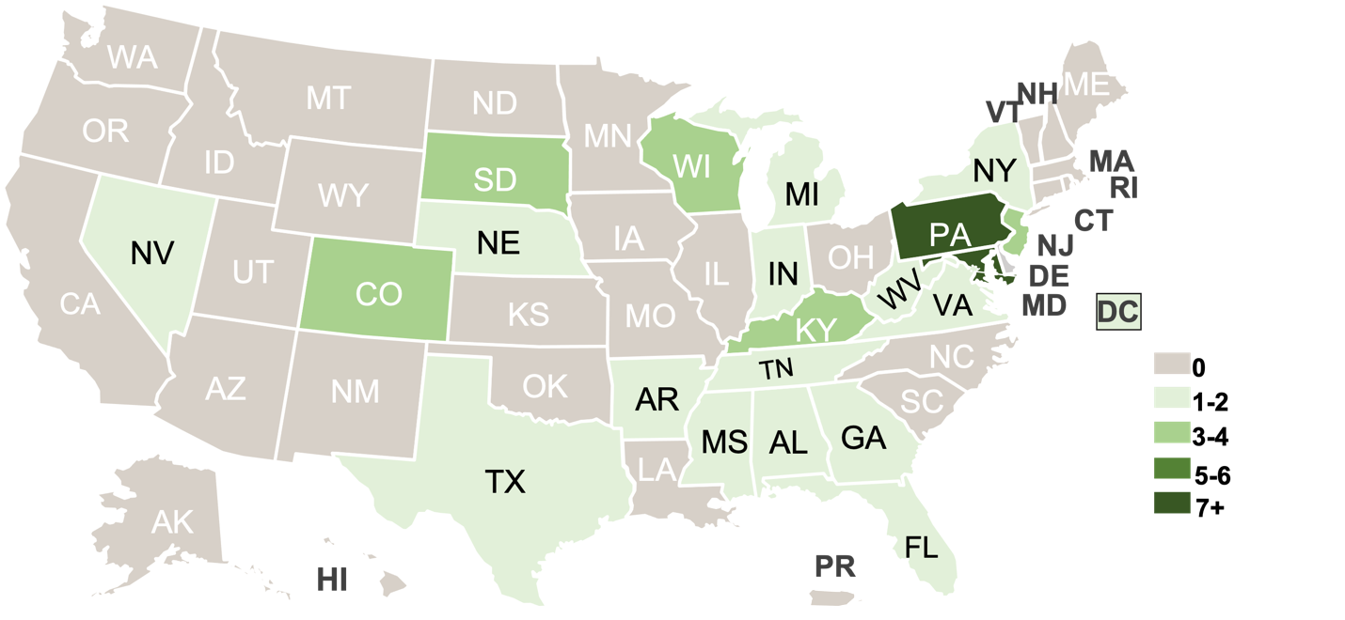
S1 Fig. Participating Institutes of Higher Education by State. Most participating states have 1-2 institutes, with 2 states having the largest number participating: Maryland (n=7) and Pennsylvania (n=9)

Variable | aOR | Lower 95% CI | Upper 95% CI | p-value | Coefficient Estimate | Std. Error
Ref: University of Colorado, Indoors, and On Campus
Colorado State | 1.323 | 0.775 | 2.200 | 0.291 | 0.280 | 0.266
Outdoors | 0.253 | 0.165 | 0.386 | <.001 | -1.376 | 0.217
Off Campus | 0.205 | 0.147 | 0.282 | <.001 | -1.583 | 0.166
S2 Table. Odds of Wearing a Mask via Logistic Regression. Adjusted odds ratios (aOR) and 95% confidence intervals of mask usage for university, inside vs. outside, and on campus vs. off campus using a logistic regression model. A higher aOR indicates an increased likelihood of wearing a mask.

