Supplementary File

The COVID-19 Pandemic’s True Death Toll in Iran after Two Years: An Interrupted Time Series Analysis of Weekly All-Cause Mortality Data

Section 1: seasional pattern of all-caused mortality number during the observation period in Iran.

Section 2: visual inspection of potential relationship between changes in monthly tempreture and monthly all-cause mortality
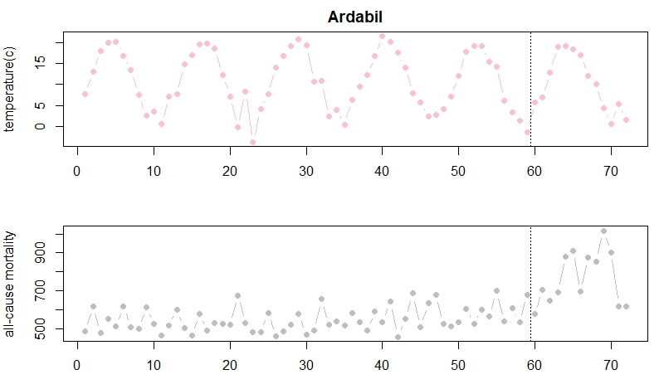
months
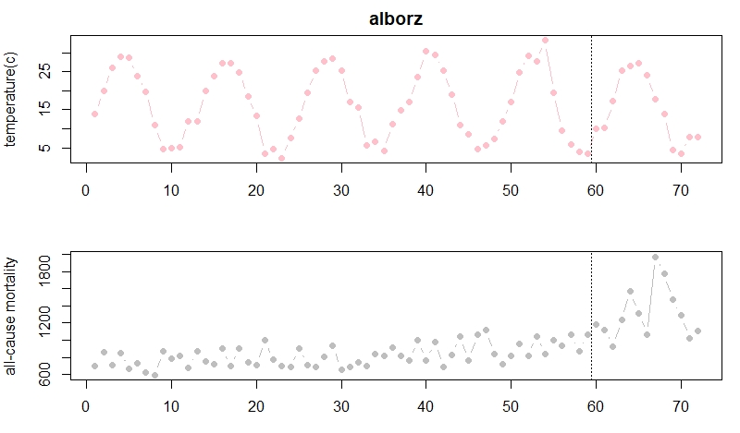
months
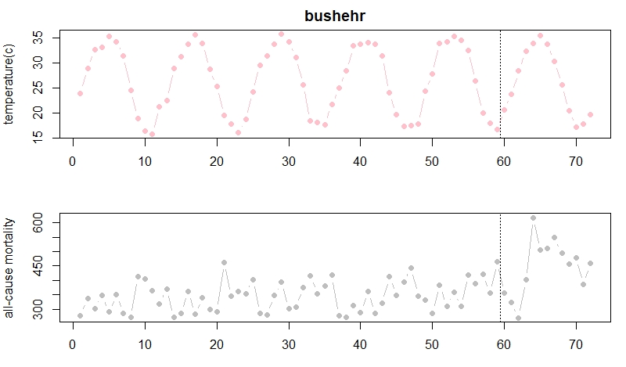
months

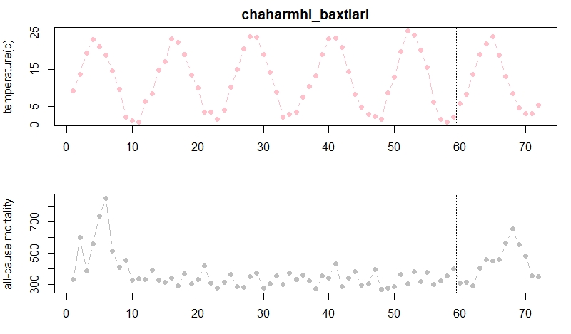
months
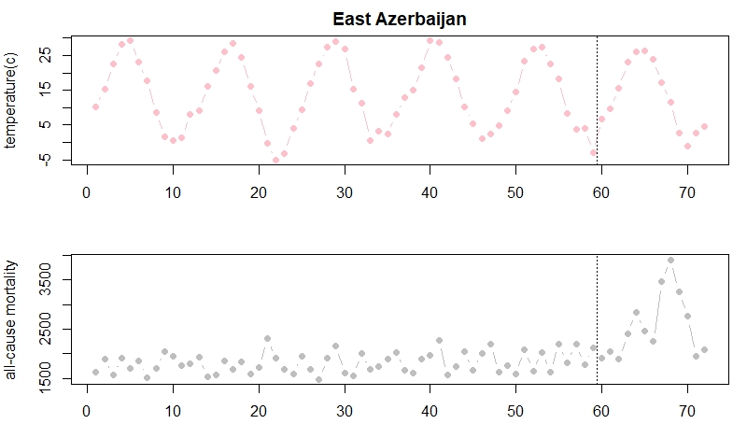
months
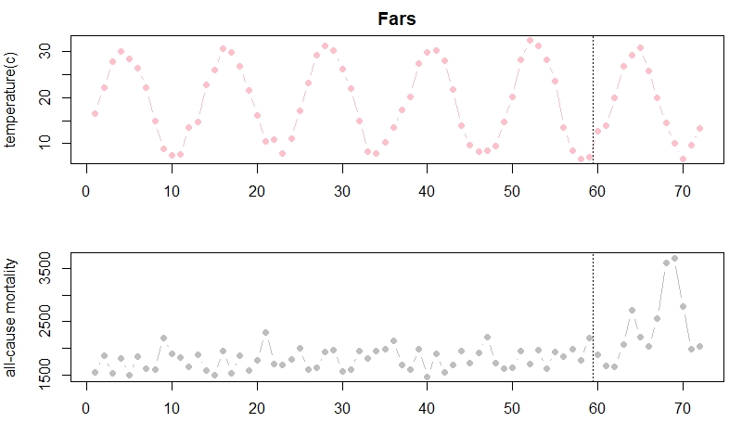
months

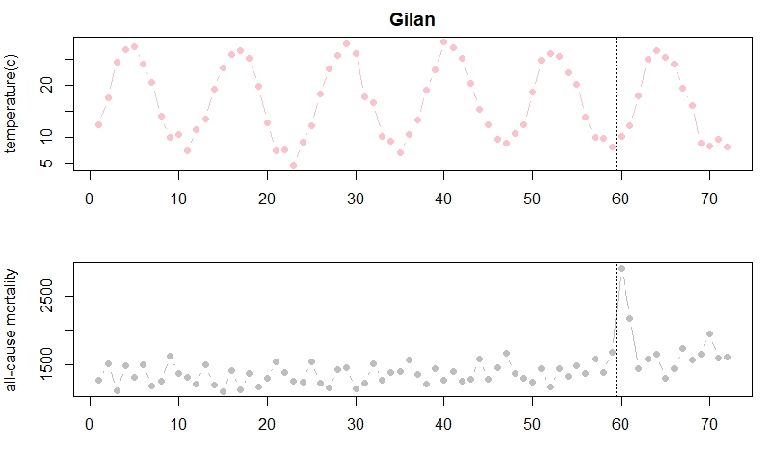
months
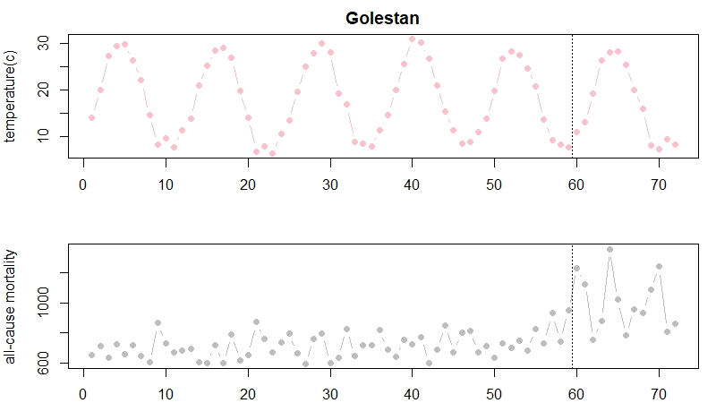
months

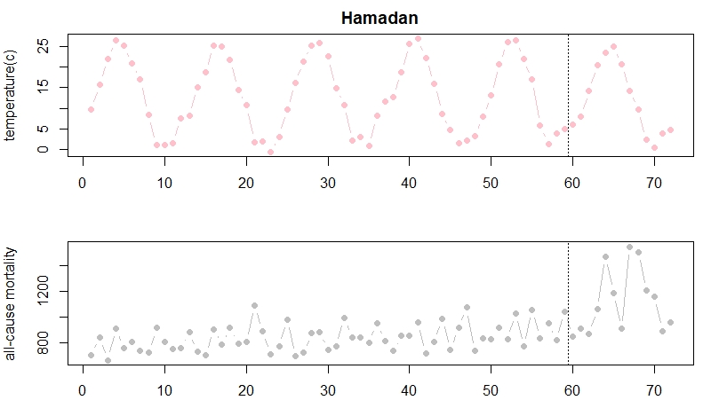
months

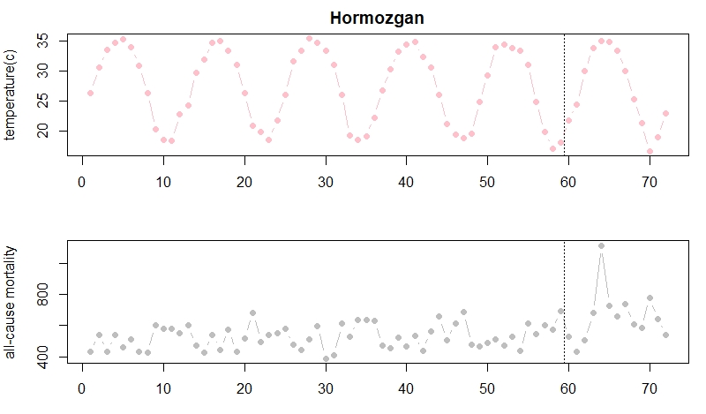
months
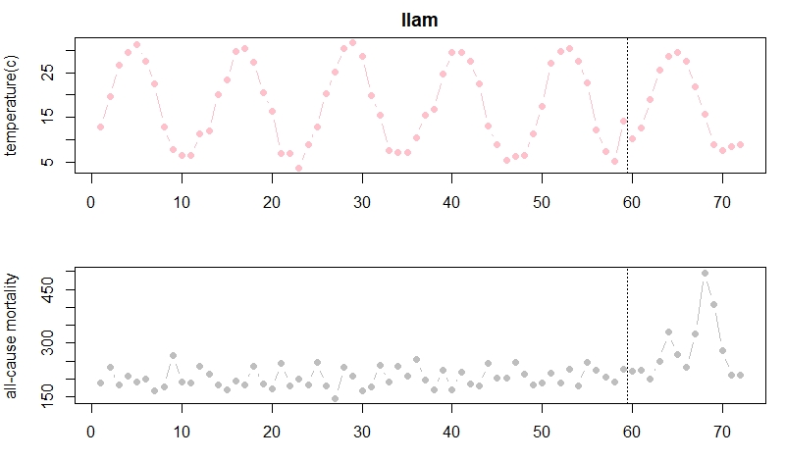
months
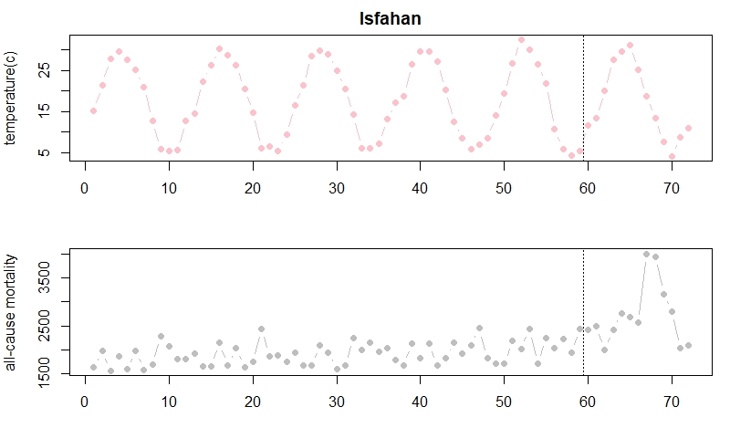
months
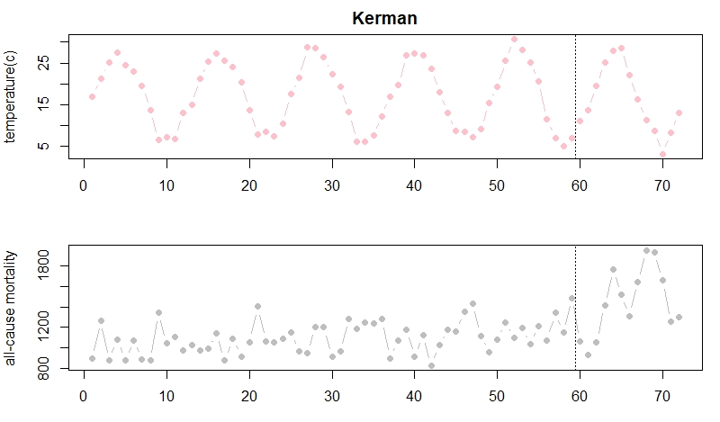
months

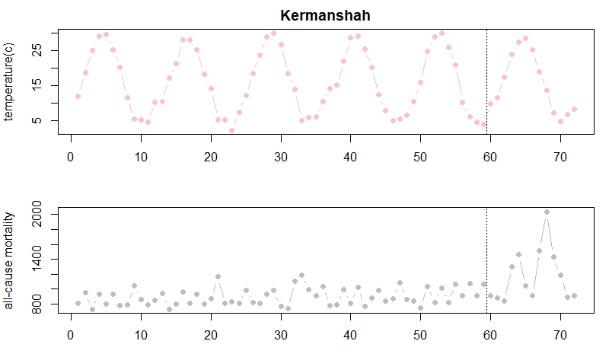
months
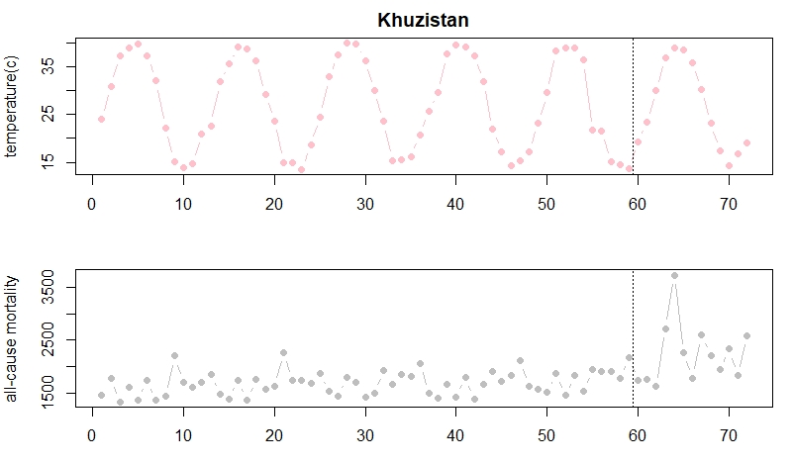
months
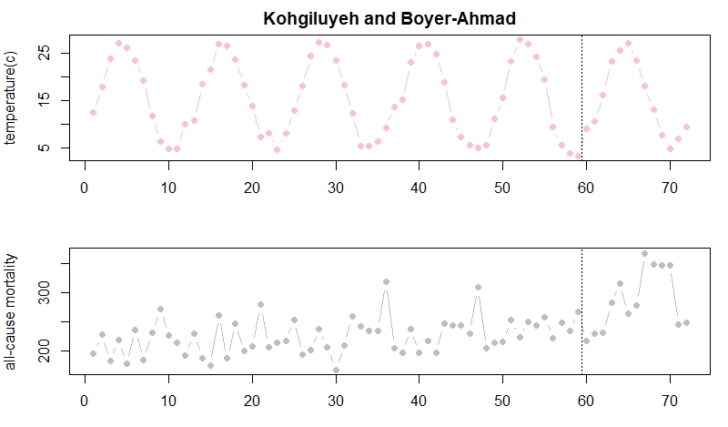
months
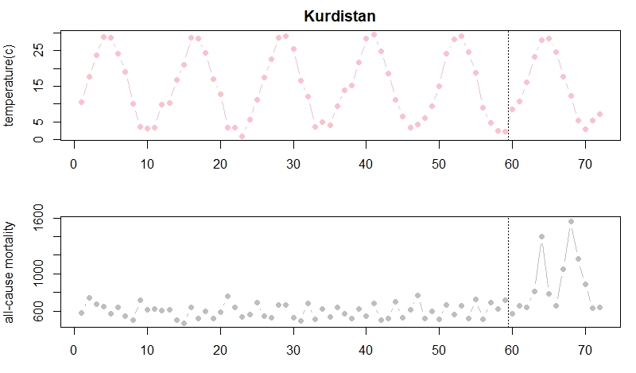
months

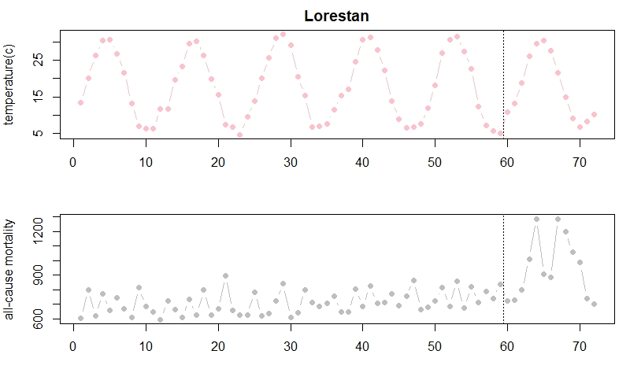
months
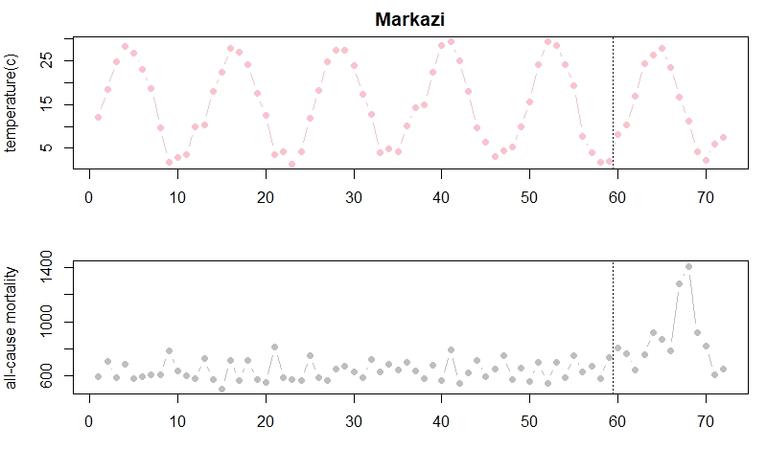
months
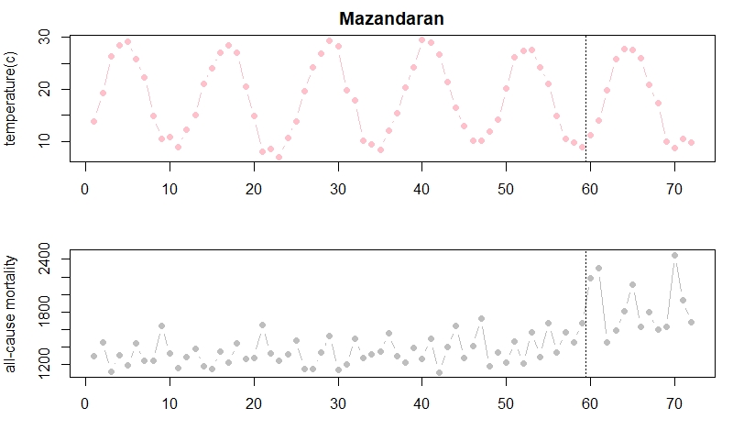
months
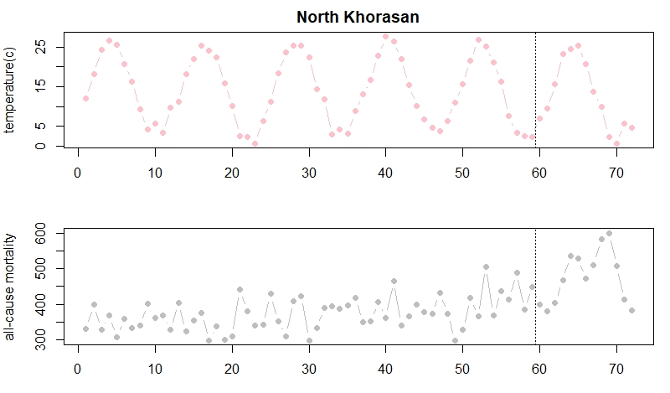
months
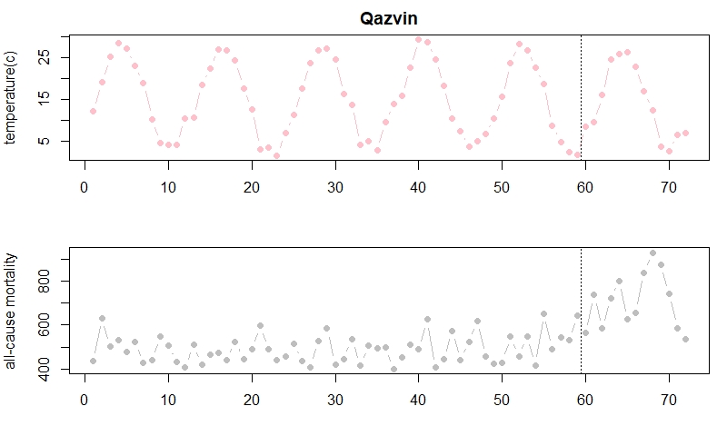
months

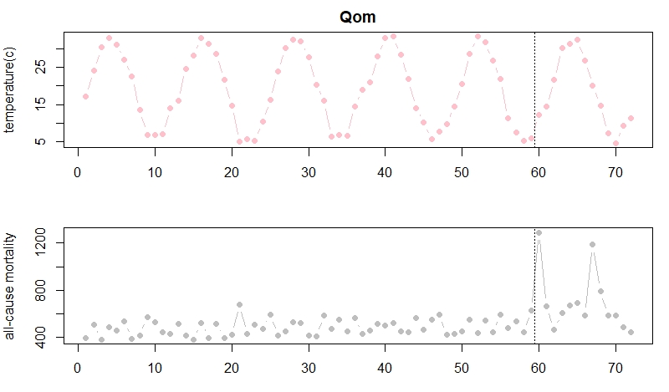
months
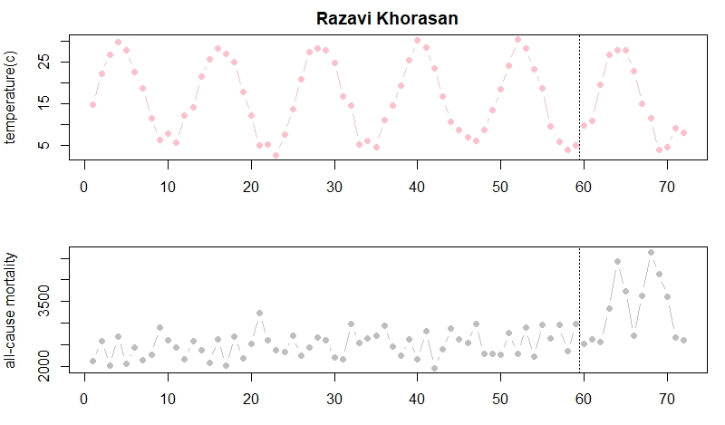
months

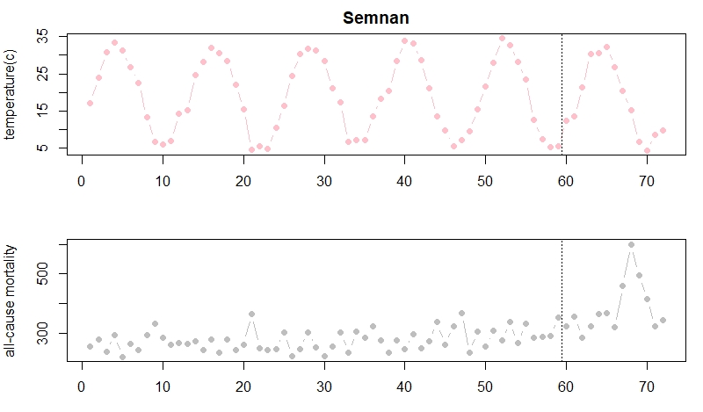
months

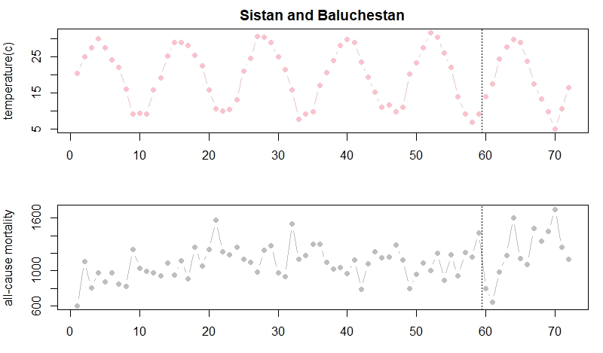
months
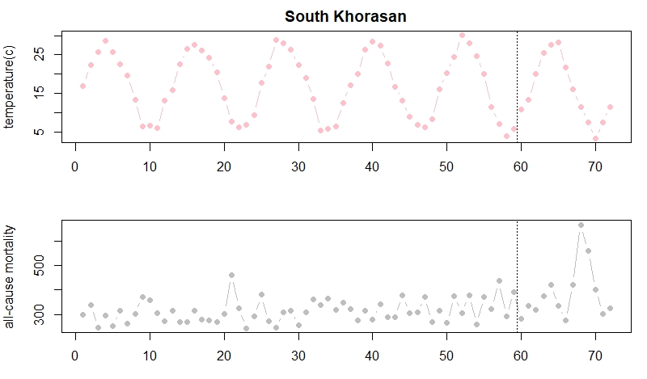
months
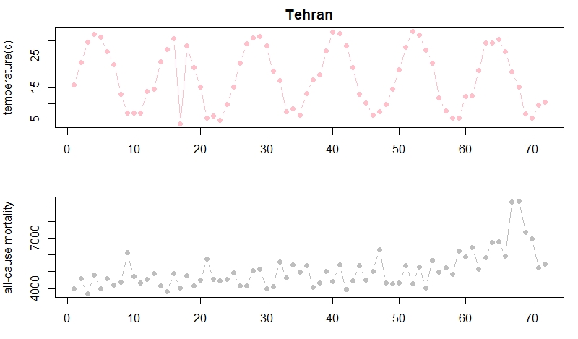
months
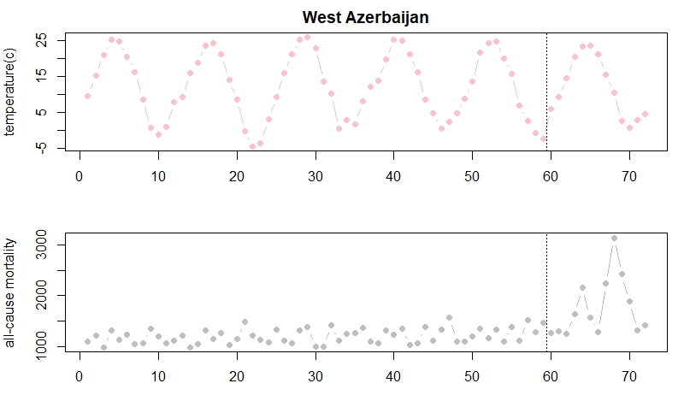
months

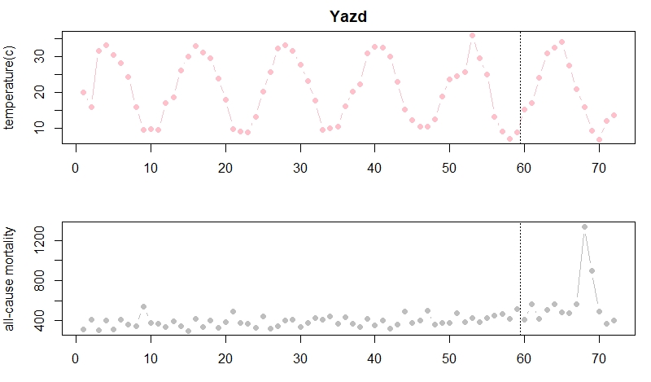
months
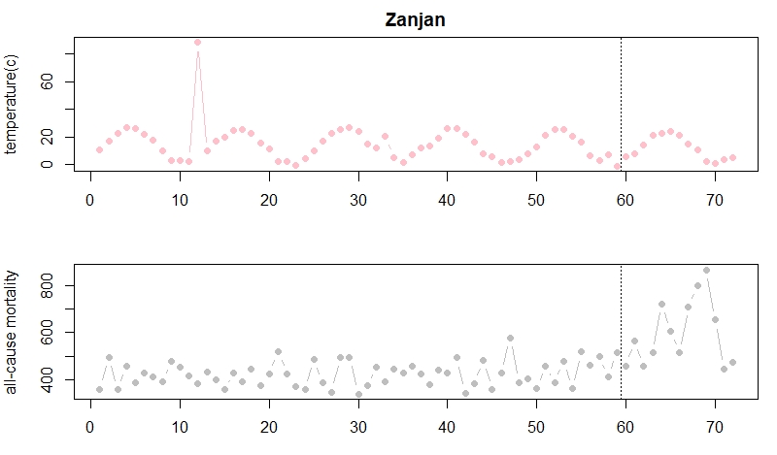
months

Section 3: Sensitivity analysis of potential confounding effect of temperature change on relationship between COVID-19 outbreak and excess all-cause mortlity
Province | Excess mortality without controlling for temperature | Excess mortality with controlling for temperature
Alborz | 4617 | 4603
Ardabil | 2404 | 2415
Bushehr | 1016 | 1023
Chaharmahal and Bakhtiari | 2377 | 2377
East Azerbaijan | 8425 | 8432
Fars | 6778 | 6767
Gilan | 4372 | 7372
Golestan | 3115 | 3120
Hamadan | 2674 | 2669
Hormozgan | 1350 | 1351
Ilam | 938 | 938
Isfahan | 8300 | 8300
Kerman | 3197 | 3201
Kermanshah | 2987 | 2985
Khuzestan | 5824 | 5799
Kohgiluyeh and Boyer-Ahmad | 565 | 565
Kurdistan | 3696 | 3710
Lorestan | 2363 | 2361
Markazi | 2809 | 2809
Mazandaran | 5531 | 5529
North Khorasan | 819 | 810
Qazvin | 2586 | 2602
Qom | 2435 | 2429
Razavi Khorasan | 8995 | 9001
Semnan | 1115 | 1109
Sistan and Baluchestan | 722 | 721
South Khorasan | 665 | 663
Tehran | 20791 | 20813
West Azerbaijan | 6058 | 6058
Yazd | 1930 | 1926
Zanjan | 2067 | 2070

