Supplemental Figure 1. Cohort creation flow diagram

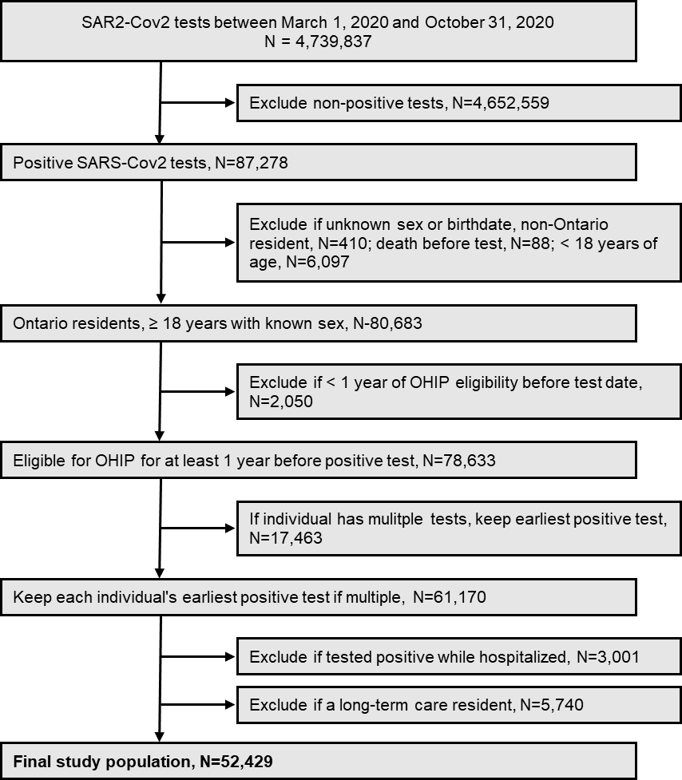

Abbreviations: OHIP, Ontario Health Insurance Plan.

