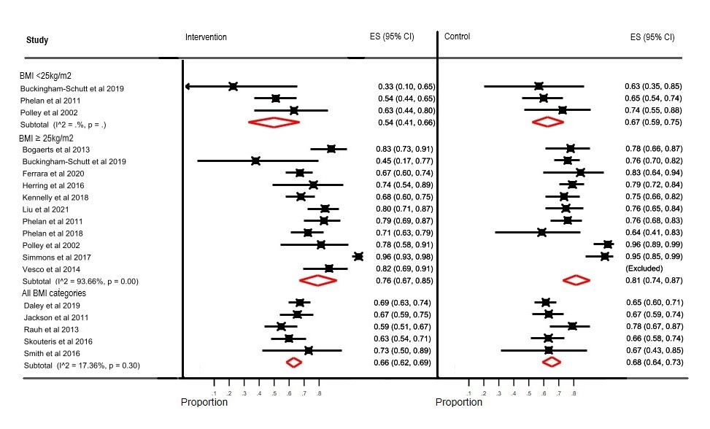
Additional figure S1 – proportion of participants with inappropriate GWG stratified by BMI category

