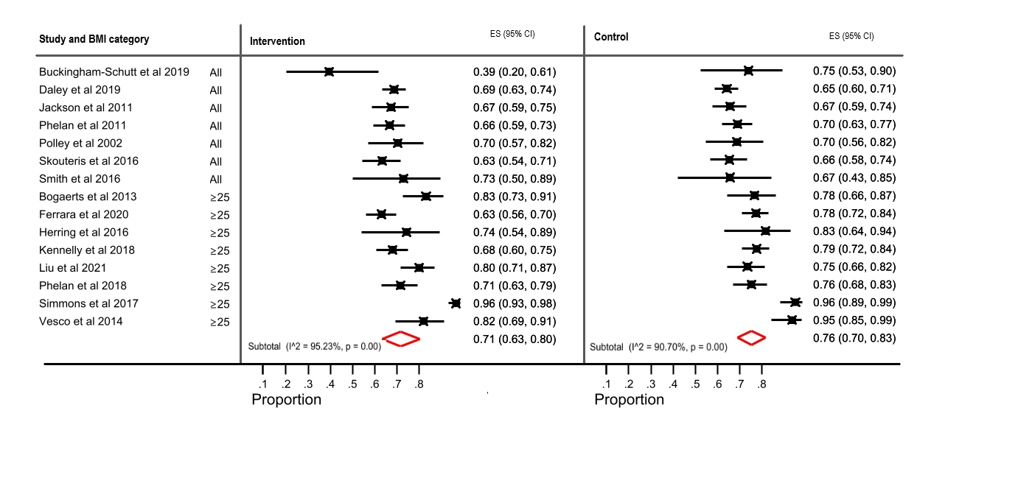
Additional figure S2 – sensitivity analysis

