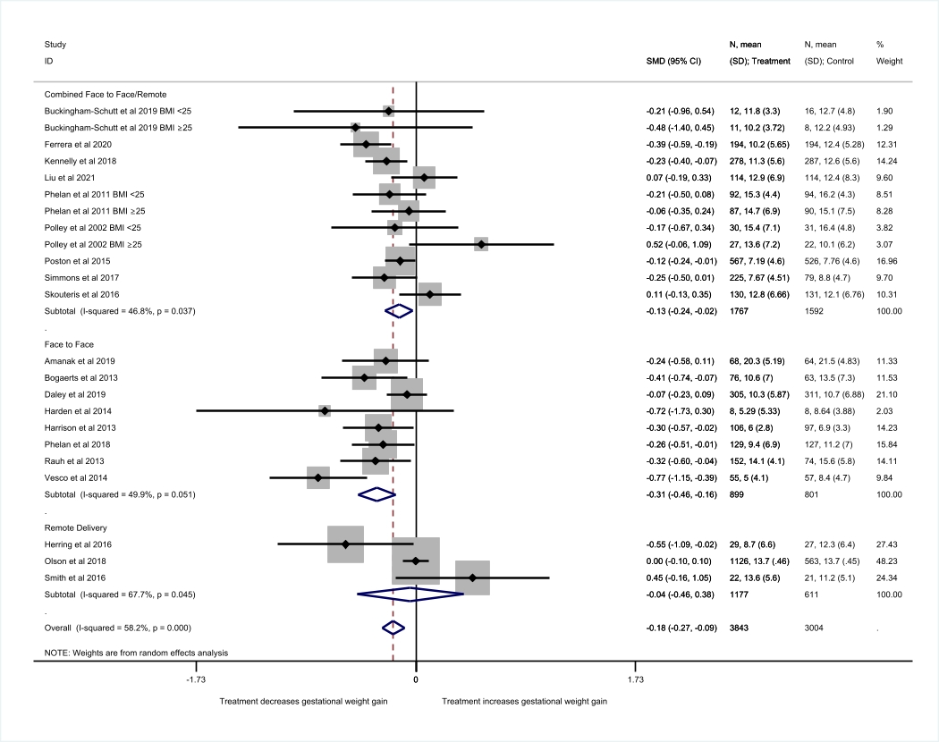
Additional figure S3 – Total GWG stratified by intervention mode of delivery

