Supporting Information

Relative Error
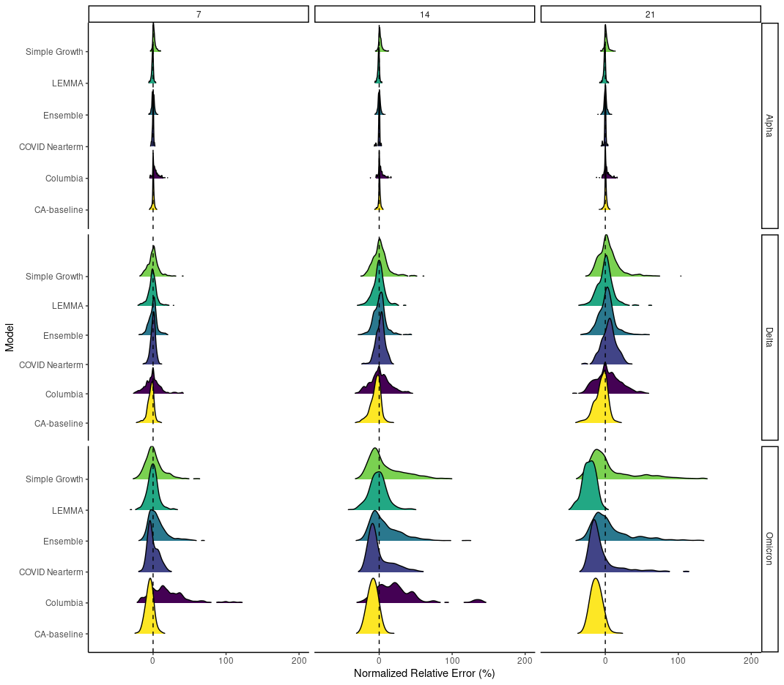
Supplementary Figure 1. Relative error distributions across all counties for different forecast horizons (columns) and across different variant periods (rows) for the entire analysis period (February 1, 2021-Feburary 1, 2022).

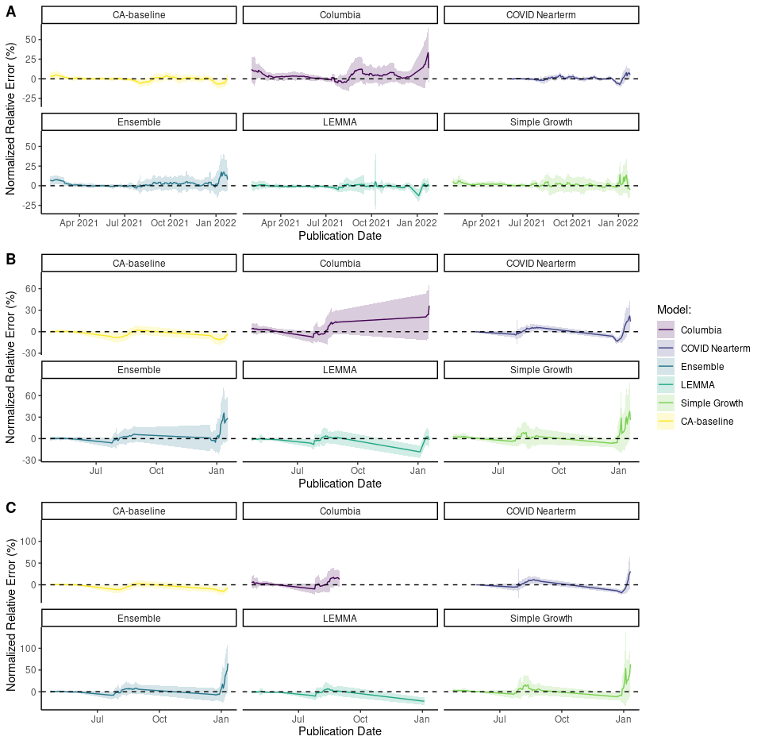
Supplementary Figure 2. Normalized relative error distributions through the time for (A) 7-day, (B) 14-day, and (C) 21-day forecast horizons.

7-day MAE

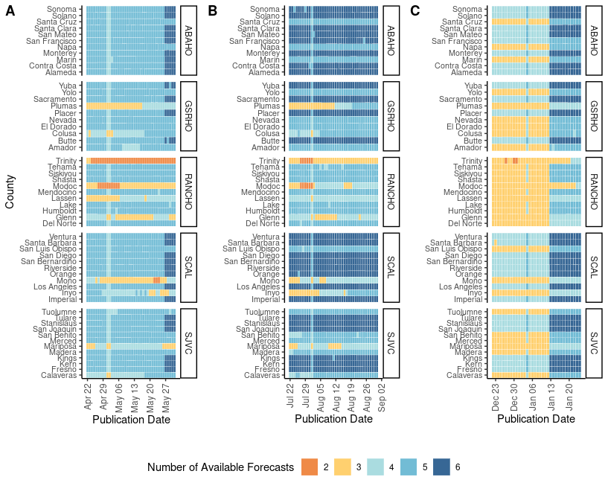
Supplementary Figure 3. Number of available forecasts for a given location and date for the (A) Alpha, (B) Delta, and (C) Omicron variant periods for 14-day MAE.
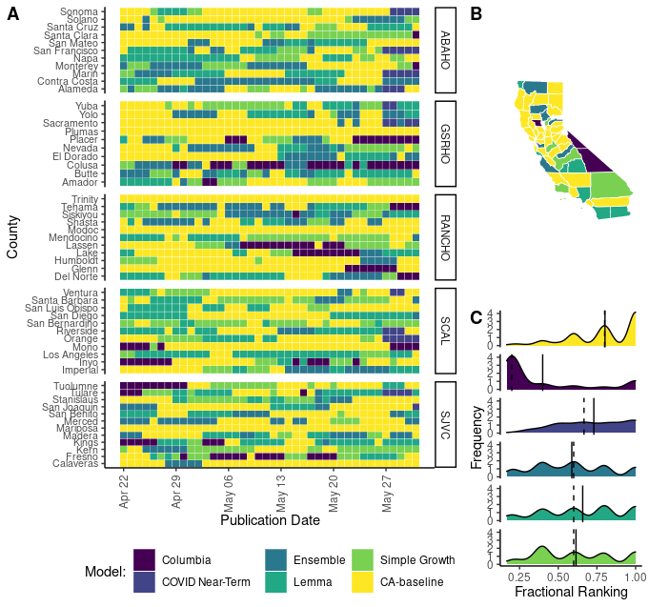
Supplementary Figure 4. Forecasting accuracy results at the county level during the Alpha wave in California as measured by mean absolute error (MAE). (A) Heat map of the best daily performing model for a given prediction date as measured by 7-day MAE. Each cell in the heat map corresponds to a standardized mean absolute error calculated for the day that a model forecast was published. Counties are grouped into panels by California health officer regions. (B) A summary map of California where the color of the county corresponds to the model with the highest sum of the standardized rank score for that period $({Σsr}_{m,i,j})$. Note that by using the summation of the standardized ranking score models are penalized for lack of participation. (C) A density distribution of the standardized rank score $({sr}_{m,i,j})$ that depicts the median (dashed) and mean (solid) as vertical lines.

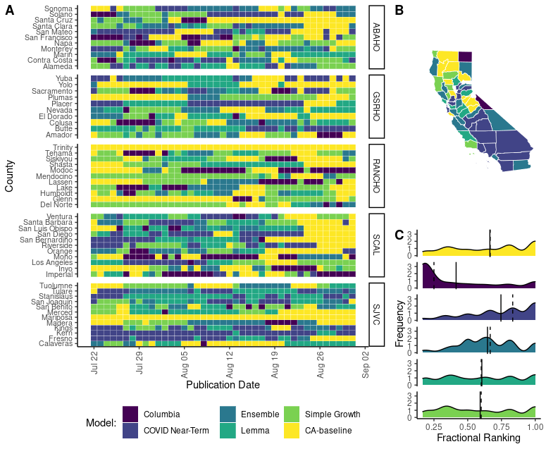
Supplementary Figure 5. Forecasting accuracy results at the county level during the Delta wave in California as measured by mean absolute error (MAE). (A) Heat map of the best daily performing model for a given prediction date as measured by 14 day MAE. Each cell in the heat map corresponds to a standardized mean absolute error calculated for the day that a model forecast was published. Counties are grouped into panels by California health officer regions. (B) A summary map of California where the color of the county corresponds to the model with the highest sum of the standardized rank score for that period $({Σsr}_{m,i,j})$. Note that by using the summation of the standardized ranking score models are penalized for lack of participation. (C) A density distribution of the standardized rank score $({sr}_{m,i,j})$ that depicts the median (dashed) and mean (solid) as vertical lines.

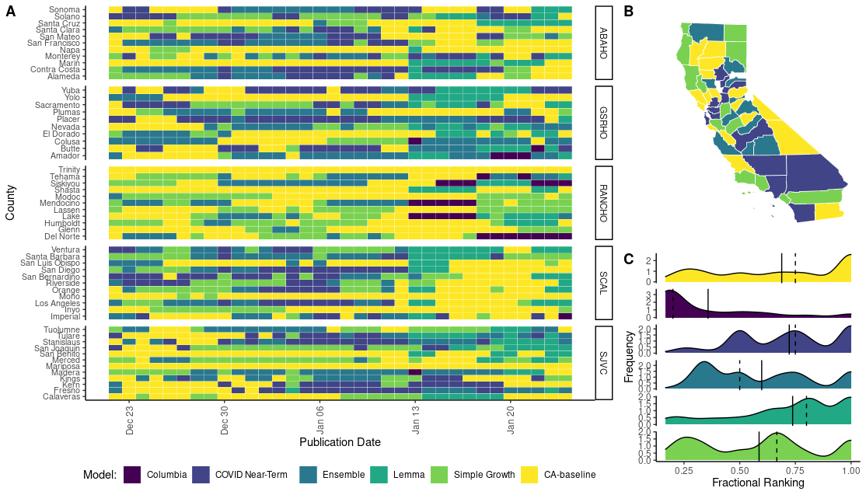
Supplementary Figure 6. Forecasting accuracy results at the county level during the Omicron wave in California as measured by mean absolute error (MAE). (A) Heat map of the best daily performing model for a given prediction date as measured by 7 day MAE. Each cell in the heat map corresponds to a standardized mean absolute error calculated for the day that a model forecast was published. Counties are grouped into panels by California health officer regions. (B) A summary map of California where the color of the county corresponds to the model with the highest sum of the standardized rank score for that period $({Σsr}_{m,i,j})$. Note that by using the summation of the standardized ranking score models are penalized for lack of participation. (C) A density distribution of the standardized rank score $({sr}_{m,i,j})$ that depicts the median (dashed) and mean (solid) as vertical lines.

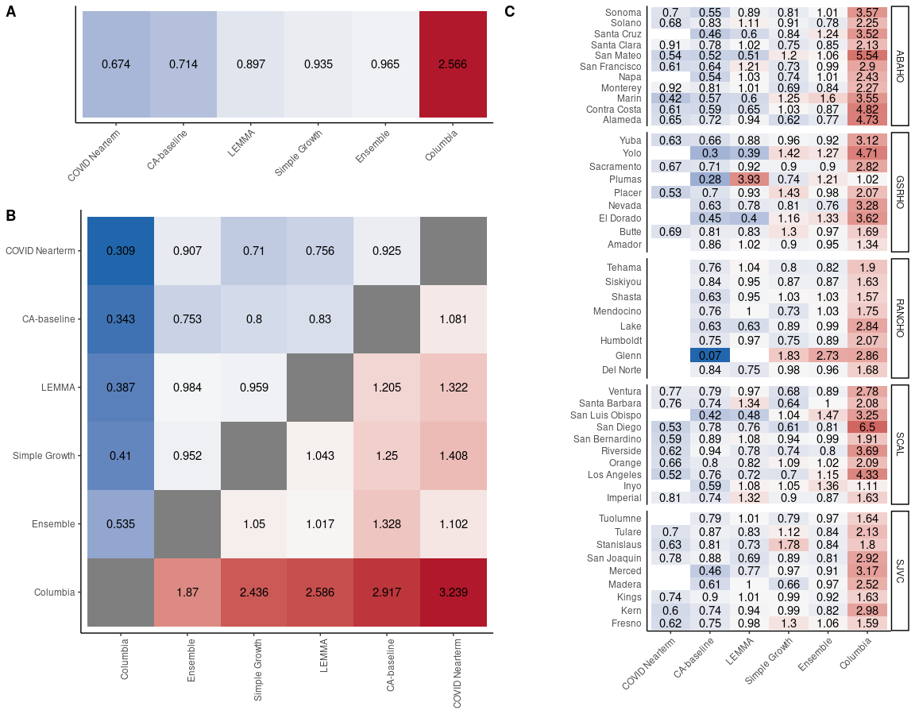
Supplementary Figure 7. Pairwise tournament median rankings of models for the entire analysis period (January 1, 2021- February 1, 2022) for 7-day MAE. (A) Overall median ranking across all locations and observation dates. (B) Median pairwise ranking comparing each model m to all available models M. Grid is symmetrical, so Model 1: Model 2 = 1/(Model 2:Model 1). (C) Overall median rankings for all available observation dates disaggregated by county.

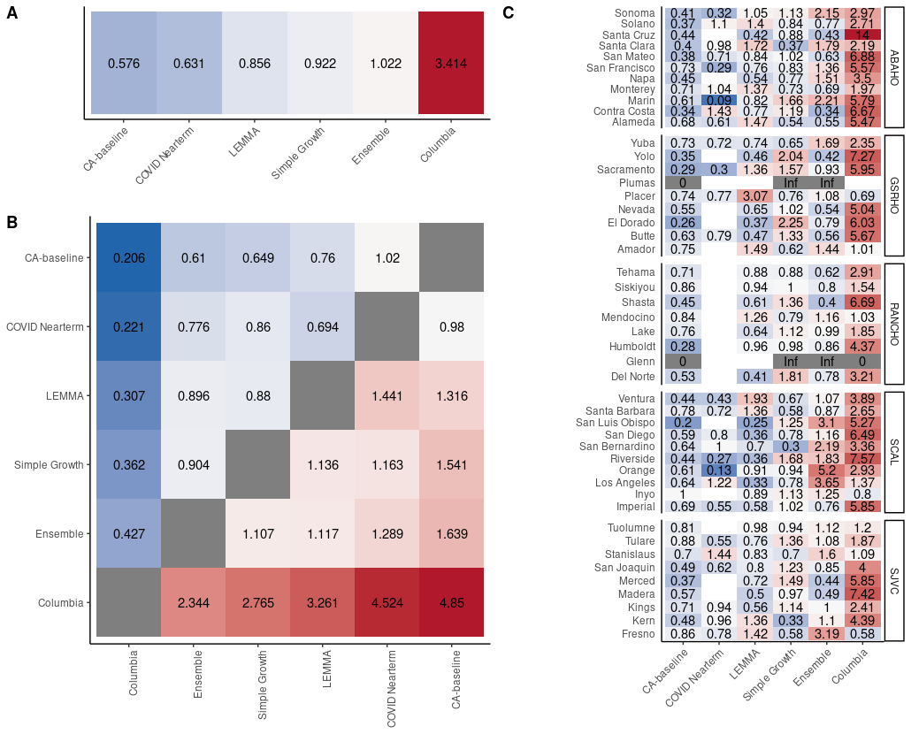
Supplementary Figure 8. Pairwise tournament median rankings of models for the Alpha variant period for 7-day MAE. (A) Overall median ranking across all locations and observation dates. (B) Median pairwise ranking comparing each model m to all available models M. Grid is symmetrical, so Model 1: Model 2 = 1/(Model 2:Model 1). (C) Overall median rankings for all available observation dates disaggregated by county.

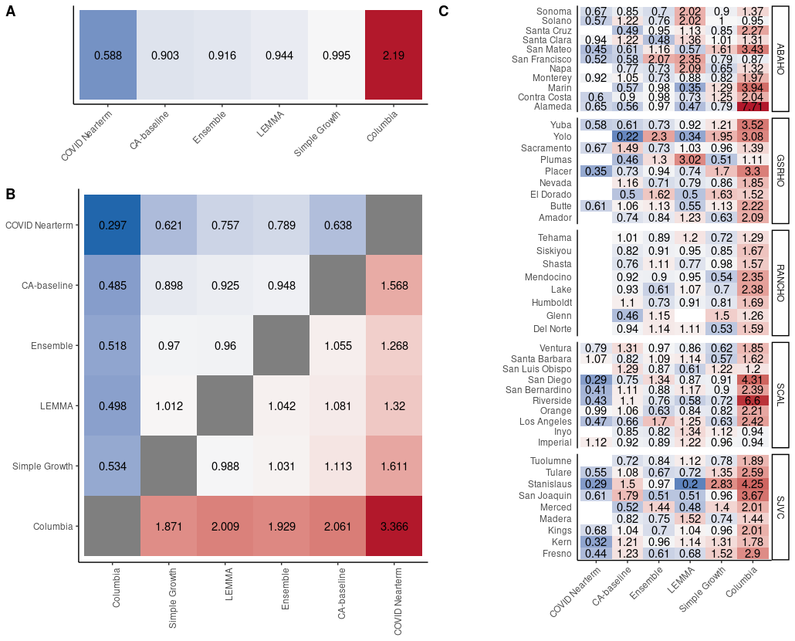
Supplementary Figure 9. Pairwise tournament median rankings of models for the Delta variant period for 7-day MAE. (A) Overall median ranking across all locations and observation dates. (B) Median pairwise ranking comparing each model m to all available models M. Grid is symmetrical, so Model 1: Model 2 = 1/(Model 2:Model 1). (C) Overall median rankings for all available observation dates disaggregated by county.

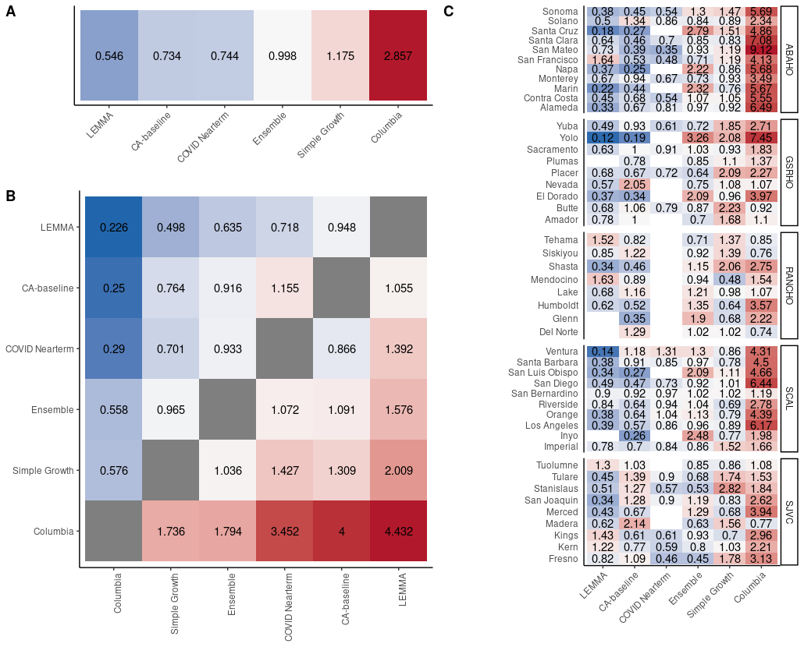
Supplementary Figure 10. Pairwise tournament median rankings of models for the Omicron variant period for 7-day MAE. (A) Overall median ranking across all locations and observation dates. (B) Median pairwise ranking comparing each model m to all available models M. Grid is symmetrical, so Model 1: Model 2 = 1/(Model 2:Model 1). (C) Overall median rankings for all available observation dates disaggregated by county.

14-day MAE

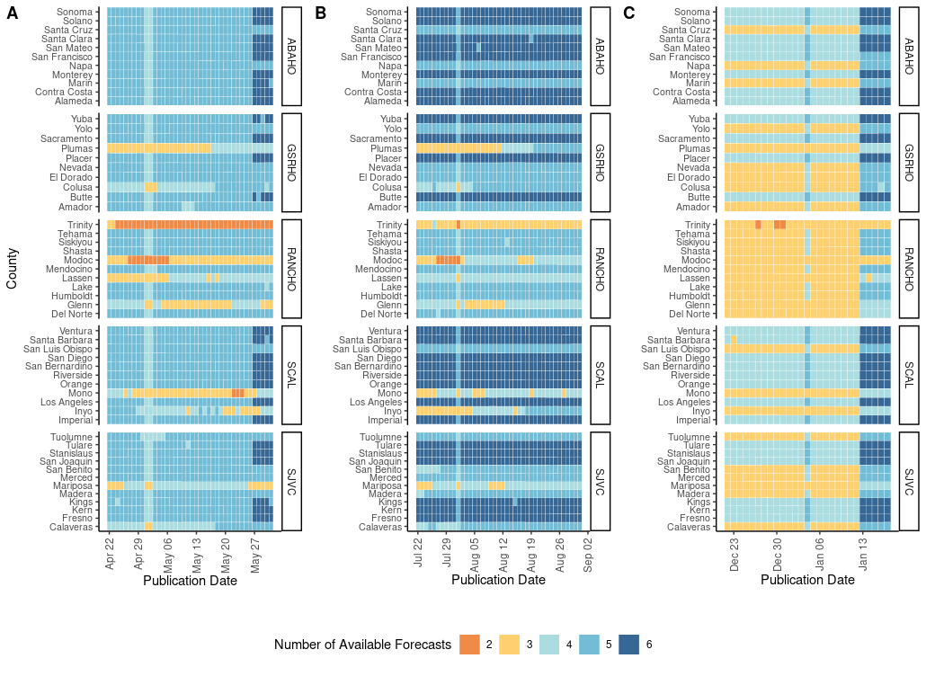
Supplementary Figure 11. Number of available forecasts for a given location and date for the (A) Alpha, (B) Delta, and (C) Omicron variant periods for 14-day MAE.
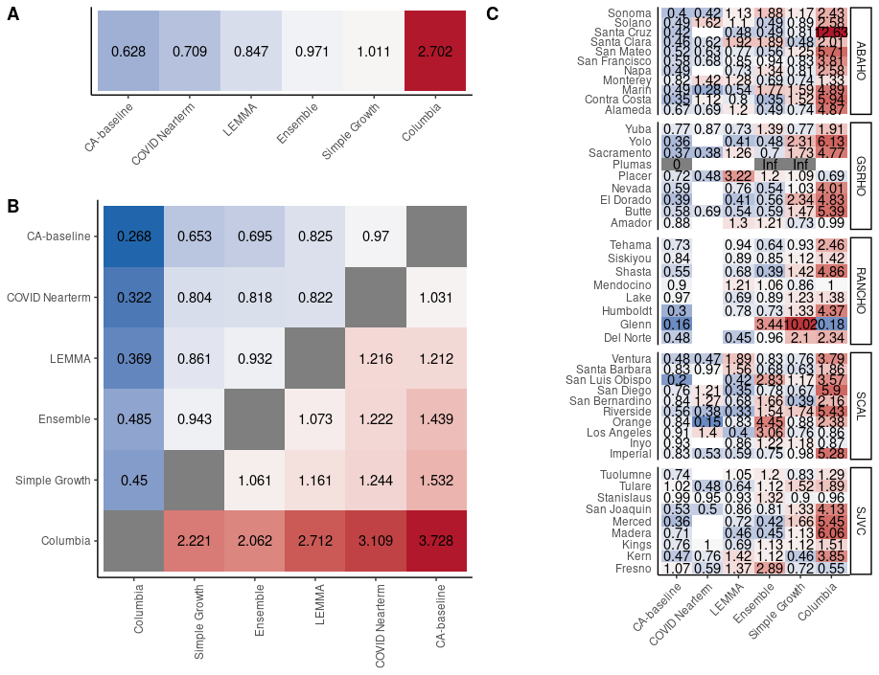
Supplementary Figure 12. Pairwise tournament median rankings of models during the Alpha analysis period for 14-day MAE. (A) Overall median ranking across all locations and observation dates. (B) Median pairwise ranking comparing each model m to all available models M. Grid is symmetrical, so Model 1: Model 2 = 1/(Model 2:Model 1). (C) Overall median rankings for all available observation dates disaggregated by county.

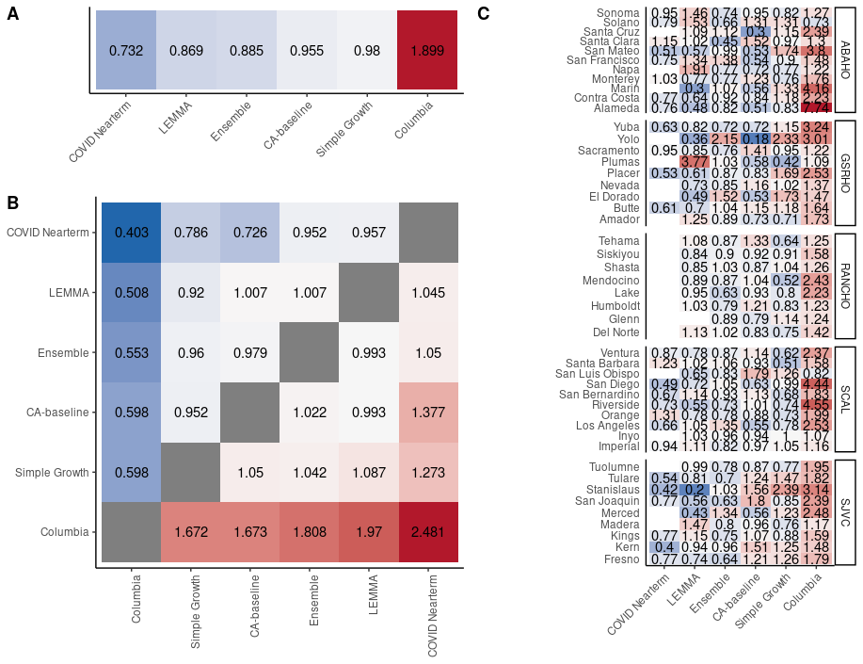 Supplementary Figure 13. Pairwise tournament median rankings of models during the Delta analysis period for 14-day MAE. (A) Overall median ranking across all locations and observation dates. (B) Median pairwise ranking comparing each model m to all available models M. Grid is symmetrical, so Model 1: Model 2 = 1/(Model 2:Model 1). (C) Overall median rankings for all available observation dates disaggregated by county.

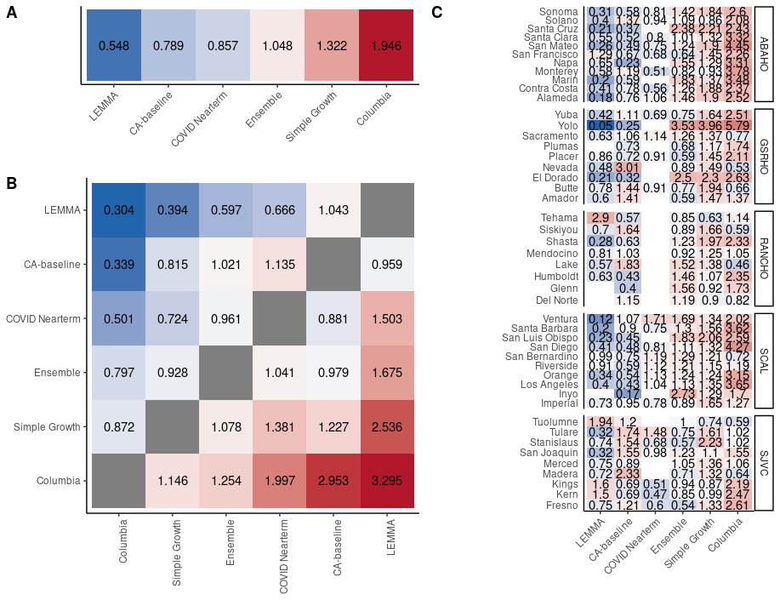
Supplementary Figure 14. Pairwise tournament median rankings of models during the Omicron analysis period for 14-day MAE. (A) Overall median ranking across all locations and observation dates. (B) Median pairwise ranking comparing each model m to all available models M. Grid is symmetrical, so Model 1: Model 2 = 1/(Model 2:Model 1). (C) Overall median rankings for all available observation dates disaggregated by county.

21-day MAE
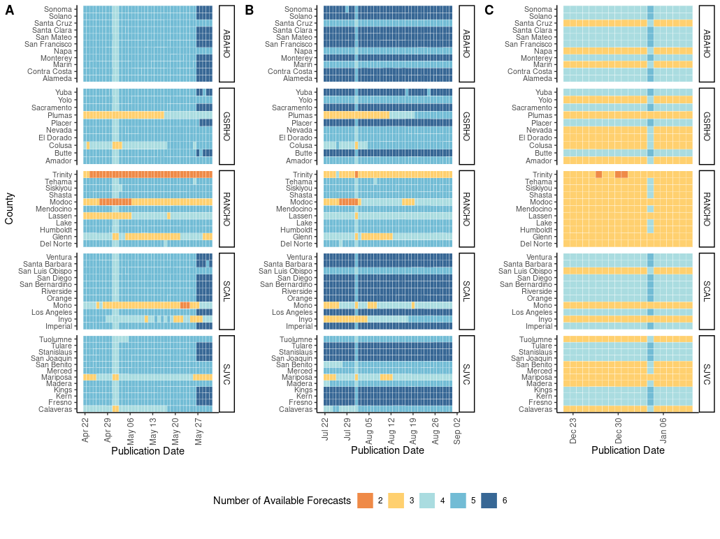
Supplementary Figure 15. Number of available forecasts for a given location and date for the (A) Alpha, (B) Delta, and (C) Omicron variant periods for 21-day MAE.

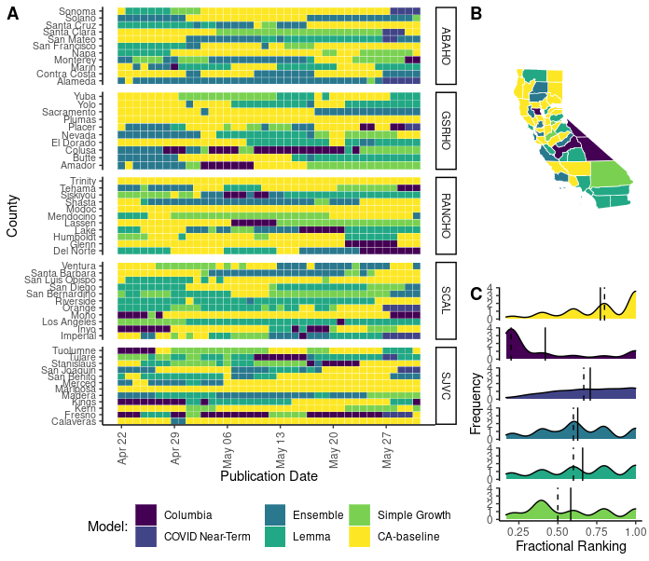
Supplementary Figure 16. Forecasting accuracy results at the county level during the Alpha wave in California as measured by 21-day mean absolute error (MAE). (A) Heat map of the best daily performing model for a given prediction date as measured by 21-day MAE. Each cell in the heat map corresponds to a standardized mean absolute error calculated for the day that a model forecast was published. Counties are grouped into panels by California health officer regions. (B) A summary map of California where the color of the county corresponds to the model with the highest sum of the standardized rank score for that period $({Σsr}_{m,i,j})$. Note that by using the summation of the standardized ranking score models are penalized for lack of participation. (C) A density distribution of the standardized rank score $({sr}_{m,i,j})$ that depicts the median (dashed) and mean (solid) as vertical lines.

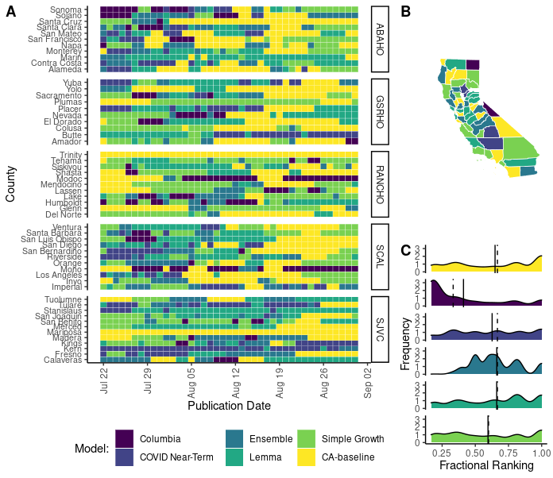
Supplementary Figure 17. Forecasting accuracy results at the county level during the Delta wave in California as measured by 21-day mean absolute error (MAE). (A) Heat map of the best daily performing model for a given prediction date as measured by 21-day MAE. Each cell in the heat map corresponds to a standardized mean absolute error calculated for the day that a model forecast was published. Counties are grouped into panels by California health officer regions. (B) A summary map of California where the color of the county corresponds to the model with the highest sum of the standardized rank score for that period $({Σsr}_{m,i,j})$. Note that by using the summation of the standardized ranking score models are penalized for lack of participation. (C) A density distribution of the standardized rank score $({sr}_{m,i,j})$ that depicts the median (dashed) and mean (solid) as vertical lines.

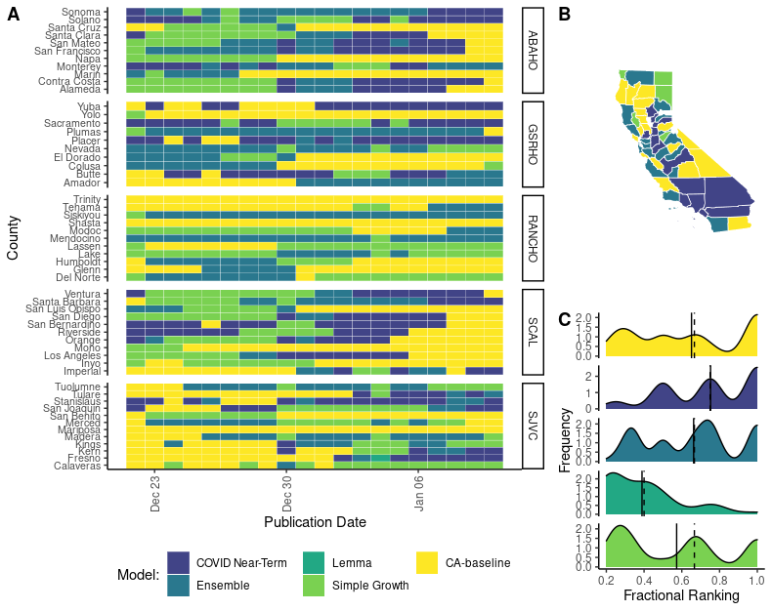
Supplementary Figure 18. Forecasting accuracy results at the county level during the Omicron wave in California as measured by 21-day mean absolute error (MAE). (A) Heat map of the best daily performing model for a given prediction date as measured by 21-day MAE. Each cell in the heat map corresponds to a standardized mean absolute error calculated for the day that a model forecast was published. Counties are grouped into panels by California health officer regions. (B) A summary map of California where the color of the county corresponds to the model with the highest sum of the standardized rank score for that period $({Σsr}_{m,i,j})$. Note that by using the summation of the standardized ranking score models are penalized for lack of participation. (C) A density distribution of the standardized rank score $({sr}_{m,i,j})$ that depicts the median (dashed) and mean (solid) as vertical lines.

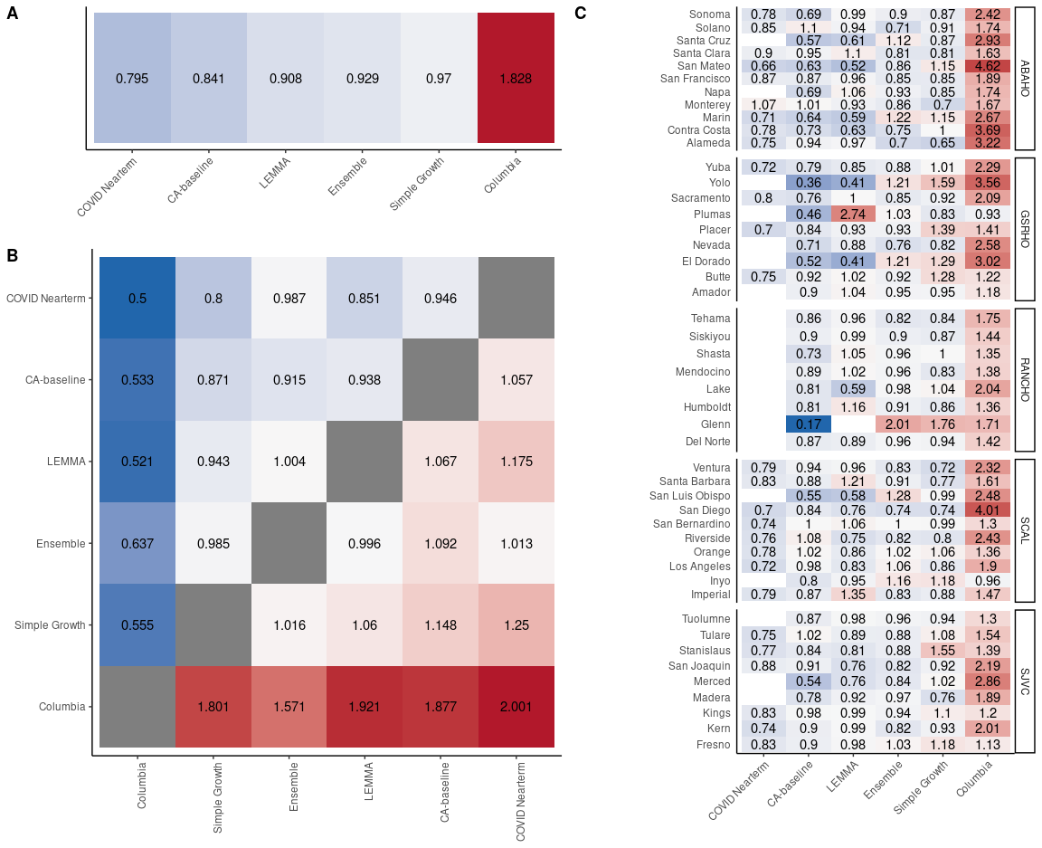
Supplementary Figure 19. Pairwise tournament median rankings of models during the whole analysis period (January 1, 2021-February 2, 2022) for 21-day MAE. (A) Overall median ranking across all locations and observation dates. (B) Median pairwise ranking comparing each model m to all available models M. Grid is symmetrical, so Model 1: Model 2 = 1/(Model 2:Model 1). (C) Overall median rankings for all available observation dates disaggregated by county.
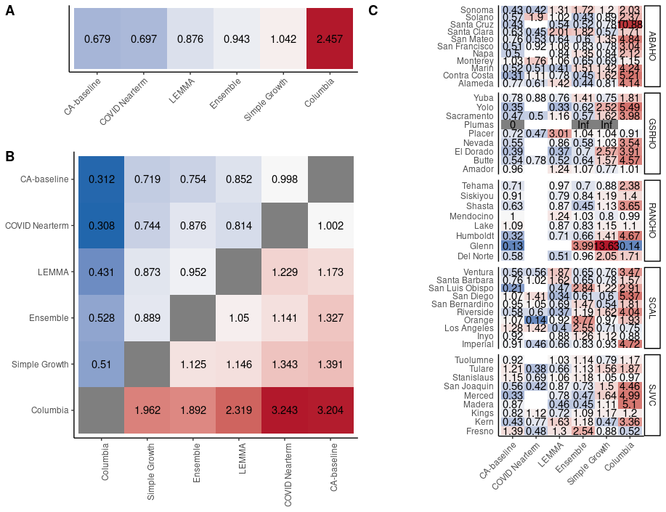
Supplementary Figure 20. Pairwise tournament median rankings of models during the Alpha period for 21-day MAE. (A) Overall median ranking across all locations and observation dates. (B) Median pairwise ranking comparing each model m to all available models M. Grid is symmetrical, so Model 1: Model 2 = 1/(Model 2:Model 1). (C) Overall median rankings for all available observation dates disaggregated by county.

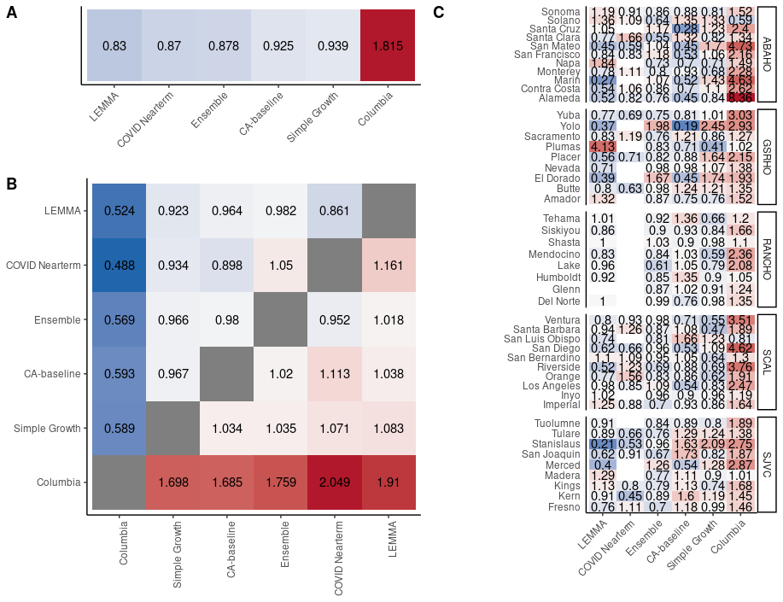
Supplementary Figure 21. Pairwise tournament median rankings of models during the Delta period for 21-day MAE. (A) Overall median ranking across all locations and observation dates. (B) Median pairwise ranking comparing each model m to all available models M. Grid is symmetrical, so Model 1: Model 2 = 1/(Model 2:Model 1). (C) Overall median rankings for all available observation dates disaggregated by county.

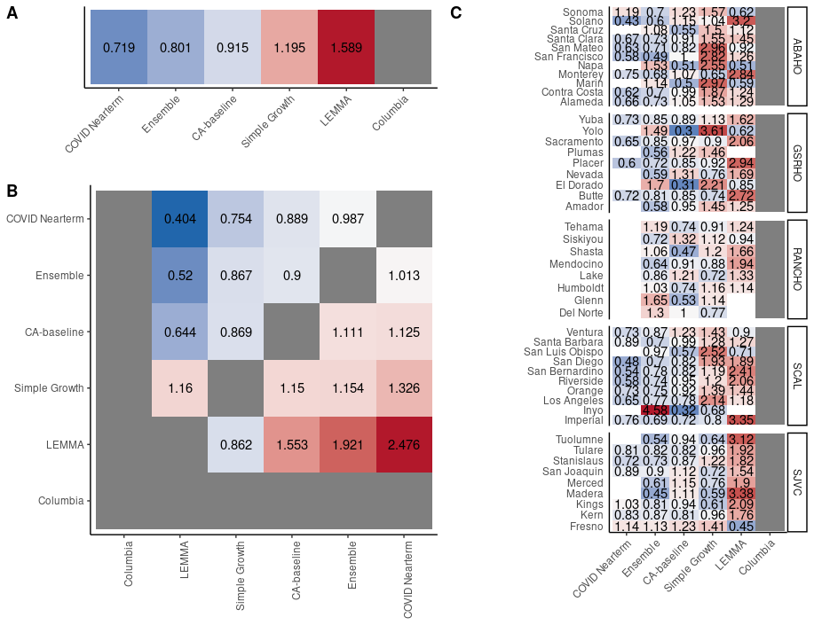
Supplementary Figure 22. Pairwise tournament median rankings of models during the Omicron period for 21-day MAE. (A) Overall median ranking across all locations and observation dates. (B) Median pairwise ranking comparing each model m to all available models M. Grid is symmetrical, so Model 1: Model 2 = 1/(Model 2:Model 1). (C) Overall median rankings for all available observation dates disaggregated by county.

Random forest variable importance
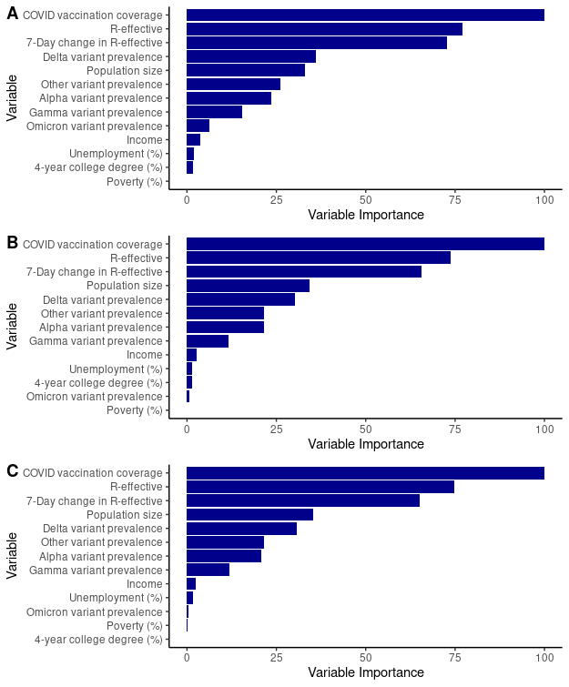 Supplementary Figure 23. Variable importance values from random forest classification analysis for (A) 7 day, (B) 14-day, and (C) 21-day MAE.

MAE vs. county size

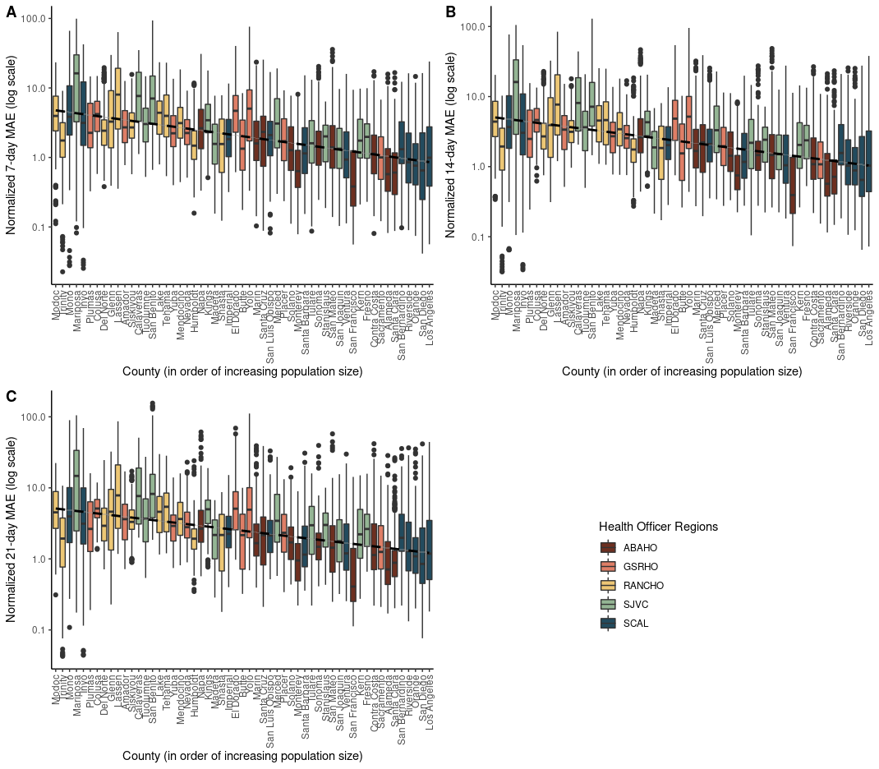
Supplementary Figure 24. Boxplots of normalized MAE distributions by county for (A) 7-day, (B) 14-day, and (C) 21-day MAE for the ensemble model. MAE is normalized by median county hospital capacity. Counties are situated on the x-axis in order of increasing population size. Counties are color-coded based on their health officer region membership. Distribution of MAE scores are from the entire analysis period: February 1, 2021- February 1, 2022.

