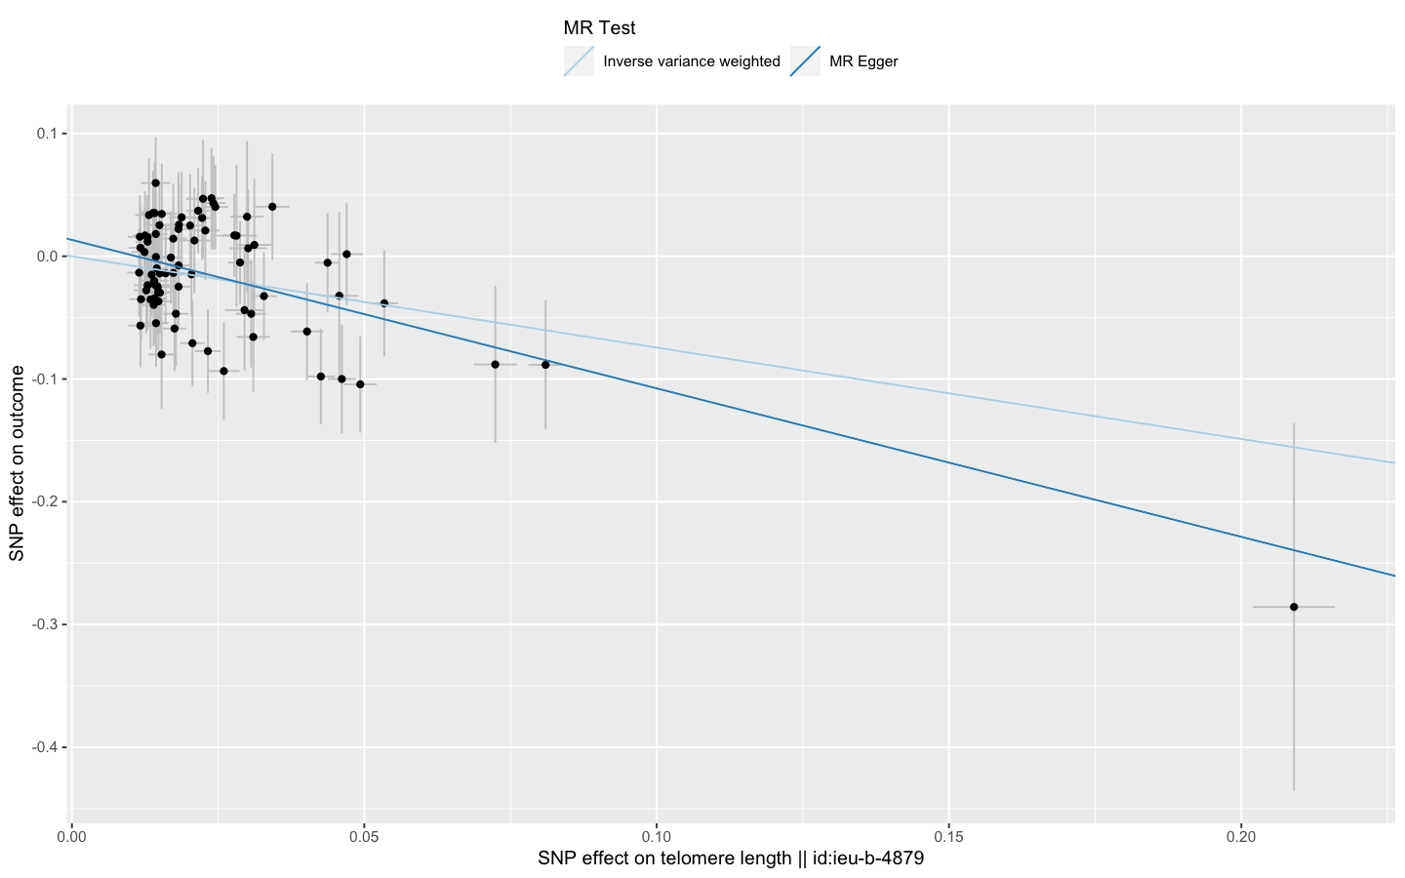
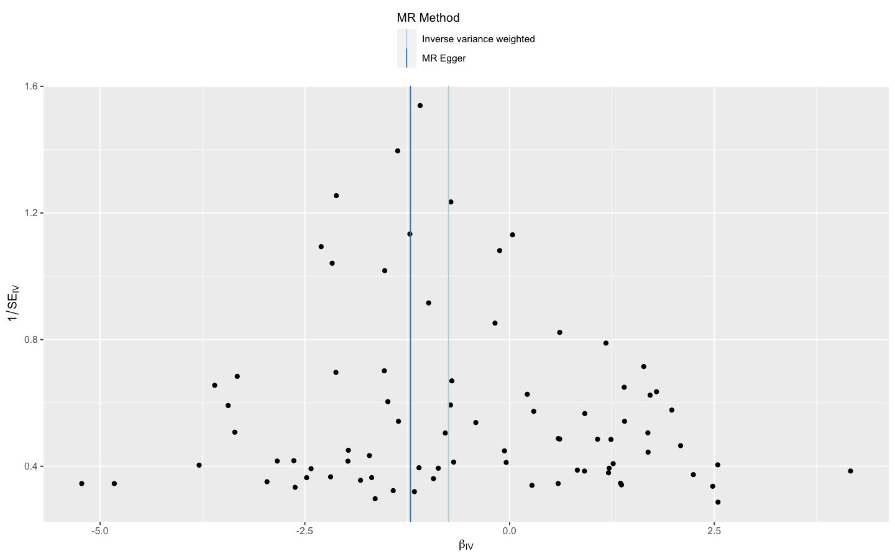
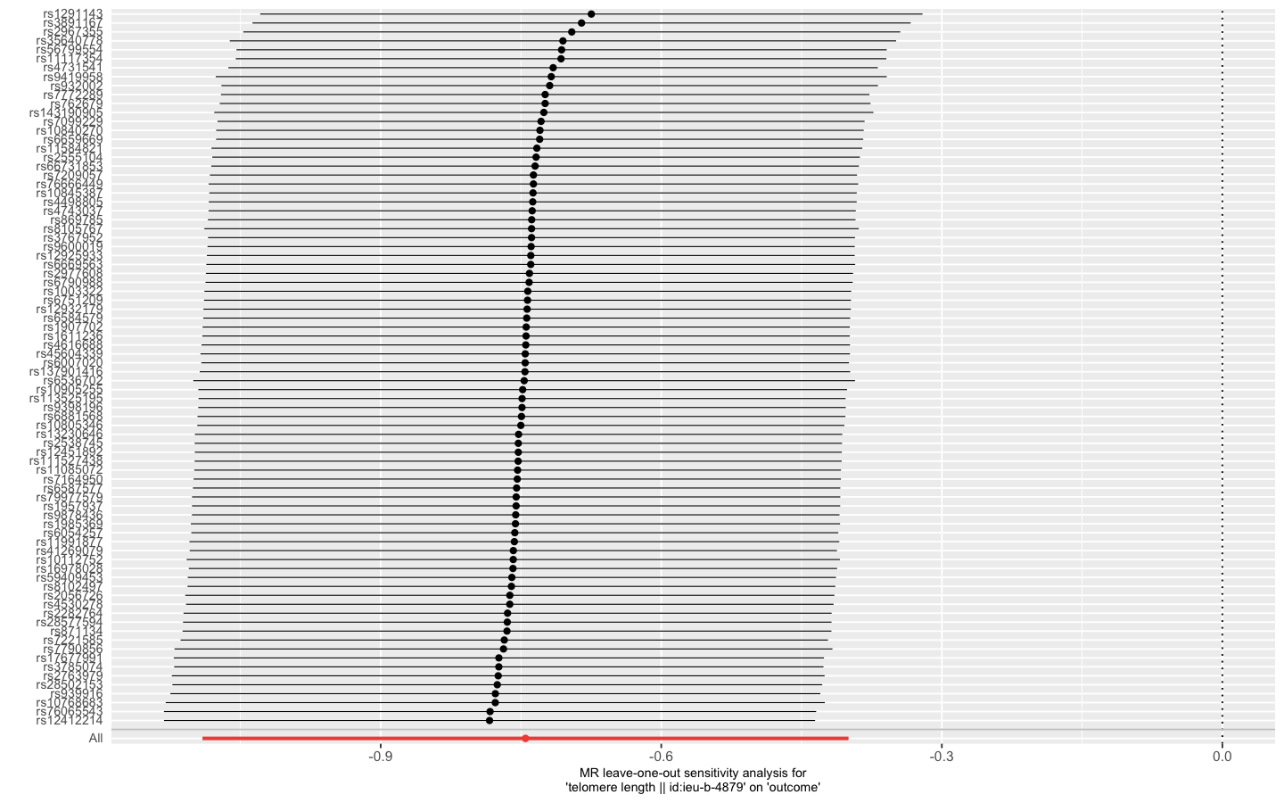
Supplemental figure 1 Scatter, leave-one-out and funnel plots for effect of telomere length on idiopathic pulmonary fibrosis risk (excluding the SNPs associated with smoking or obesity)

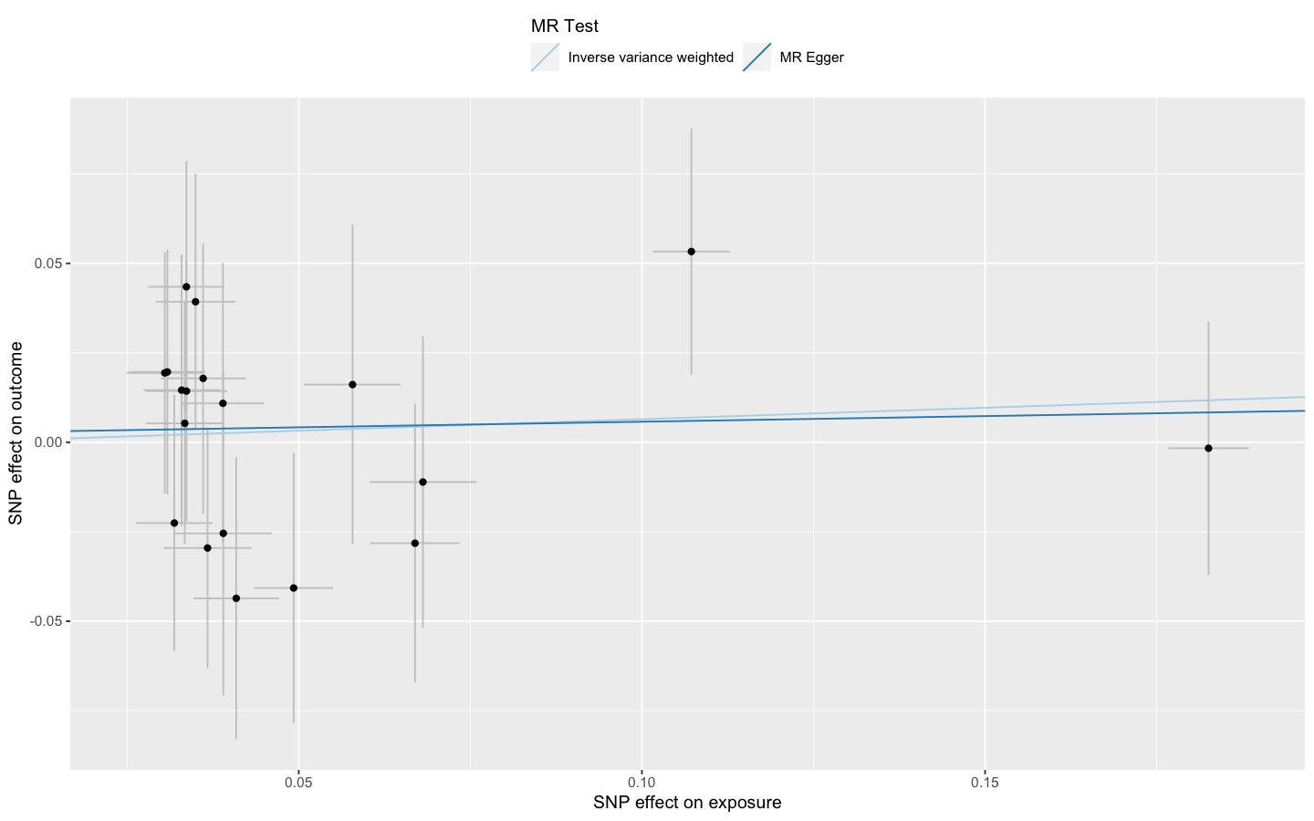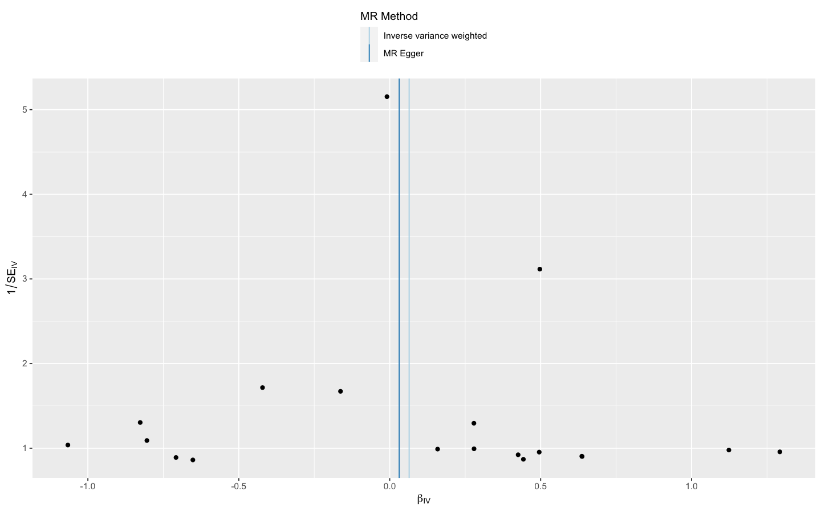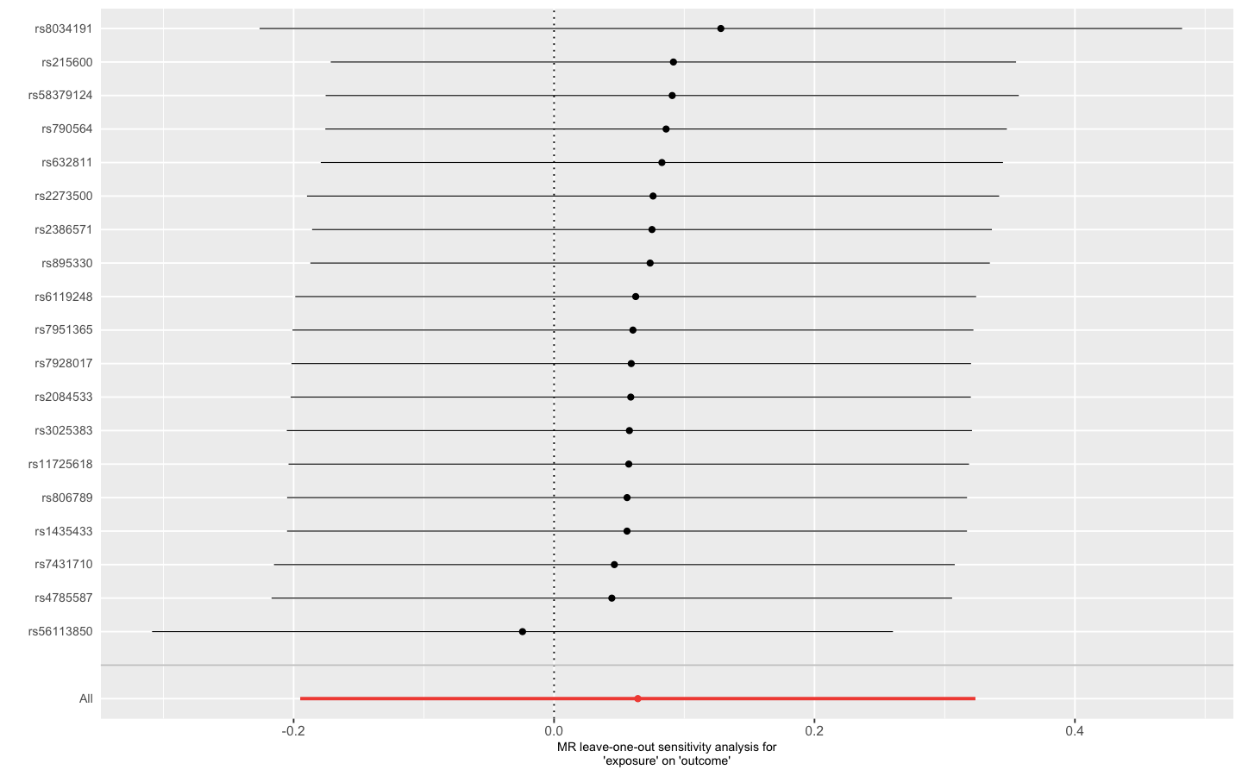
Supplemental figure 2 Scatter, leave-one-out and funnel plots for effect of heavy smoking on idiopathic pulmonary fibrosis risk

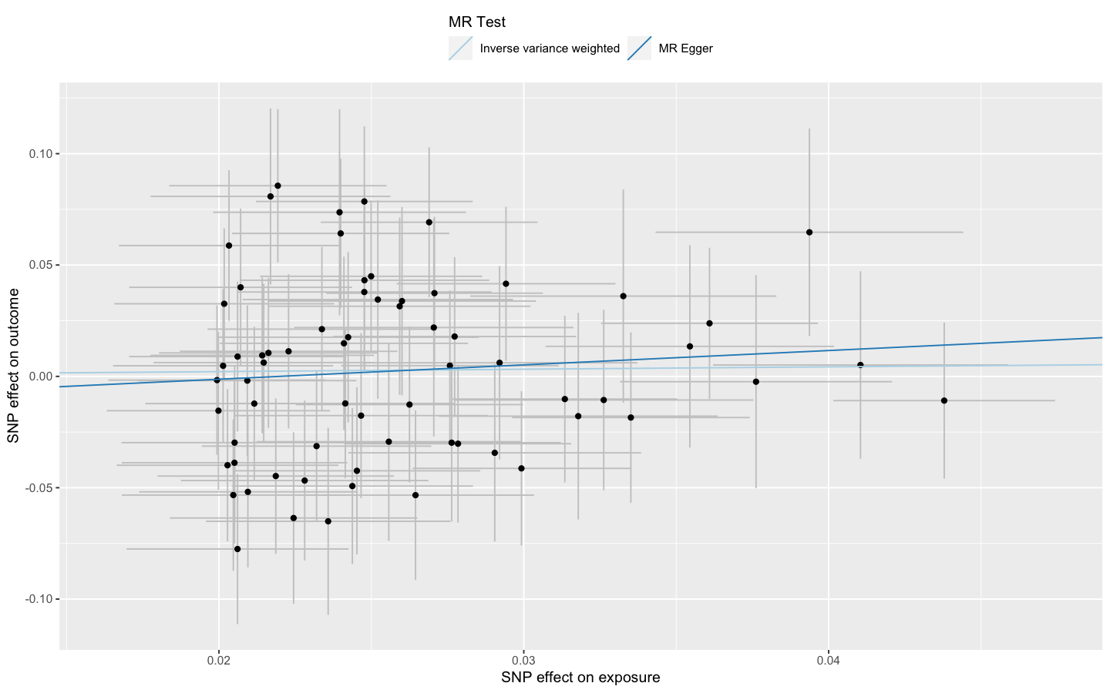
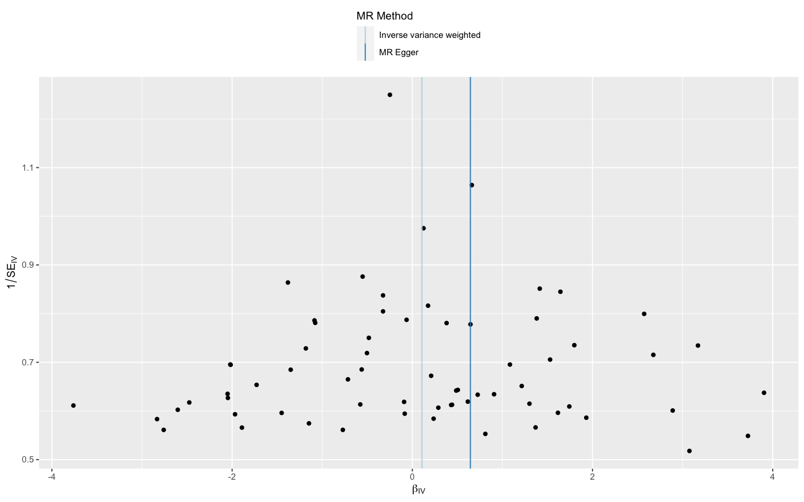
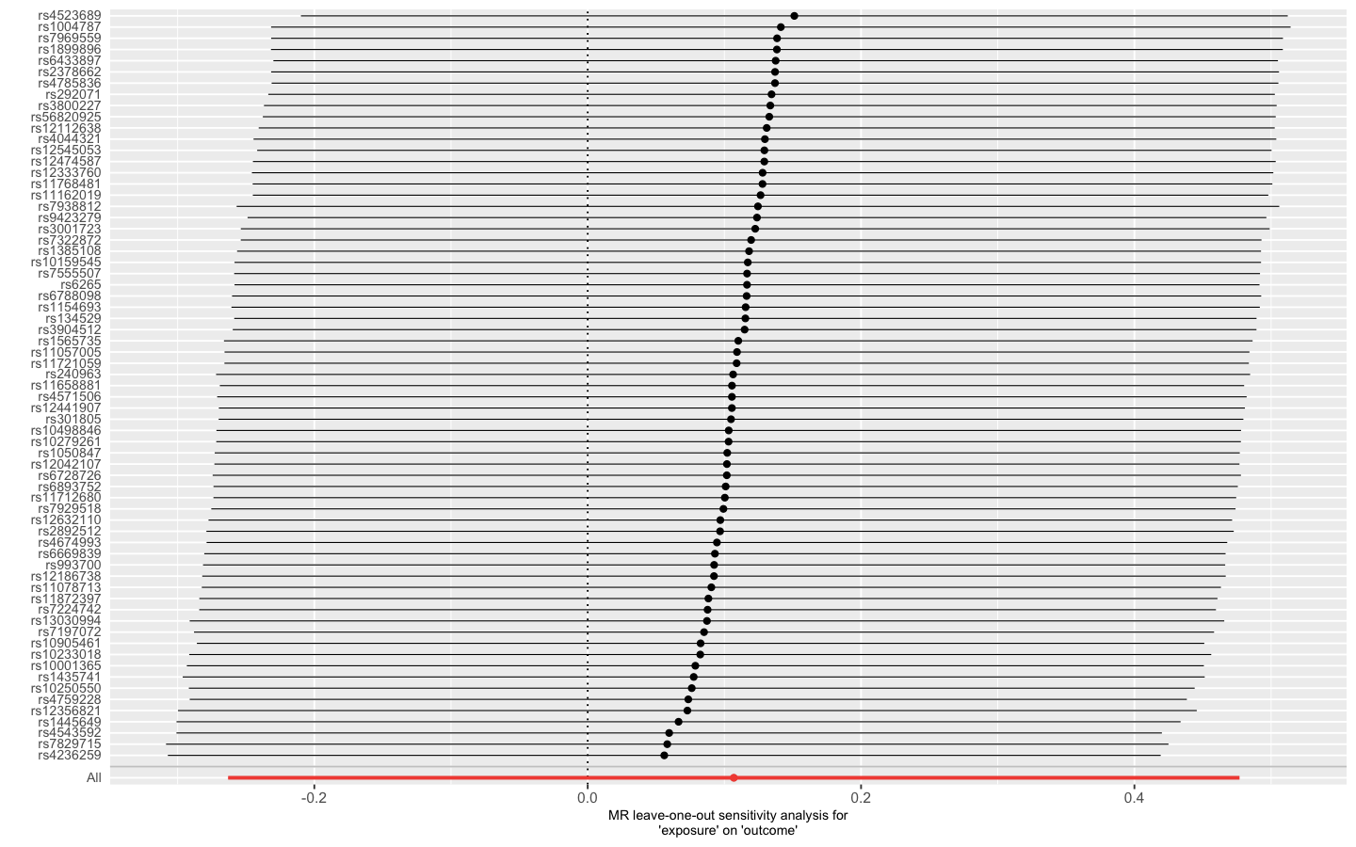
Supplemental figure 3 Scatter, leave-one-out and funnel plots for effect of smoking
initiation on idiopathic pulmonary fibrosis risk

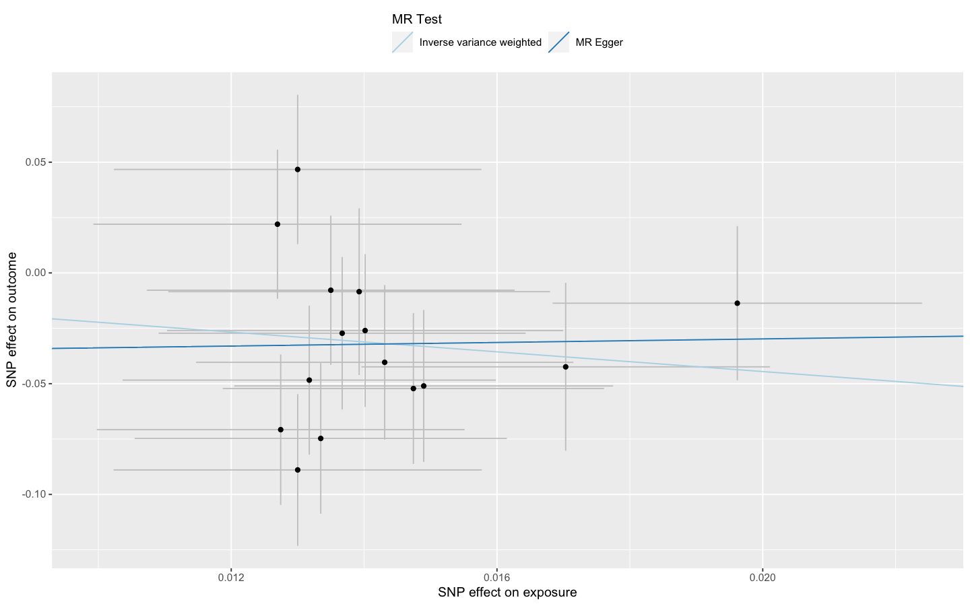
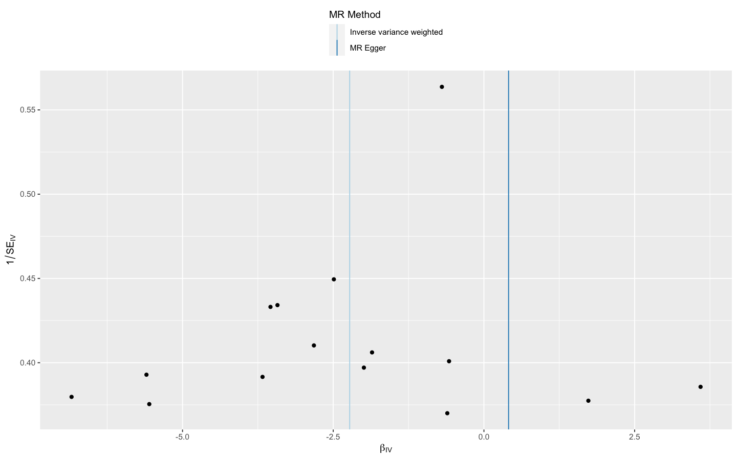
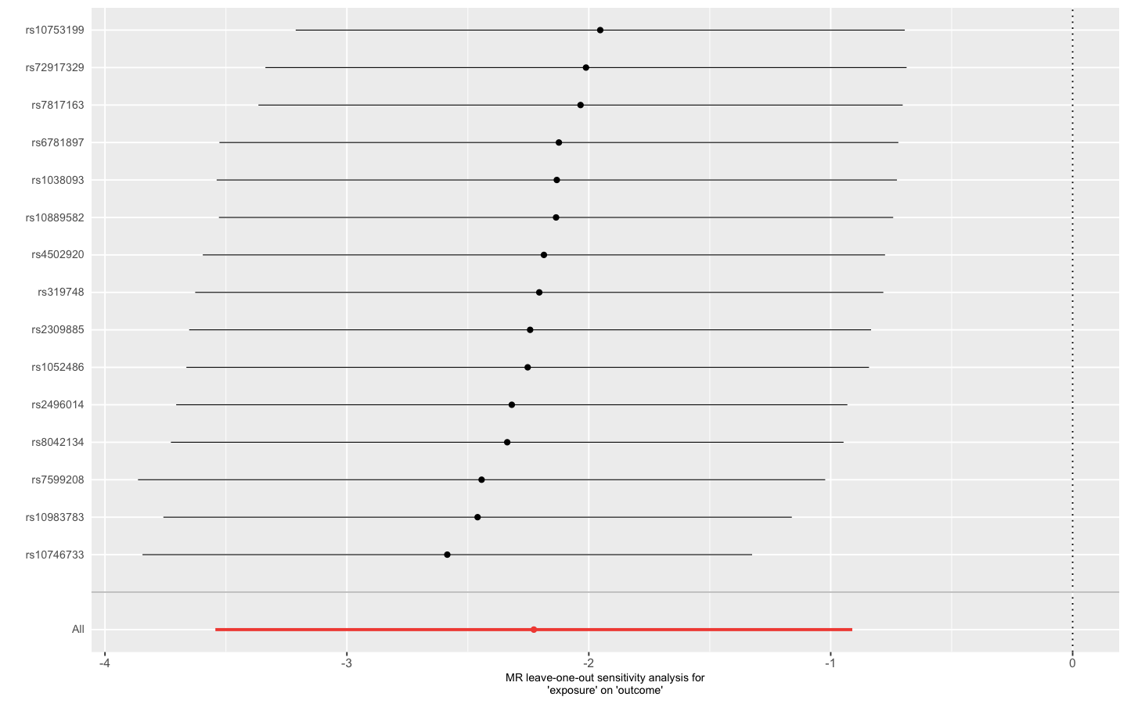
Supplemental figure 4 Scatter, leave-one-out and funnel plots for effect of age of smoking initiation on idiopathic pulmonary fibrosis risk (excluding the SNPs associated with telomere length or obesity)

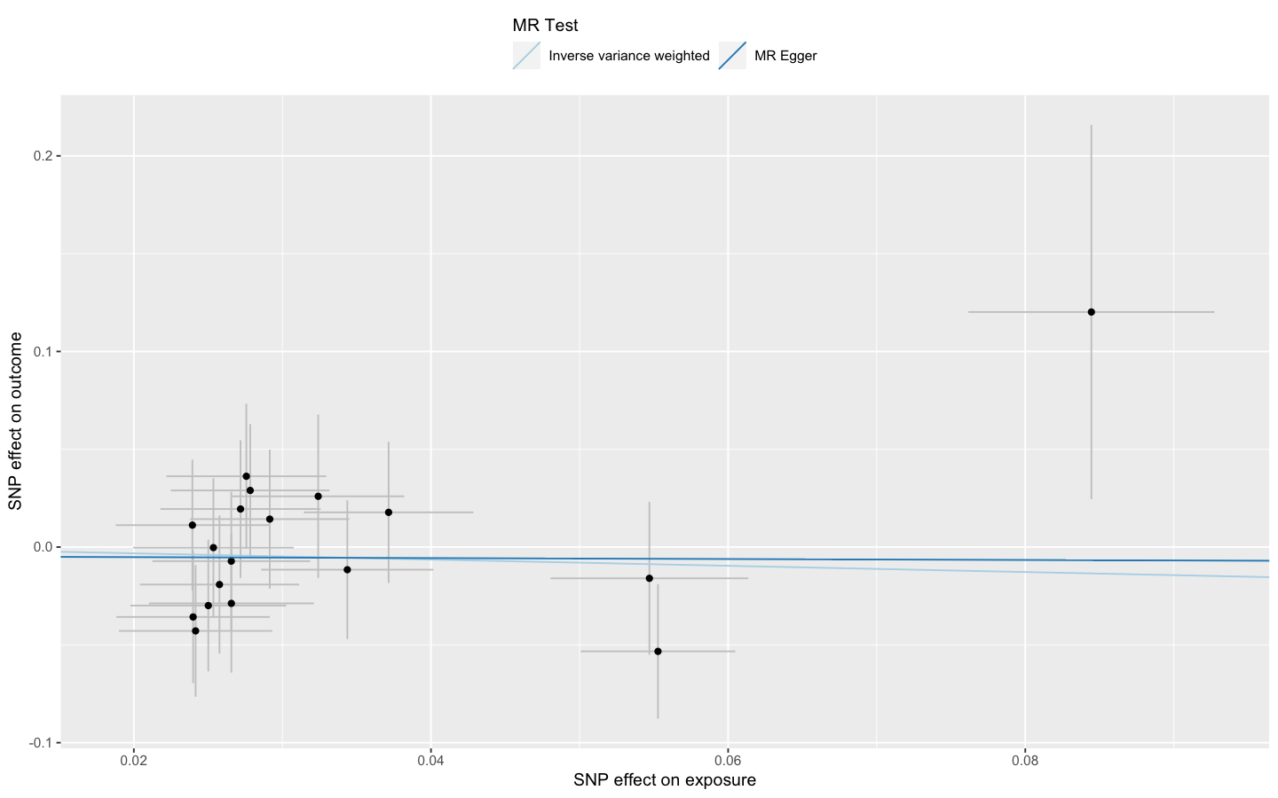
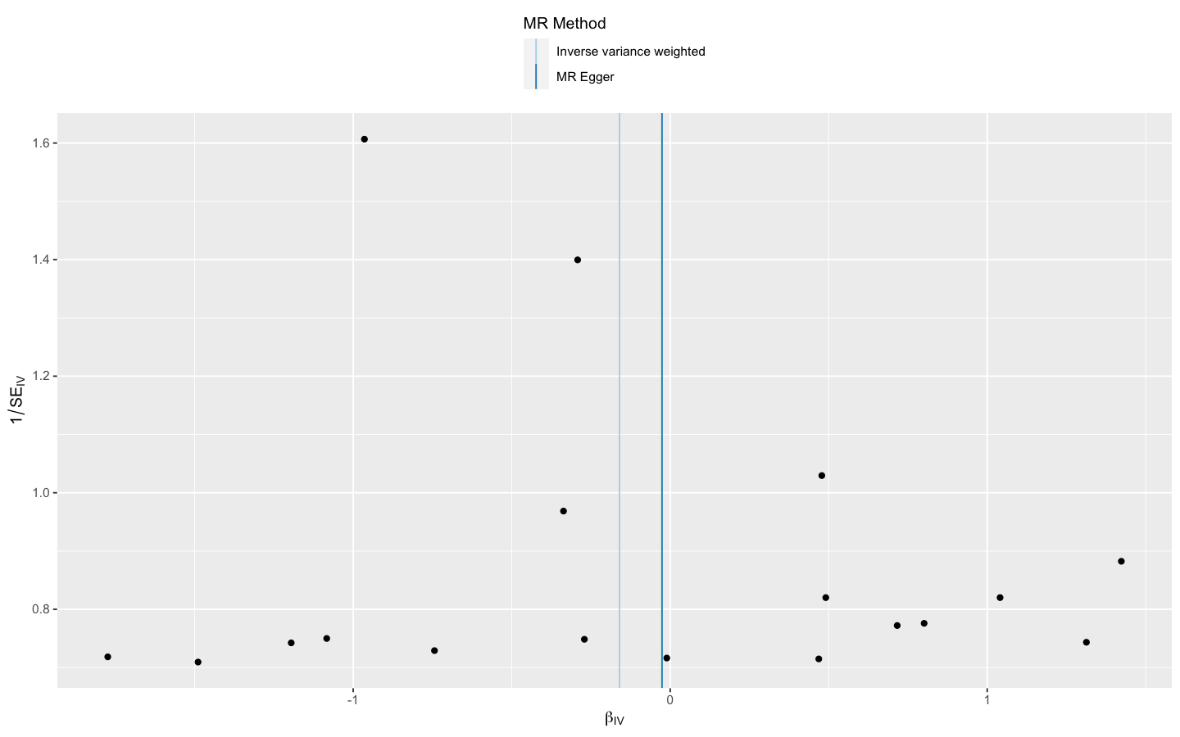
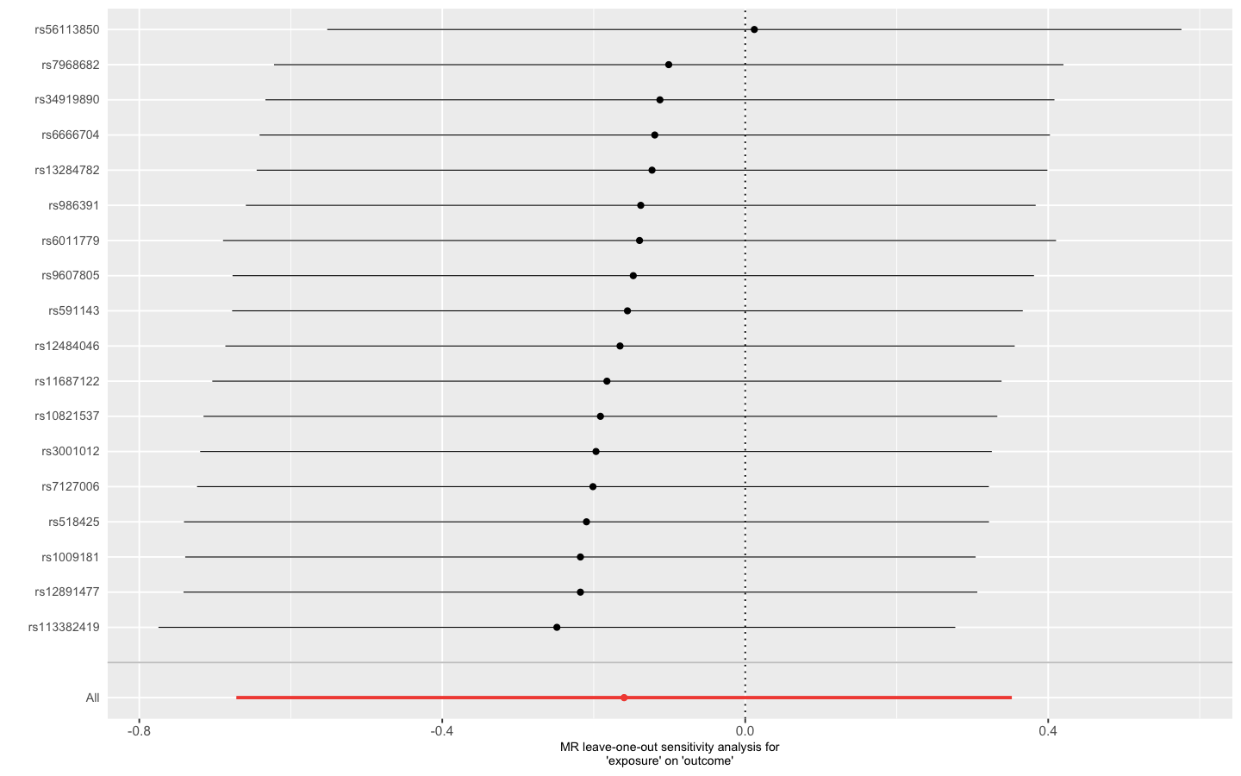
Supplemental figure 5 Scatter, leave-one-out and funnel plots for effect of smoking cessation on idiopathic pulmonary fibrosis risk

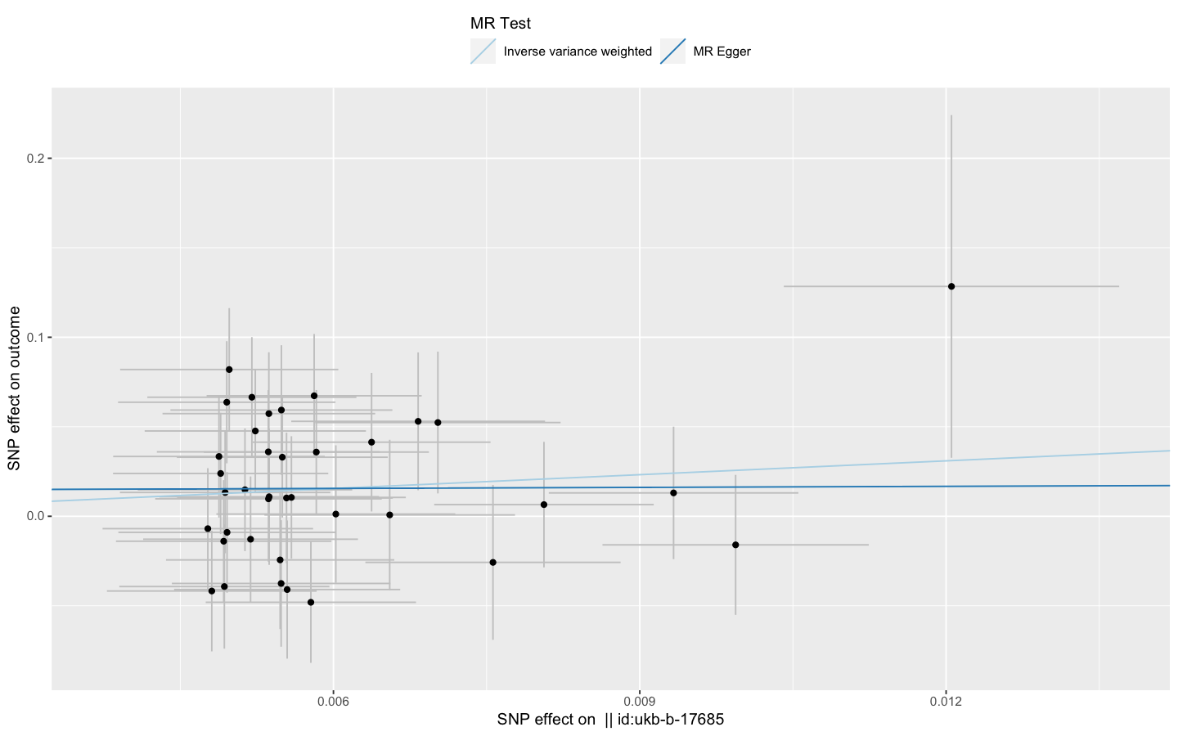
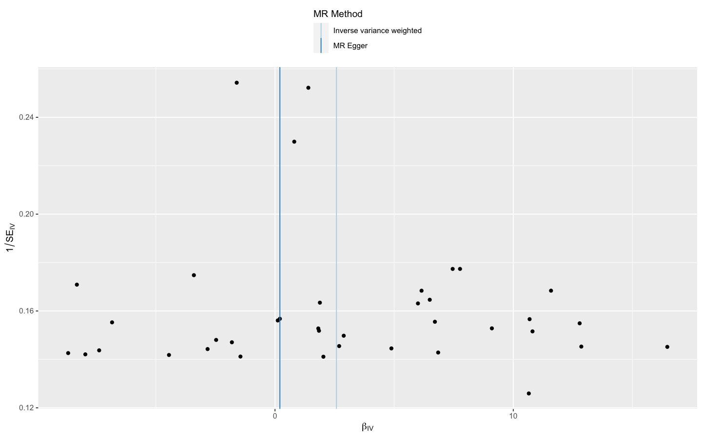
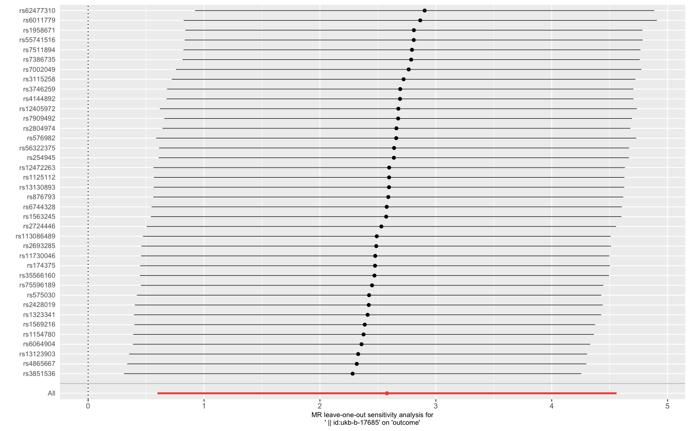
Supplemental figure 6 Scatter, leave-one-out and funnel plots for effect of maternal smoking on idiopathic pulmonary fibrosis risk (excluding the SNPs associated with telomere length or obesity)

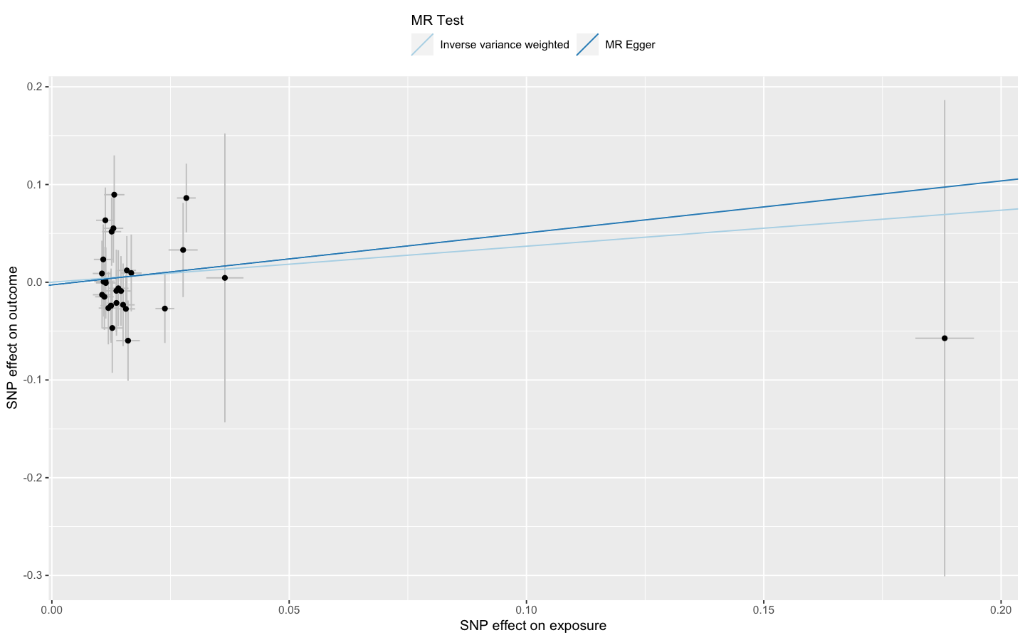
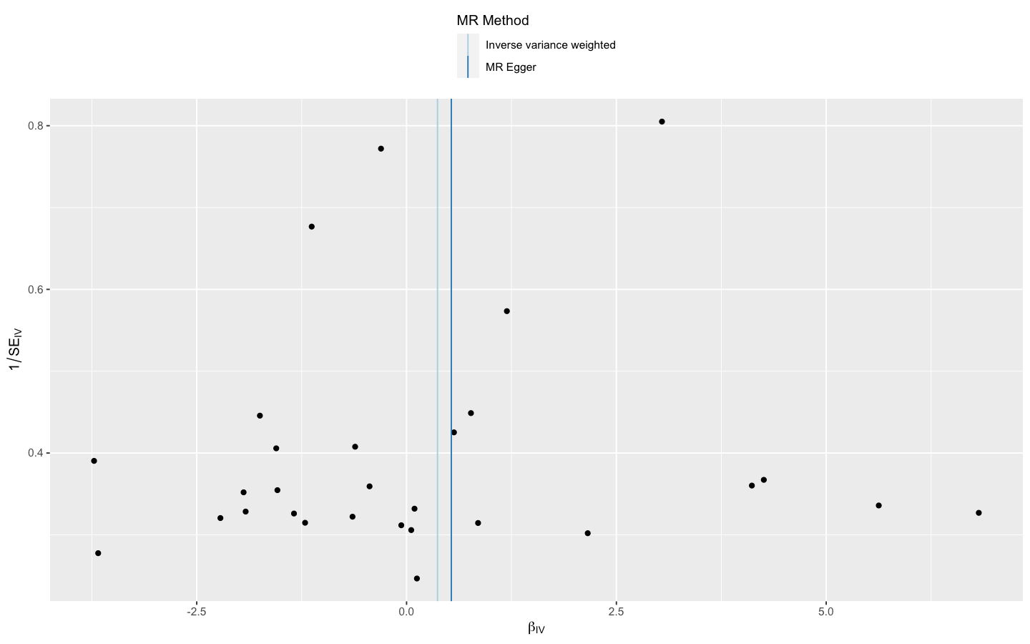
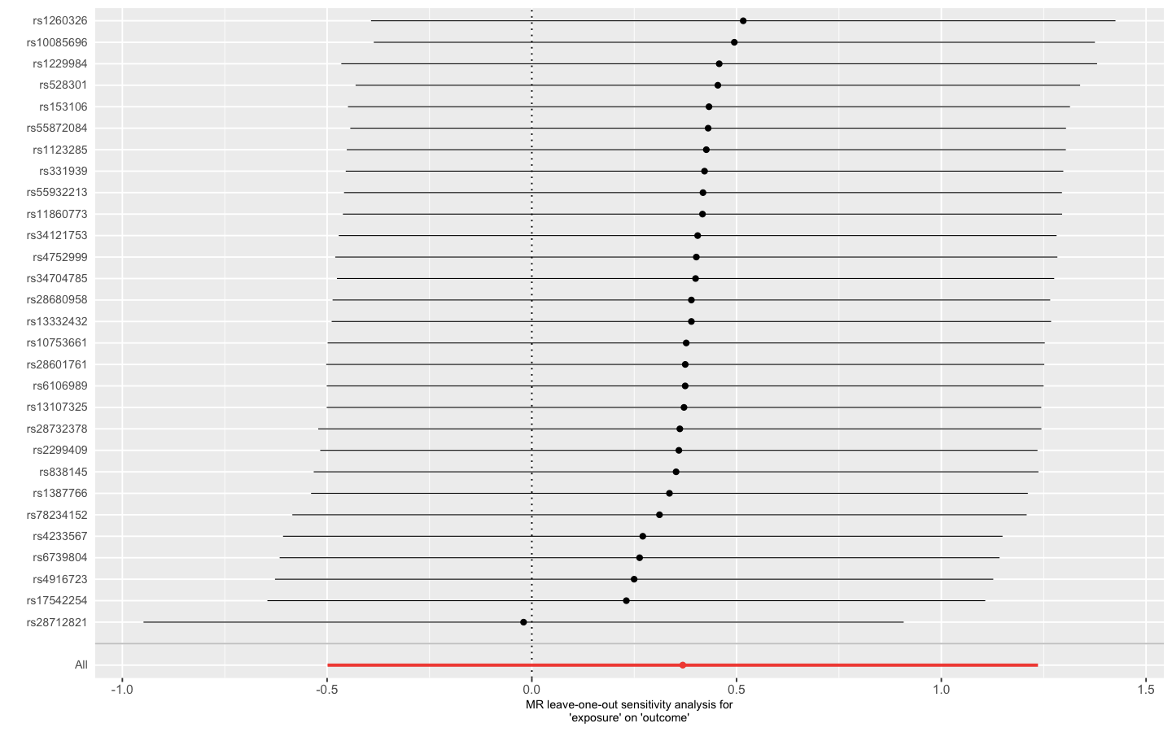
Supplemental figure 7 Scatter, leave-one-out and funnel plots for effect of heavy drinking on idiopathic pulmonary fibrosis risk

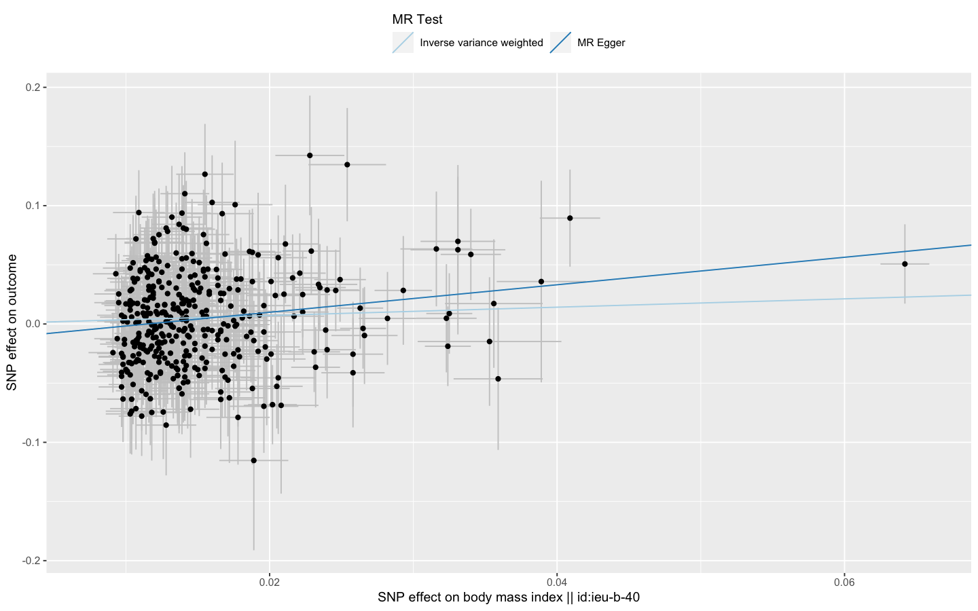
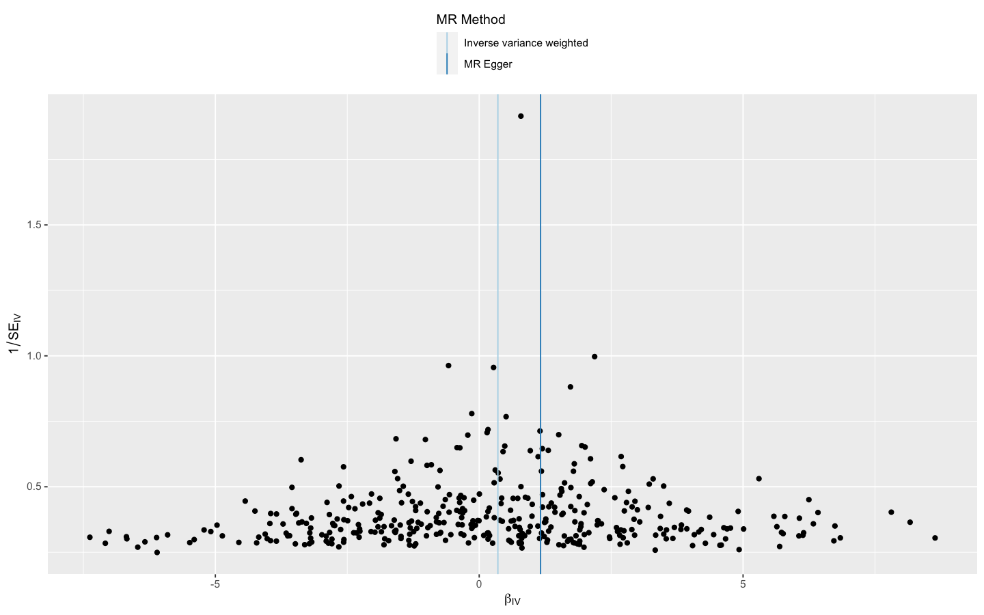
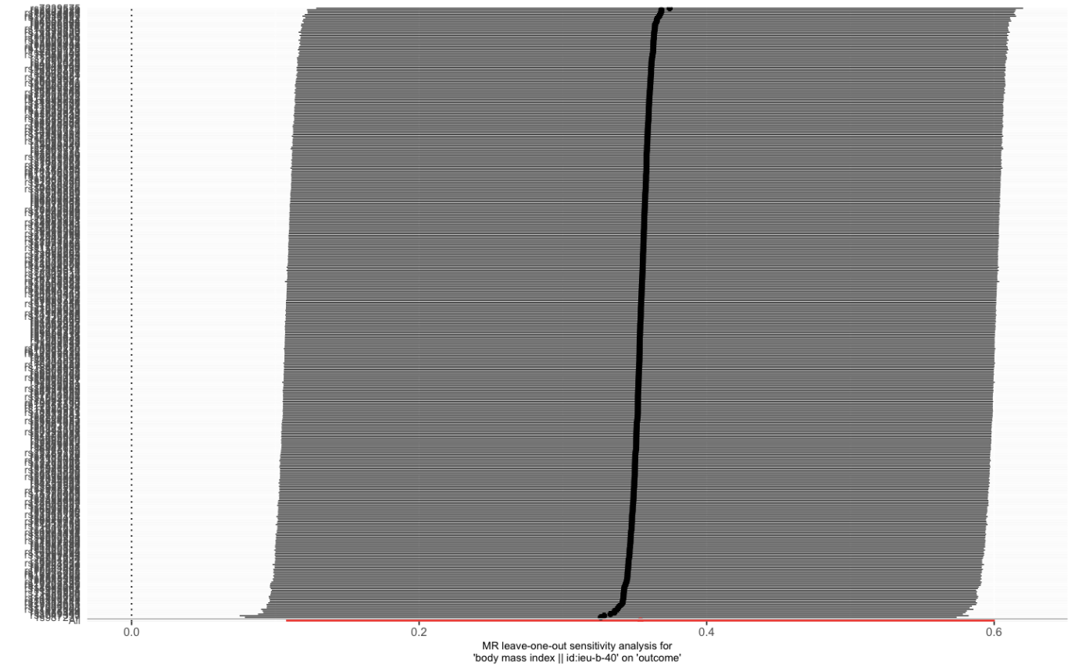
Supplemental figure 8 Scatter, leave-one-out and funnel plots for effect of body mass index on idiopathic pulmonary fibrosis risk (excluding the SNPs associated with telomere length or smoking)

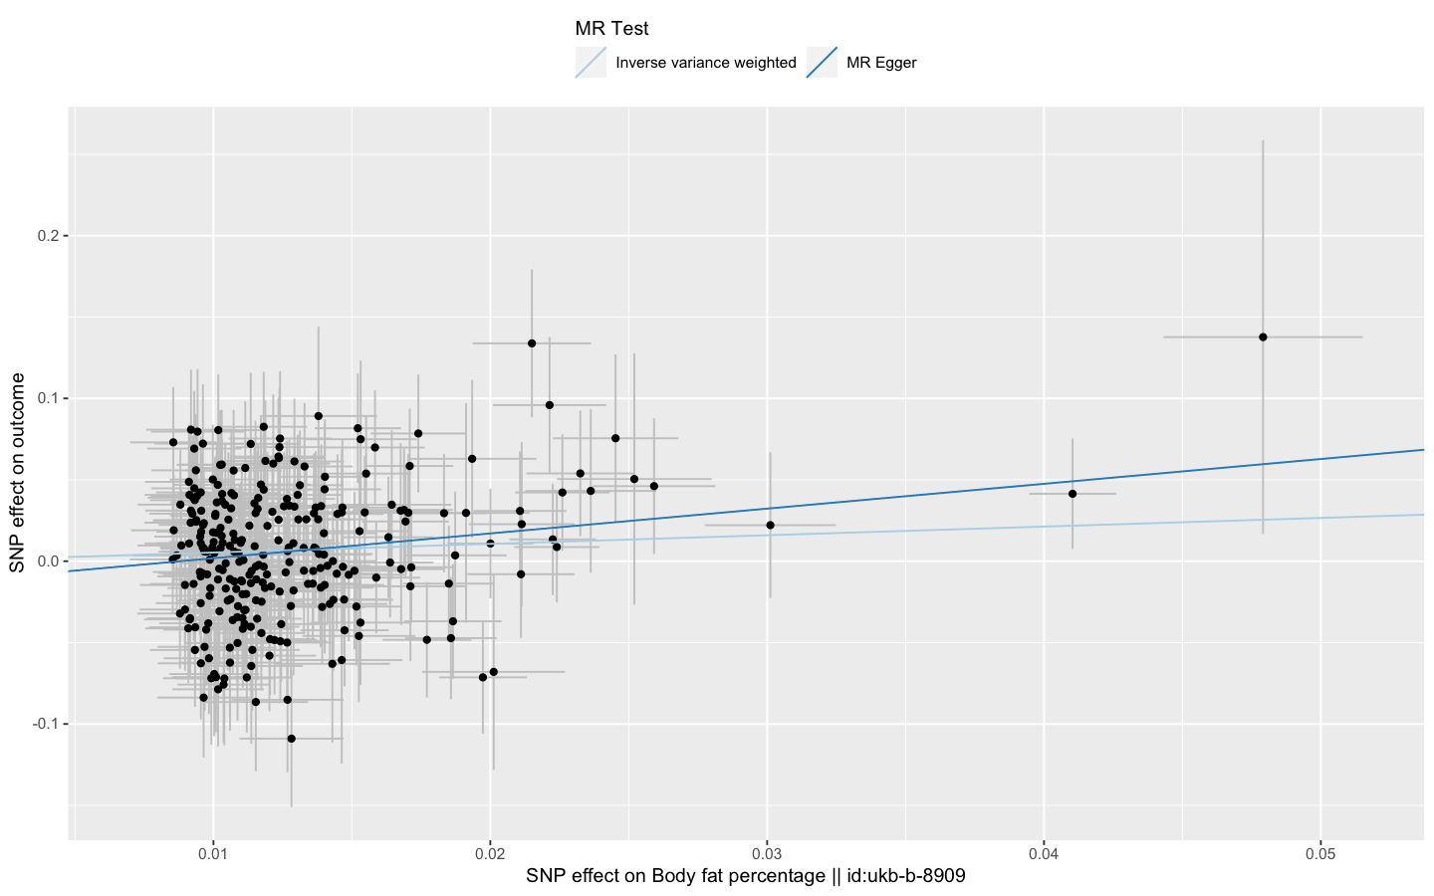
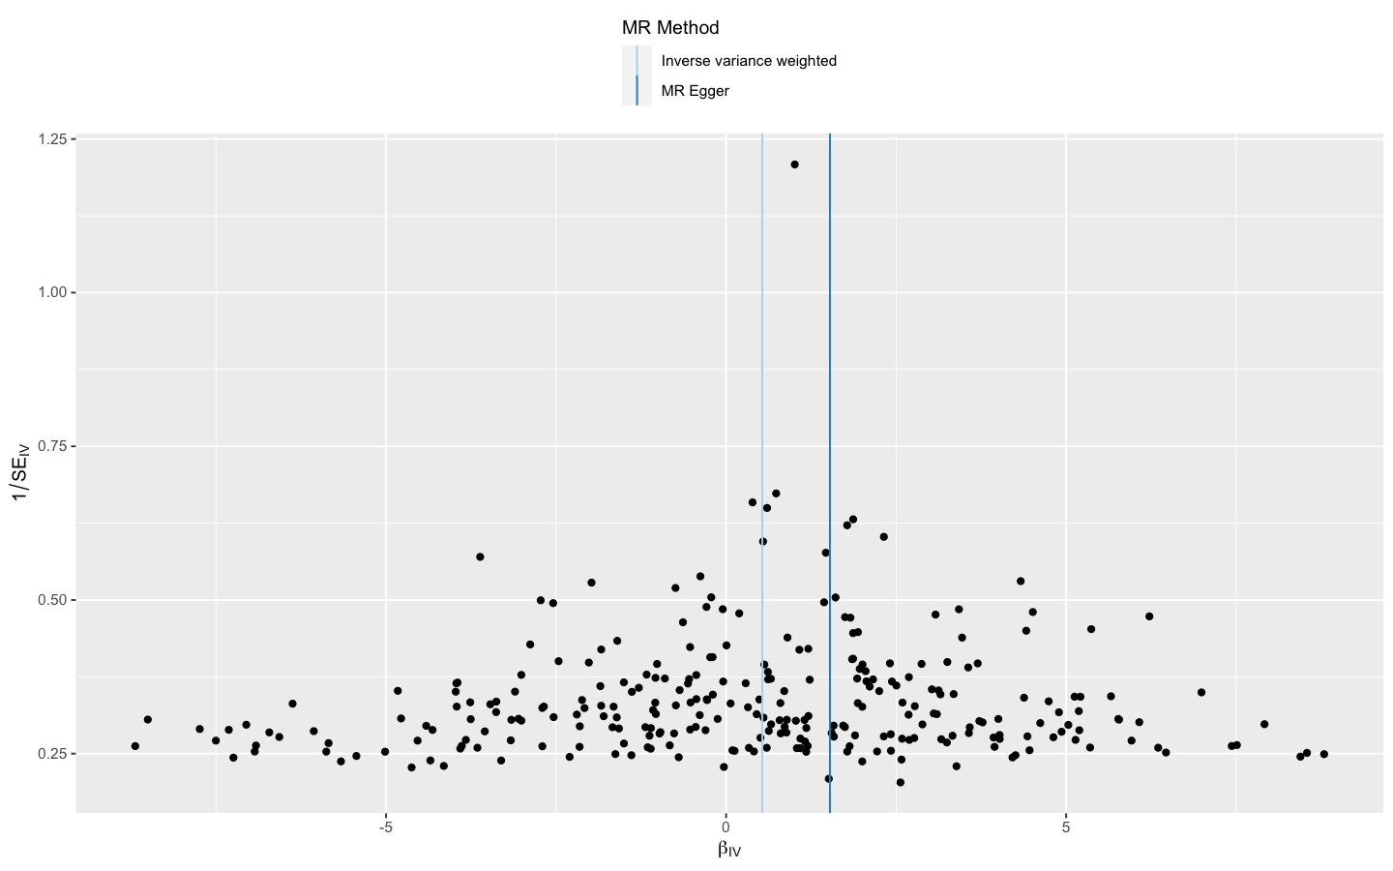
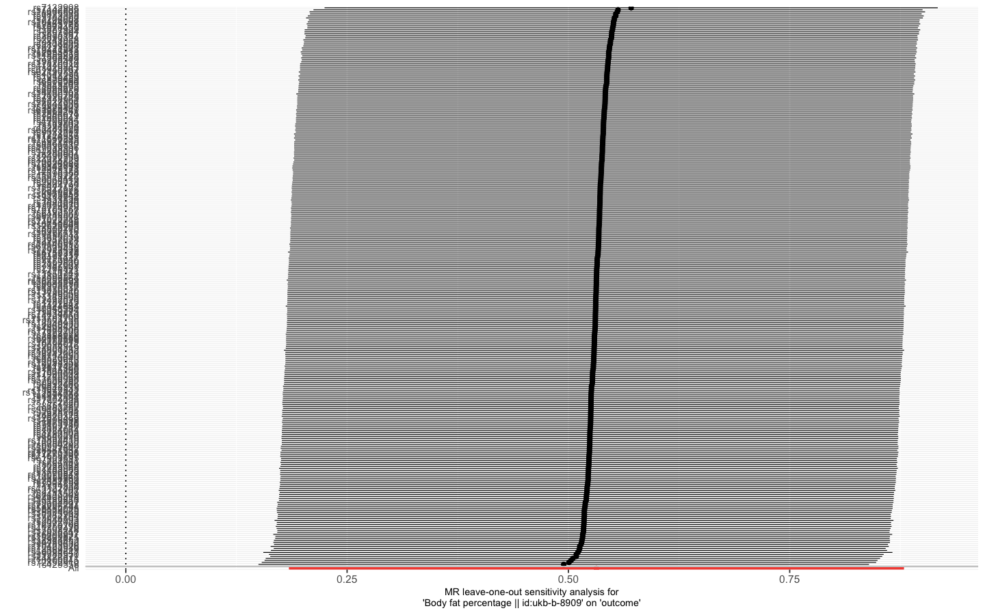
Supplemental figure 9 Scatter, leave-one-out and funnel plots for effect of body fat percentage on idiopathic pulmonary fibrosis risk (excluding the SNPs associated with telomere length or smoking)

