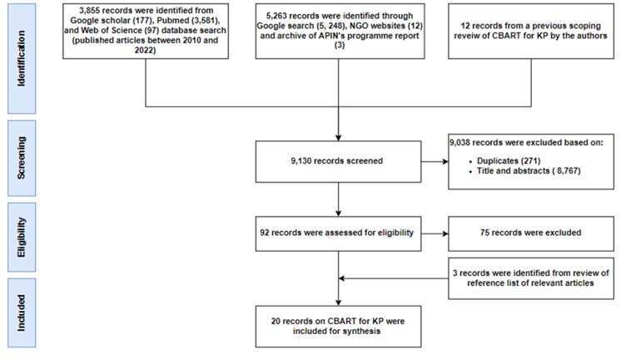
Supplementary figure 1. Prisma diagram of literature search for community-based ART model for key populations’ study and selection process

