Additional file: Fig.S1-18: Concentration curves of age-standardized DALY rates for HIV/AIDS from 2001 to 2018
Figure S1. Concentration curve of age-standardized DALY rates for HIV/AIDS in 2001
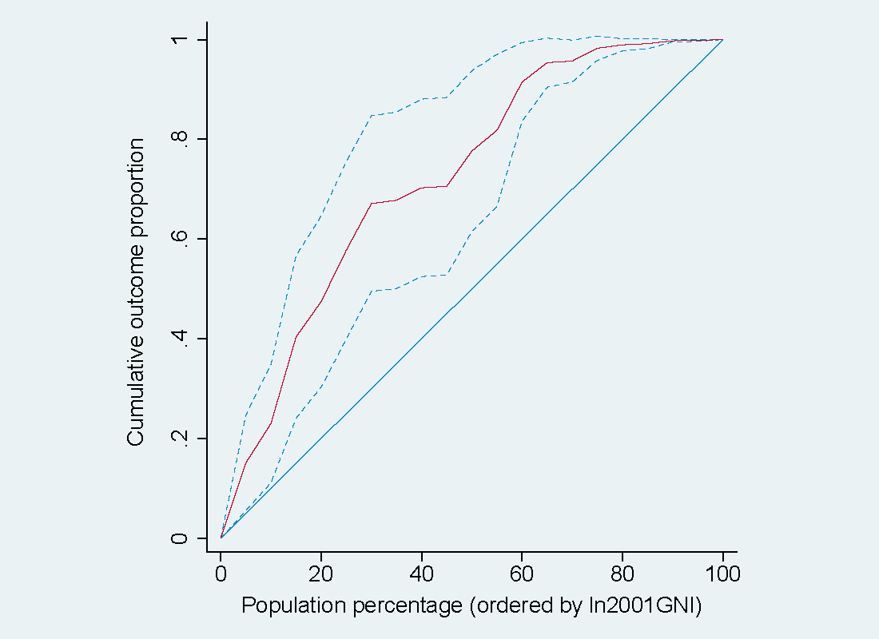 Figure S2. Concentration curve of age-standardized DALY rates for HIV/AIDS in 2002
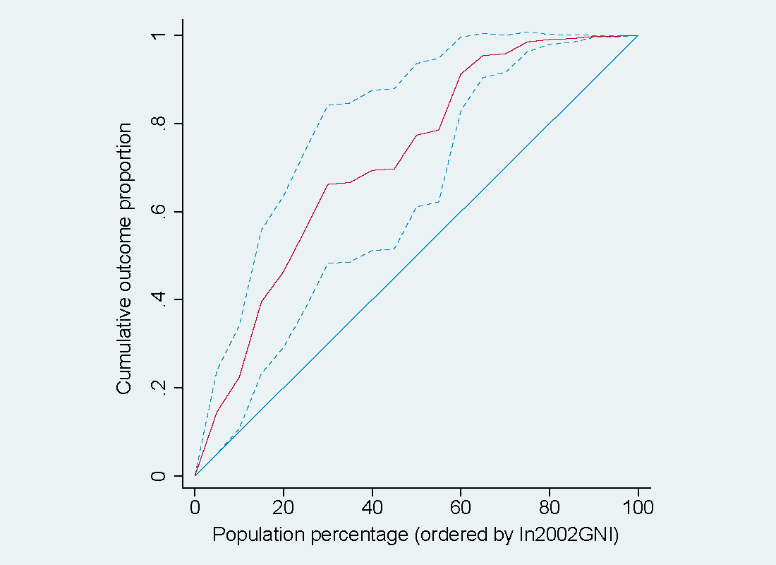

Figure S3. Concentration curve of age-standardized DALY rates for HIV/AIDS in 2003
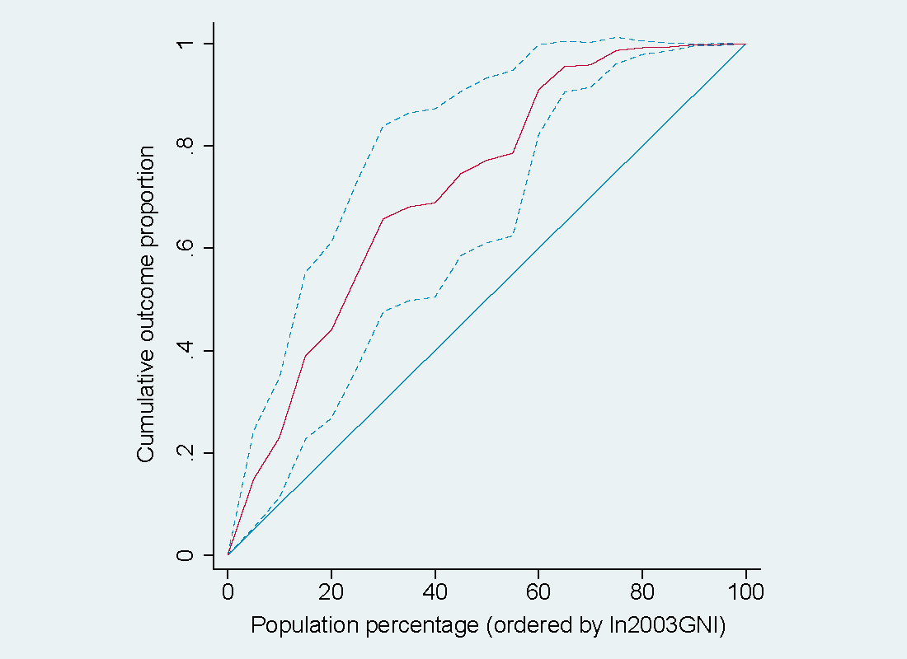 Figure S4. Concentration curve of age-standardized DALY rates for HIV/AIDS in 2004
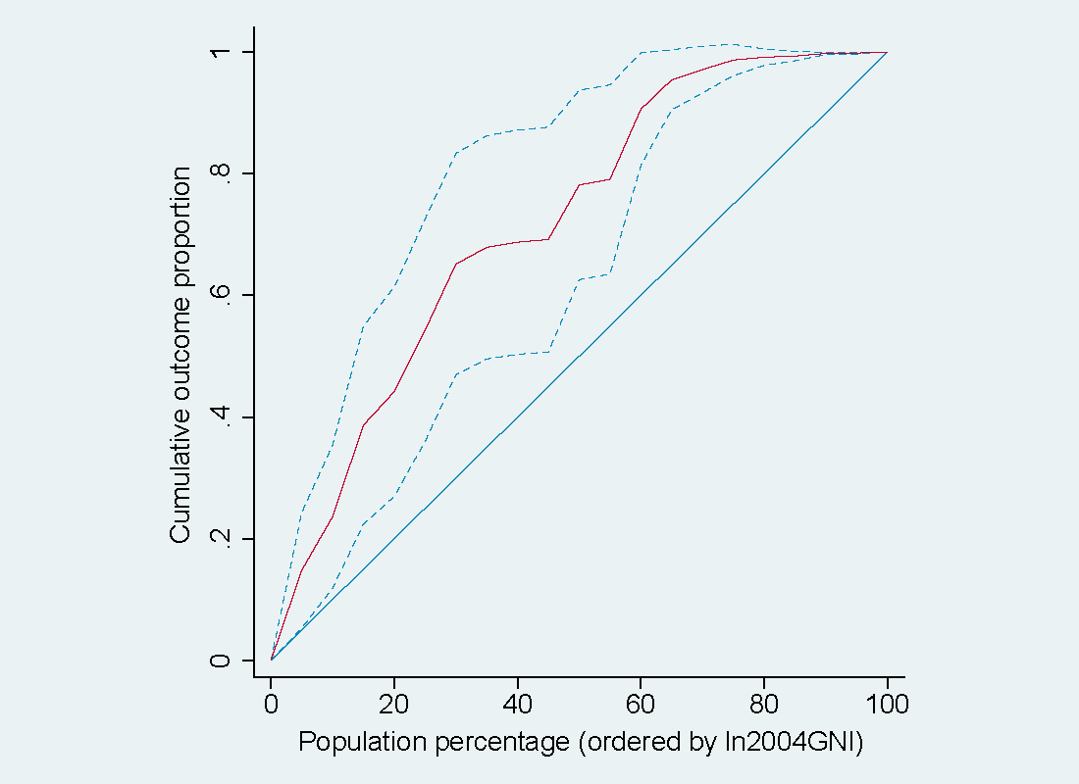

Figure S5. Concentration curve of age-standardized DALY rates for HIV/AIDS in 2005
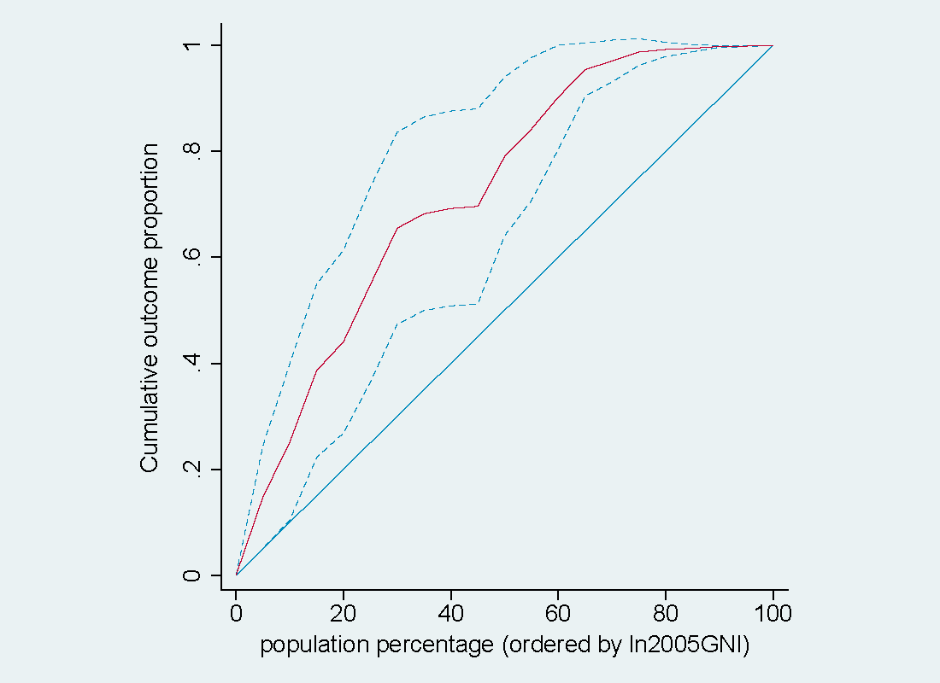 Figure S6. Concentration curve of age-standardized DALY rates for HIV/AIDS in 2006
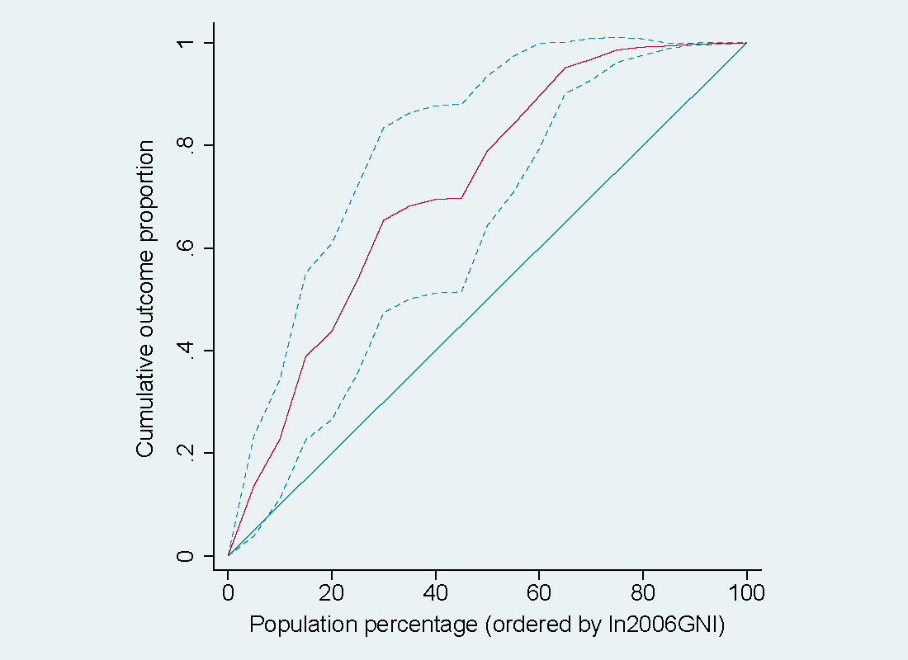

Figure S7. Concentration curve of age-standardized DALY rates for HIV/AIDS in 2007
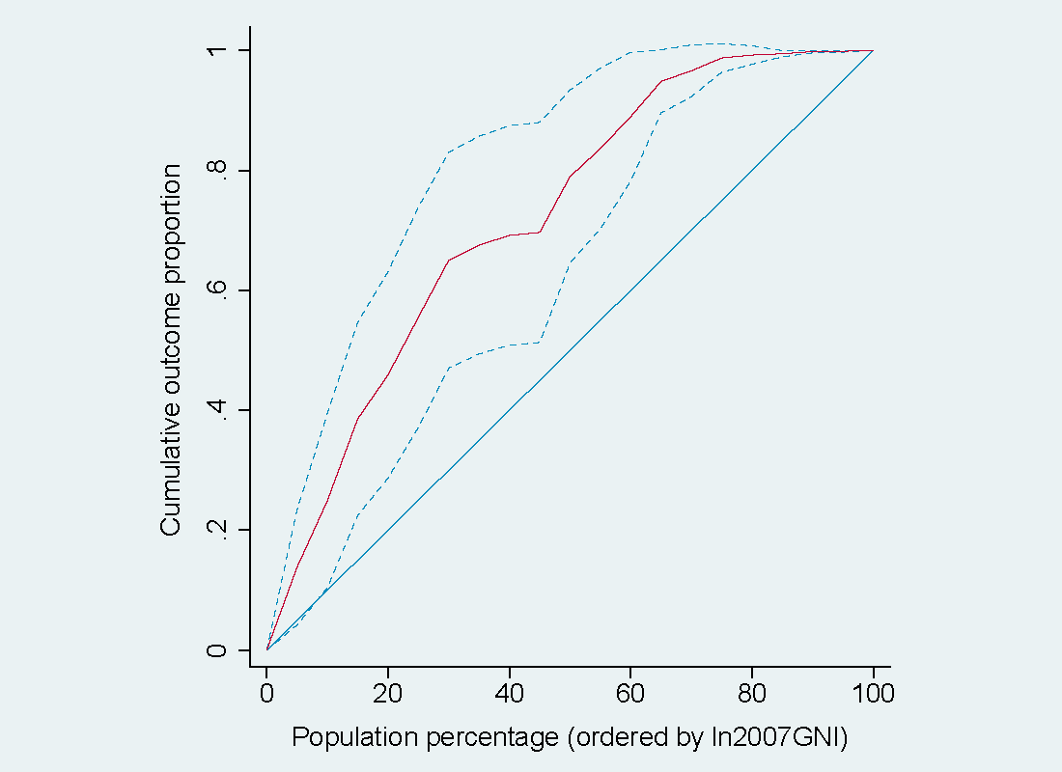 Figure S8. Concentration curve of age-standardized DALY rates for HIV/AIDS in 2008
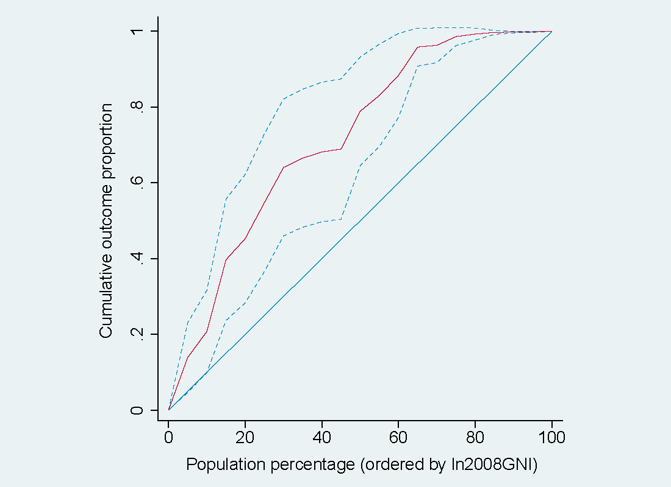

Figure S9. Concentration curve of age-standardized DALY rates for HIV/AIDS in 2009
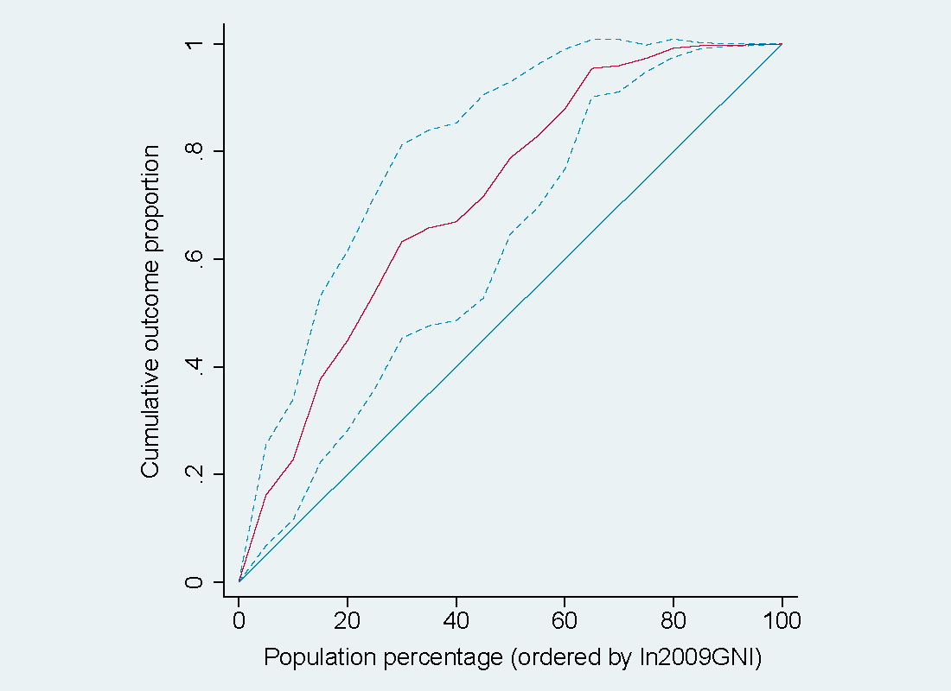 Figure S10. Concentration curve of age-standardized DALY rates for HIV/AIDS in 2010
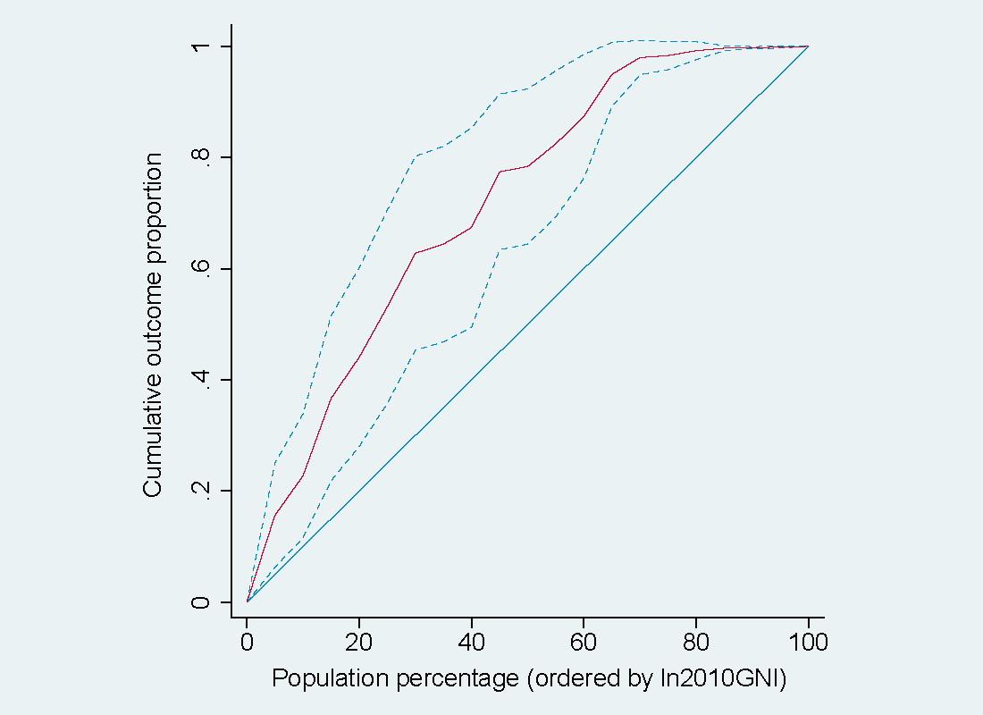

Figure S11. Concentration curve of age-standardized DALY rates for HIV/AIDS in 2011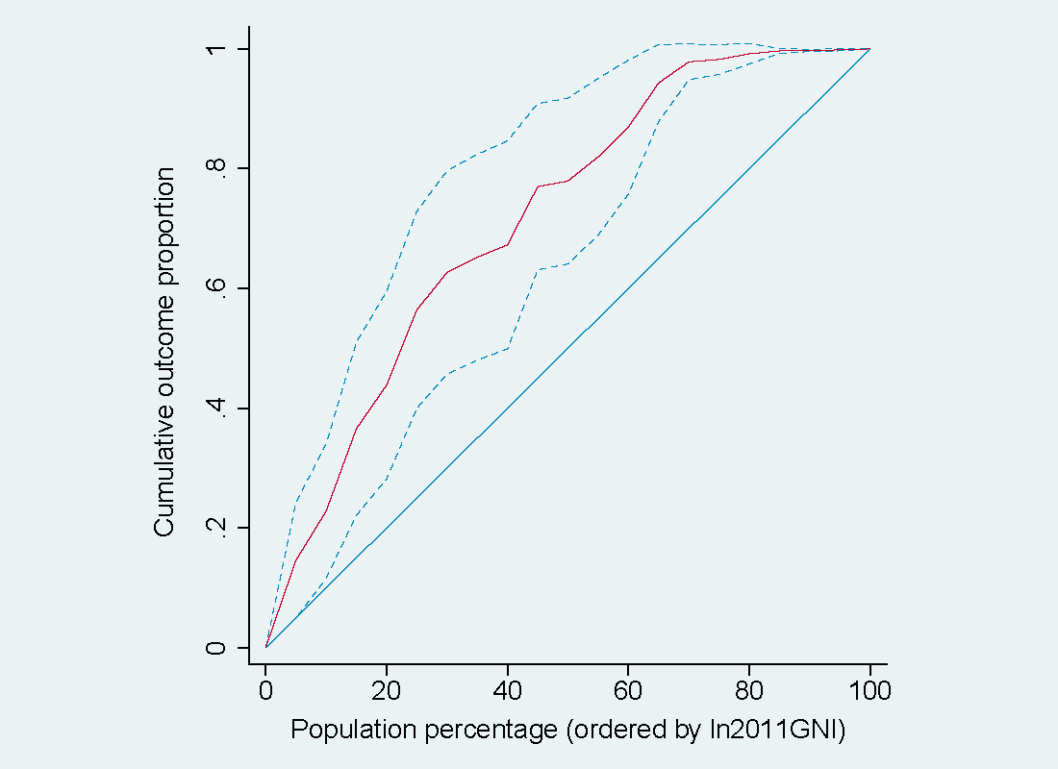 Figure S12. Concentration curve of age-standardized DALY rates for HIV/AIDS in 2012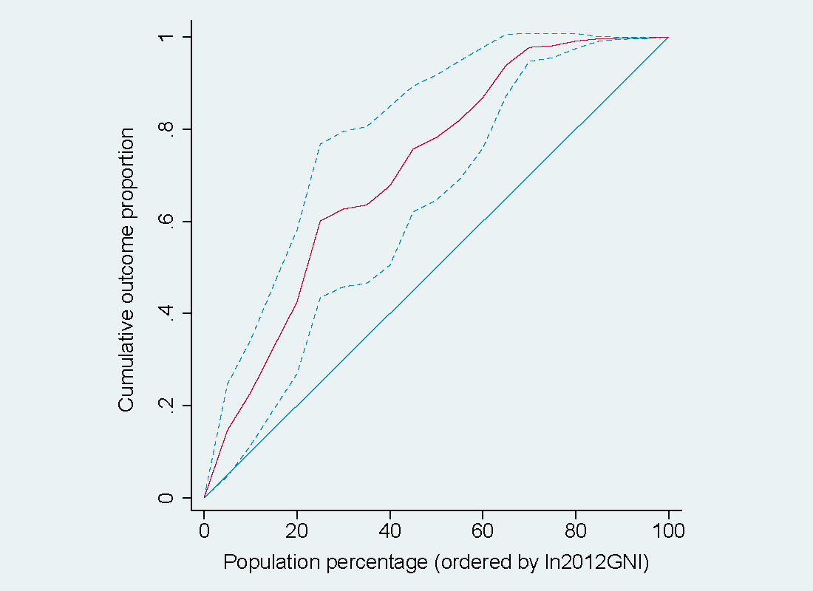

Figure S13. Concentration curve of age-standardized DALY rates for HIV/AIDS in 2013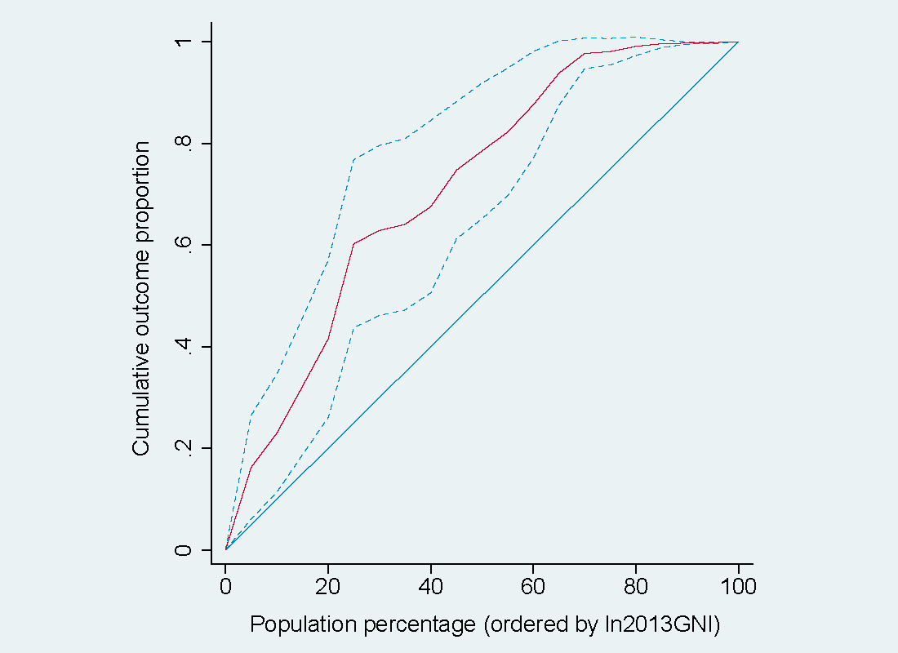 Figure S14. Concentration curve of age-standardized DALY rates for HIV/AIDS in 2014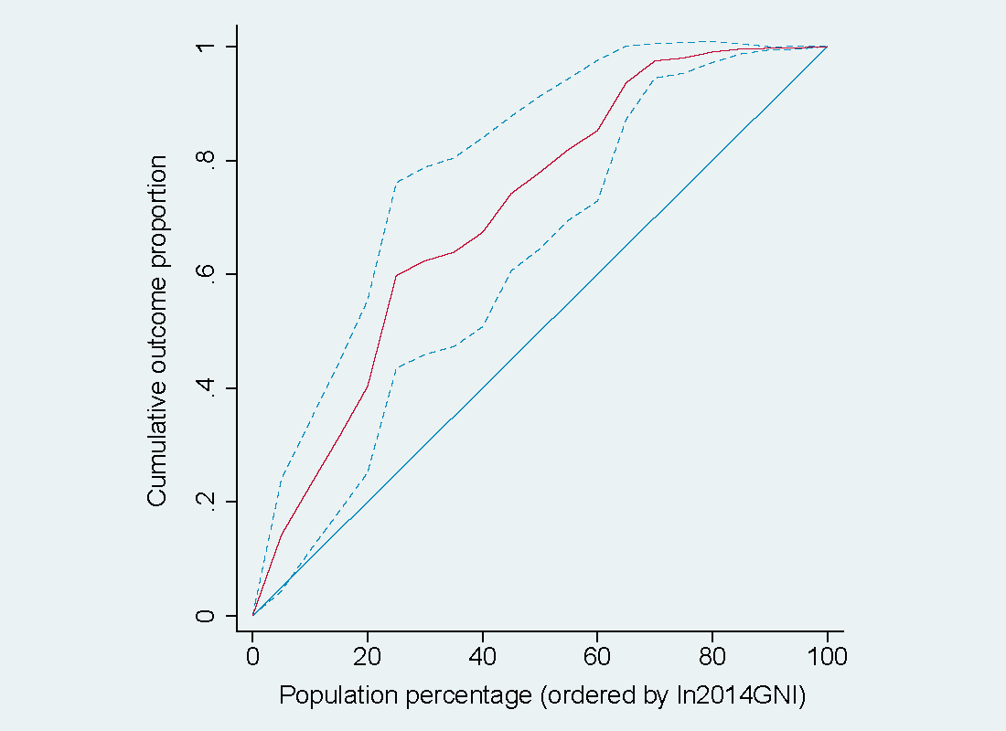

Figure S15. Concentration curve of age-standardized DALY rates for HIV/AIDS in 2015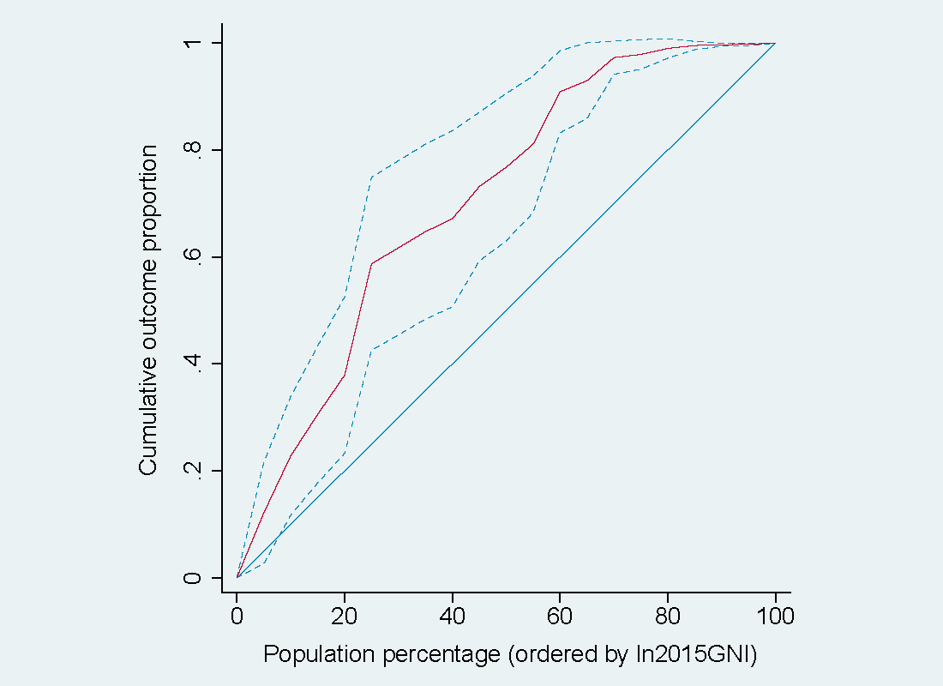 Figure S16. Concentration curve of age-standardized DALY rates for HIV/AIDS in 2016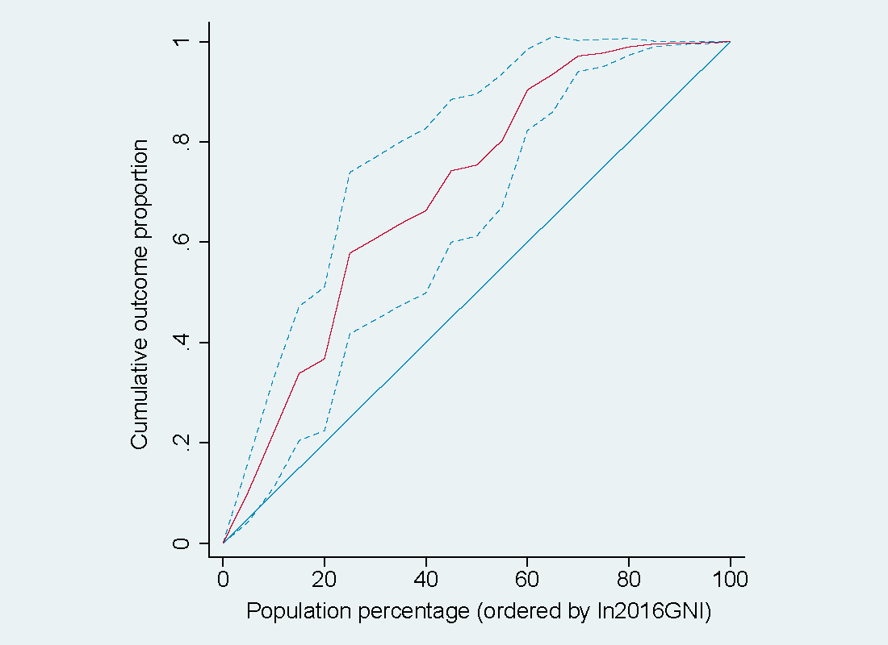

Figure S17. Concentration curve of age-standardized DALY rates for HIV/AIDS in 2017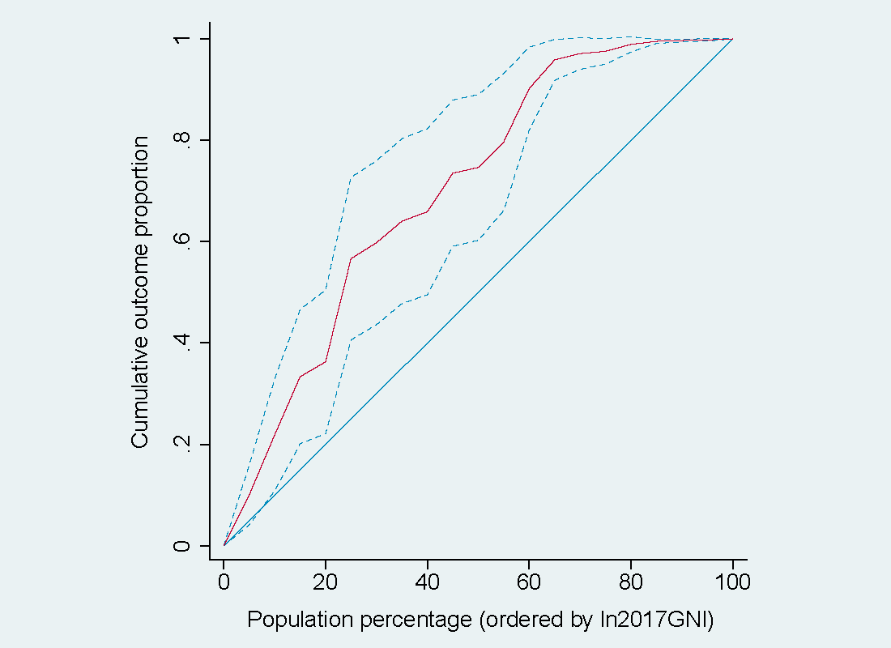 Figure S18. Concentration curve of age-standardized DALY rates for HIV/AIDS in 2018