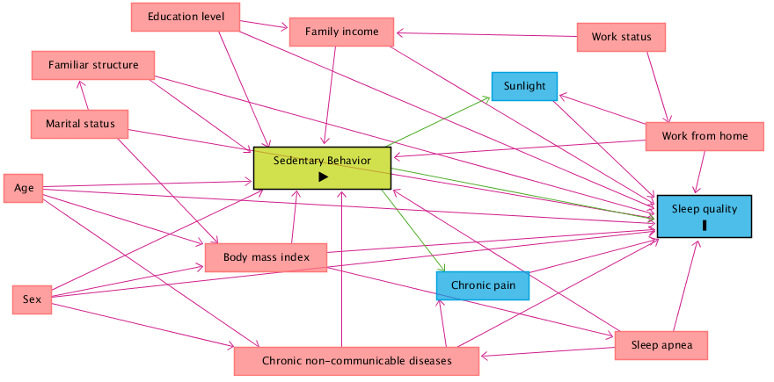

Supplementary figure 1: Directed acyclic graph (DAG) on sedentary behavior and sleep quality in adults during the covid-19 pandemic.

Legend: The variable in green and with the “►” symbol inside the rectangle was the exposure variable; those in blue and with the letter “I” inside the rectangle were the response variables; variables in blue are the antecedents of the outcome variable; and those in red are antecedents of the outcome and exposure variables.

