Questionnaire

＊ Please answer before giving birth.

＊ Please answer alone without consulting with anyone.

＊ There are 6 questionnaire sheets on both sides and it takes about 10 minutes to
answer.

＊ After answering, please put it in the enclosed envelope and post it in the collection box of the questionnaire about feelings and support of pregnant women
installed on the hospital floor. (or please put it in the mailbox.)

Thank you for your cooperation.

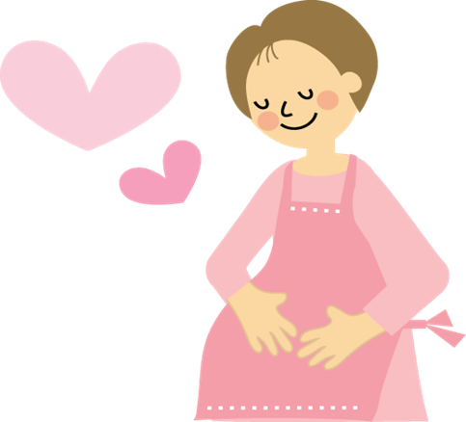

Note: Excerpts from only the items used in the analysis of this study.

【Question1】Please answer about your current pregnancy.
Please fill in the number in parenthesis and select an applicable answer.

1. How many weeks are you pregnant today? | （ ）weeks
2. How many times have you given birth this time?  (Excludes miscarriage and stillbirth) | １．First | ２．2nd or more
3. Did you receive hospital treatment due to complications during pregnancy? | １．Yes | ２．No

【Question2】 Finally, please answer about you.
Please fill in the number or specific matters in parentheses and select an applicable answer.
About question 2, please select all applicable answers.

1．How old are you? | （ ）years old
2．Are you legally married？ | １．Yes
2．Are you legally married？ | ２．No, I plan to register our marriage.
2．Are you legally married？ | ３．No, I have no plans to get married.
3．Do you have the possibility of becoming a single mother  after the current delivery? | １．Yes
 | ２．No
4．Do you have a job? | １．Yes
4．Do you have a job? | ２．No
5．How much is your household income for the last year?  Household income is the income of the entire household, including the income of the family living together. | １．<3 million Yen
 | ２．3-6 million Yen
 | ３．>6 million Yen

6．What is your educational background？ | １．Junior high school
6．What is your educational background？ | ２．High school
6．What is your educational background？ | ３．Junior college or career college
6．What is your educational background？ | ４．University or higher degree
7． Questions 9.-12. ★ are questions about your relationship with your partner over the past year.  ★Do you feel frightened by what he does or said? | １．Never
 | ２．Sometimes
 | ３．Often
8.★Has your partner hit the wall or thrown an object? | １．Never
8.★Has your partner hit the wall or thrown an object? | ２．Sometimes
8.★Has your partner hit the wall or thrown an object? | ３．Often
9.★Has your partner forced you to have sex? | １．Never
9.★Has your partner forced you to have sex? | ２．Sometimes
9.★Has your partner forced you to have sex? | ３．Often
10.★Has your partner pulled your arm, pushed, and/or slapped  you? | １．Never
 | ２．Sometimes
 | ３．Often
11．Have you ever had a miscarriage, stillbirth or abortion? | １．Yes
11．Have you ever had a miscarriage, stillbirth or abortion? | ２．No
12．Have you been treated for a mental illness? | １．Yes
12．Have you been treated for a mental illness? | ２．No

 That's all for the questionnaire.
Thank you very much for your cooperation.

